Fission Reactor
Filter Reactor, splits input events into sequences of output events based on any number of criteria you might set.
When you add a Fission Reactor you will be prompted for the following fields:
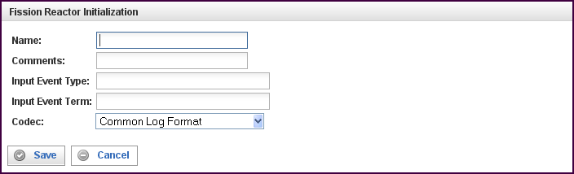

Field | Description
Name | Specify the name of this reactor. This can be any name you find descriptive, we recommend something which describes the data this reactor is processing.  The name may be any combination of letters and numbers.
Comments | Enter some descriptive comments about this reactor. Any comment you feel will help you in the future, we recommend choosing something that describes the data being processed.
Input Event Type | The input event type must be a Term of type “object” (this rule is enforced by the Pion user interface). Only input events of this type are processed; any other events are dropped.  An Input Event Type must be specified.
Input Event Term | A term to be parsed from the Input Event (described above). The type of the input event term must be one of the string types (this rule is enforced by the Pion user interface). One or more values from each Input Event Term in the input event are parsed by the Codec to create output events.  An Input Event Term must be specified.
Codec | Defines the codec used to parse the Input Event Term(s) specified above.  A Codec must be specified.
This creates the Fission Reactor in the workspace. Double-clicking on the reactor brings you to the configuration screen:
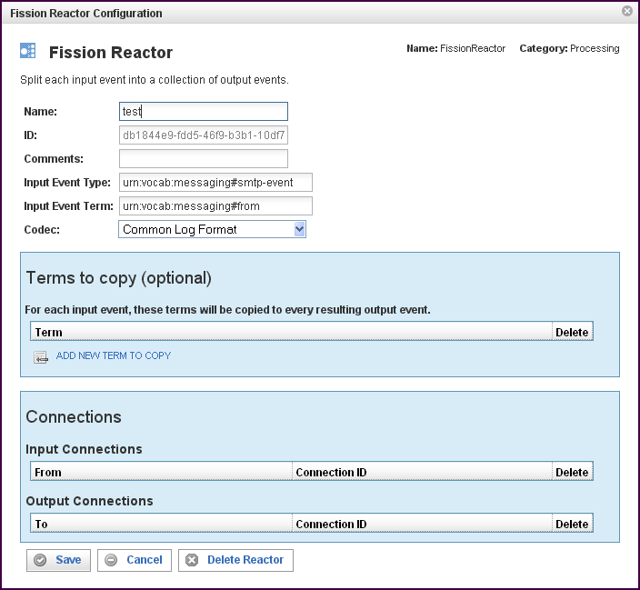
In addition to the fields you saw when adding the reactor initially (described above), you will see some additional fields and sections for Terms to copy and Connections. The additional fields are:
Field | Description
ID | The reactor ID, a unique ID generated by the Pion server. This ID identifies a particular reactor.

The Terms to Copy Section
The Inclusion Conditions section describes a list of terms whose values will be copied into all output events.
Field | Description
Terms (to copy) | The value or values of each of the terms defined will be copied from the original event into all derived events.
To add a new term in the Terms to copy list, click on the ADD NEW TERM TO COPY link. When you click on the new row, a list of vocabularies and their associated terms appears. Select the vocabulary and term you want to add, then click Select term.
To delete a term from the list, click on the “x” at the end of the row containing that term.

The Connections Section
The Connections section describes input and output connections for this Fission Reactor. See “Error: Reference source not foundX“ on page XError: Reference source not foundX for more information.

