Python Reactor
The Python Reactor allows you to use the popular Python programming language to collect, manipulate and store events within Pion.
When you add a Python Reactor you will be prompted for the following fields:
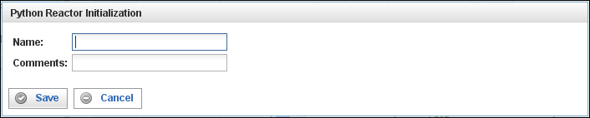
Field | Description
Name | Specify the name of this reactor. This can be any name you find descriptive, we recommend something which describes the data this reactor is processing.  The name may be any combination of letters and numbers.
Comments | Enter some descriptive comments about this reactor. Any comment you feel will help you in the future, we recommend choosing something that describes the data being processed.

This creates the Python Reactor in the workspace. Double-clicking on the reactor brings you to the configuration screen:
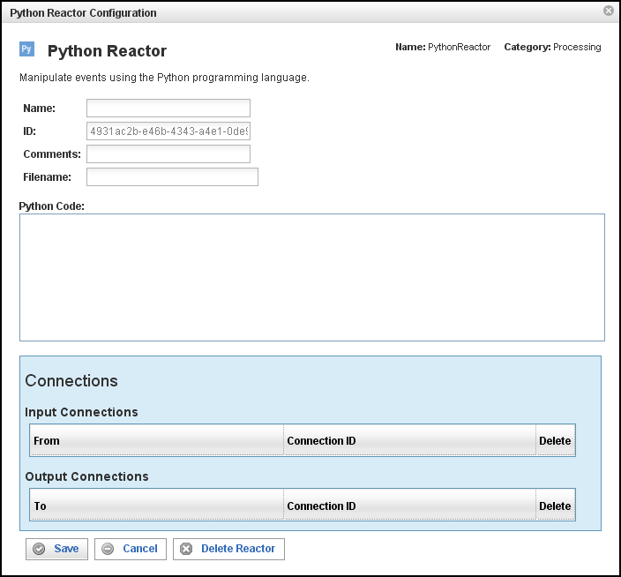
In addition to the fields you saw when adding the reactor initially (described above), you will see one additional field and the Connections section. The additional field is:
Field | Description
ID | The reactor ID, a unique ID generated by the Pion server. This ID identifies a particular reactor.
Filename | If specified, this file should contain the Python source code used to manipulate events.
Python Code | If a file name is not specified above, you may enter your Python code into this box (see About Your Source Code in the Python Reactor, below). Code in this box is ignored if a file name is specified above.

About Your Source Code in the Python Reactor
The Python Reactor automatically compiles your source code into a byte code format that is stored in memory. Your code is automatically imported into a Pion module which supports two special data types, Event and Reactor, and three "callback" functions, start(), stop(), and process().

The Event Data Type
The Event data type is a subclass of the Python dict (dictionary) type. It contains one additional attribute:
(name / type / description)
-------------------------------
type str type of Event (i.e. "urn:vocab:clickstream#http-event")

Events must always have a valid "type" (as configured in a Pion vocabulary). The keys of Event items must be string types representing a particular Term identifier (i.e. "urn:vocab:clickstream#uri-stem"). The value of an Event item must be a Python sequence (tuple or list) containing zero or more objects (note that in most cases it will contain a single item). All objects in a value sequence must be of a type corresponding to the Pion data type assigned to the corresponding Term.
The following are the Python types that correspond to Pion Vocabulary data types:
Pion Type | Python Type
undefined | int = 1
event type | int = 1
signed int (8-bit) | int
positive int (8-bit) | int
signed int (16-bit) | int
positive int (16-bit) | int
signed int (32-bit) | int
positive int (32-bit) | long
signed int (64-bit) | long
positive int (64-bit) | long
small real number | float
medium real number | float
large real number | float
small string | str
medium string | str
large string | str
fixed-length string | str
binary large object | str
blob (stored compressed) | str
specific date | date
specific time | time
specific time & date | datetime

The Reactor Data Type
The Reactor data type supports the attributes “id,” “name,” and “deliver” where:
- id: Is a string (str) value of the unique identifier of the Python Reactor.
- name: Is a string (str) value of the name assigned to the Python Reactor.
- deliver: Is a function that takes a single Event object argument, and delivers the event to all of the Python Reactor's output connections.

The Callback Functions
The following three callback functions are optional, and can be used to define the behavior of this reactor:
- start(Reactor)
Pion calls this function whenever the reactor is started. It is given a single parameter, a Reactor object representing the Python Reactor.
- stop(Reactor)
Pion calls this function whenever the reactor is stopped. It is given a single parameter, a Reactor object representing the Python Reactor.
- process(Reactor, Event)
Pion calls this function whenever the reactor receives a new event to process via an input connection. The first parameter is a Reactor object ID representing the Python Reactor. The second parameter is an Event object representing the original Pion event.
- If no process() function is provided, the Python Reactor passes all events it receives to its output connections without modification.
- If a process() function is defined, you must explicitly deliver any events to the reactor's output connections by calling the deliver method of the Reactor object ("r.deliver(e)").
Any exceptions raised by a custom process() function will result in an ERROR message being logged and the event being dropped.
The following is an example of callback functions that can be used by the Python Reactor:
URI_STEM = 'urn:vocab:clickstream#uri-stem'

def start(r):
print 'starting reactor', r.name

def stop(r):
print 'starting reactor', r.name

def process(r, e):
print 'reactor', r.name, 'received an event of type', e.type
e[URI_STEM] = ['/new_uri_stem']
r.deliver(e)
Note that all code defined outside of the three callback functions will be executed when the reactor starts. Any classes or functions defined are reusable by the callback functions, and any attributes persist until the reactor is stopped.
For more information on the Python programming language, please see: http://www.python.org or the many books available.

The Connections Section
The Connections section describes input and output connections for this Python Reactor. See “Error: Reference source not foundX”“ on page XError: Reference source not foundX for more information.

