SQL Reactor
SQL Reactor, which lets Pion interact with any relational database based on real time information. This means that Pion can gather additional information on sessions based on past activity. For example, you can see how much a customer spent during the last 2 years to add context to their session and to improve segmentation for analytics. Based on real-time information, the SQL Reactor can also update or insert data in the database to ensure that the information you have is always the most current possible.
When you add a SQL Reactor you will be prompted for the following fields:
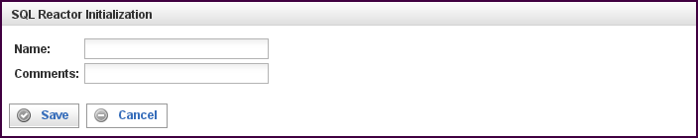

Field | Description
Name | Specify the name of this reactor. This can be any name you find descriptive, we recommend something which describes the data this reactor is processing.  The name may be any combination of letters and numbers.
Comments | Enter some descriptive comments about this reactor. Any comment you feel will help you in the future, we recommend choosing something that describes the data being processed.
This creates the SQL Reactor in the workspace. Double-clicking on the reactor brings you to the configuration screen:
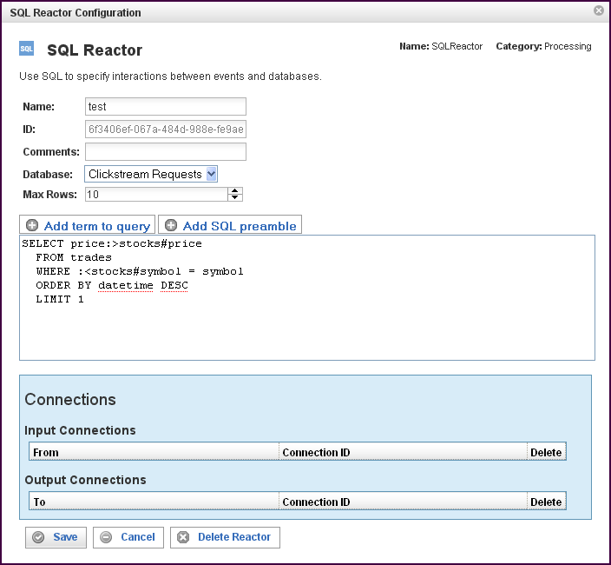

In addition to the fields you saw when adding the reactor initially (described above), you will see some additional fields and sections for Comparisons and Connections. The additional fields are:
Field | Description
ID | The reactor ID, a unique ID generated by the Pion server. This ID identifies a particular reactor.
Database | The database on which queries are executed.
Max Rows | The maximum number of rows allowed in a result set, limiting the size of a result set.  One of the most damaging aspects of database query results is the possibility of a large result set size, which generally locks the table, or consumes resources until the result set has been transferred. Even though is advisable to put a LIMIT n statement into the query to limit the result set size, Pion allows you to define the result set size using Max Rows. When Max Rows is specified, after n results have been received and processed into the event, the rest of the result set is discarded and resources are freed.
Add term to query | When selected, opens up a term selector dialog, exposing the available vocabularies and the terms in the vocabularies. When a term is selected, shorthand notation is inserted into the query.  Preface the term with ":<" for input, or ":>" for output.
Add SQL preamble | The SQL preamble allows you to configuring a set of SQL queries. The SQL queries in the SQL preamble are executed as the SQL Reactor starts. The SQL preamble is commonly used to establish things such as:  Pragma's (in SQLite); to limit result set, locking, caching, etc.  Views, if you are using materialized views.  Keep-connection-open configurations.  Linking tables in MySQL(federated tables) or SQLite (attaching databases).
The SQL query | The SQL query to be executed, in "Pion SQL."  In the sample above:  SELECT price:>stocks#price  FROM trades  WHERE :<stocks#symbol = symbol  ORDER BY datetime DESC  LIMIT 1  The table "trades" is assumed to be available via the database connection.  The columns "price" and "symbol" are assumed to exist in the “trades” table.  A query is executed using the Pion term "urn:vocab:stocks#symbol" (represented in short-hand form as "stocks#symbol").  The term stocks#symbol is used as an INPUT parameter (":<" denotes input), meaning that the statement ":<stocks#symbol" will be replaced with the actual value of the term, in a SQL injection safe manner.  The value of the column "price" will be put into the Pion term "stocks#price" (the full Pion notation is “urn:vocab:stocks#price" upon result.  Note: If more than one line were permitted (LIMIT 1), the term stocks#price may contain multiple values.  There is no practical limit of number of parameters that can be passed into the database, nor a limit on parameters coming back.  Note: There is no inherent requirement that the query is actually a query (SELECT). Instead, the SQL statement can be:  INSERT: "INSERT INTO trades VALUES (:<stocks#symbol,:<stocks#price)  DELETE: "DELETE FROM trades WHERE symbol = :<stocks#symbol"  Also, note that a table name is not required at all, the SQL Reactor can be used against "DUAL" or shadow table:  "SELECT :<stocks#price + :<stocks#price :>stocks#price"  Which effectively will take the stocks#price and multiply by two.  The same method can be used for tricks, such as concatenating strings, doing string functions, math, etc. Remember that the actual code is dependent on the flavor of SQL used.  Pion has a complete version of SQLite embedded, which provides a rich set of math, string, and date functions.

The Connections Section
The Connections section describes input and output connections for this SQL Reactor. See ”Error: Reference source not foundX“ on page XError: Reference source not foundX for more information.

