Script Reactor
The Script Reactor enables you to leverage existing command line scripts to quickly add capabilities to Pion. Through the use of the script reactor you can do things such as create follow-up queues based on customer behavior or retrieve additional information from disparate sources on the fly.
When you add a Script Reactor you will be prompted for the following fields:
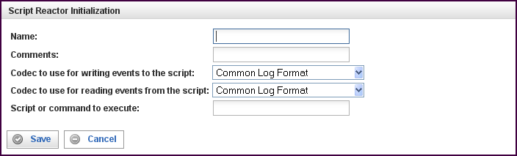

Field | Description
Name | Specify the name of this reactor. This can be any name you find descriptive, we recommend something which describes the data this reactor is processing.  The name may be any combination of letters and numbers.
Comments | Enter some descriptive comments about this reactor. Any comment you feel will help you in the future, we recommend choosing something that describes the data being processed.
Codec to use for writing events to the script | Events from other reactors will be delivered to the script's stdin file descriptor. These events will be serialized using the specified codec.
Codec to use for reading events from the script | Events going to other reactors from this Script Reactor will be read using the script's stdout file descriptor. These events will be serialized using the specified codec.
Script or command to execute | When running, the Script Reactor will execute the command specified and pipe events through the command. The command is executed once and will remain running until the reactor is stopped (or the command terminates by itself).

This creates the Script Reactor in the workspace. Double-clicking on the reactor brings you to the configuration screen:
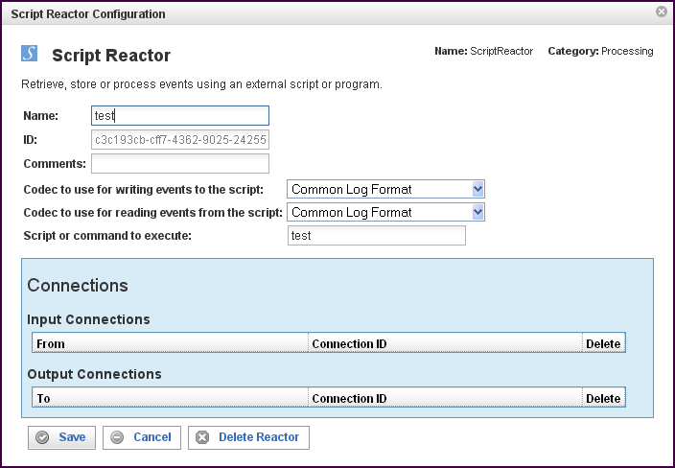
In addition to the fields you saw when adding the reactor initially (described above), you will see one additional field and the Connections section. The additional field is:
Field | Description
ID | The reactor ID, a unique ID generated by the Pion server. This ID identifies a particular reactor.

The Connections Section
The Connections section describes input and output connections for this Script Reactor. See “Error: Reference source not foundX”“ on page XError: Reference source not foundX for more information.

