Transform Reactor
Transform Reactor, which is able to do deep manipulation of the data in the data stream. For example, this can be as simple as formatting a URL to be something more easily readable or consistent if sites are constantly changing, or calculating dollar values from a page to see total spend (even taking into account if the currency must be converted). Because the Transform Reactor is very flexible, it can also do more complex things such as capturing and translating a bank branch or user identification on the fly.
Note: An event processed by the Transform Reactor is transformed. The original (unmodified) event is not passed through. The Transform Reactor’s only output is transformed events. If the original (unmodified) event is desired, make an additional connection from the reactor preceding the Transform Reactor to the reactor(s) following the Transform Reactor.
When you add a Transform Reactor you will be prompted for the following fields:
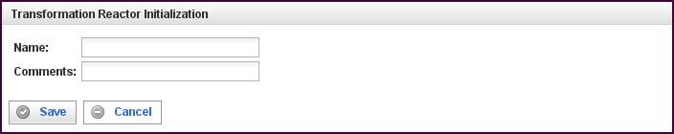

Field | Description
Name | Specify the name of this reactor. This can be any name you find descriptive, we recommend something which describes the data this reactor is processing.  The name may be any combination of letters and numbers.
Comments | Enter some descriptive comments about this reactor. Any comment you feel will help you in the future, we recommend choosing something that describes the data being processed.
This creates the Transform Reactor in the workspace. Double-clicking on the reactor brings you to the configuration screen: this reactor gets
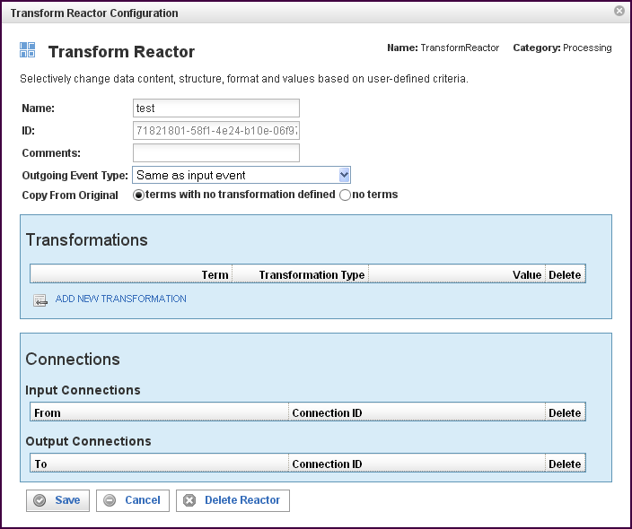

In addition to the fields you saw when adding the reactor initially (described above), you will see some additional fields and sections for Transformations and Connections. The additional fields are:
Field | Description
ID | The reactor ID, a unique ID generated by the Pion server. This ID identifies a particular reactor.
Outgoing Event Type | Event that is output (transformed) may either be of same type as the incoming event, or a user definable type.
Copy From Original | Terms (fields) in the original event are:  Copied-if-not-present. Copy all the terms for which there are no transformations. Note that transformations are not always successful, so some terms with transformations may not exist in the output event (example: lookup, with a failure and no default).  Not copied. Only terms that are transformed are copied, and if there is no transformation, the term will not exist in the transformed event.  Copied in full, and transformations *add* to the copied terms.  Note: Do not use unless you know how to handle multiple values on terms. This option is now deprecated.

The Transformations Section
The Transformations section describes the transformation processing to be done on the term(s).
Field | Description
Term | Defines the name of the term that will be set to the resulting value of the Transformation Rule. You can select a term (an identified data item) from an existing vocabulary, or you can add a new vocabulary and define the term(s) to be found.
Transformation Type | Depending on the vocabulary and term selected, there are transformation types available:  - AssignValue  Assigns a constant value to the term defined. Appropriate lexical casting is performed, converting the value to a string, numeric or date value as appropriate. AssignValue will fail to assign only if the cast fails (for example a text string into a numeric value).  - AssignTerm  Assigns a source term (from the original event) to a destination term (resulting event). The value is re-cast, allowing type conversions (text to numeric, or numeric to text). AssignTerm will fail to create the destination term if the source term does not exist, or if the transformation fails to cast. If there are multiple matching source terms, all are copied to destination.  - Lookup  Applies a regular expression (optional) with a format string (optional, default $&) to a source term (the original event), producing a key. The key is applied (case sensitive) against a table of key/value pairs.  If a matching key is found, the value is used.  If a key is not found, one of the default actions is taken.  If the key is left undefined, the original (pre-regex) value is used with the regex 'p'd (post-regex) value, and a fixed value is used. The result is cast and assigned. Lookup is repeated for each matching source term.  - Rules  [StopOnFirstMatch] Rules will either execute through all rules in a transformation, or stop on the first successfully matched rule. The source term (original event), is matched against a comparison, which can be any of the normal comparisons, true/false/defined/less-than/is-equal/etc...  If the comparison succeeds, the SetValue is assigned like AssignValue.  If the comparison fails, the regex is evaluated, and SetValue defines the output format.  Note: Not-RegExp assigns SetValue as a literal, since the regex failed.  Note: To copy source-term value(s), use RegExp with ".*" (true will assign a literal value).  If source term has multiple values, the rule is applied to each value individually (StopOnFirstMatch does not apply to multiple term values).  If a rule was successful (even for one term value), and StopOnFirstMatch was defined, processing of rules stops.  Setting StopOnFirstMatch not true will cause many values to be compounded in a destination term. This setting is useful for "adding tags" to a term.  Note: Use with caution!  Assignment of values (SetValue or RegExp/format-output) is re-cast and assigned.  Note. All rules, all conditions always use the source term from the original event. Multi-step, or progressive processing can only be done with successive separate Transform Reactors.  - Regex  Uses a source term (must be of string type), and executes a number of regular expressions (with optional format strings). For each regular expression, if the expression fails, the source value (for the expression) is used instead of a transformed value. Expressions are executed for each value in the source term individually, and the resulting strings are copied to the destination term.  Note: Both Lookup and Rules already have a regex, this is a serial regex.  The non-use of StopOnFirstMatch (short-circuit) in Rules is available, and can be used when creating "tag lists" in terms. Do not, however, uncheck it if you don't know how to use the result.
Value | The meaning of this column differs based upon the Transformation Type selected. This allows you to input a value for "AssignValue", select a term for "AssignTerm", and opens additional configuration windows for Lookup, Rules and Regex.
To add a row for a new transformation in the Transformations section, click on the ADD NEW transformation link.
To delete a transformation, click on the “x” at the end of the row describing that term.

58BURegular Expressions in the Transform Reactor
The Transform Reactor uses regex in three different ways:
- In Lookup, regex can be used initially
- In Rules, regex is one of the many options
- In Regex, regex is used in a successive manner
In all cases, the regex being used is the Boost.org regex.
For more information about the basic (Perl) regex by boost, see:
http://www.boost.org/doc/libs/1_39_0/libs/regex/doc/html/boost_regex/syntax/perl_syntax.htmlH.
For information on the format string as it is used in the regular expressions, see:
http://www.boost.org/doc/libs/1_39_0/libs/regex/doc/html/boost_regex/format/perl_format.htmlH.

The Connections Section
The Connections section describes input and output connections for this Transform Reactor. See “Error: Reference source not found“X” on page XError: Reference source not foundX for more information.

