Log Output Reactor
The Log Output Reactor enables you to write any data to a structured flat file of your choice in real time. This is often very useful for web analytics, because most tools are written to take in web server files as their default input format. Pion can capture, process and enrich user information before creating the distilled log files for use by other tools. This enables Pion to easily integrate with almost any on-site web analytics package including the open source efforts.
When you add a Log Output Reactor you will be prompted for the following fields:
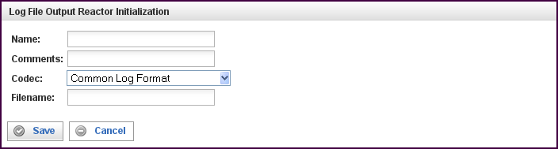

Field | Description
Name | Specify the name of this reactor. This can be any name you find descriptive, we recommend something which describes the data this reactor is processing.  The name may be any combination of letters and numbers.
Comments | Enter some descriptive comments about this reactor. Any comment you feel will help you in the future, we recommend choosing something that describes the data being stored.
Codec | The name of the codec that controls the output format used to write the data to the log file named in filename.
Filename | The name of the log file to which the data will be written.  This name may be fully qualified, or it may also be relative. When a relative file name is specified, the base path is equal to the "DataDirectory" defined in your platform.xml file. On Unix machines, this is /var/lib/pion/.

This creates the Log Output Reactor in the workspace. Double-clicking on the reactor brings you to the configuration screen:
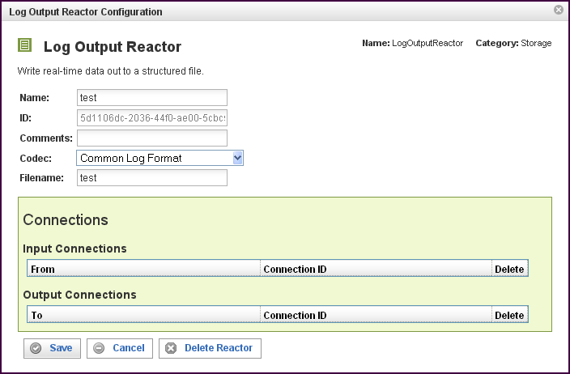

In addition to the fields you saw when adding the reactor initially (described above), you will see one additional field and the Connections section. The additional field is:
Field | Description
ID | The reactor ID, a unique ID generated by the Pion server. This ID identifies a particular reactor.

The Connections Section
The Connections section describes input and output connections for this Log Output Reactor. See “Error: Reference source not found“X on page XError: Reference source not foundX for more information.

