Multi Database Reactor
The Multi Database Reactor enables Pion to store data in several databases, based on the data being stored. The Multi Database Reactor stores using rotating partitions, such that the partitions for all tables are divided synchronously based upon sessionizing criteria, size and time.

When you add a Multi Database Reactor you will be prompted for the following fields:
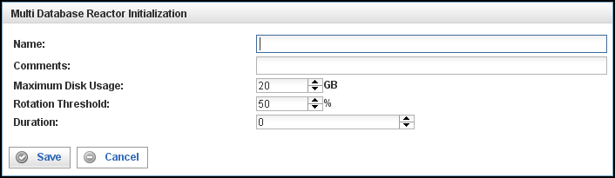

Field | Description
Name | Specify the name of this reactor. This can be any name you find descriptive, we recommend something which describes the data this reactor is processing.  The name may be any combination of letters and numbers.
Comments | Enter some descriptive comments about this reactor. Any comment you feel will help you in the future, we recommend choosing something that describes the data being stored.
Maximum Disk Usage | The number of gigabytes this particular Multi Database Reactor can use to store data.  Note: Pion makes a best effort attempt to comply with this setting, but you should expect the actual amount of space to to vary ± 10% from the specification. For example, if you specify 50GB, the server can easily use 55 GB, or it may only use 45 GB.  Note also: If you have two (or more) Multi Database Reactors, this is an individual, per-reactor setting. For example, if you have 100 GB of free space, and you have two Multi Database Reactors, you should not give more than 40 GB to each reactor (or however you want to balance it). Do not over-commit your available storage.  Regarding the size given:  - Do not commit more than 80% of your total free disk space.  - If you are using local Database Output Reactors or Log Output Reactors, remember to take into account their storage needs.
Rotation Threshold | Rotation Threshold is a measure of cache utilization, which is calculated by:  - The number of columns indexed (in the Multi Database Reactors configuration information) multiplied by size of the content of those columns.  - Adjusted for the overhead of SQLite.  - Compared to the configured database index cache size (dbengines.xml)  Rotation Threshold is expressed as a percentage:  - For high volumes of data (400Mbps), you should not exceed 50%.  - For low volumes of data (<200Mbps), you can probably go 200%.  See Error: Reference source not found. on page Error: Reference source not found for information on configuring Pion for high volumes of data.
Duration | The amount of time (in seconds) after which the Multi Database Reactor rotates partitions.
SessionTimeout | Specifies the number of seconds between pruning of the session cache maintained by the Multi Database Reactor. This value should always be just slightly higher than the session timeout defined in your Clickstream Reactor.
Prune Interval | Specifies how often (in seconds) the Multi Database Reactor will prune its session cache.
Session Term | The vocabulary term used to uniquely identify a visitor session (urn:vocab:clickstream#session-id).
This creates the Multi Database Reactor in the workspace. Double-clicking on the reactor brings you to the configuration screen:

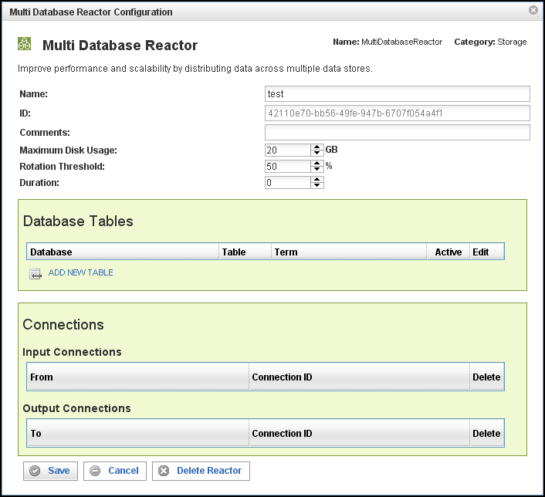
In addition to the fields you saw when adding the reactor initially (described above), you will see one additional field and the Connections section. The additional field is:
Field | Description
ID | The reactor ID, a unique ID generated by the Pion server. This ID identifies a particular reactor.

The Database Tables Section
The Database Tables section specifies what data gets stored in which databases. By specifying a database, a table within that database, and a term to be stored in that table, you control what information is stored in which database.
Note: Each Database Table is essentially a separate instance of the Database Output Reactor.
Field | Description
Database | Select the database into which you want to write events.
Table | Specify the table in the database named above. The events will be written to this table.
Term | Defines the type of event to be stored in the database and table specified above.
Active | If this check box is filled, the table is active and events of the type specified will be stored in the database and table specified above.  If this check box is empty, the table is temporarily disabled and no events will be stored.
Edit | Opens another window to specify the database field mappings and other characteristics for the table.
To delete a connection, click on the “x” at the end of the row describing that connection.

The Connections Section
The Connections section describes input and output connections for this Multi Database Reactor. See “Error: Reference source not found“ on page XError: Reference source not foundX for more information.

