Omniture Analytics Reactor
The Omniture Analytics Reactor is able to take web user behavior information and send it through the Omniture Genesis integration system to SiteCatalyst via its native XML web service interface in real-time. All you need to supply is the relevant account information and site name to connect Pion to Omniture.
When you add a Omniture Analytics Reactor you will be prompted for the following fields:
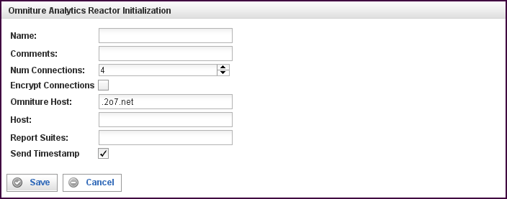

Field | Description
Name | Specify the name of this reactor. This can be any name you find descriptive, we recommend something which describes the data this reactor is processing.  The name may be any combination of letters and numbers.
Comments | Enter some descriptive comments about this reactor. Any comment you feel will help you in the future, we recommend choosing something that describes the data being stored.
Num Connections | Specify the maximum number of concurrent connections.  With Omniture; you can deliver 50 events/second with one connection. If you need higher speed (taking bursts/peaks into account), use a higher number of connections. Using a higher number of connections will use more bandwidth, and you may have to consult with Omniture to make sure that they are able to receive the traffic.  Generally, a value of 2 or 4 and up to 16 is reasonable.
Encrypt Connections (check box) | Fill this check box to encrypt connections between Pion and the Omniture Genesis host.
Omniture Host | Omniture Analytics Reactor; this is the “Omniture Host” that you get from the Omniture SiteCatalyst [check verbiage from Omniture] as the destination where all the page hits are sent for processing. Must be of the form customername.122.2o7.net or customername.112.2o7.net.  Note: The ‘o’ in 2o7 is the letter, not a zero.
Host | The Omniture Host to which your reporting is to be sent. Specified as a URI, and given by the Omniture "wizard" at the time of registering your account.  The Omniture Host URI is of the form accountid.122.2o7.net or accountid.112.2o7.net (do not try to guess it, use what Omniture supplies).
Report Suites | Check with Omniture for description of a Report Suite.  In Omniture Analytics Reactor, you would fill in ALL the Report Suites you want the page views to be delivered to. Separate multiple Report Suite names with commas.
Send Timestamp (check box) | For Omniture accounts used with Pion, you must enable time stamps (this check box should be filled).  Pion will supply the time stamps for all events (in UTC format), adjusting for the local time zone.  If you are experimenting, with an Omniture account not used with Pion, Timestamps must be set off (this check box should be empty).  Note: Only Omniture technical support can change the Timestamp setting on the Omniture account.  If the Timestamp setting does not match the Omniture back end, all events are silently dropped.
This creates the Omniture Analytics Reactor in the workspace. Double-clicking on the reactor brings you to the configuration screen:
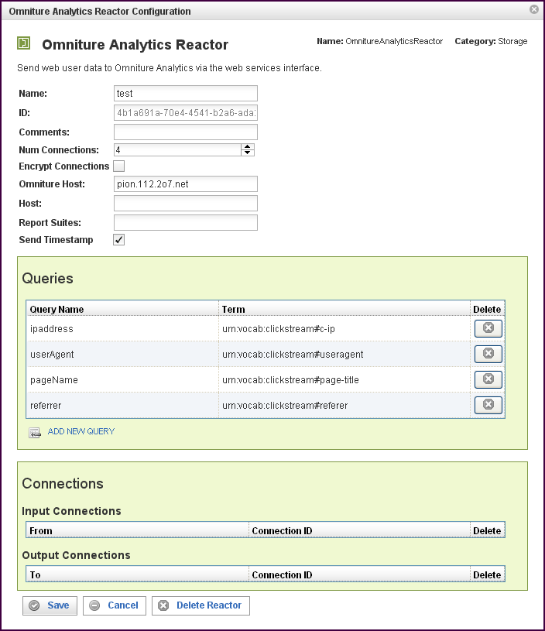

In addition to the fields you saw when adding the reactor initially (described above), you will see one additional field and the Queries and Connections sections. The additional field is:
Field | Description
ID | The reactor ID, a unique ID generated by the Pion server. This ID identifies a particular reactor.

The Queries Section
The Queries section allows you match Omniture queries with Pion terms. This matching allows you to send Pion data directly to Omniture Analytics.
Field | Description
Query Name | Select one of the available queries from the list.  In previous versions, some query terms were hard coded to “[computed]" and as such were not visible. Now, however, the "[computed]" can be overridden, with a term, but you must be sure to compute the proper value for such term.  Generally, this is *very*special* usage, most users should not attempt it. Contact Pion professional services for advice before using this functionality.  The [computed] values are:  - visitorID  Computed to be a persistent visitor ID, Omniture enforces some strict requirements on what it can be. Do not override unless confirming with Omniture what is allowed.  - server  Computed to be the "host" configuration parameter. The only time you might want to override this is if you have multiple servers, and logic programmed to determine the correct server.  - pageURL  Computed to be the PageURL, complete with http/https, port (if applicable), URL, and query parameters.  - timestamp  If applicable, computed to be the timestamp of the event, in ISO-8601 format, adjusted for Zulu timezone. For more information, see: http://en.wikipedia.org/wiki/ISO-8601.  - reportSuiteID  The same as Account ID, useful only if you are feeding multiple accounts, and have to logic to replace the Account ID  All of the parameters above will be XML_Encoded on the way out, so they should not be encoded coming in.
Term | Select the term to match with the query.
To add a row for a new query in the Queries section, click on the ADD NEW QUERY link.
To delete a query, click on the “x” at the end of the row describing that query.

The Connections Section
The Connections section describes input and output connections for this Omniture Analytics Reactor. See “Error: Reference source not found“X on page XError: Reference source not foundX for more information.

