

Enterprise Edition

Overview



Last update: January 2010
Table of Contents
Pion: A Quick Introduction 3
Pion: What Is It? 3
Pion: What Will It Do For Me? 5
Pion: Architecture 7
The Pion Server 7
Pion Sniffer Placement 8
Using Network Taps and Spans 8
Spanning/Mirroring vs. Taps Comparison 10
Network Communication Channels 10
Other Network Considerations 12
Working with Load Balancers 12
Working with Proxy Servers 12
Pion Security Elements 13
Pion and SSL 13
Configuring MS IIS to Work with Pion 14
High-Volume Pion Implementation Guidelines 14
Pion: The Application 17
Getting Started with Pion 17
Reactor Configuration Page 17
Reactor Types Toolbar 18
The Vocabulary Configuration Page 21
The Codec Configuration Page 23
The Database Configuration Page 25
The Protocol Configuration Page 26
Managing and Configuring Pion 28
User Configuration 28
System Configuration 29

Pion: A Quick Introduction

Pion: What Is It?
Pion is a robust, highly configurable, extremely fast data analytics application, including a server tuned specifically for data acquisition and transformation. The flexibility of Pion's building-blocks architecture allows you to gather data from a wide variety of sources, filter out the parts you don't need, and then keep the useful information. Additionally, Pion allows you to transform the data (or parts of the data) according to rules you specify, and you can store the data for compliance purposes or later review.
Pion has specialized building blocks (called reactors) that you chain together to form a chain that gathers, and transforms data from the sources you choose, and then stores the parts you want to keep.
Pion is passive, in the sense that it does not alter the original data in any way. Pion monitors live data streams or reads log files, then transforms the data as necessary, and finally stores the results or the transformed data, but the original data is not changed in any way.
Pion is standards-based, in that it works and uses with standard protocols, log and data formats, processing libraries, and APIs.
The Pion application is browser-based; and is controlled through a Web Browser. All standard web browsers are supported, but due to implementation differences within the browsers, some Pion features may look different in one browser than they do in another. Pion recommends Mozilla Firefox or Apple Safari for all platforms (note that Google Chrome is not supported).
Pion also provides an XML-based web services API that allows you to do everything the browser-based application does. Documentation for this API is available at our web site:
http://pion.org/projects/pion-platform/documentation/servicesU
To help you understand more about Pion, it will be necessary to define some Pion-specific terms and concepts:
Events
An event is a message that represents any type of action or occurrence. Pion is a real-time platform which enables both simple and complex event processing using pipelines of interconnected plug-ins, called Reactors.
Reactors
A Pion Reactor performs a defined task, and there are many specialized Reactors. Each reactor performs a specific task, and each reactor is specialized for a particular task. A Reactor can be thought of as atomic in the sense in that it is the smallest unit of work. Reactors are the basic building blocks which are chained together to accomplish tasks.
To make organization easy the Reactors are broken down into three basic families by their functions:
- Collection Reactors receive some sort of input (either through monitoring a data stream, an application log, or from a script or another Reactor) and create Events when defined criteria are met.
- Processing Reactors process and/or change Events. Processing Reactors may interact with other systems, for example the SQL Reactor interacts with a SQL Database, such as MySQL.
- Storage Reactors handle the output of one or more Processing Reactors. Depending on the Storage Reactor, the processed Event may be stored in a database or log file, or it may be sent to another application (such as Google Analytics or Omniture Genesis).
Storage Reactors are needed whenever data needs to be persisted for later use for reporting or record keeping. For web analytics to take place, a Pion Workflow must always end with a Storage Reactor.
Reactors of different types are chained to form a complete processing path, starting with data acquisition, and ending with some form of output. For example, when reading a web server log (or even when capturing/monitoring a web server's traffic):
- A Collection Reactor detects an an instance of that server generating a 404 (page not found) error. The Collection Reactor creates an event and sends it to a Processing Reactor.
- The Processing Reactor receives the Event, and strips out everything but the ID of the server that generated the error, the bad URL, the time, the date, and the session ID of the user. The Processing Reactor then passes this Event to another Processing Reactor and to a logging Storage Reactor.
- The second Processing Reactor compares the server ID to a list of server ID and email address pairs, and inserts the email address at the beginning of the Event before sending the Event to an alerting Storage Reactor.
- After receiving the Event from a Processing Reactor, the first Storage Reactor records the information in a log file, and the second Storage Reactor sends an email to the email address in the Event.
In this way, the Reactors receive data, create and process Events, and output the results.
Pion provides an open source platform users or third parties can also create their own Reactors if they need additional functionality without having to modify the core of Pion in any way.
Codec
A Pion Codec defines an input or output format for things like logs, for example CLF (Common Log Format) or ELF (Extended Log Format). A Codec can also define notation such as JSON or XML. Codecs are used by Reactors to 'break' data into chunks that can be recognized or manipulated.
Vocabulary
A Pion vocabulary is a list of terms (and types, such as shortstring, string, longstring, date, uint8, uint16) that form the possible elements of information contained in an event. The most common vocabulary is the Clickstream vocabulary; which is used to describe the Terms in an web page view or HTTP event. Examples of other vocabularies are RSS, Atom, stock prices, and aggregate (see “Vocabulary Configuration“ on page 21, for more information on vocabularies). Users can create new vocabularies, or modify and extend existing vocabularies to meet their needs.
Terms
A Pion term refers to an item within a vocabulary. The term is a way to label a value that is collected or calculated. Events in Pion have a type (that matches an "event type" term such as "urn:vocab:http-event") and may contain zero or more fields, each of which corresponds with a particular term and value.
Requests, Page Views, and Sessions
Within Pion, request events are used to describe individual HTTP requests. A page view event represents an individual web page rendered within a browser window (also sometimes referred to as a "click"), and is usually made up of many HTTP requests. A session event represents a specific visitor session, and usually includes one or more page views.
Workspace
A Pion workspace is a graphical presentation of a group of Pion reactors chained together. Pion allows for multiple workspaces, each of which can contain a self-sustained, parallel-running set of reactors. Pion workspaces are browser-based; that is, thee Pion application is controlled through a Web Browser.
All standard web browsers are supported, but due to implementation differences within the browsers, some Pion features may look different in one browser than they do in another. Pion recommends Mozilla Firefox or Apple Safari for all platforms (note that Google Chrome is not supported).
Other terms and concepts that are important to Pion, but are not Pion-specific. Some are specific to other applications (such as Omniture Genesis or Google Analytics). These terms and concepts are used throughout Pion, and you should know what they mean in order to make sure you understand what Pion does and how to use Pion's features and the related technologies.
Regex
A “regex” or “regexp” (REGular Expression) is a common method of describing a text pattern for filtering, matching or transformation purposes.
Queue Size
Generally used to describe optional Queuing (or grouping) of items. For databases, Queue Size defines the maximum number of events to queue before writing them (in bulk) to a database.
Queue Timeout
Defines the amount of idle time before a queue is written (in bulk) to a database.

Pion: What Will It Do For Me?
Pion will provide you with better information for less effort then you are putting in today with traditional page tags, data warehouses and ETL tools. Pion does this through:
- Capturing the complete conversation between your users and the web backend servers.
- Identify and track individual users across visits.
- Sessionize clickstreams to establish unique behavioral patters.
- Extract critical information and events from the conversation (Totals, Products, Promotions, etc)
- Handle non-browser interactions from RSS and ATOM news services.
- Capture Mobile Phone browsers.
- Eliminate the need for most page tags (90%+ reduction).
- Combining real-time and historical information.
- Collect information from relational databases (Oracle, DB2, MS-SQL, MySQL, Informix, Sybase and more).
- Pull in customer information from ERP and CRM systems.
- Connect to back end log files.
- Provide an merged stream of data from different sources.
- Freeing your data through integration.
- Feed your existing web analytics solution from Omniture, WebTrends, Google Analytics and others.
- Store data in your data warehouse (Oracle, DB2, MS-SQL, MySQL, Teradata and others).
- Feed your existing business intelligence tools (Cognos, Business Objects and others).
- Provide web services streams to real-time applications.
- Replaying customer interactions.
- Provide a visual, page by page representation of what the user saw.
- Expose detailed session information about the user and their environment.
- Report on the performance of the end user experience.
- Provide detailed information on the user submission and server response.

Pion: Architecture
Pion uses a very straight-forward architecture design based on the ability for it to listen to the conversation between the user’s web browsers and the back end servers. When properly placed in the network, Pion is able to both capture the live browser conversation and listen for any active content calls from the browser for purely client-side content (such as videos, music, or files). Capturing data from web log files is easily accomplished from almost any network location with remote file access.
A basic conceptual architectural diagram looks like this:
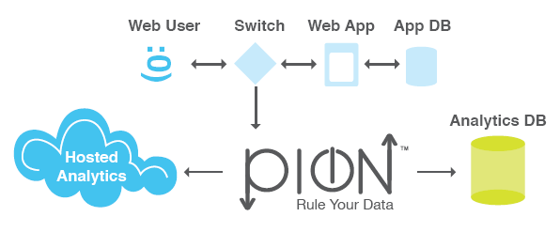
As you can see in the above diagram, Pion is completely passive and in no way impacts the user’s web experience. This is accomplished by using either network tapping or spanning to simply take a copy of the conversation between the web clients and the servers (the data stream). The very nature of a tap/span is a one way conversation; meaning Pion never communicates back with your web site visitors browsers. This ensures that the highest levels of both security and performance are delivered to your web site visitors, because Pion does not interact with the clients browser at all. After the Pion server captures and interprets the user traffic, it communicates with your analytics database. In the case of hosted providers such as Omniture Genesis and Google Analytics, this communication occurs via a web service. For internal analytics packages, this communication is most often performed via a relational database output Reactor or a structured file Reactor.
The critical pieces of this architecture are:
- Pion Server
- Pion Sniffer Reactor placement in your network
- Network communication channels
These, and other topics that affect Pion's operation, are covered in greater detail below.

The Pion Server
The Pion software takes full advantage of the latest commodity hardware available, as well as multiple operating systems. Pion currently supports the following operating systems:
- Linux x86– RedHat EL 4, 5 (32 and 64 bit), CentOS 4,5 (32 and 64 bit)
- Windows – XP, Vista, Windows 2000, Windows 2003 and Windows 2008 (32 bit x86)
- MacOS X – 10.5 Intel (32 bit x86)
Pion will also run on VM Ware, but for product network traffic capture we suggest dedicated hardware. Because VM Ware is known to occasionally drop packets, if you plan on using a Sniffer Reactor to monitor network data, you should not run the Pion server on a VM Ware installation.
Although Pion will run on very minimal hardware it is important to size it appropriately for production applications. The most critical components are CPU and RAM. A good rule of thumb is a 2GHz CPU core and 2GB of RAM are generally able to handle about 100Mbps worth of HTTP(S) traffic with a normal configuration. Because Pion is highly multi-threaded, and it makes very effective use of multiple CPU cores, a single server can scale to handle approximately 1.2 Gbps worth of HTTP(S) traffic.
For sniffing purposes, Pion also needs high quality network interface cards, and we have had great experience with the Intel Pro cards. They aren’t an absolute requirement, but we have seen Broadcom and 3com cards dropping packets for no apparent reason from time to time. It is also important to ensure that you have an extra network interface for server management in addition to the number of ports you’ll need available for sniffing traffic.

Pion Sniffer Placement
The first step in designing the architecture is to determine where the best place is to capture your network data. Ideally Pion would only capture the traffic you want it to see and nothing else. Therefore, the best place to place to tap/span is often very close to the web servers. This allows us to minimize both the amount of “garbage” traffic we see, and reduce the amount of network listening we need to do. Fortunately, most networks are hierarchical in their design. The hierarchy is usually made up of “server” switches (sometime referred to as “server farms”, “farm switches”, “edge switches” or similar) and “aggregation switches”. As their names suggest “server” switches connect servers to switches while “aggregation” ones connect “server” switches to each other. Because of this it is often possible to monitor even very large data centers with one or two network listening points.

Using Network Taps and Spans
In order for the Pion to passively capture user traffic it must receive a duplicate stream of traffic to analyze. There are 2 methods to implement this:
- Spanning/mirroring, which is implemented by configuring the switch to duplicate a stream of traffic from one port(s) to another. You connect one of the sniffing NIC(s) on the Pion server to the physical port(s) on the switch to which the duplicate stream is sent.
- Network taps, which fall into several categories depending on their configuration.
- Basic Network Taps, which are device with typically one set of inputs (transmit and receive) to one set of outputs (transmit and receive) similar to your standard stereo splitter as shown:

- Regeneration Taps, which have a set of inputs (transmit and receive) and are able to send the same output to multiple transmit and receive ports allowing multiple devices to evaluate the same traffic as shown below:

- Aggregation Taps, which are able to take in multiple sources of traffic and combine that traffic so that it can be consumed for one monitoring device as illustrated in the picture below:

Spanning/Mirroring vs. Taps Comparison

Factor | Span/Mirror | Tap
Description | Using the software in network device to copy traffic from one or many ports to another | An “in stream” device that passively copies traffic to another source, like a stereo splitter
Type | Software configuration | Hardware device
Cost | None. Implemented in software on the switch | Varies by vendor and type of device but usually low
Scalability | Limited. Each switch has a limited number that can be implemented | Unlimited
Flexibility | May allow you to filter the traffic | None. All traffic is duplicated
Quality | Under high loads switch may drop packets | Always a clear signal and copy
Installation | On-the-fly, no downtime | Requires cabling and may also require switch downtime

Network Communication Channels
Pion must be able to communicate in order to be effective. To manage Pion you’ll want to have at least one secure channel to the web server or terminal.
Management Channels | Port | Protocol | Direction
Secure command line management | 22 | SSH | User → Pion
Web administration | Any, default is 8888 | HTTP(S) | User → Pion
Windows Terminal Services | Any, default is 3389 | RDP | User → Pion
Pion must also have network access to write the data you want to the desired location. This can occur over any port you define. The common ones and their defaults are listed below.
Data Output Channels | Port | Protocol | Direction
Omniture Genesis Web Services | 80/443 | HTTP(S) | Pion → Omniture
Google Analytics Web Services | 80/443 | HTTP(S) | Pion → Google
Oracle Database Server | Any, default is 1521 | OCI | Pion → DB
Microsoft SQL Server | Any, default is 1433 | DB-Lib, OLE-DB | Pion → DB
Sybase | Any | Open Client, ASE or ASA | Pion → DB
DB2 | Any, default is 50000 or 446 | DB2 CLI | Pion → DB
MySQL Enterprise | Any, default is 3306 | MySQL CAPI | Pion → DB
ODBC | Any | ODBC | Pion → DB
Informix | Any, default is 1526 | Informix CLI | Pion → DB
Interbase/Firebird | Any | Native | Pion → DB
Centura/Gupta SQLBase | Any | CAPI | Pion → DB
PostgreSQL | Any | Libpq | Pion → DB
SQLite | Local | Local | Pion → DB

Other Network Considerations

Working with Load Balancers
Load balancers are very common in enterprise environments. In most cases they present a complication when it comes to Sniffer Reactor placement because they perform what is known as Network Address Translation or NAT. When a load balancer receives a request from a user, it determines which server will receive the request, then opens a connection to this server and forwards the request, replacing the user’s IP address with its own. This results in a situation where users always see the load balancer as the destination and servers always see the load balancer as the source. Based on whether the sniffer is listening to traffic “before” the load balancer (between the client and the load balancer) or “after” the load balancer (between the load balancer and the servers), Pion may lose its ability to link the client to the specific server if this situation is not addressed. Two easy solutions exist to handle load balancers:
- Using the X-Forwarded-For (XFF) tag. This solution is very simple, and often requires little or no effort because it is built into almost all modern load balancers and is set to work by default. The X-Forwarded-For (XFF) tag is the unofficial standard for identifying the originating IP address of a client connecting to a web server through an HTTP proxy. Most load balancers have it turned on by default, and those that don’t often allow you to enable XFF easily. By default, if the XFF is used, it is interpreted by Pion as the original IP tag. This means that it is very likely that you won’t have to do anything. You can read more about XFF on http://en.wikipedia.org/wiki/X-Forwarded-For and http://meta.wikimedia.org/wiki/XFF_project.
- Having a Pion Reactor extract client session information directly. This solution requires a little more effort, but is more flexible. Since Pion sees all of the traffic, it doesn’t have to rely on the network data and Pion can extract the content from the user session. Therefore, Pion can easily identify and track people by user name, host name, session ID, cookies or anything else that is communicated with the server.

Working with Proxy Servers
Proxy servers, while very different in function than load balancers, have similar implications due to the fact that they also implement NAT. There are a few additional issue to contend with when dealing with proxy servers.
- Unlike load balancers, which only re-write the host address, proxy servers often re-write the URL (or more accurately the URI). If this is the case, Pion may need to be configured to reconstruct the original URI with the Transform Reactor.
- Proxy servers may implement an additional caching mechanism that doesn’t follow normal browser caching rules. Rather than retrieve all resources from the server for each user request they cache resources (typically static resources such as graphics, entire static pages, rich media, etc.) locally. This means that you may have to place the Pion sniffer before the proxy server to ensure you get all of the calls.
- Proxy servers are not traditionally considered part of the network architecture. Therefore, they are not always present on network diagrams. You should find out if they are part of the network environment.

Pion Security Elements
Since Pion captures real user behavior by listening to the conversation that occurs between your web users (customers) and the infrastructure you use to deliver their online experience, it is reasonable to be concerned about what happens to this conversation. Pion takes great pains at every step of the way to ensure the security of the information it touches using a variety of techniques:
- One-way communication for the Pion Sniffer Reactor. The Pion Sniffer Reactor cannot communicate with anything other than the Pion server application under any circumstances. It is completely passive and is only fed one-way traffic. Because of this, Pion is more secure than any of the web servers it is listening to because it cannot communicate.
- Extra security layers for SSL keys. Pion often needs to decrypt information on the fly for interpretation and as such requires the critical private SSL keys. These sensitive keys can be kept securely under additional layers of encryption and password protection to ensure safety on top of the network layer security previously mentioned.
- Filtering/masking of sensitive information. Once the user and network data is inside of Pion, you can have Pion filter out or translate sensitive fields at the point of collection to ensure privacy and security. For example, account numbers could have the last six digits replaced with “x” characters.
- Encryption. Even after data is processed and ready for transmission outside of Pion, it can be encrypted with SSL to ensure secure delivery.
- Passwords. Pion itself is password protected and the administration interface supports encryption and VPN technologies to ensure that no one can manipulate Pion itself.
- Protected by network security. Pion benefits from the protection offered by the base operating system on which it resides. This means your security people can use their own additional measures to provide security.
- Out-of-band management interfaces . Pion supports out-of-band management interfaces, enabling the construction of completely isolated network components that are inaccessible to outside influences.

Pion and SSL
Pion's Sniffer Reactor is able to passively decrypt SSL2, SSL3 and TLS1 network traffic that uses RSA private keys. This is accomplished using the web server's RSA private key to decrypt the random number secrets generated by the client and server and used to encode the session's communications.
By default, some web servers can negotiate session ciphers that do not use RSA private keys. These ephemeral key exchange protocols (such as Diffie-Hellman) make it impossible for any passive observer to decrypt the traffic, and are therefore not supported by Pion.
To ensure that Pion is able to intercept all of your encrypted traffic, it may be necessary to disable support for ephemeral ciphers within your web server's configuration. Doing so does not make your server any less secure, because the web server simply uses alternative ciphers to use for the connections instead, which are just as strong or even better.

Configuring Tomcat to Work with Pion
If you are using Tomcat directly as the web server, then the attribute to add to the Tomcat connector is called "ciphers". Add the "ciphers" attribute to the Tomcat "connector" XML tag, right after "sslProtocol" attribute. The following is a sample ciphers attribute string that should work for most Tomcat installations::
ciphers="TLS_RSA_WITH_AES_256_CBC_SHA, TLS_RSA_WITH_AES_128_CBC_SHA, SSL_RSA_WITH_3DES_EDE_CBC_SHA, SSL_RSA_WITH_RC4_128_MD5, SSL_RSA_WITH_RC4_128_SHA"
The above list includes some "medium" to "strong" ciphers, but by no means does it include all the available "medium" to "strong" ciphers. You could add more ciphers to this list, as long as you avoid the ones whose names contain "DHE" or "EDH." Those ciphers use the Diffie-Hellman ephemeral key-exchange algorithm, which renders the data unencryptable by "non-participants" in the SSL session (such as a Pion, which is a passive observer). Usually, these letters are near the beginning of the cipher suite name. As a rule of thumb, the ones you want are "SSL_RSA_*" and "TLS_RSA_*", because the RSA key-exchanges are the most common ones that can be passively decrypted.
For more information, see http://java.sun.com/javase/6/docs/technotes/guides/security/StandardNames.html#jssenames.

Configuring Apache to Work with Pion
Modify your ssl.conf file (this may be within a different file depending on your version of Apache and your particular distribution). Look for the "SSLCipherSuite" line and replace it with the following:
SSLCipherSuite ALL:!ADH:!EDH:!EXP:!NULL

Configuring MS IIS to Work with Pion
If you serve content using IIS instead of Tomcat or Apache, your IIS front-end must be configured so that:
- Only the RSA key-exchange algorithm is supported, and
- Disable any Diffie-Hellman key-exchange ciphers"

High-Volume Pion Implementation Guidelines
For Pion, “High-volume” really means more than 200Mbps bandwidth implementations. This section provides best practices and guidelines for configuring high-volume implementations of Pion. For assistance in configuring a high-volume system, contact Atomic Labs professional services.
The system running Pion must be appropriately sized and configured. For low data volumes (up to 100Mbps), it is easy to make the system stable, but with higher data volumes (over 200Mbps), very long storage (in Replay), or increased number of external dependencies (such as external database or third-party analytics), the configuration becomes more delicate.
The following are some best practices for systems with higher bandwidth:
- System Hardware:
- Dedicate at least 8 to 16 GB (or more) of RAM. This much memory will allow burst buffering and database caching.
- For the Replay feature; using a separate RAID disk set for the storage will ensure that other processes do not compete for disk bandwidth.
- Use at least 4 core CPUs (preferably 8 cores).
- System Configuration:
- Consider using a 64 bit operating system (RHEL/CentOS 5/64) to allow use of more than 2GB of RAM. (Note: 64 bit Pion is not yet available on Windows or Mac OSX.)
- Remove conflicting (and/or unnecessary) applications from cron jobs; for example, take out slocate/mlocate, man-db, systemupdate.
- If you require disk-intensive applications (logrotate, backups), make sure that they run with "ionice -c3" (idle only).
- Reschedule cron apps to periods that usually have low traffic.
- Run only what is necessary on the Pion server; do not run anything that you don't absolutely need, such as web servers like Apache or Tomcat, or applications such as sendmail.
- Pion Configuration and Usage:
- When using the Replay feature:
- Disable "requests" table.
- Do not index unnecessary columns. While indexing speeds up queries, it reduces insert speed and shortens the partition sizes.
- Configure the embedded SQLite for more cache, if you have many indexes or a high volume of traffic.
- Avoid queries such as "like", "ends-with" and "contains." (These types of queries cannot use indexes.)
- Use "sessions from sessions" instead of "sessions from pages" or "sessions from requests" queries whenever possible.
- Specify time ranges appropriately, to avoid scanning too many partitions.
- Multi Database Reactor: disable "requests" table.
- Google/Omniture Analytics: configure the right amount of threads so that the analytics reactors can keep up with the traffic.
- SQL Reactor/Database Output Reactor: be very cautious about adding an external database connection with the full speed of events – most databases can not handle more than 5k or 30k transactions without careful fine tuning.
- Session Filter Reactor: avoid storing large number of pages/requests.

Pion: The Application
Pion is built to be fast and easy to use without requiring a great amount of technical savvy. The application interface is browser-based, and uses drag-and-drop items and simple menus. The pre-configured Reactors, Codecs, and Vocabularies allow you to be productive quickly, and the ability to customize and create new Reactors, Codecs, and Vocabularies means your Pion system will never become outdated.

Getting Started with Pion
Getting started is simple, just point your favorite web browser to port 8888 on the server Pion is installed on (for example http://myserver.mycompany.com:8888UH). The login screen will appear after a few seconds. (Note that, the first time you access a Pion instance from a new client, it will take a few extra seconds longer for the login screen to appear, because some tools are being loaded in background.)

Enter your user name and password. The default username and password are both “pion” and it is strongly suggested that you change the default login information if you are the administrator. For more details on administration please see the chapter on managing users later in this guide.
After logging into Pion you will be presented with the Reactors Configuration screen where you will spend most of your time.
The screen is made up of four main sections (indicated in red):
- Along the left hand side of the screen you will find the Reactor Types toolbar. This toolbar contains the basic building blocks of every workflow you will design.
- The configuration workspace where you will draw your chain reactions.
- Workspace tabs are used to separated workspaces, making organization quick and easy.
- Navigation tabs for the different sections of Pion.

Reactor Configuration Page
The Pion Reactor Configuration page is where you build your chains. By dragging Reactors of different types to the workspace, and then connecting them, you define the sequence of data capture, processing, and output.

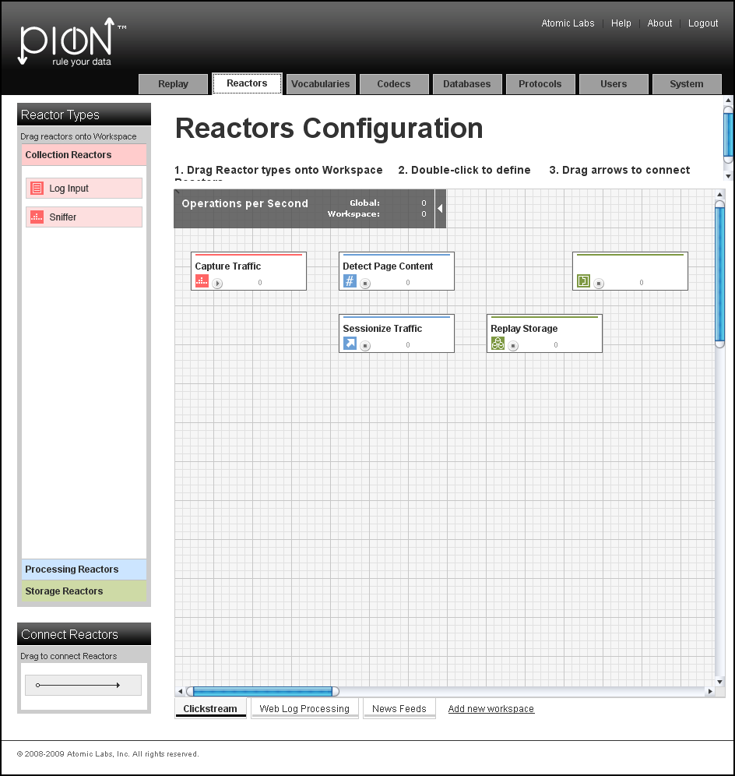

Reactor Types Toolbar
In the Pion application, the “Reactor Types” menu is divided along Reactor family lines. Working with reactors is pretty easy, because reactors can be dragged from the pallet on the left into the workspace area.
When you place the reactor in the workspace, you will be prompted for some basic naming information for the reactor plus any special information for the particular reactor you are creating. For example when you a Sniffer Reactor you are prompted for the general fields for “Name” and ”Comment” as well as two fields specific to the Sniffer Reactor.

29BCollection Reactors
Collection Reactors are responsible for getting data into Pion and therefore every Pion workflow needs to start with at least one collection reactor. Collection Reactors acquire the data from its native format and translate it into normalized Pion events that can be understood and processed by any other reactor.
The two main Collection Reactors are:
- Sniffer Reactor, which captures/monitors network traffic.
- Log File Input Reactor, which reads log files.

30BProcessing Reactors
After Pion has collected data it must do something with it in order to make it more useful. The Processing Reactors are responsible for manipulating and enriching the raw data to create the desired information.
The Processing Reactors include:
- Transform Reactor, which is able to do deep manipulation of the data in the data stream. For example, this can be as simple as formatting a URL to be something more easily readable or consistent if sites are constantly changing, or calculating dollar values from a page to see total spend (even taking into account if the currency must be converted). Because the Transform Reactor is very flexible, it can also do more complex things such as capturing and translating a bank branch or user identification on the fly.
- Session Filter Reactor, which enables you hold entire sessions until they meet certain criteria. The Session Filter Reactor must always be used after a Clickstream Reactor to ensure that the sessions are created. Using the Session Filter Reactor, you can do things such as saving full page view detail on only users that purchased a certain book or encountered an error.
- Aggregate Reactor, which is able to take large volumes of raw data and distill critical pieces of information out of them. For example, the Aggregate Reactor could count all of the web users on the site in the last hour, calculate the average page size the downloaded and tell you the total amount of traffic the site consumed in the last day. The Aggregate Reactor could even tell you each unique user name that accessed the site. Because it performs these calculations inside of Pion the Aggregate Reactor can do real-time report and reduce the stress on backend networks and systems which is especially critical in high volume applications.
- Fission Reactor, which splits input events into sequences of output events. For example, after receiving an input event of a news feed containing multiple RSS and XML items, the Fission Reactor can split the incoming event into an series of events containing only the RSS items.
- Content Hash Reactor, creates and then stores an md5 hash as an identifier (a content_id) for a specified content term in an HTTP response. This identifier is stored in a database, which is then used by the Replay feature when reviewing the user experience.
- SQL Reactor, which lets Pion interact with any relational database based on real time information. This means that Pion can gather additional information on sessions based on past activity. For example, you can see how much a customer spent during the last 2 years to add context to their session and to improve segmentation for analytics. Based on real-time information, the SQL Reactor can also update or insert data in the database to ensure that the information you have is always the most current possible.
- Filter Reactor, which filters information based on any number of criteria you might set. For example, you could do something simple like only looking at a particular set of users of web servers, or you could do something much more complicated such as only tracking certain individuals who are spending more than $50 on kitchen ware in their sessions.
- Clickstream Reactor, by understanding how browsers normally communicate with backend systems and how session state is maintained, is able take raw web traffic and organize it into logical pages and individual user sessions. The Clickstream Reactor does this in order to determine who is who and gather overall session statistics such as visit length, pages viewed, images viewed, time per page view, and more. Often, you won’t have to configure any of the options inside of the Clickstream Reactor for it to work correctly. If necessary though, though the Clickstream Reactor also contains the ability to handle very complex and custom sessionization parameters that are sometimes employed by very large applications to maintain session state across globally distributed application instances.
- Python Reactor, which allows you to use the Python programming language to collect, manipulate and store events within Pion.
- Script Reactor, which enables you to leverage existing command line scripts to quickly add capabilities to Pion. Using Script Reactor, you can do things such as create follow-up queues based on customer behavior or retrieve additional information from disparate sources on the fly.

31BStorage Reactors
Storage Reactors are needed whenever data needs to be persisted for later use for reporting or record keeping. For web analytics to take place a Pion workflow must always end with a Storage Reactor.
The main Storage Reactors include:
- Database Output Reactor, which enables Pion to store information in almost any database. The Database Output Reactor handles the format translation, table organization and performance tuning aspects required to ensure Pion events are written with the best performance and quality possible. To ensure high performance, native database communication is available for MySQL, Oracle, Microsoft, Sybase, IBM, Informix, Centura, Interbase, PostgreSQL and SQL Lite databases. The Database Output Reactor can also send data to any ODBC compliant database for storage. Because Pion enables direct database output, it can be easily integrated into any business intelligence implementation or data warehouse without requiring custom code or a separate extract, transfer and load (ETL) tool.
- Google Analytics Reactor, which is able to take web user behavior information and send it to Google Analytics servers via its native web services interface in real-time. From Google Analytics perspective, data collected by Pion is indistinguishable from that collected via page tags. All you need to supply is the correct Google Analytics Account ID and site name to connect Pion to Google Analytics.
- Omniture Genesis Reactor, which is able to take web user behavior information and send it through the Omniture Genesis integration system to SiteCatalyst via its native web services interface (in real-time) or the XML loading interface. All you need to supply is the relevant account information and site name to connect Pion to Omniture..
- Log Output Reactor, which enables you to write any data to a structured flat file of your choice in real time. This is often very useful for web analytics, because most tools are written to take in web server files as their default input format. Pion can capture, process and enrich user information before creating the distilled log files for use by other tools. This enables Pion to easily integrate with almost any on-site web analytics package including the open source efforts.
- Multi Database Reactor enables Pion to store data in several databases, based on the data being stored.
Once Reactors have been dragged into the workspace and connected, you can:
- Double-click on a Reactor to display its configuration dialog. You can then change the Reactor's configuration or connection characteristics.
- Right-click on a Reactor to:
- Display the Reactor's configuration dialog. You can then change the Reactor's configuration or connection characteristics.
- Display its configuration in XML format in a new page (note that this is read-only).
- Delete the Reactor.

The Vocabulary Configuration Page
This page allows you to manage and specify (define) the vocabularies used to describe events. Vocabularies allow you to define the terms and the format of the elements (data structures) that make up an event. There are six (6) built-in vocabularies:
- Clickstream
- RSS Channels
- Atom Feeds
- Stock Prices
- Aggregate
- Messaging (for SMTP)
If necessary, you can alter the built-in vocabularies, or even create your own specialized vocabulary to describe another kind of event.

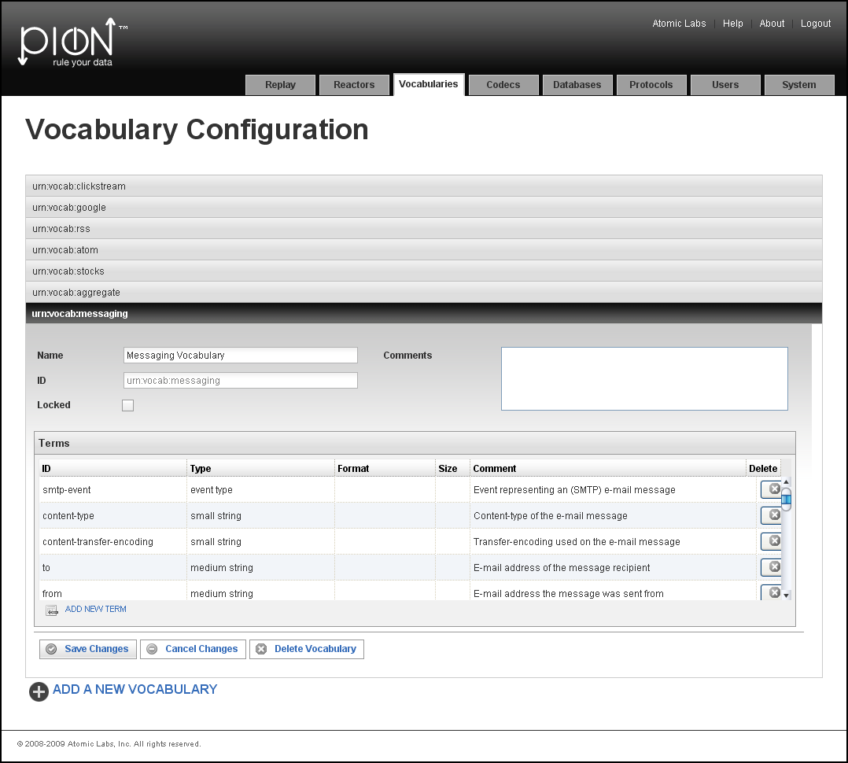

The Codec Configuration Page
A Pion Codec defines an input or output format for a log or a data stream (feed). Once the codec is defined, the log or data stream can be read and events can be created from the data in those logs/data streams. Codecs can also be used by Storage Reactors when writing events or results.
There are 18 built-in codecs in Pion:
- Common Log Format
- Combined Log Format
- Extended Log Format
- Page View Log Format
- Visitor Session Log Format
- WebTrends Log
- Response Content Log
- RSS Channel Extraction Codec
- RSS Channel Log Format
- RSS Item Extraction Codec
- RSS Item Log Format
- Atom Feed Extraction Codec
- Atom Feed Log Codec
- Atom Entry Extraction Codec
- Atom Entry Log Codec
- Stock Price Log
- JSON Log Format
- XML Log Format
If necessary, you can alter the built-in codecs, or create your own specialized codec to describe another kind of input or output format.

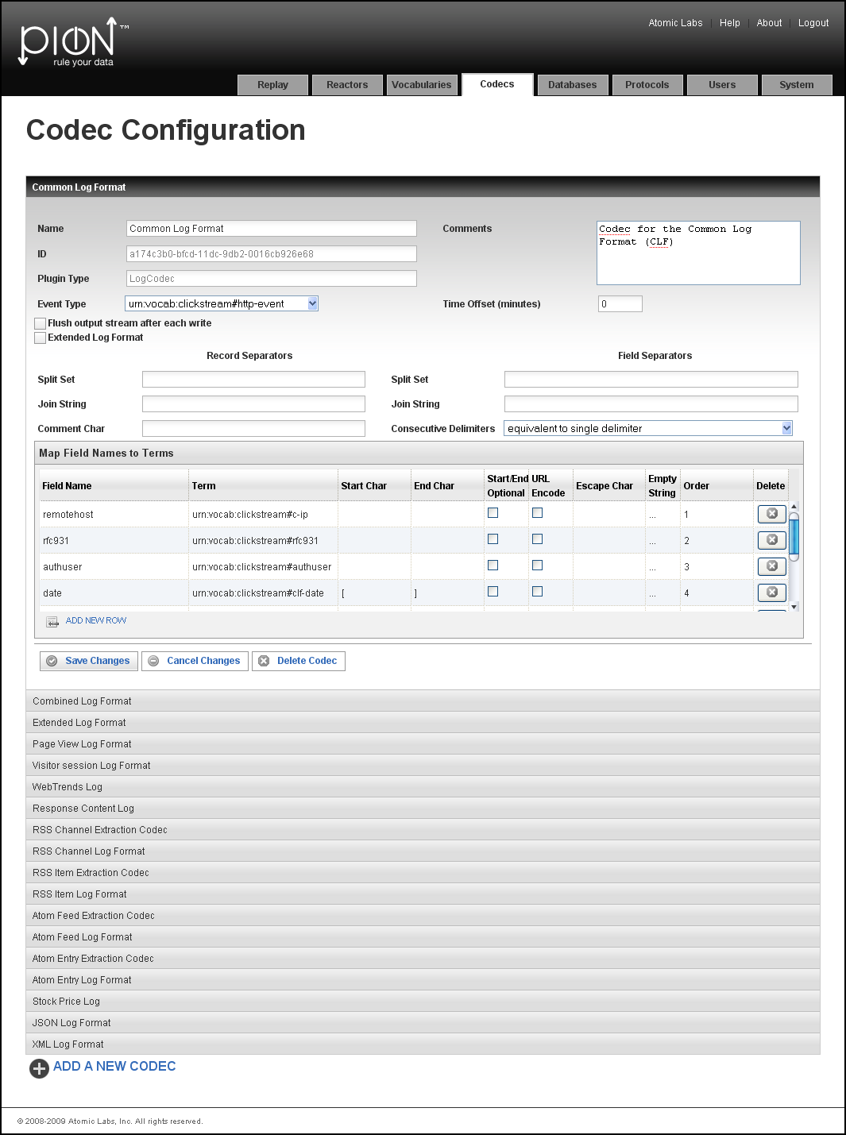

The Database Configuration Page
The Database Configuration Page is used to configure a connection with a database. Connecting to a database means:
Identifying the type of database (for example MySQL, SQLite or Oracle).
Note: In some cases, you will also have to identify the sub-type (engine) of the database being used. For example MySQL-MyISAM or MySQL-InnoDB; there are differences in the engines, and Pion makes effective use of those differences to optimize performance by changing the SQL syntax and/or the Isolation level.
Specifying the database connection information:
- The Username/Password for the Pion user account (the Pion login) on the database.
- The host/machine/instance of the database to connect to (host:port, or similar).
- The individual database instance (the database name space).
- The "connect strings" Pion uses to connect to the database (note that the connect string will be different for each kind/type of database, and may be different for individual databases of the same type/kind). For more information about connect strings, see http://sqlapi.com/OnLineDoc/Connection_Connect.htmlU
SQLite is Pion's embedded database, meaning it is always available, and by default will be used by Reactors, the analytics interfaces (for both Omniture Genesis and Google Analytics), and the Replay feature.
Note: SQLite is not a client/server database, though it is a RDBMS (relational database management system). Instead of a username and password pair, SQLite only has a file name.

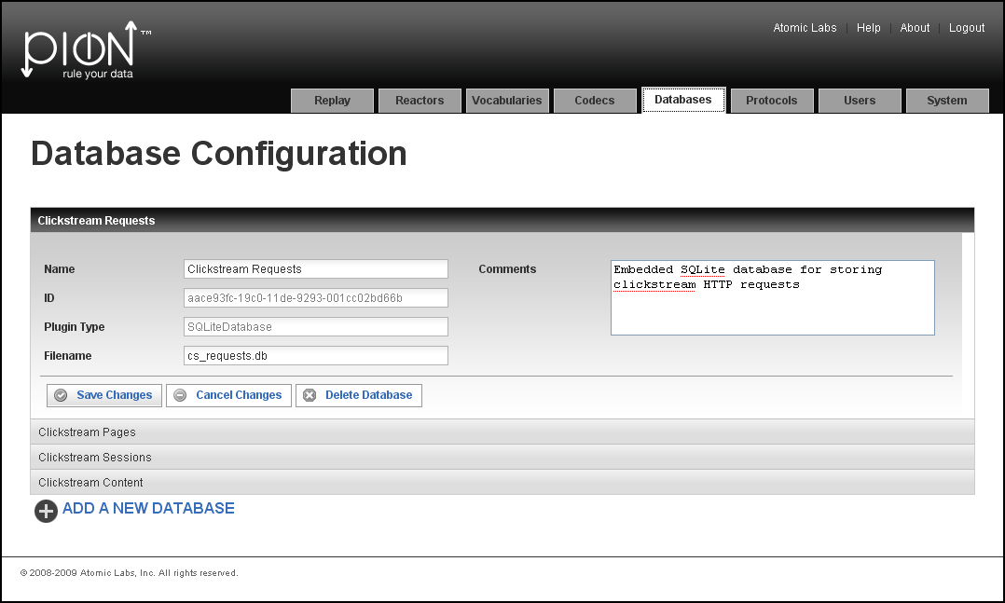

The Protocol Configuration Page
The Protocol Configuration Page is used to specify and configure the protocols Pion monitors. Currently there are two (2) basic protocols (HTTP and SMTP), and two (2) variations of the HTML protocol built-in to Pion:
- HTTP (No Content), which is used when Pion is monitoring visitor sessions to your web site(s), but not collecting data to be used by the Replay feature.
- HTTP (Full Content), which is used to capture the data required by the Replay feature. See “Error: Reference source not foundX“ on page XError: Reference source not foundX for more information.
- SMTP (Email) protocol, which is used to capture data by parsing/sniffing email traffic.
Because of Pion's extensible architecture, adding support for additional protocols is simply a matter of altering or creating codecs and/or vocabularies.

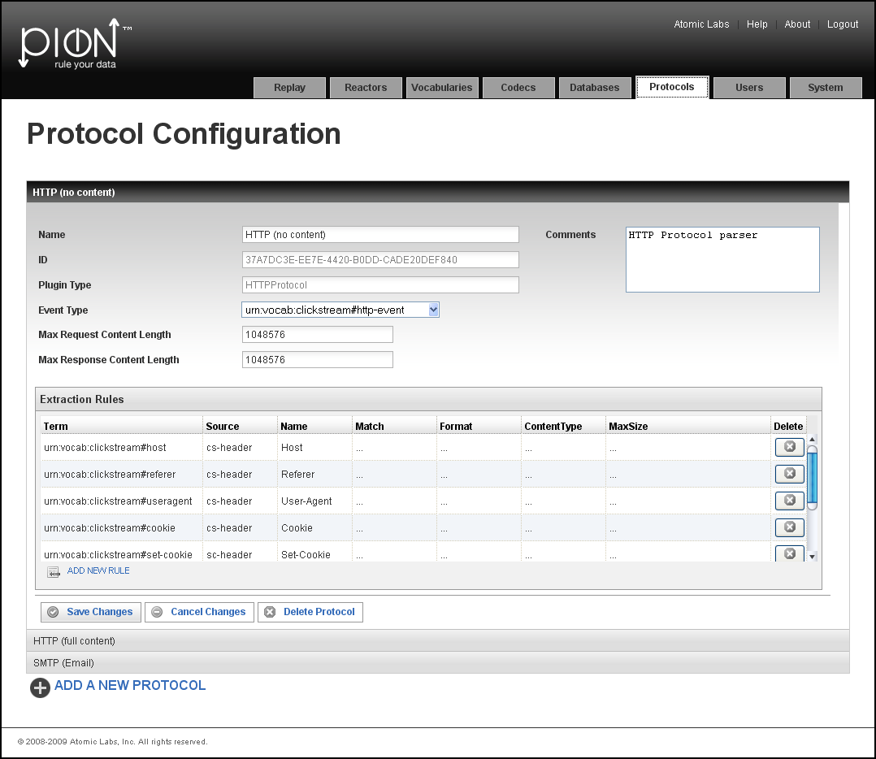

Managing and Configuring Pion

User Configuration
The User Configuration page is used to manage Pion user accounts. You can add, delete, or modify user accounts.

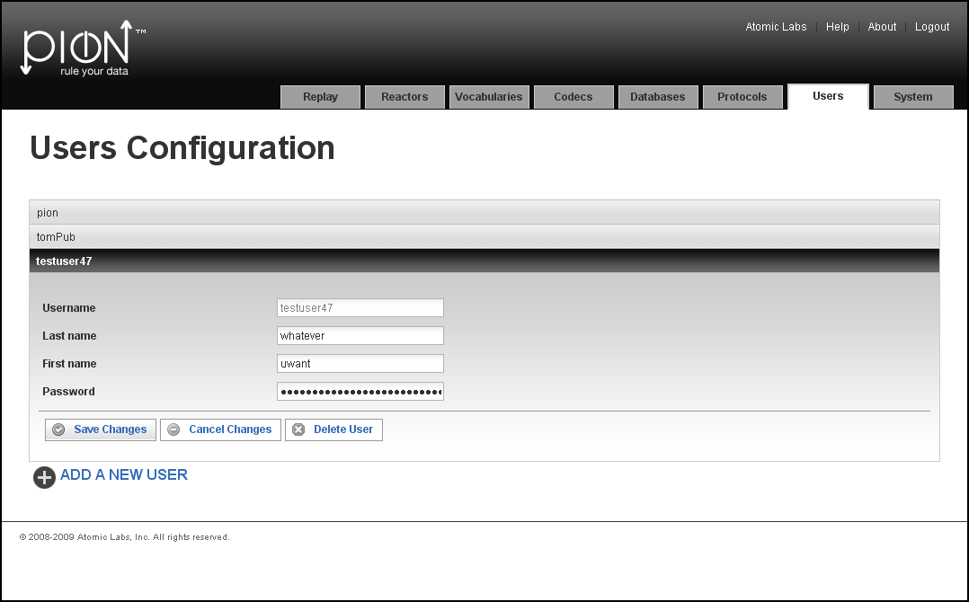

System Configuration
The System Configuration page is used to view the configuration of the Pion application, including configuration file location, services, configuration paths, and plugin paths. You cannot make changes from this page, but you can find out where the configuration files are, and then edit them separately, if necessary. Note that all configuration files are in XML format.
The System Configuration page is also where you can add a Reactor, Connection, codec, or database by importing the XML definition of the Reactor, Connection, codec, or database.

