Unica OnDemand Reactor
The Unica OnDemand Reactor is able to take web user behavior information and send it through the Unica OnDemand marketing management system at Unica.com via its native XML web service interface in real-time. All you need to supply is the relevant site and Unica account name to connect Pion to Unica OnDemand.
When you add a Unica OnDemand Reactor you will be prompted for the following fields:
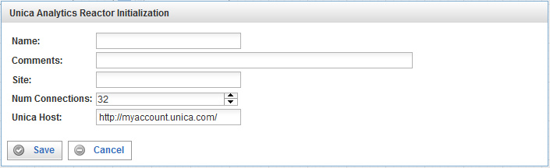

Field | Description
Name | Specify the name of this reactor. This can be any name you find descriptive, we recommend something which describes the data this reactor is processing.  The name may be any combination of letters and numbers.
Comments | Enter some descriptive comments about this reactor. Any comment you feel will help you in the future, we recommend choosing something that describes the data being stored.
Site | The name of the site being monitored.
Num Connections | Specify the maximum number of concurrent connections.  With Unica OnDemand; you can deliver 50 events/second with one connection. If you need higher speed (taking bursts/peaks into account), use a higher number of connections. Using a higher number of connections will use more bandwidth, and you may have to consult with Omniture to make sure that they are able to receive the traffic.  Generally, a value of 2 or 4 and up to 16 is reasonable.
Unica Host | This is the Unica OnDemand host that you connect to (you get the account information from Unica for this host). This host is the destination where all the page hits are sent for processing. The Unica Host is usually specified in the form accountname.unica.com.
This creates the Unica OnDemand Reactor in the workspace. Double-clicking on the reactor brings you to the configuration screen:
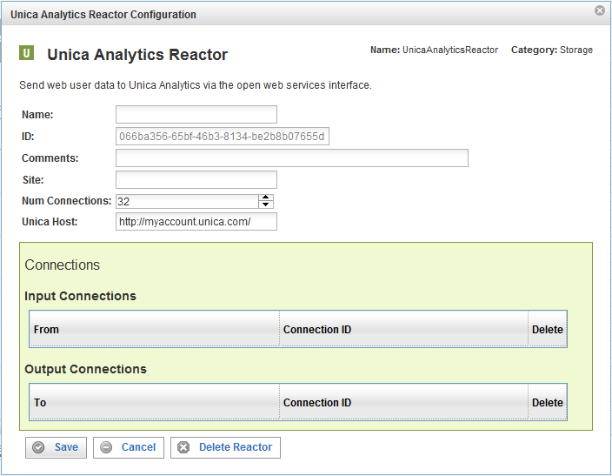
In addition to the fields you saw when adding the reactor initially (described above), you will see one additional field and the Connections sections. The additional field is:
Field | Description
ID | The reactor ID, a unique ID generated by the Pion server. This ID identifies a particular reactor.

The Connections Section
The Connections section describes input and output connections for this Unica OnDemand Reactor. See “Error: Reference source not found“X on page XError: Reference source not foundX for more information.

