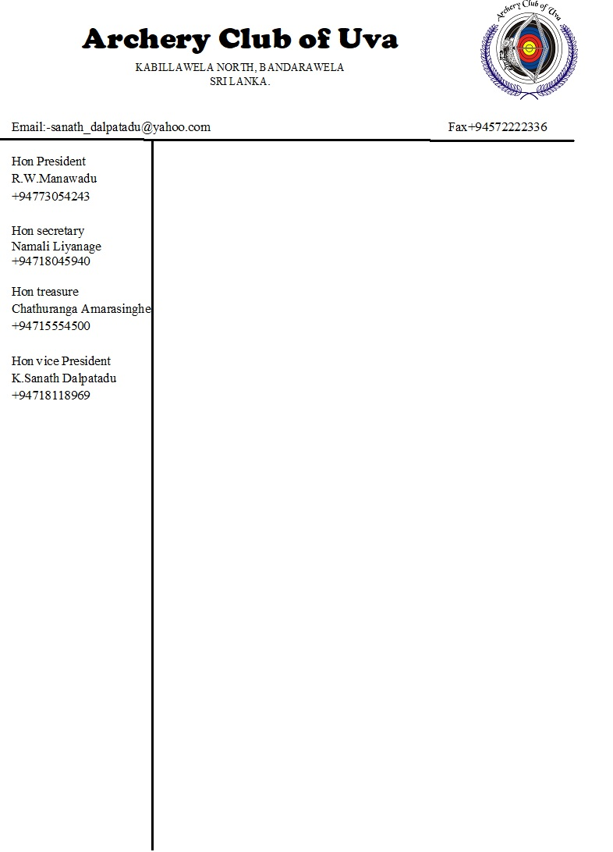

06.02.2020

To whom it may concern

This is to certify that Mr. P.C.Amarasinghe is an active member of our society and he is carrying out his duties as the treasurer since year 2014.

Thank tou

Hon secretary