1. Run command - sudo apt-get update
2. Install pip package - sudo apt-get -y install python-pip
3. Install google client library using below command -

pip install --upgrade google-api-python-client

1. Go to below link

<https://console.developers.google.com/apis/library/sheets.googleapis.com>

1. If project already created select project else create new project
2. Click on ENABLE API
3. Now search for Google Sheets API, click on Google Sheets API.
4. Check Google Sheets API & Drive API are ENABLE or DISABLE if ENABLE then click on label.In below screenshot API is already enabled

Then **Go to credentials**. (In top left)

1. At the top of the page, select the **OAuth consent screen** tab. Select an **Email address**, enter a **Product name** if not already set, and click the **Save** button.

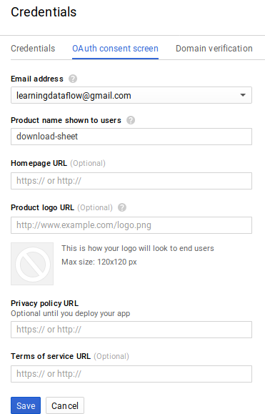

1. Select the **Credentials** tab, click the **Create credentials** button and select **OAuth client ID**.
2. Select the application type **Other**, enter the name , and click the **Create** button.
3. Click **OK** to dismiss the resulting dialog.
4. Click the download icon (Download JSON) button to the right of the client ID.



1. Move this file to your working directory and rename it client_secret.json.
2. Give access permission to the folder in which you want to download the file using below command

cd path of folder

sudo chmod 777 -R dirpath

1. Fill the credential in ini file , And run below command.
2. python fileDownloadfromGdrive.py 'fileDownloadfromGdrive.ini'

18. Ini file parameter description are below.

1. clientsecretkeypath = your dir path/client_secret.json
2. spreadsheetid = your spreadsheet id
3. filename = file name you want to save
4. filepath = file path where you want to save
5. mimetype = application/vnd.openxmlformats-officedocument.spreadsheetml.sheet

19. Mime list is below:

1. MS Excel = application/vnd.openxmlformats-officedocument.spreadsheetml.sheet
2. Open Office sheet = application/x-vnd.oasis.opendocument.spreadsheet
3. PDF = application/pdf
4. CSV (first sheet only) = text/csv
5. TSV (first sheet only) = text/tab-separated-values
6. HTML (zipped) = application/zip