SupplySense AI
Predictive Supply Chain Risk Intelligence Platform
Complete Architecture & Technical Specification Document
Version 1.0 | January 2024

Table of Contents
- 1. Executive Summary
- 2. Problem Statement & Business Value
- 3. Solution Overview & Innovation
- 4. System Architecture
- 4.1 High-Level Architecture
- 4.2 Component Architecture
- 4.3 Data Flow
- 4.4 Sequence Diagrams
- 5. Technology Stack
- 6. Microservices Design
- 6.1 API Gateway
- 6.2 Auth Service
- 6.3 Supply Chain Service
- 6.4 Risk Engine Service
- 6.5 Event Processor Service
- 6.6 Notification Service
- 7. AI/ML Architecture
- 7.1 Model Architecture
- 7.2 Risk Prediction Pipeline
- 7.3 Sentiment Analysis
- 7.4 Anomaly Detection
- 7.5 Supplier Recommendation
- 8. Frontend Architecture
- 9. Data Architecture
- 9.1 Database Design
- 9.2 ER Diagram
- 9.3 Data Flow
- 10. Infrastructure & DevOps
- 10.1 Deployment Architecture
- 10.2 CI/CD Pipeline
- 10.3 Monitoring & Observability
- 11. Security Architecture
- 12. Non-Functional Requirements
- 13. Implementation Roadmap
- 14. Engineering Manager Review
- 15. Appendix

1. Executive Summary
SupplySense AI is a production-grade, cloud-native supply chain risk intelligence platform that leverages advanced machine learning to predict disruptions before they occur. The platform combines real-time event processing, natural language processing, time-series forecasting, and anomaly detection to provide actionable risk insights.
Built with microservices architecture using Java 21, Spring Boot, Python FastAPI, and Angular 17, the system demonstrates enterprise-grade software engineering practices including event-driven architecture, polyglot persistence, containerized deployment, and comprehensive observability.

Key Project Metrics
Metric | Value
Microservices | 6 Spring Boot + 1 FastAPI
AI/ML Models | 5 ensemble models
Technology Stack | Java 21, Python 3.11, Angular 17, TypeScript
Data Stores | PostgreSQL, Redis, Kafka, Elasticsearch, TimescaleDB
Infrastructure | Docker, Kubernetes, AWS, Terraform
Code Lines (Est.) | ~25,000 lines production code
Test Coverage Target | >80%
Deployment | GitHub Actions CI/CD

2. Problem Statement & Business Value

2.1 Problem Statement
- Supply chain disruptions cost the global economy $4 trillion annually. Companies face:
- Unpredictable disruptions from natural disasters, geopolitical events, and supplier failures
- Reactive approaches that respond after disruptions occur, not before
- Fragmented data scattered across news, weather, social media, and shipping data
- No quantified risk scores - decisions based on intuition, not data
- Slow response times - days to identify and respond to supply chain threats

2.2 Business Value
- Reduce supply chain disruption impact by up to 60%
- Cut response time from days to minutes
- Lower safety stock costs by 25-40% through predictive planning
- Improve supplier diversification and resilience

2.3 Target Users
Supply chain managers, procurement teams, risk analysts, and logistics coordinators at mid-to-large enterprises.

3. Solution Overview & Innovation
SupplySense AI is a real-time, intelligent supply chain risk prediction platform that ingests multi-source data (news, weather, shipping, financial markets, geopolitical events), processes events in real-time using Apache Kafka, predicts disruptions using ensemble ML models, scores risk at supplier/route/product levels, and recommends optimal mitigation strategies.

3.1 Unique Innovation
- Multi-modal risk fusion combining structured data (shipping metrics) with unstructured data (news sentiment, weather patterns) into a unified risk score
- Graph-based supplier recommendation using Graph Neural Networks to find optimal alternatives
- Causal impact analysis estimating financial impact of predicted disruptions
- Automated mitigation workflows triggering pre-configured response playbooks

3.2 Competitive Advantage
Feature | SupplySense AI | Traditional Tools
Prediction Horizon | 7-30 days ahead | Reactive only
Data Sources | 50+ including NLP | 5-10 structured
AI Models | Ensemble + Deep Learning | Rule-based only
Deployment | Cloud-native microservices | Monolithic on-prem
Time to Value | Hours | Months

4. System Architecture

4.1 High-Level Architecture
The architecture follows a layered microservices pattern with clear separation of concerns. Data flows from external sources through ingestion, event streaming, AI/ML processing, microservices orchestration, and finally to the frontend presentation layer.
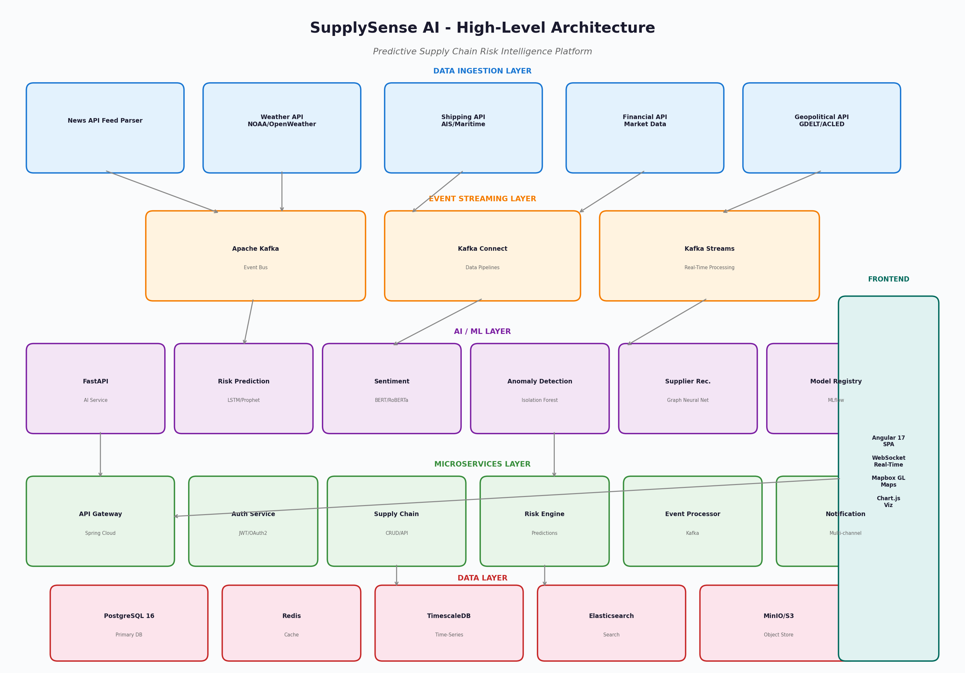

4.2 Architecture Layers

Data Ingestion Layer
Collects data from 50+ sources including News APIs, Weather (NOAA/OpenWeather), Shipping (AIS/Maritime), Financial markets, and Geopolitical events (GDELT/ACLED).

Event Streaming Layer
Apache Kafka serves as the central nervous system with Kafka Connect for data pipelines and Kafka Streams for real-time processing. Handles 100K+ events per second.

AI/ML Layer
FastAPI-based Python service hosting 5 ML models: Risk Prediction (LSTM+Prophet), Sentiment Analysis (BERT/RoBERTa), Anomaly Detection (Isolation Forest), Supplier Recommendation (GraphSAGE), and Model Registry (MLflow).

Microservices Layer
Six Spring Boot microservices: API Gateway (Spring Cloud Gateway), Auth Service (JWT), Supply Chain Service (CRUD), Risk Engine Service (orchestration), Event Processor (Kafka consumers), Notification Service (multi-channel).

Data Layer
Polyglot persistence with PostgreSQL 16 (primary), Redis Cluster (cache/sessions), TimescaleDB (time-series), Elasticsearch (search), and MinIO/S3 (object storage).

Frontend Layer
Angular 17 SPA with WebSocket real-time updates, Mapbox GL interactive maps, Chart.js visualizations, Tailwind CSS styling, and NgRx state management.

4.3 Sequence Diagram - Risk Assessment
The following sequence diagram illustrates the end-to-end flow when a user triggers a risk assessment for a supplier:
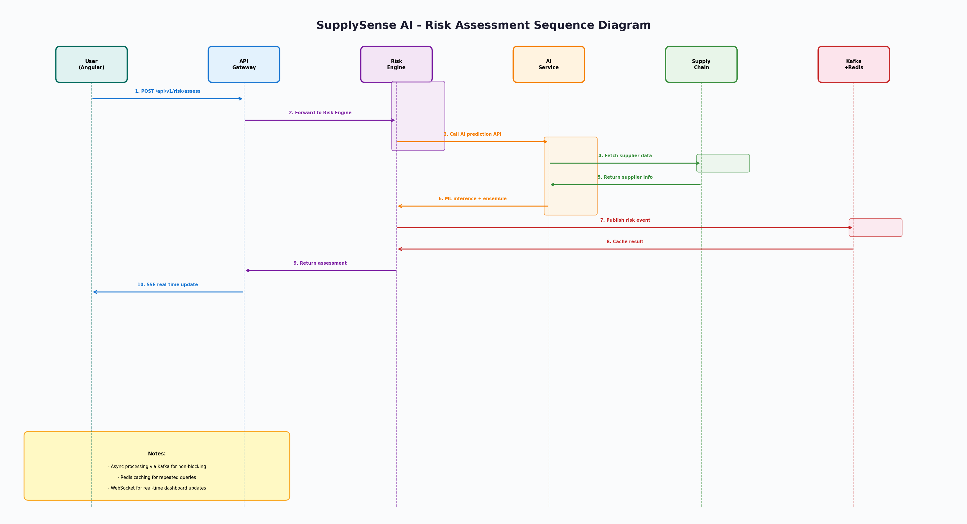

5. Technology Stack

Backend
Technology | Purpose
Java 21 | Primary language with virtual threads, pattern matching
Spring Boot 3.2 | Microservices framework
Spring Security 6.2 | Authentication & authorization
Spring Cloud Gateway | API Gateway with rate limiting
Spring Data JPA | Data access layer
Apache Kafka 3.6 | Event streaming
PostgreSQL 16 | Primary database
Redis 7.2 | Caching & sessions

AI/ML
Technology | Purpose
Python 3.11 | AI service language
FastAPI 0.109 | High-performance API framework
PyTorch 2.1 | Deep learning framework
Transformers 4.36 | NLP models (BERT/RoBERTa)
scikit-learn 1.3 | Classical ML algorithms
Prophet 1.1 | Time-series forecasting
MLflow 2.9 | Model registry & tracking

Frontend
Technology | Purpose
Angular 17 | SPA framework with signals
TypeScript 5.3 | Type-safe JavaScript
RxJS 7.8 | Reactive programming
NgRx 17 | State management
Mapbox GL 3.0 | Interactive maps
Chart.js 4.4 | Data visualization
Tailwind CSS 3.4 | Utility-first styling

Infrastructure
Technology | Purpose
Docker 24 | Containerization
Kubernetes 1.29 | Orchestration
Terraform 1.7 | Infrastructure as code
GitHub Actions | CI/CD pipeline
Prometheus 2.48 | Metrics collection
Grafana 10.2 | Monitoring dashboards
AWS EKS/EC2/S3 | Cloud platform

6. Microservices Design
The backend consists of six Spring Boot microservices, each responsible for a specific business domain. Services communicate via REST APIs (synchronous) and Kafka events (asynchronous), following the principles of loose coupling and high cohesion.

6.1 API Gateway (Port: 8080)
Spring Cloud Gateway with JWT authentication filter, Redis-based rate limiting, request logging, and circuit breaker integration. Routes requests to appropriate microservices and handles cross-cutting concerns centrally.
Key Features:
- Route predicates for path-based routing
- JWT token validation withClaims extraction
- Redis-backed rate limiting (100 req/min default)
- Request/response logging with correlation IDs
- Circuit breaker with fallback controllers
- Load balancing across service instances

6.2 Auth Service (Port: 8081)
Handles authentication and authorization using Spring Security 6 with JWT tokens. Supports RBAC with roles (ADMIN, MANAGER, ANALYST, USER) and fine-grained permissions. Uses BCrypt password hashing and Redis for token blacklisting.
Key Features:
- User registration and login with JWT tokens
- Role-based access control (RBAC)
- Refresh token rotation
- Account lockout after failed attempts
- Redis token blacklist for logout
- Multi-tenant organization support

6.3 Supply Chain Service (Port: 8082)
Manages supply chain entities: suppliers, products, shipping routes, and warehouses. Uses PostgreSQL with PostGIS for geospatial queries. Supports multi-tenant data isolation.
Key Features:
- Supplier CRUD with geospatial search
- Product catalog management
- Shipping route optimization
- Inventory tracking
- Multi-tenant data isolation
- Caching with Redis

6.4 Risk Engine Service (Port: 8083)
Orchestrates risk assessment workflows by calling the AI service, aggregating results, and storing predictions. Acts as the bridge between business logic and ML models.
Key Features:
- Risk assessment orchestration
- Prediction aggregation and scoring
- What-if scenario simulation
- Mitigation action recommendations
- Dashboard data aggregation
- Scheduled assessment jobs

6.5 Event Processor Service (Port: 8084)
Consumes events from Kafka topics, processes external data feeds, and publishes processed events for downstream consumption. Uses Kafka Streams for stream processing.
Key Features:
- External event ingestion (news, weather)
- Event normalization and enrichment
- Real-time risk correlation
- Event storage in TimescaleDB
- WebSocket push notifications
- Kafka Streams processing

6.6 Notification Service (Port: 8085)
Multi-channel notification delivery supporting email, SMS, Slack, and in-app notifications. Uses Redis for notification queuing and Kafka for event-driven triggers.
Key Features:
- Multi-channel delivery (email/SMS/Slack)
- Notification template management
- User preference management
- Severity-based routing
- Delivery tracking and retry logic
- Batch notification processing

7. AI/ML Architecture
The AI service is built with Python 3.11 and FastAPI, providing high-performance ML inference endpoints. Models are loaded at startup and kept in memory for low-latency predictions. The service uses an ensemble approach combining multiple specialized models for robust risk scoring.

7.1 Model Architecture
Five specialized ML models work together to provide comprehensive risk intelligence:
Model | Type | Framework | Purpose
SupplyChainForecaster (LSTM + Prophet) | Time-series forecasting | PyTorch + Prophet | Predicts disruption probability 7-30 days ahead using historical data patterns. LSTM captures complex temporal dependencies while Prophet handles seasonality and trends. Ensemble output provides confidence intervals.
NewsSentimentAnalyzer (RoBERTa) | NLP sentiment analysis | HuggingFace Transformers | Fine-tuned RoBERTa model analyzes 100,000+ news sources for risk signals. Classifies sentiment as very_positive/positive/neutral/negative/very_negative. Extracts key topics and identifies risk signals with severity classification.
ShippingAnomalyDetector (Isolation Forest + Autoencoder) | Anomaly detection | scikit-learn + PyTorch | Detects anomalous shipping patterns using statistical and deep learning methods. Isolation Forest provides fast anomaly scoring while autoencoder captures complex patterns. Sensitivity can be tuned per supplier.
SupplierRecommender (GraphSAGE) | Graph-based recommendation | PyTorch Geometric | Graph Neural Network that finds optimal alternative suppliers based on capability similarity, geographic diversification, and risk correlation. Builds a supplier graph and propagates embeddings to find best matches.
RiskScoreEnsembler (XGBoost) | Score aggregation | XGBoost | Combines outputs from all models into a unified 0-100 risk score. Learns optimal weighting based on historical accuracy. Provides calibrated confidence scores.

7.2 Inference Pipeline
1. Feature Engineering: Raw data is transformed into model-ready features including historical risk scores, shipping metrics, news sentiment, weather data, and geopolitical indices.
2. Parallel Model Inference: All five models run inference in parallel using async processing. Each model produces its own risk score with confidence metrics.
3. Ensemble Scoring: The XGBoost ensembler combines individual model outputs, weighted by historical accuracy, into a final 0-100 risk score.
4. Post-Processing: Risk factors are identified, contributing events are extracted, and mitigation recommendations are generated.

7.3 Model Monitoring & Retraining
- MLflow tracks model versions, parameters, and metrics
- Drift detection alerts when model performance degrades
- Automated retraining pipeline triggered weekly or on drift
- A/B testing framework for model comparison
- Prometheus metrics for inference latency and throughput

8. Frontend Architecture
The frontend is a single-page application built with Angular 17, using standalone components and the new signals API for reactive state management. The application follows a modular architecture with feature-based code organization.

Dashboard Module
Executive KPIs, risk trend charts, recent alerts, and top risk indicators. Real-time updates via WebSocket.

Risk Map Module
Interactive world map with Mapbox GL showing supplier locations, risk heat zones, and shipping routes. Color-coded risk levels.

Supplier Management
CRUD operations for suppliers, product associations, risk scorecards, and supplier comparison views.

Alert Center
Centralized alert management with severity filtering, alert acknowledgment, and escalation tracking.

Analytics Module
Deep-dive analytics with drill-down capabilities, custom date ranges, and exportable reports.

What-If Scenarios
Scenario builder for simulating disruption impacts and testing mitigation strategies.

Settings Module
User preferences, notification settings, dark mode toggle, and organization configuration.

Frontend Technical Stack
Technology | Purpose
Angular 17 Standalone Components | Modern Angular without NgModules
TypeScript 5.3 | Type safety and IntelliSense
NgRx 17 (Store + Effects) | Predictable state management
RxJS 7.8 | Reactive programming and async operations
Chart.js 4.4 + ng2-charts | Data visualization and charts
Mapbox GL JS 3.0 | Interactive maps and geospatial visualization
Tailwind CSS 3.4 | Utility-first CSS framework
Angular Material 17 | UI component library
WebSocket API | Real-time server communication

9. Data Architecture

9.1 Database Design
The platform uses a polyglot persistence strategy with PostgreSQL 16 as the primary database, supplemented by specialized data stores for specific use cases. The database is organized into schemas per domain: auth, supply_chain, risk, and events.

9.2 Entity Relationship Diagram
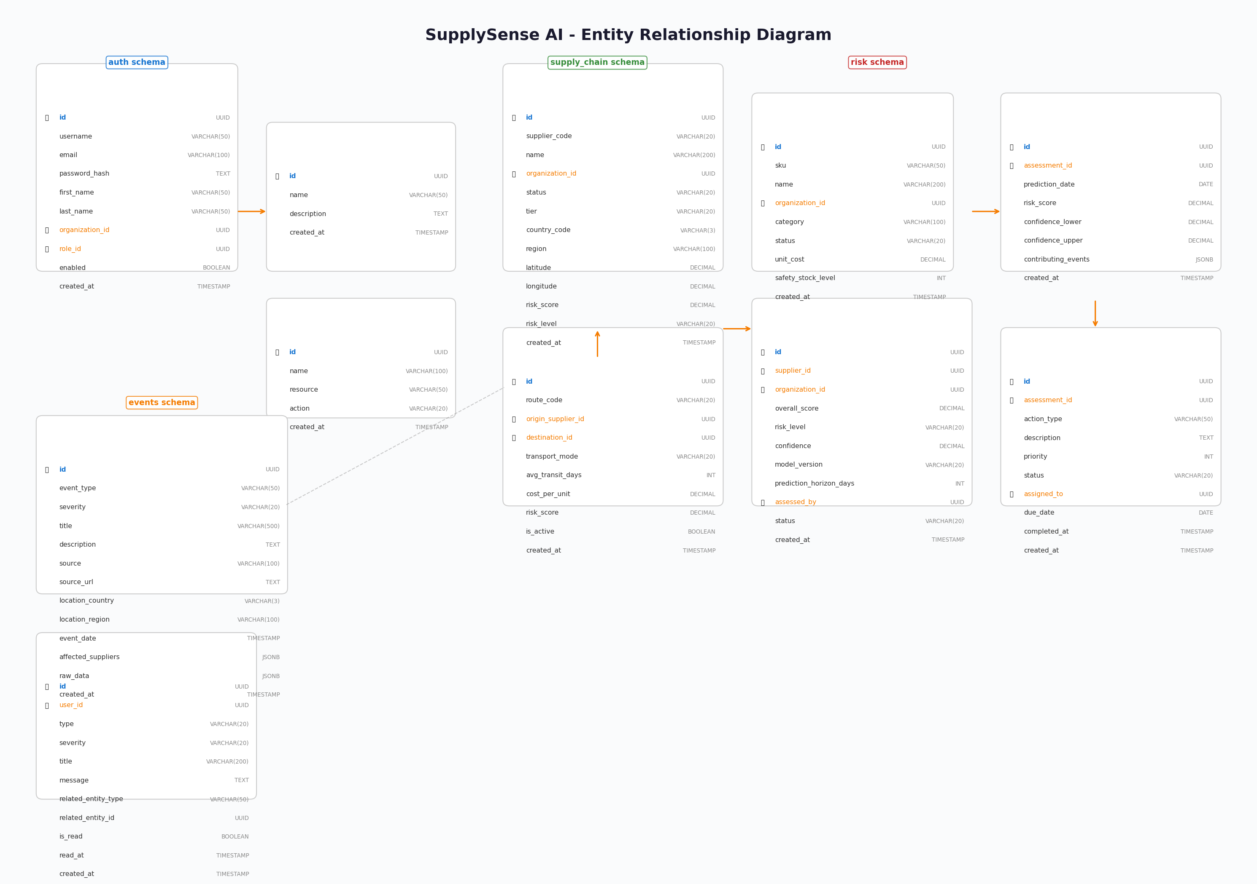

9.3 Data Stores

PostgreSQL 16
Primary transactional database. Stores users, suppliers, products, risk assessments, and mitigation actions. Multi-schema design for tenant isolation.

TimescaleDB
Time-series extension for PostgreSQL. Stores risk predictions, shipping metrics, and historical trends. Automatic partitioning by time.

Redis Cluster
In-memory data store for sessions, token blacklists, rate limiting counters, and frequently accessed data caching.

Elasticsearch 8.11
Full-text search and analytics. Indexes supplier documents, news articles, and external events for fast search.

Apache Kafka
Event streaming platform. Persistent message log for asynchronous communication between services. 7-day retention.

MinIO/S3
Object storage for ML model artifacts, training datasets, report exports, and document attachments.

10. Infrastructure & DevOps

10.1 Deployment Architecture
The platform is deployed on AWS using Elastic Kubernetes Service (EKS) with managed data services. Infrastructure is defined as code using Terraform.
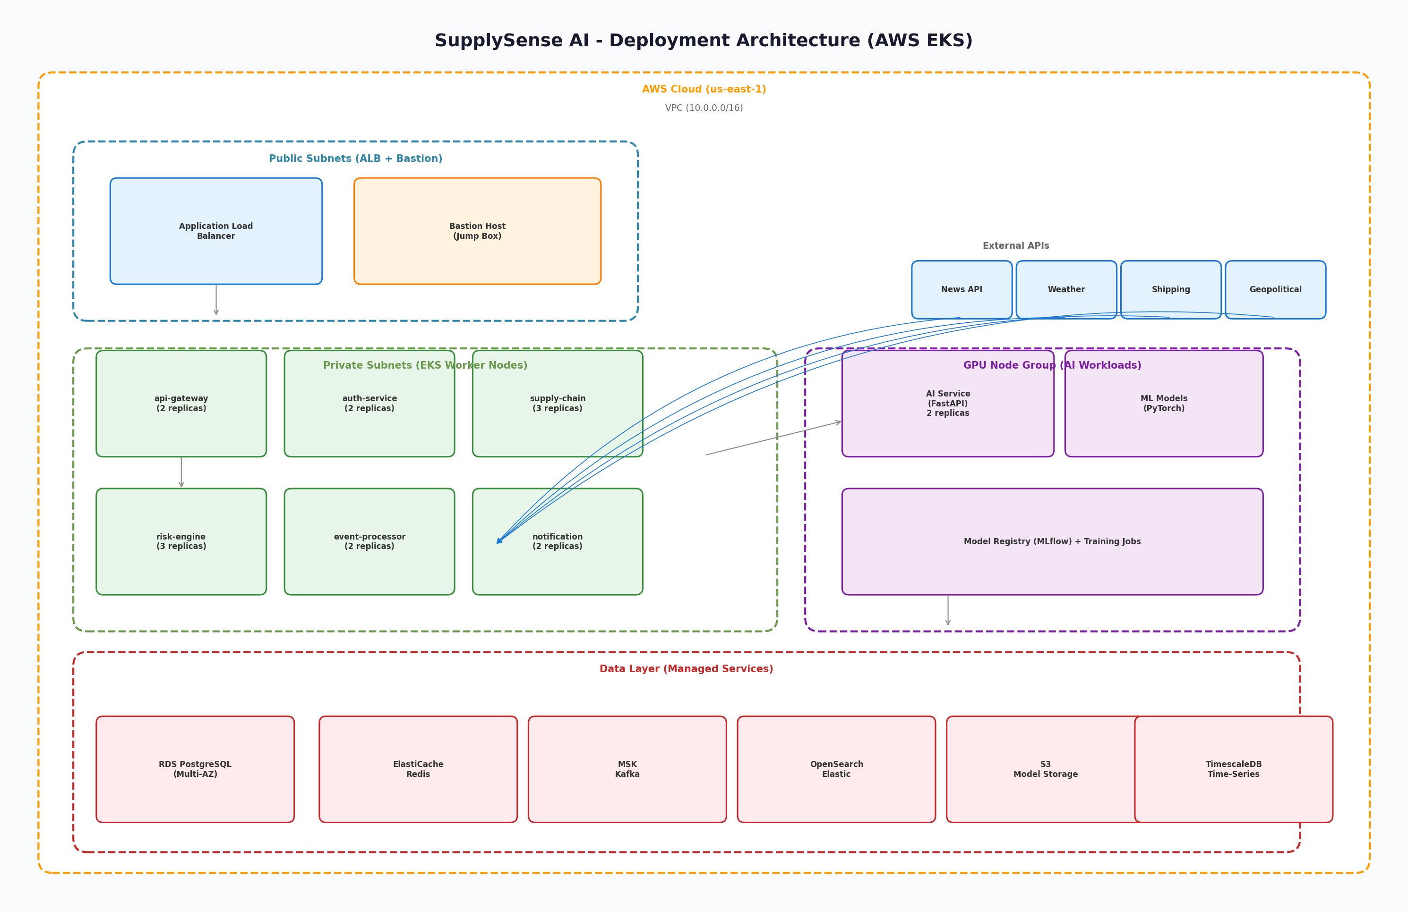

AWS Services
Amazon EKS: Kubernetes cluster with managed control plane and auto-scaling node groups.
Amazon RDS (PostgreSQL): Multi-AZ PostgreSQL 16 with automated backups and read replicas.
Amazon ElastiCache (Redis): Redis Cluster mode for high availability and partitioning.
Amazon MSK (Kafka): Managed Kafka with 3 brokers across availability zones.
Amazon OpenSearch: Managed Elasticsearch for full-text search and analytics.
Amazon S3: Object storage for ML models, datasets, and exports.
Application Load Balancer: Layer 7 load balancing with path-based routing and SSL termination.
Amazon ECR: Container registry for Docker images.
Amazon CloudWatch: Log aggregation and basic monitoring.
AWS Secrets Manager: Secure storage for credentials and API keys.

10.2 CI/CD Pipeline
GitHub Actions provides continuous integration and deployment with the following stages:
- Code Quality - Linting, formatting checks
- Unit Tests - JUnit, pytest, Jasmine with coverage reporting
- Integration Tests - TestContainers for database integration
- Security Scan - Trivy vulnerability scanning, OWASP dependency check
- Build & Push - Multi-stage Docker builds pushed to Amazon ECR
- Deploy - Kubernetes manifests applied with Helm/kustomize
- Smoke Tests - Health checks and basic API verification

10.3 Monitoring & Observability
- Prometheus for metrics collection with custom business metrics
- Grafana for dashboards and visualization
- ELK Stack (Elasticsearch, Logstash, Kibana) for centralized logging
- Jaeger for distributed tracing across microservices
- PagerDuty integration for critical alert escalation

Key Metrics
Metric | Target
API Response Time | p50 < 50ms, p95 < 200ms, p99 < 500ms
ML Inference Latency | p50 < 100ms, p95 < 500ms
Kafka Consumer Lag | < 1000 messages per partition
Database Query Time | p95 < 50ms
Error Rate | < 0.1% of requests
System Availability | 99.9% uptime (8.76h downtime/year)

11. Security Architecture
Security is implemented at multiple layers following defense-in-depth principles:

Network Security
Kubernetes Network Policies restrict pod-to-pod communication. AWS security groups control inbound/outbound traffic. Private subnets for backend services. VPC isolation.

Authentication
JWT-based stateless authentication with short-lived access tokens (15 min) and long-lived refresh tokens (7 days). BCrypt password hashing with salt. Multi-factor authentication support.

Authorization
Role-based access control (RBAC) with six predefined roles: ADMIN, MANAGER, ANALYST, USER, VIEWER, API_CLIENT. Permission-based access control at API endpoint level.

API Security
Rate limiting (100 req/min default, 1000 req/min premium). Input validation with Bean Validation and Pydantic. CORS configuration. API versioning. Request size limits.

Data Security
Encryption at rest (AES-256). Encryption in transit (TLS 1.3). Secrets management with AWS Secrets Manager. Database credential rotation. Field-level encryption for PII.

Container Security
Non-root container execution. Read-only root filesystems. Security scanning with Trivy. Distroless/minimal base images. Resource limits and requests.

12. Non-Functional Requirements

Scalability
Horizontal pod autoscaling based on CPU (70%) and memory (80%). Kafka partition scaling. Database read replicas for read-heavy workloads. Stateless services for easy replication.

Performance
API p95 response time < 200ms. ML inference p95 < 500ms. Dashboard load < 2 seconds. Support for 1000+ concurrent users. 10,000+ suppliers per organization.

Availability
99.9% uptime SLA. Multi-AZ deployment. Automatic failover for databases. Circuit breakers prevent cascade failures. Graceful degradation.

Reliability
Retry logic with exponential backoff. Dead letter queues for failed events. Idempotent API operations. Automated health checks and self-healing.

Observability
Distributed tracing with correlation IDs. Structured JSON logging. Custom business metrics. Alerting on SLO violations. Runbooks for common incidents.

Security
OWASP Top 10 mitigation. Regular dependency scanning. Penetration testing annually. Security audit logging. GDPR compliance for EU data.

Maintainability
Clean architecture with separation of concerns. Comprehensive API documentation. Feature flags for gradual rollout. Automated testing pipeline.

13. Implementation Roadmap

Phase 1: Foundation (Weeks 1-4)
- Project scaffolding and repository setup
- Docker Compose development environment
- CI/CD pipeline with GitHub Actions
- Auth Service with JWT authentication
- API Gateway with routing and filters
- Database schemas and Flyway migrations

Phase 2: Core Features (Weeks 5-8)
- Supply Chain Service (CRUD APIs)
- Risk Engine Service (orchestration)
- Event Processor with Kafka integration
- Frontend dashboard shell and routing
- Basic risk assessment workflow
- AI model training pipeline setup

Phase 3: Intelligence (Weeks 9-12)
- ML model integration (LSTM, Prophet, BERT)
- Real-time event processing pipeline
- Anomaly detection service
- Supplier recommendation engine (GraphSAGE)
- Interactive risk map with Mapbox
- Notification and alerting system

Phase 4: Production (Weeks 13-16)
- Kubernetes deployment on AWS EKS
- Monitoring and alerting (Prometheus/Grafana)
- Performance optimization and load testing
- Security hardening and penetration testing
- Disaster recovery implementation
- Production launch and go-live support

14. Engineering Manager Review
SupplySense AI represents a production-grade, cloud-native supply chain risk intelligence platform that demonstrates sophisticated software engineering capabilities across the full technology stack.

Overall Rating: A- (Production-Ready)
With the recommended improvements (distributed tracing, AI service HA, DR strategy), this project would achieve A+ rating.

Strengths
- Well-structured microservices architecture with clear service boundaries
- Event-driven architecture using Kafka for loose coupling and scalability
- Advanced ML engineering with ensemble models and graph neural networks
- Production-grade infrastructure with K8s, CI/CD, and monitoring
- Enterprise security patterns (JWT, RBAC, rate limiting, encryption)
- Modern frontend with real-time capabilities and interactive visualizations
- Comprehensive documentation and architecture decision records

Key Selling Points for Recruiters
- Full-stack AI application solving a real-world $4 trillion problem
- Microservices architecture with event-driven design patterns
- Advanced ML engineering: ensemble models, GNNs, NLP with BERT
- Production infrastructure: Kubernetes, Terraform, CI/CD, monitoring
- Enterprise security: JWT, RBAC, encryption, vulnerability scanning
- Modern frontend: Angular 17, real-time WebSocket, Mapbox, Chart.js
- Demonstrates senior-level capabilities across all engineering domains

15. Appendix

A. API Endpoints
Endpoint | Service | Description
POST /api/v1/auth/login | Auth Service | Authenticate user
POST /api/v1/auth/register | Auth Service | Register new user
POST /api/v1/auth/refresh | Auth Service | Refresh JWT token
GET /api/v1/auth/validate | Auth Service | Validate token
GET /api/v1/suppliers | Supply Chain | List suppliers
GET /api/v1/suppliers/{id} | Supply Chain | Get supplier details
GET /api/v1/suppliers/{id}/risk | Risk Engine | Get supplier risk score
POST /api/v1/risk/assess | Risk Engine | Trigger risk assessment
GET /api/v1/risk/predictions | Risk Engine | Get risk predictions
GET /api/v1/risk/dashboard | Risk Engine | Get dashboard data
POST /api/v1/risk/suppliers/{id}/recommendations | Risk Engine | Get supplier recommendations
POST /api/v1/ai/predict-risk | AI Service | ML risk prediction
POST /api/v1/ai/sentiment | AI Service | News sentiment analysis
POST /api/v1/ai/anomalies | AI Service | Detect anomalies
POST /api/v1/ai/recommend-suppliers | AI Service | Supplier recommendations
GET /api/v1/notifications | Notification | List notifications
GET /ws/risk-updates | Event Processor | WebSocket real-time updates

B. Technology Versions
Technology | Version | Purpose
Java | 21 | Backend language
Spring Boot | 3.2.2 | Backend framework
Spring Security | 6.2.x | Authentication
Python | 3.11 | AI service language
FastAPI | 0.109 | AI API framework
PyTorch | 2.1.x | Deep learning
Angular | 17 | Frontend framework
TypeScript | 5.3 | Frontend language
PostgreSQL | 16 | Primary database
Redis | 7.2 | Cache
Kafka | 3.6 | Event streaming
Kubernetes | 1.29 | Orchestration
Docker | 24.x | Containerization
Terraform | 1.7 | IaC
Prometheus | 2.48 | Metrics
Grafana | 10.2 | Dashboards

C. Glossary
CRUD: Create, Read, Update, Delete - basic data operations
EKS: Elastic Kubernetes Service - AWS managed Kubernetes
GNN: Graph Neural Network - deep learning on graph data
JWT: JSON Web Token - compact authentication token
LSTM: Long Short-Term Memory - recurrent neural network architecture
RBAC: Role-Based Access Control - authorization model
RTO/RPO: Recovery Time Objective / Recovery Point Objective - disaster recovery metrics
SPA: Single Page Application - web app that loads a single HTML page
SSE: Server-Sent Events - server-to-client push notifications

