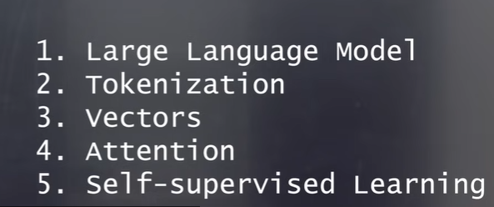

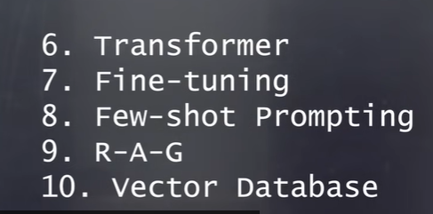

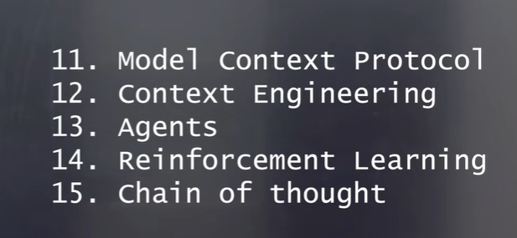
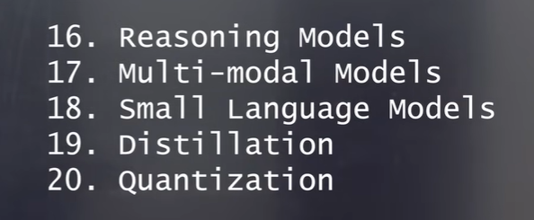

Explain in brief about Name in simple terminology with a real-time example
What is Name
Why do we use Name
When we use Name
✅ What is an LLM (Large Language Model)?
An LLM (Large Language Model) is an AI system trained on a huge amount of text data (books, websites, articles) so it can understand and generate human-like language.
👉 In simple words:
It’s like a super-smart text predictor that can answer questions, write content, and have conversations.

🎯 Why do we use LLM?
We use LLMs to make machines understand and respond like humans, which helps in:
- Answering questions (like chatbots)
- Writing emails, code, or summaries
- Translating languages
- Automating customer support
- Generating ideas or content
👉 Basically, it saves time and effort by automating language-based tasks.

⏰ When do we use LLM?
We use LLMs whenever there is a need to work with text or human language, such as:
- Building chatbots (customer support, assistants)
- Searching and summarizing documents
- Code generation or debugging
- Personal assistants (like AI helping you write resumes)
- Analyzing feedback or reviews

🌍 Real-Time Example
Imagine you are shopping online and you ask:
“Which laptop is best under $1000 for coding?”
An LLM-powered chatbot:
- Understands your question
- Analyzes your needs (budget + coding)
- Gives a helpful answer with recommendations
👉 Just like a human sales assistant, but faster and available 24/7.

🧠 One-line summary
LLM = AI that reads, understands, and writes human language like a smart assistant.

