* Install Git for windows:- Search Git install.
* After installation open GIT BASH
* Configure :- git config --global user.name "Himanshu" then

git config --global user. Email [ravihimanshu141293@gmail.com](mailto:ravihimanshu141293@gmail.com)

To check:- git config –list

* 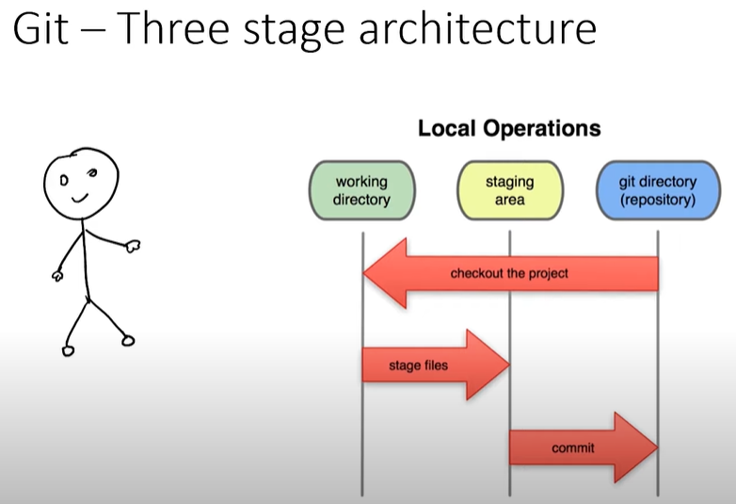
* Git init:- make folder as git repository
* Git status: check git status
* Git add --a:- Add all files to staging area or git add filename
* git commit -m "initial commit":- Commit with msg
* git log :- To track log details