**_________________________________________**

**Developer: --** RAVI KASHYAP

**GitHubLink:**

**-: Virtual Key for your Repositories: -**

**Background of the problem statement: ---**

Company Lockers Pvt. Ltd. hired you as a Full Stack Developer. They aim to digitize their products and chose LockedMe.com as their first project to start with. You’re asked to develop a prototype of the application. The prototype of the application will be then presented to the relevant stakeholders for the budget approval. Your manager has set up a meeting where you’re asked to present the following in the next 15 working days (3 weeks):

* Specification document - Product’s capabilities, appearance, and user interactions
* Number and duration of sprints required
* Setting up Git and GitHub account to store and track your enhancements of the prototype
* Java concepts being used in the project
* Data Structures where sorting and searching techniques are used.
* Generic features and three operations:
  + Retrieving the file names in an ascending order
  + Business-level operations:
    - Option to add a user specified file to the application
    - Option to delete a user specified file from the application
    - Option to search a user specified file from the application
    - Navigation option to close the current execution context and return to the main context
  + Option to close the application

__________________________________________________________________________________

**DESCRIPTION**

In this Project, I developed a prototype of the application. In which it can display name and developer (Ravi kashyap) details, The details of the User Interface such as options displaying the User Interactions information and features to accept the user input to select one of the options Listed. In this project it will display the welcome information and then ask for the user interaction as accessing files in the given path, Display menu for File Operations and exit application. In Display File options menu options we can

1. Add a File

2. Delete a file

3. Search for a file

4. Return to Main Menu

**Core Concepts Used in the Project: -**

• Collection Framework

• Flow control

• Recursion

• File Handling

• Exception Handling

**Product Capabilities The application has the following capabilities: --**

1. Show files – shows files from the directory in ascending order (Sorted).

2. Show files menu – shows the following file operations:

2.1. Add a file – adds files to the directory.

2.2. Delete a file – deletes files from the directory.

2.3. Search for a file – searches for file in the directory.

2.4. Return to main menu -Returns to main menu.

3. Exit the application.

Source code for each of the capabilities with output is shown below:

**Note: -** Complete source code of the app is in ***Details.docx/Git repository*** for reference.

**CODES/OUTPUTS(Screenshots):-**

**Welcome screen with main menu: -**

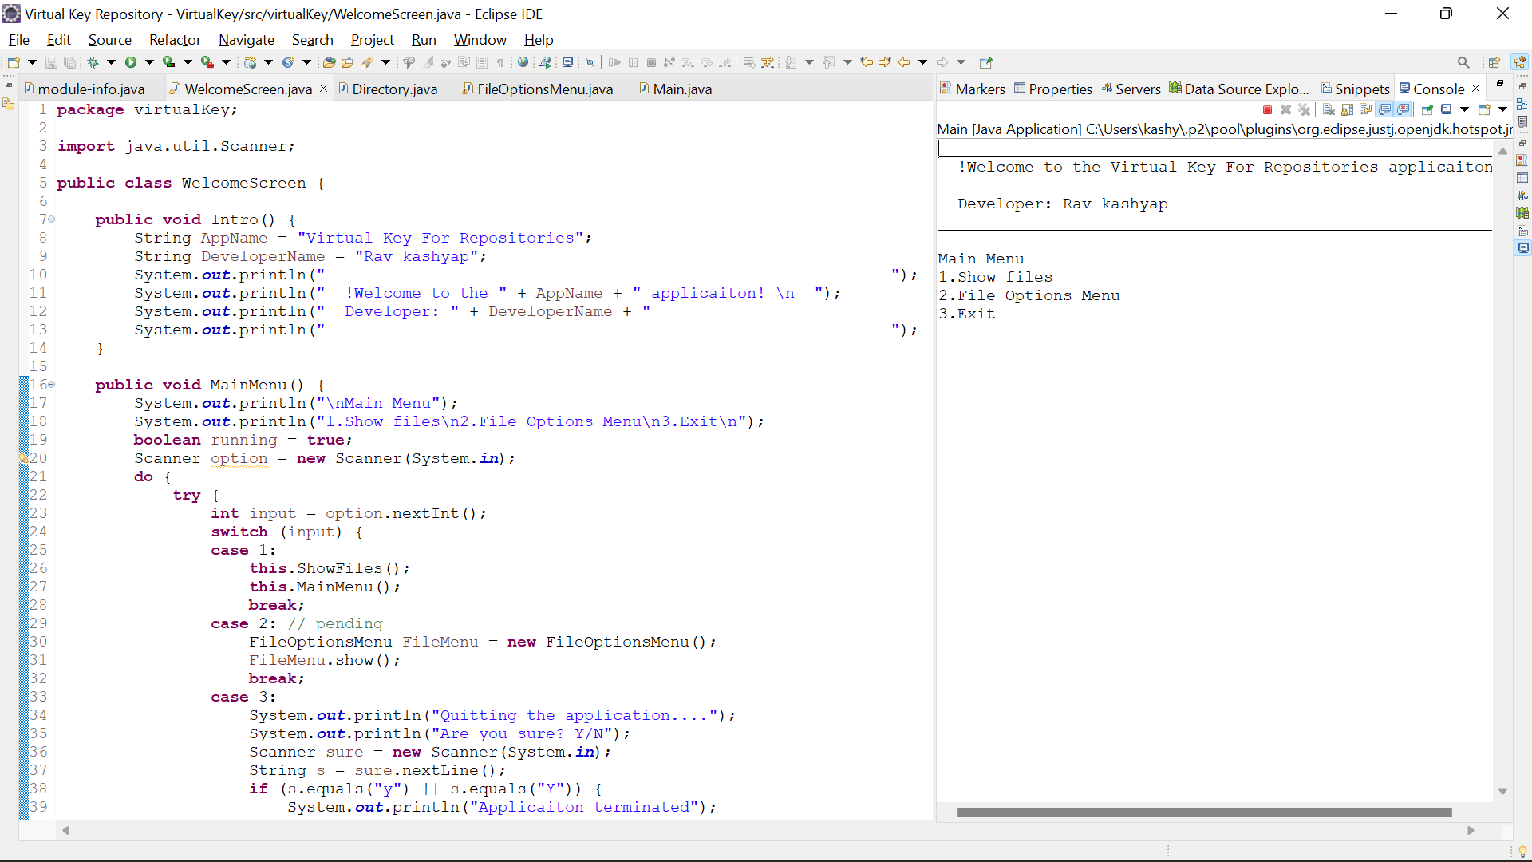

**Show files (Existing Files):--**

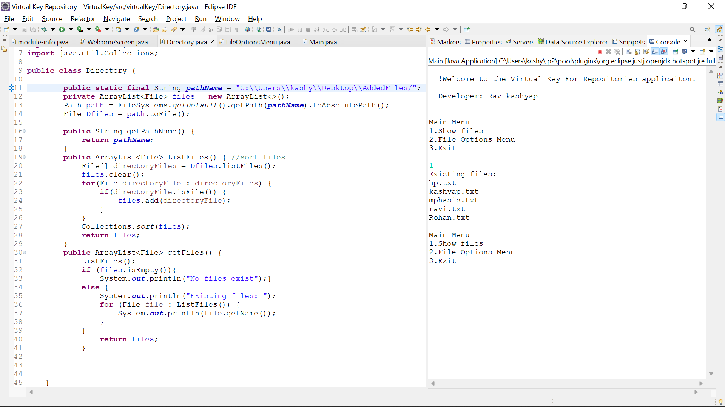

**Adding the file:--**

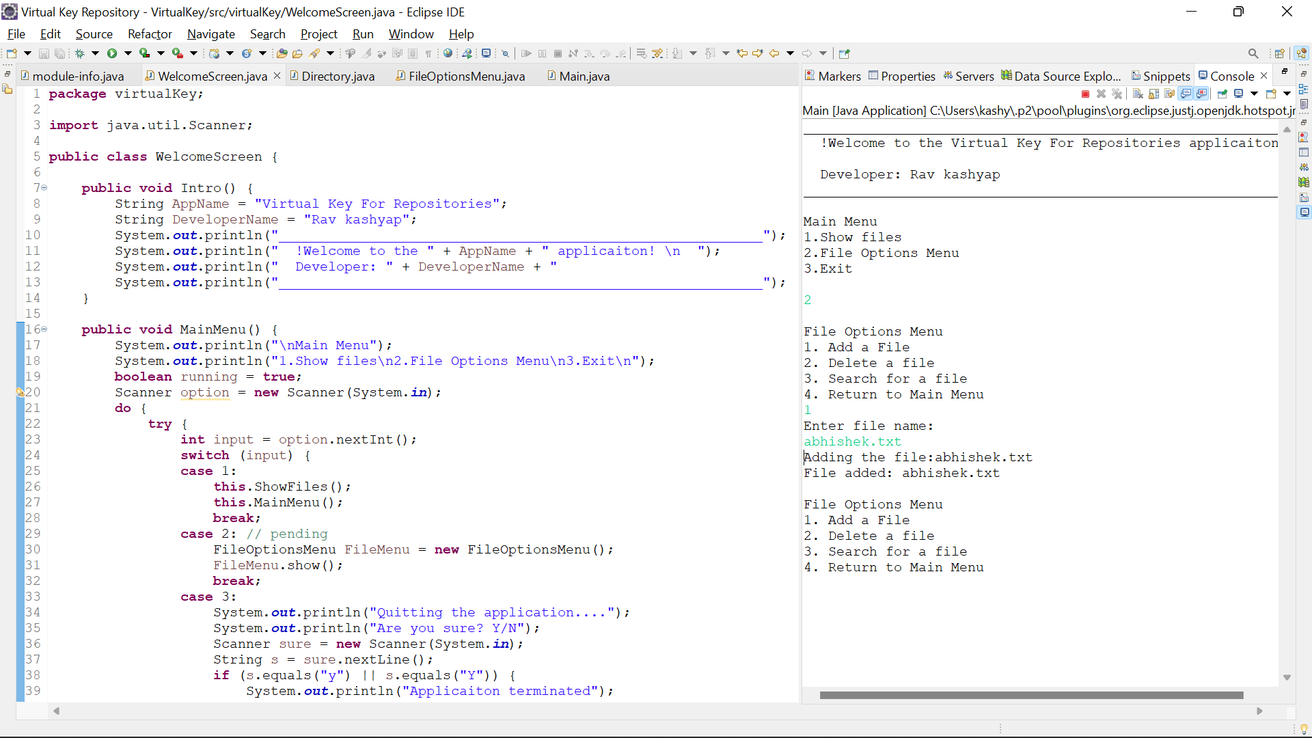

**Deleting the file; --**

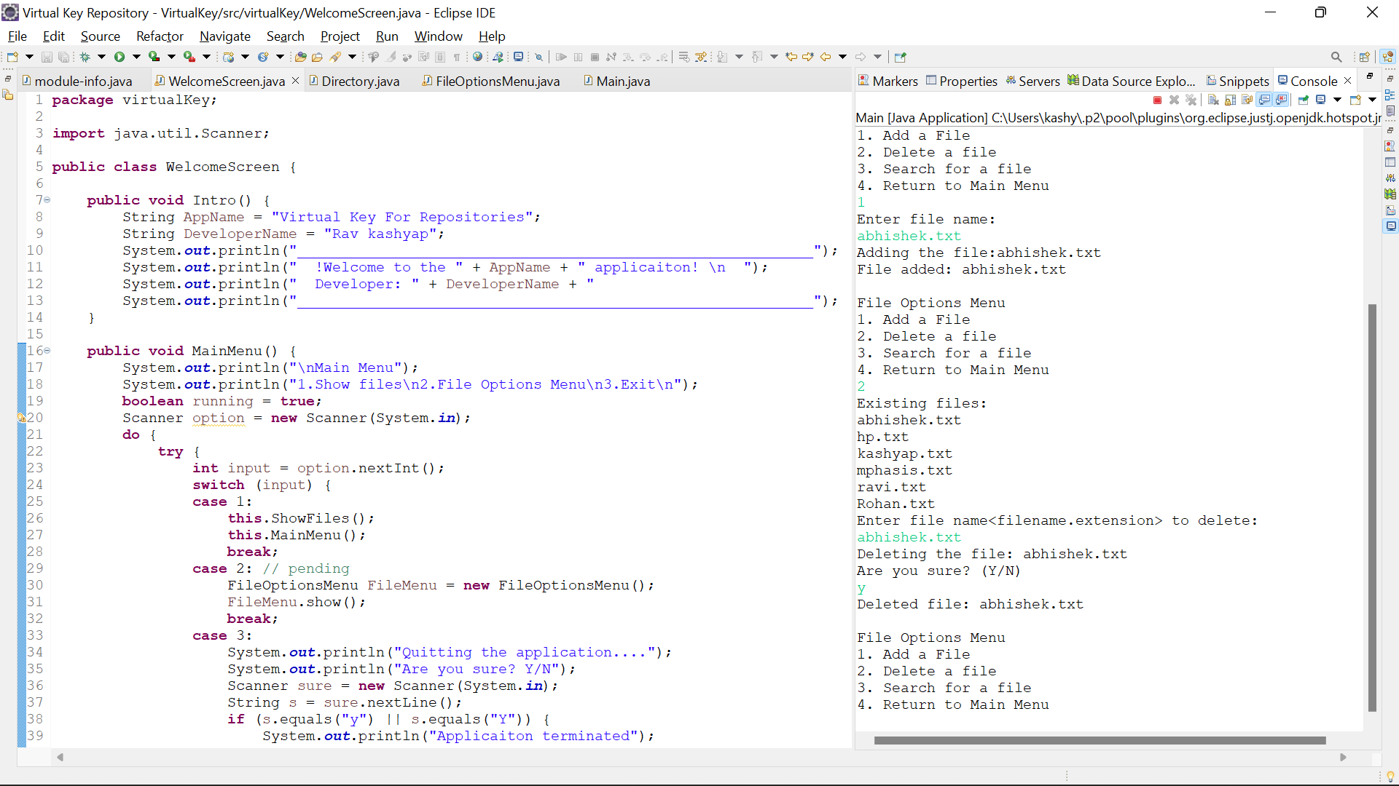

**Searching for a file:--**

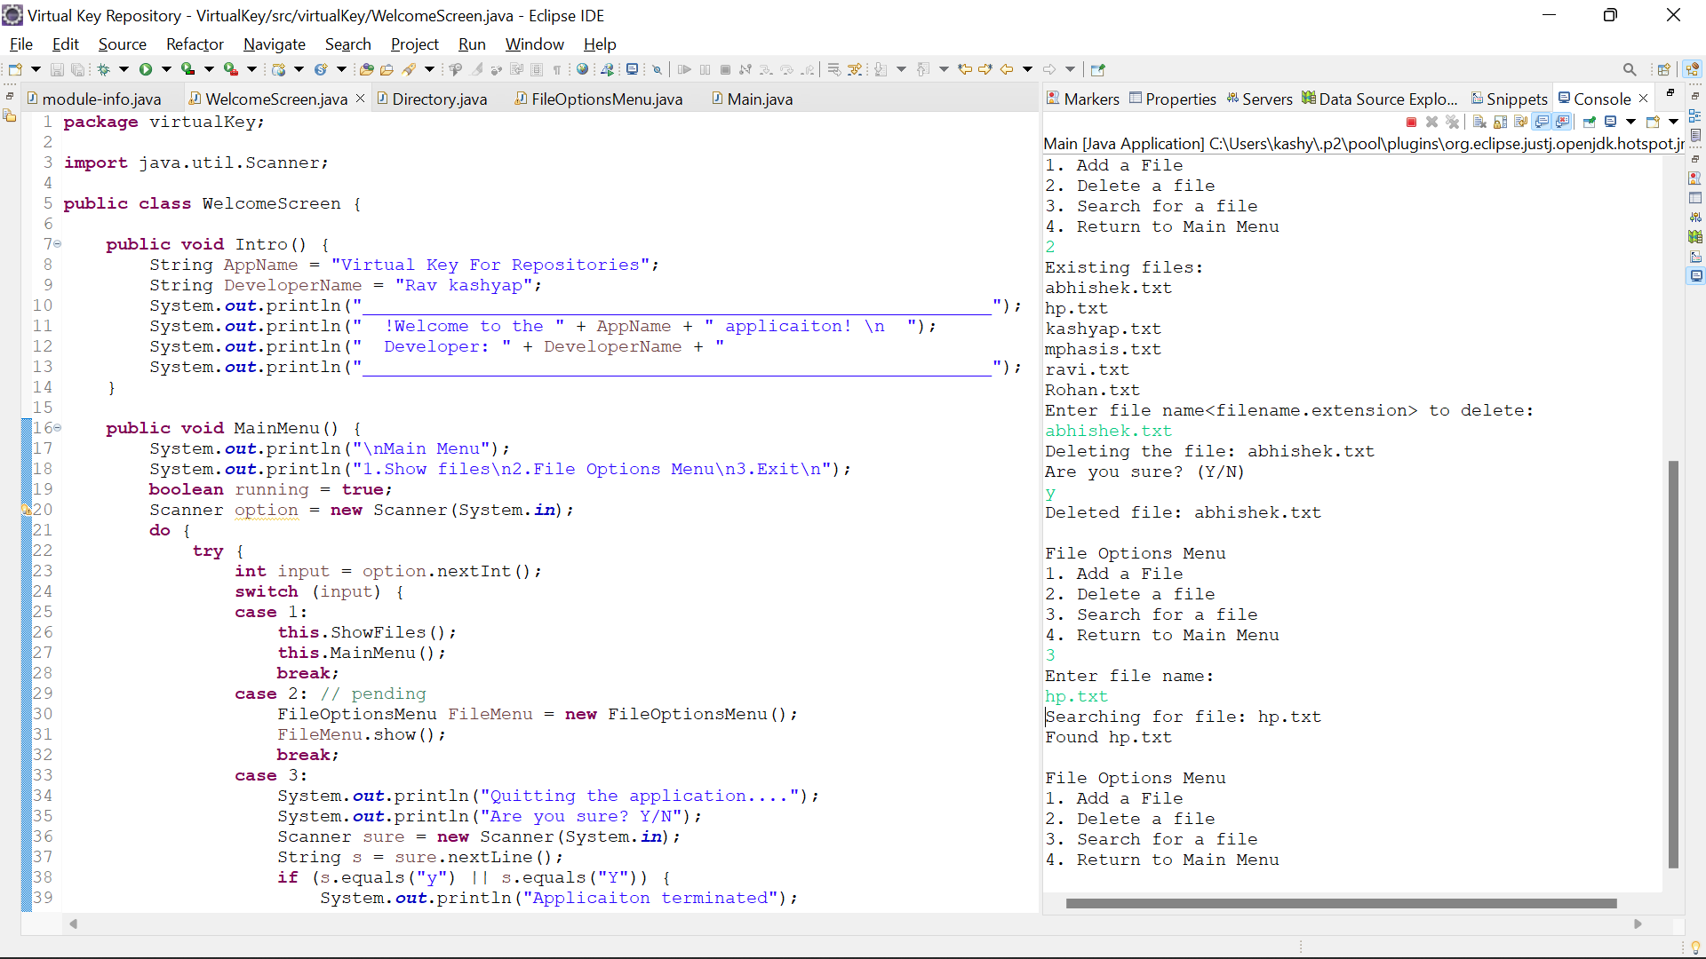

**Returning to Main Menu:--**

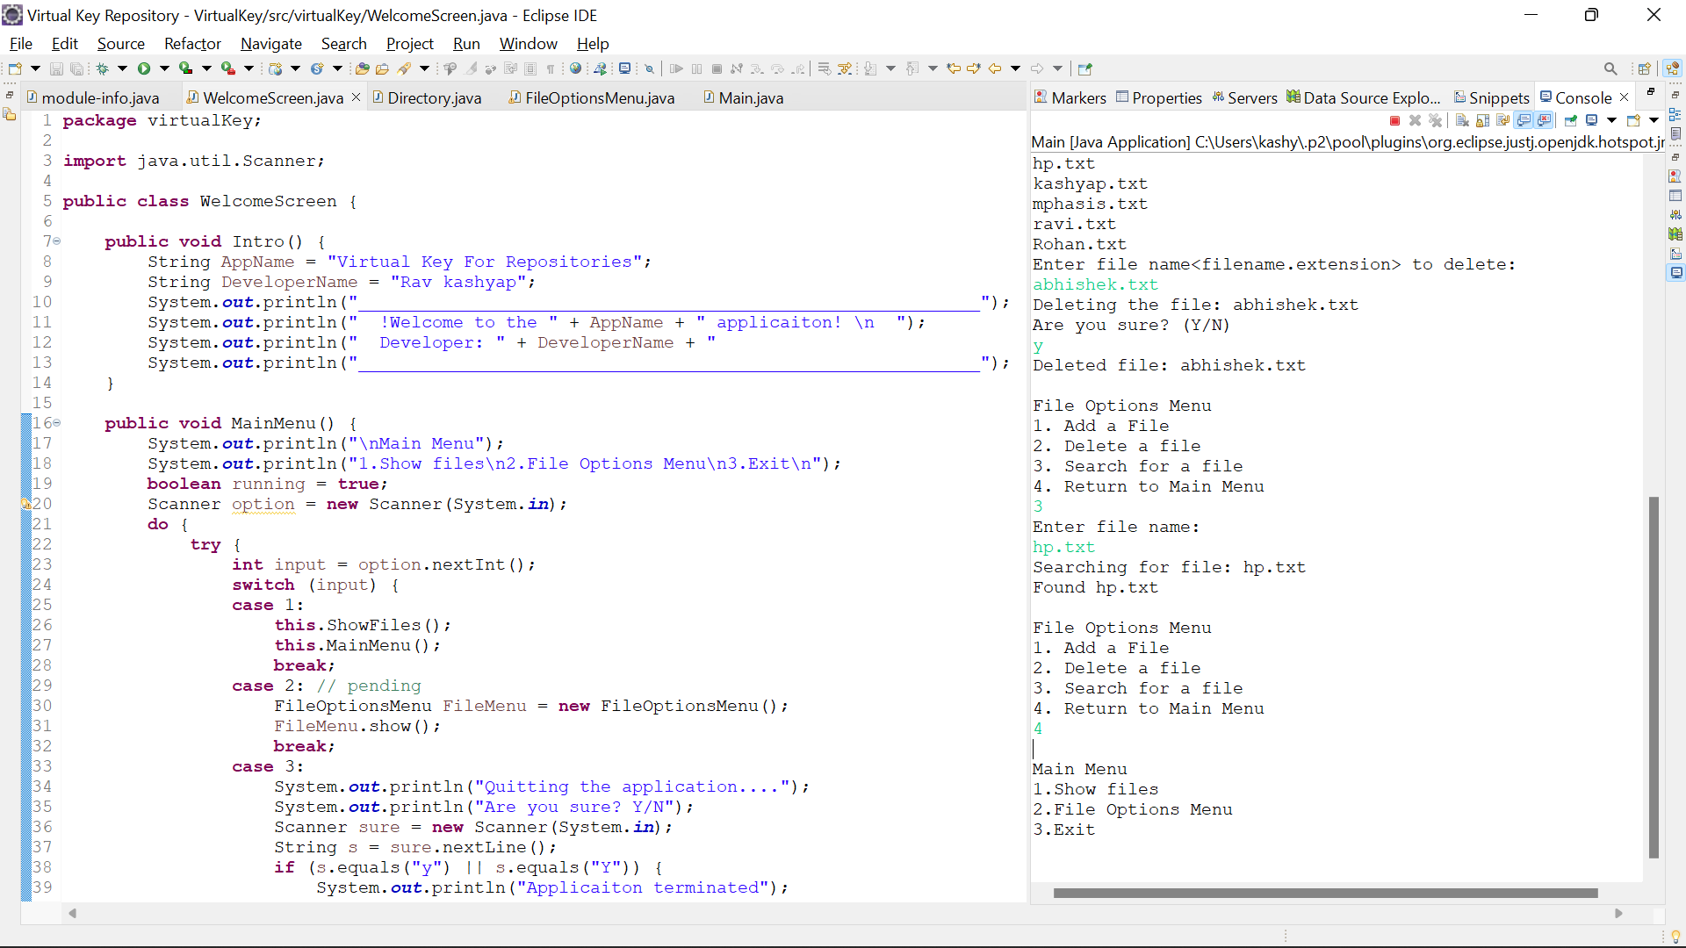

**Quitting the Application:--**

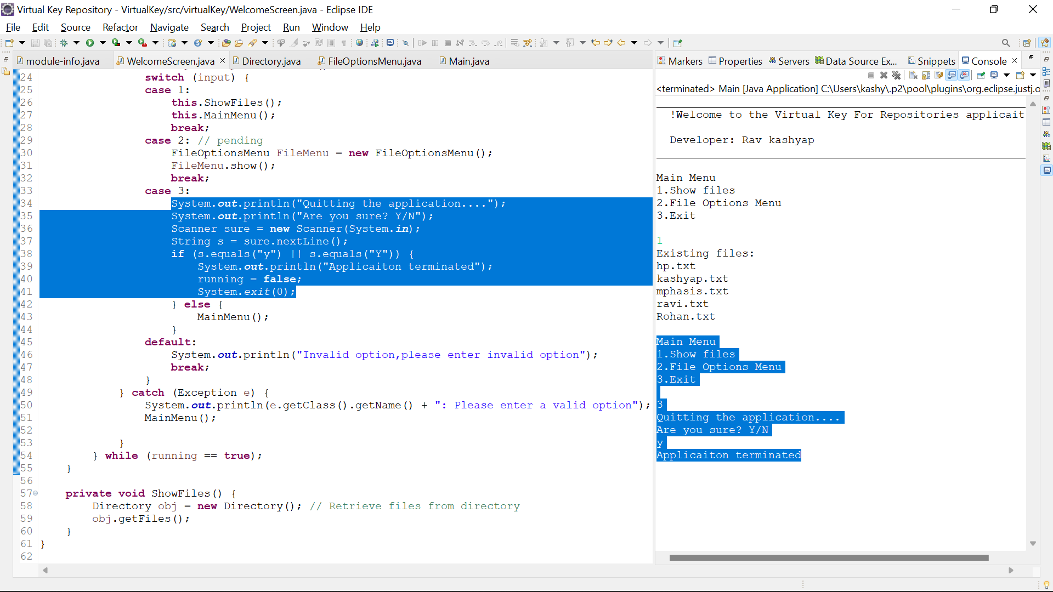

**Flowchart Of the Application:--**

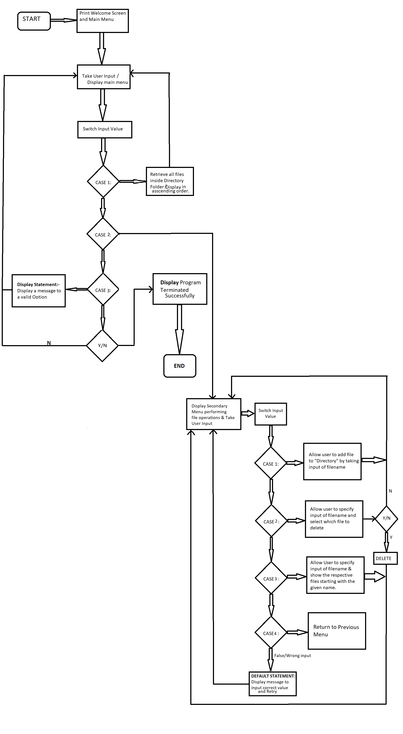

**Unique Selling Points of the Application:-**

1. The application is designed to keep on running and taking user inputs even after exceptions occur. To terminate the application, appropriate option needs to be selected.

2. The application can take any type of file name as input.

3. The application provides the list of files while delete. User can enter exact file name from the list to delete.

4. The application seamlessly switches between options and return to previous menu after certain file operation is done(adding/deleting/searching)

5. The application designed is purely modular. If one wants to update the path, they can change it through source code

Further improvements to the application can be done which may include:-

1. Functionality to create folders in directory.

2. Add and append data to files.

3.Search for file based on Type, last modified..