
Atmanand Saraswati Science College

Bachelor of Computer Application (BCA)
Programme

Project Report
T.Y.B.C.A. SEMESTER – VI
AY 2024-25

Project title
OATLY
By

Exam No | Name of Student
6252 | Italiya Ravi Lalitbhai
6238 | Gondaliya Kenil Ashokbhai
6178 | Bhatiya Het Kantibhai

Guided by:
Ms. Priya Dhaduk

Atmanand Saraswati Science College

C E R T I F I C A T E

This is to certify that Mr./Ms. _Italiya Ravi Lalitbhai examination number _6252_ has satisfactorily completed his project work entitled __Oatly_as partial fulfilment of requirements for T.Y.B.C.A. Semester – VI, during the academic year 2024-25.

Date: 02/04/2025
Place: Surat

Guided by External Examiner Sign

Ms. Priya Dhaduk

Atmanand Saraswati Science College

C E R T I F I C A T E

This is to certify that Mr./Ms. _Gondaliya Kenil Ashokbhai_ examination number _6238_ has satisfactorily completed his project work entitled _Oatly _as partial fulfilment of requirements for T.Y.B.C.A. Semester – VI, during the academic year 2024-25.

Date: 02/04/2025
Place: Surat

Guided by External Examiner Sign

Ms. Priya Dhaduk

Atmanand Saraswati Science College

C E R T I F I C A T E

This is to certify that Mr. _Bhatiya Het Kantibhai_ examination number _6178_ has satisfactorily completed his project work entitled __Oatly___as partial fulfilment of requirements for T.Y.B.C.A. Semester – VI, during the academic year 2024-25.

Date: 02/04/2025
Place: Surat

Guided by External Examiner Sign

Ms. Priya Dhaduk

ACKNOWLEDGEMENT

I would like to express my gratitude and appreciation to all those who
gave me the possibility to complete this report. Special thanks is due to my
supervisor Mr. Hazami bin Che Hussain whose help, stimulating suggestions
and encouragement helped me in all time of fabrication process and in writing
this report. I also sincerely thanks for the time spent proofreading and correcting
my many mistakes.
I would like to express my gratitude and appreciation to all those who gave me the possibility to complete this project. Special thanks are to my mentor Ms. Priya Dhaduk whose help, stimulating suggestions and encouragement helped me in all time of fabrication process and in writing this report. I also sincerely thanks for the time spent proofreading and correcting my many mistakes.
I would also like to acknowledge with much appreciation the crucial role of the staff in B.C.A. Laboratory, who gave me a permission to use the lab equipment and also the machine and to design the drawing and giving a permission to use all the necessary tools in the laboratory.
Many thanks go to the all lecturers who have given their full effort in guiding me in achieving the goal as well as their encouragement to maintain our progress in track. My profound thanks go to all classmates, especially to my friends for spending their time in helping and giving support whenever I need it in fabricating my project.
ABSTRACT

Oatly is a web-based e-commerce platform designed to provide a seamless shopping experience for Oatly’s plant-based dairy alternatives. Developed using the MERN stack (MongoDB, Express, React, and Node.js), this platform ensures efficient interaction between customers, administrators, and delivery personnel.
Users can register, log in, and securely purchase Oatly products. The platform includes essential authentication features such as sign-in, sign-up, password reset, and forgot password functionality to enhance user security. Customers can add products to their cart, make payments via Razorpay, and track their orders in real-time using Socket.io.
The admin panel plays a crucial role in managing the system by handling user and delivery personnel details, ensuring smooth coordination and tracking of product deliveries.
By integrating modern web technologies such as React.js, Zustand, and Tailwind CSS for the frontend and Node.js, Express.js, Socket.io, and MongoDB Cluster for the backend, Oatly delivers high performance, security, and scalability.
This project aims to enhance user convenience, streamline the shopping experience, and promote sustainable living by making Oatly’s plant-based products easily accessible to consumers.

Index

Sr. No. | Description | Page No.
1 | Introduction | 1
2 | Environment Description | 2
 | 2.1 Hardware Requirements
 | 2.2 Software Requirements
3 | System Analysis and Planning | 4
 | 3.1 Existing System and its drawbacks
 | 3.2 Feasibility study
4 | Proposed System | 8
 | 4.1 Scope
 | 4.2 Project modules
 | 4.3 Module wise objectives and functionalities
5 | Detail Planning | 13
 | 5.1 Data flow diagram
 | 5.2 Data dictionary
 | 5.3 Entity – Relationship Diagram
6 | System Design | 22
 | 6.1 Input design
 | 6.2 Output design
 | 6.3 Screenshots of the system
7 | Software Testing | 42
8 | Limitations and Scope of Enhancement | 46
9 | References | 49

I would like to express my gratitude and appreciation to all those who
gave me the possibility to complete this report. Special thanks is due to my
supervisor Mr. Hazami bin Che Hussain whose help, stimulating suggestions
and encouragement helped me in all time of fabrication process and in writing
this report. I also sincerely thanks for the time spent proofreading and correcting
my many mistakes.

1.Introduction

Oatly is a feature-rich e-commerce platform designed to provide a seamless shopping experience for Oatly’s plant-based dairy alternatives. This platform allows users to browse, purchase, and track their orders in real time, ensuring convenience and efficiency.
The platform is built using modern web technologies, including React.js for the frontend, Node.js and Express.js for the backend, and MongoDB Cluster for data storage. Zustand is utilized for state management, and Tailwind CSS ensures a responsive and visually appealing interface. Secure payments are handled through Razorpay, allowing users to complete transactions effortlessly.
To enhance user security and accessibility, Oatly includes user authentication features such as sign-up, login, password reset, and forgot password functionalities. Additionally, real-time order tracking is implemented using Socket.io, enabling customers to monitor their purchases at every stage.
The admin panel serves as the control center for managing the platform, where administrators can oversee user details and handle delivery personnel to ensure smooth and efficient order fulfillment.
By integrating cutting-edge technology with user-friendly features, Oatly aims to revolutionize the online shopping experience for plant-based dairy consumers, making it more accessible, efficient, and environmentally friendly.

- Environment Description

2.1 Hardware Requirements

- Client System (User-side):

  - Processor: Intel Core i5 (8th Gen) / AMD Ryzen 5 or higher
  - RAM: 8GB (Recommended: 16GB)
  - Storage: 256GB SSD (Recommended: 512GB SSD or higher)
  - Graphics: Integrated GPU (Dedicated GPU optional)
  - OS: Windows 10/11, macOS, or Linux (Ubuntu 20.04+)
  - Internet: Required for package installation, API calls, and database connection

- Server System (for hosting the web application) :

- Processor: Intel Xeon / AMD Ryzen (Multi-core recommended)
- RAM: 8GB (Recommended: 16GB+)
- Storage: 50GB SSD or higher
- Network: High-speed internet with static IP
- OS: Linux-based (Ubuntu 20.04+ recommended)
- Cloud Hosting: AWS (EC2), DigitalOcean, Vercel (Frontend), MongoDB Atlas (Database)

2.2 Software Requirements
For the successful development, testing, and deployment of Oatly, the following software components are required:

Development Tools & Technologies
- Operating System: Windows 10/11, macOS, or Linux
- Code Editor: VS Code / WebStorm / Atom
- Version Control: Git & GitHub
- Package Manager: npm / yarn
- Database: MongoDB (Atlas or Local)
- Backend Framework: Node.js with Express.js
- Frontend Framework: React.js
- State Management: Zustand
- Real-Time Communication: Socket.io
- File Storage: Cloudinary
- Styling: Tailwind CSS & ShadCN
- API Testing: Postman

Deployment Tools & Services
- Hosting for Backend: Vercel, AWS, or Heroku
- Hosting for Database: MongoDB Atlas
- Domain & SSL: Cloudflare / Namecheap
- CI/CD Tools: GitHub Actions (optional)

- System Analysis and Planning

  - Existing System and its drawbacks

- Existing Systems :

- E-commerce Platform for Oatly's Products :

The current system provides a dedicated e-commerce platform exclusively for Oatly’s products, allowing customers to browse, select, and purchase plant-based dairy alternatives seamlessly. The platform ensures a user-friendly shopping experience with intuitive navigation, product categorization, and an optimized cart management system.

- Payment System through Razorpay :

For secure and seamless transactions, the system integrates Razorpay as the payment gateway, enabling users to complete their purchases using multiple payment methods such as credit/debit cards, UPI, and net banking. This ensures a smooth, fast, and reliable checkout experience while maintaining high security standards for financial transactions.

- Manual Order Tracking System :

The system includes a real-time order tracking feature, allowing customers to monitor the progress of their orders. Once an order is placed, users receive status updates, including "Processing," "Out for Delivery," and "Dispatched," ensuring transparency and better communication between the platform, delivery personnel, and customers.

- Drawbacks :

- Lack of Real-Time Order Tracking :

Oatly provides only manual order status updates, but lacks real-time GPS tracking. This can cause uncertainty for customers as they cannot track the exact location of their orders. Adding live tracking with estimated delivery times would enhance transparency and user experience.

- Delayed Status Updates :

In the Oatly e-commerce platform, order tracking relies on manual status updates by the delivery personnel. This can lead to delays in reflecting real-time order progress, causing uncertainty for customers regarding their delivery status. A more automated tracking system could enhance user experience and transparency.

- Manual Order Status Updates :

The Oatly e-commerce platform requires delivery personnel to manually update order statuses, such as "Out for Delivery" and "Dispatched." This process can introduce delays or human errors, making it difficult for customers to get accurate real-time updates on their orders.

Security Concerns:
Oatly’s e-commerce platform lacks advanced security measures, leaving user data vulnerable to breaches. Implementing robust authentication, data encryption, and secure payment processing is essential for protecting sensitive information.

Scalability Issues:
The current system is not optimized for handling increased traffic and expanding product inventory. Implementing scalable architecture and cloud-based solutions will ensure smooth performance during high-demand periods.
  - Feasibility study

Technical Feasibility :
- The project is developed using React.js, Node.js, Express.js, and MongoDB, ensuring scalability and flexibility.
- Razorpay integration allows secure and seamless payment processing.
- Socket.io enables real-time order tracking for customers.
- The system is cloud-hosted using MongoDB Cluster and Vercel, reducing infrastructure costs.

Operational Feasibility :
- Users can easily browse, add Oatly products to the cart, and make purchases.
- Razorpay-powered payment gateway ensures smooth transaction processing.
- A dedicated delivery boy panel helps manage orders efficiently.
- The platform automates order status updates, reducing manual efforts and improving customer satisfaction.

Economic Feasibility :
- Cloud-based hosting with MongoDB Cluster and Vercel minimizes hardware and maintenance costs.
- Third-party payment integration (Razorpay) reduces the need for an in-house financial system.
- The platform is designed to provide cost-effective and scalable solutions for future expansion.

- Legal Feasibility :

- The platform ensures compliance with data privacy laws by securing customer information using MongoDB Cluster and encrypted transactions via Razorpay.
- Follows Indian e-commerce regulations and payment gateway guidelines for secure online transactions.
- Terms and conditions, refund policies, and data protection policies are clearly defined to avoid legal disputes.

- Schedule Feasibility :

- The project is structured into design, development, testing, and deployment phases using an Agile approach.
- React.js and Tailwind CSS speed up frontend development, while Node.js and Express.js allow rapid backend implementation.
- Socket.io enables real-time updates, ensuring efficient order tracking and smooth delivery management.
- The platform is built to handle scalability, ensuring it can support increased user demand over time.

- Proposed System

  - Scope

The proposed system, Oatly E-commerce Platform, aims to provide a seamless online shopping experience exclusively for Oatly’s plant-based dairy products. The platform is designed to:
- Enable customers to browse and purchase Oatly products effortlessly with an intuitive and responsive interface.
- Provide a secure payment gateway through Razorpay, supporting multiple payment methods like credit/debit cards, UPI, and net banking.
- Allow real-time order tracking using Socket.io, ensuring customers stay updated on their order status from placement to delivery.
- Offer a dedicated delivery boy panel, enabling delivery personnel to update order status from “Out for Delivery” to “Delivered” in real time.
- Ensure efficient product and inventory management with an admin panel, allowing the addition, modification, and removal of products.
- Use MongoDB Cluster as the primary database, ensuring a scalable, cloud-based storage solution for handling customer orders and transactions.
- Provide a modern and responsive UI/UX using React.js and Tailwind CSS, optimizing the platform for both desktop and mobile users.
- Enhance security and authentication with JWT-based authentication, ensuring safe user logins and secure transactions.
- Deploy on Vercel and MongoDB Atlas, enabling high-performance hosting with cost-effective cloud-based scalability.

  - Project Modules

User Module :
- User registration and authentication using JWT.
- Profile management (view/update personal details, order history).
- Secure login and logout functionality.
- Add products to the cart and proceed to checkout.

Admin Panel Module :
- Manage product listings (add, edit, delete Oatly products).
- View and manage all user orders and payment statuses.
- Monitor system performance and analytics.

Delivery Boy Panel Module :
- Receive assigned orders from the admin panel.
- Update the status of orders: "Out for Delivery" → "Delivered".
- Real-time order updates synced with the customer’s tracking system.

Product Management Module :
- Display all Oatly products with images, descriptions, and pricing.
- Enable product search, filtering, and sorting for a better user experience.
- Admin can add, update, and delete product details.

Order Management Module :
- Users can place orders and receive instant confirmation.
- Order summary and invoice generation.
- Status updates handled dynamically (Pending, Out for Delivery, Delivered).
- Real-time order tracking powered by Socket.io.

Payment Module :
- Integrated Razorpay payment gateway for secure transactions.
- Supports multiple payment methods (credit/debit cards, UPI, net banking).
- Automatic order confirmation upon successful payment.

  - Module wise objectives and functionalities

- User Module :

Objective :
To provide a seamless shopping experience, allowing users to browse, purchase Oatly products, and track their orders.

Functionalities :
- User Authentication: Secure login/signup using JWT.
- Profile Management: View/update user details and order history.
- Cart Management: Add/remove products and proceed to checkout.
- Order Placement: Place orders and receive real-time updates.
- Admin Panel Module :

Objective:
To manage products, orders, and user interactions efficiently from a centralized dashboard.

Functionalities:
- Product Management: Add, update, and remove Oatly products.
- Order Management: View, approve, and track orders.
- Delivery Assignment: Assign delivery tasks to delivery personnel.
- User & Feedback Management: Monitor user activities and respond to reviews.

- Delivery Boy Panel Module :

Objective:
To facilitate smooth order fulfillment by updating the delivery status in real-time.

Functionalities:
- Order Assignment: Receive assigned orders from the admin.
- Status Updates: Mark orders as “Out for Delivery” or “Delivered”.
- Real-Time Tracking: Sync status updates with the customer’s tracking system.
- Product Management Module :

Objective:
To ensure accurate product listings, availability, and seamless customer experience.

Functionalities:
- Product Display: Showcase Oatly products with images, descriptions, and pricing.
- Search & Filter: Enable users to find products easily.
- Stock Management: Admin can update availability status.
- Order Management Module :

Objective:
To handle the entire order process, from placement to final delivery.

Functionalities:
- Order Processing: Accept user orders and generate invoices.
- Status Updates: Display order progress (Pending, Out for Delivery, Delivered).
- Real-Time Tracking: Powered by Socket.io for instant updates.

- Payment Module :

Objective:
To provide a secure and convenient payment experience for users.

Functionalities:
- Secure Payment Processing: Integrated Razorpay payment gateway.
- Multiple Payment Options: Support for credit/debit cards, UPI, and net banking.
- Order Confirmation: Automatic order update upon successful payment.

- Detail Planning

  - Data flow diagram

- 0 Level Diagram :-

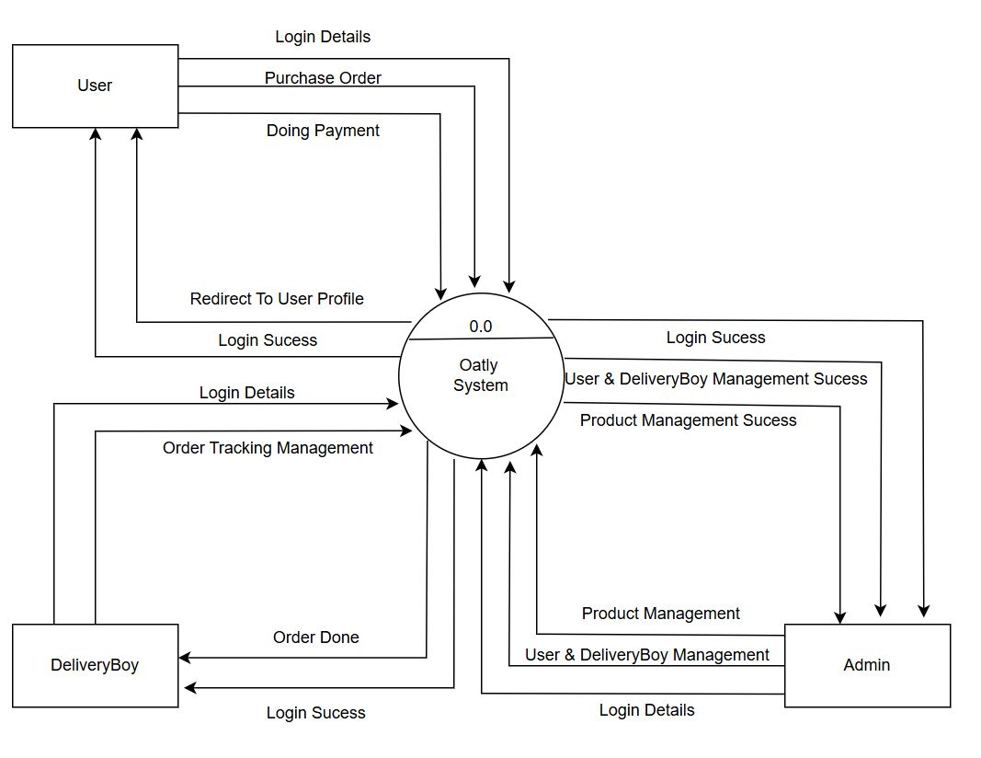

- 1 Level Diagram :-

- User :-

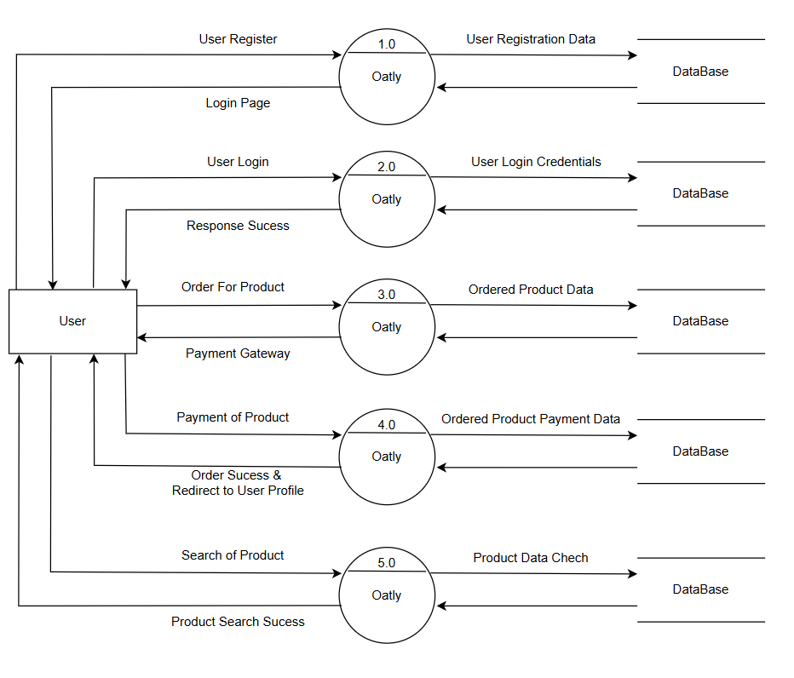

- Admin :-

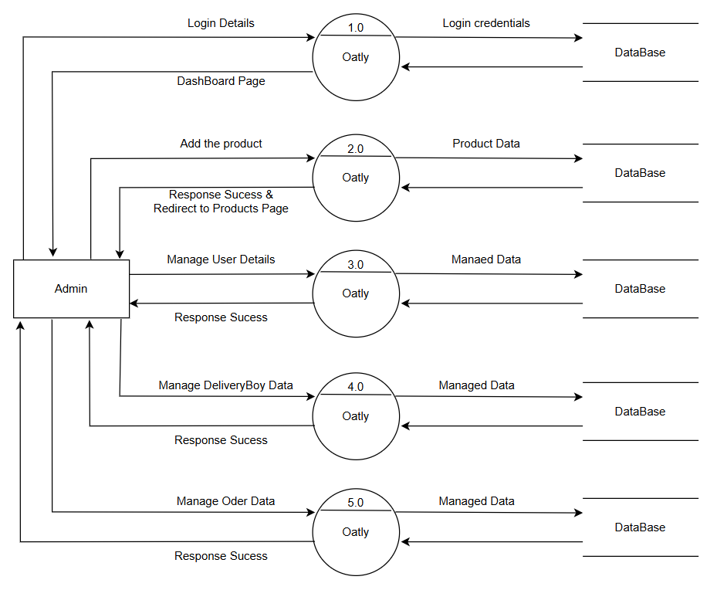

- DeliveryBoy :-

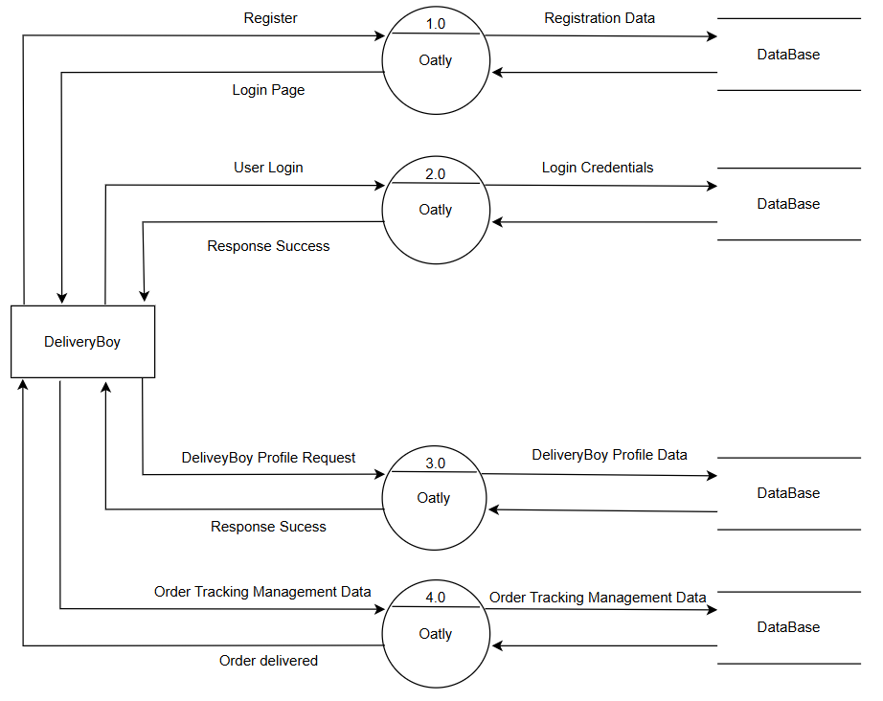

  - Data Dictionary

- User Table :-
Field Name | Data Type | Constraints | Description
_id | ObjectId | Auto-generated (Primary Key) | Unique identifier for each user.
name | String | Required | Full name of the user.
username | String | Required, Unique | Unique username for login.
email | String | Required, Unique | User's email address.
mobile | String | Required | User's mobile number.
password | String | Required | Hashed password for authentication.
address1 | String | Required | Primary address line.
address2 | String | Required | Secondary address line.
city | String | Required | City of residence.
state | String | Required | State of residence.
country | String | Required | Country of residence.
zipcode | String | Required | Postal code.
primaryMobile | String | Required | User’s primary mobile contact number.
lastLogin | Date | Defaults to the current date/time | Last login timestamp.
role | String | Enum: user, admin, delivery_boy (Default: user) | Role of the user (User, Admin, Delivery Boy).
isVerified | Boolean | Defaults to false | Indicates if the user is verified.
isBlocked | Boolean | Defaults to false | Indicates if the user is blocked.
resetPasswordToken | String | Optional | Token for password reset.
resetPasswordExpires | Date | Optional | Expiry time for reset password token.
verificationToken | String | Optional | Token for email verification.
verificationTokenExpiresAt | Date | Optional | Expiry time for verification token.
timestamps | Date | Auto-generated | Auto-generated timestamps for creation & updates.

- DeliveryBoy :-

Field Name | Data Type | Description | Constraints
_id | ObjectId | Unique identifier for each delivery boy. | Auto-generated (Primary Key)
userId | ObjectId | Reference to the User collection. | Required, Unique, Foreign Key
fullName | String | Full name of the delivery boy. | Required
mobile | String | Mobile number of the delivery boy. | Required
vehicleDetails | String | Information about the delivery boy's vehicle. | Required
isAvailable | Boolean | Availability status of the delivery boy. | Default: true
location | GeoJSON | Current location (latitude & longitude) of the delivery boy. | Default: Point
totalDeliveries | Number | Total number of deliveries completed. | Default: 0
earnings | Number | Total earnings from completed deliveries. | Default: 0
status | String | Account status of the delivery boy. | Enum: active, inactive, suspended Default: active
timestamps | Date | Auto-generated timestamp for created/updated date. | Auto-generated

- Order Table :-

Field Name | Data Type | Constraints | Description
_id | ObjectId | Auto-generated (Primary Key) | Unique identifier for each order.
userId | ObjectId | Required, Foreign Key | Reference to the User collection.
Items | Array | Required | List of products included in the order.
productName | String | Required | Name of the product in the order.
quantity | Number | Required | Quantity of the product ordered.
Price | Number | Required | Price of the product at the time of order.
productImage | String | Optional | Image URL of the product.
totalAmount | Number | Required | Total amount for the order.
deliveryAddress | Object | Required | Stores detailed delivery address.
address1 | String | Required | Primary address line.
address2 | String | Optional | Secondary address line.
City | String | Required | City of delivery.
State | String | Required | State of delivery.
country | String | Required | Country of delivery.
zipcode | String | Required | Zip/Postal code.
razorpayOrderId | String | Required | Unique order ID generated by Razorpay.
razorpayPaymentId | String | Optional | Payment ID generated by Razorpay after transaction.
Status | String | Default: Pending | Order status (Pending, Assigned, Out for Delivery, Delivered, Cancelled).
deliveryBoyId | ObjectId | Optional, Foreign Key | Reference to the DeliveryBoy collection.
location | Object | Optional | Geolocation data for delivery tracking.
coordinates | Array | Optional | Latitude and longitude for tracking delivery.
assignedAt | Date | Optional | Timestamp when the order was assigned to a delivery boy.
deliveredAt | Date | Optional | Timestamp when the order was marked as delivered.
timestamps | Date | Auto-generated | Auto-generated timestamps for created/updated dates.

- Product Table :-

Field Name | Data Type | Constraints | Description
_id | ObjectId | Auto-generated (Primary Key) | Unique identifier for each product.
productname | String | Required | Name of the product.
description | String | Required | Detailed description of the product.
image | String | Required | URL of the product image.
category | String | Required | Category under which the product falls.
heading1 | String | Required | First key feature heading.
description1 | String | Required | Description of the first key feature.
heading2 | String | Required | Second key feature heading.
description2 | String | Required | Description of the second key feature.
question1 | String | Required | Frequently asked question about the product.
answer1 | String | Required | Answer to the FAQ.
price | String | Required | Price of the product.
timestamps | Date | Auto-generated | Auto-generated timestamp for created/updated date.

  - Entity – Relationship diagram

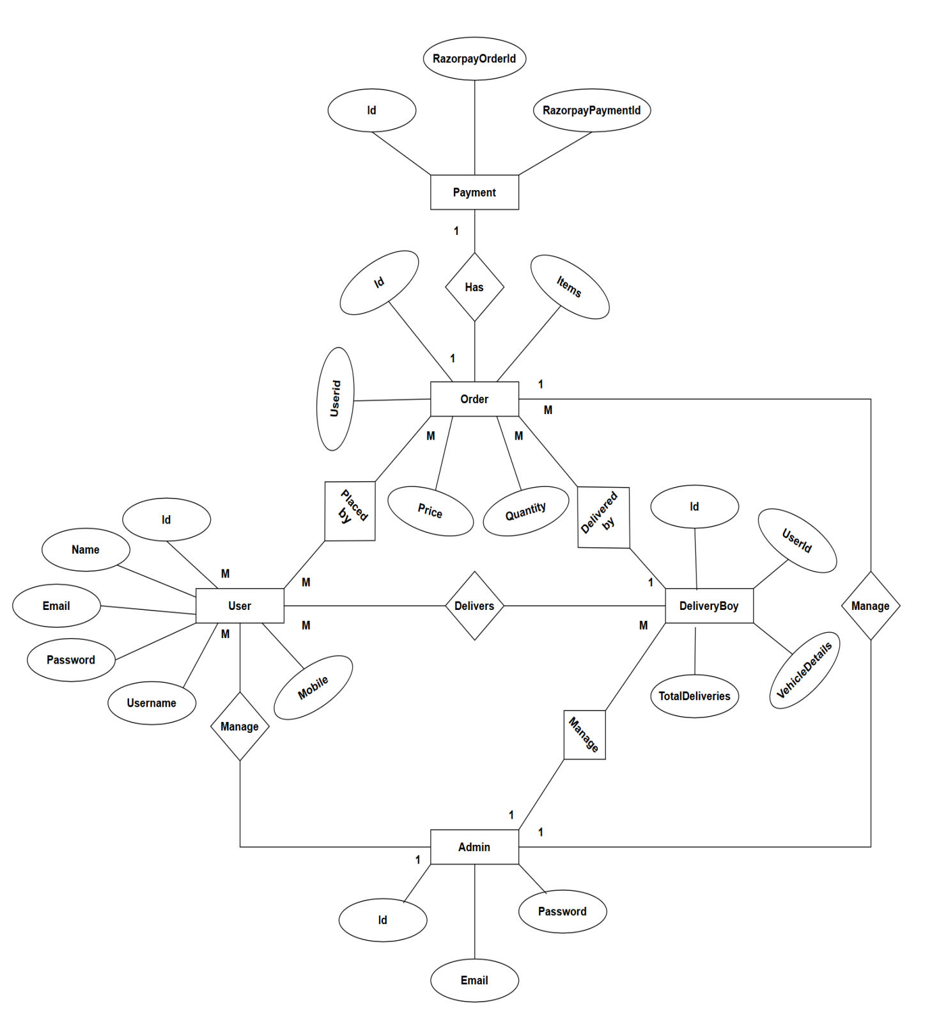

- System Design
  - Input Design

- For User :-

- Registration Form :-
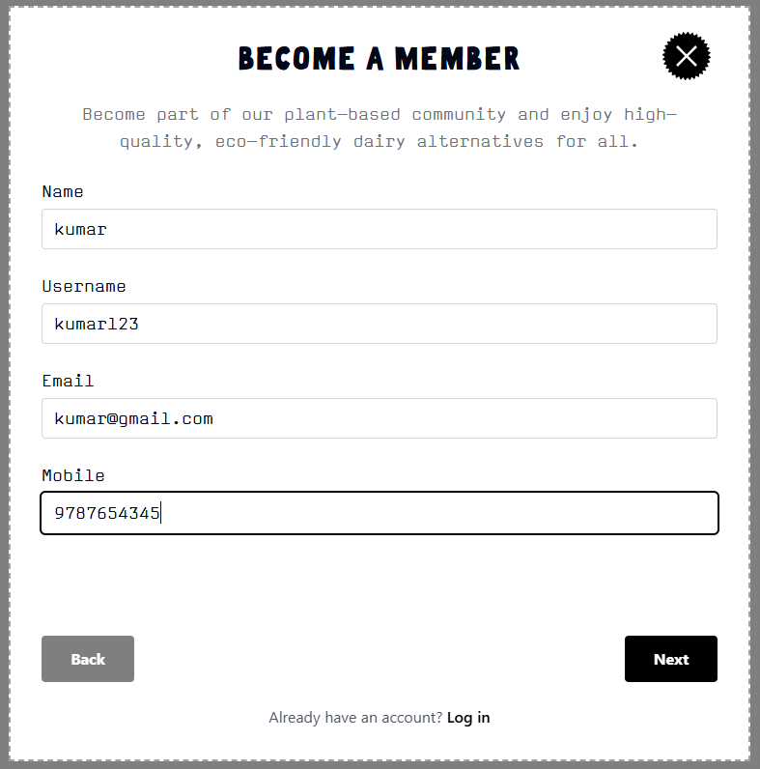

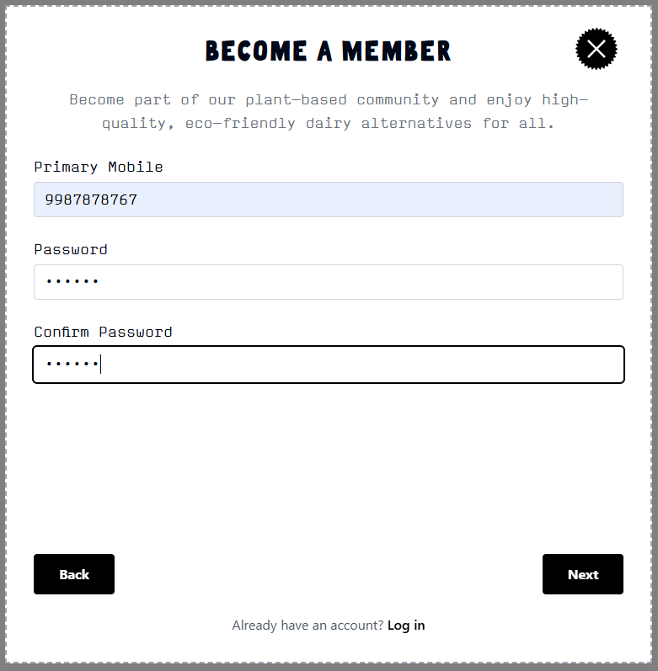

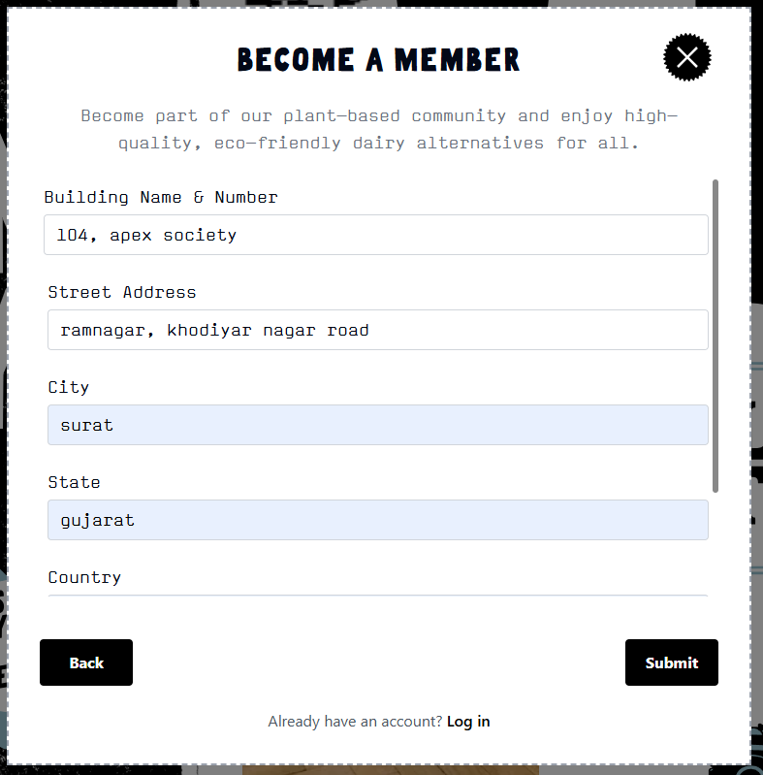

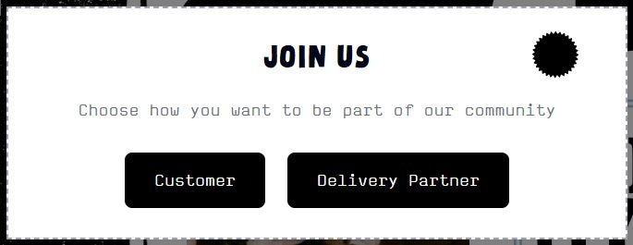
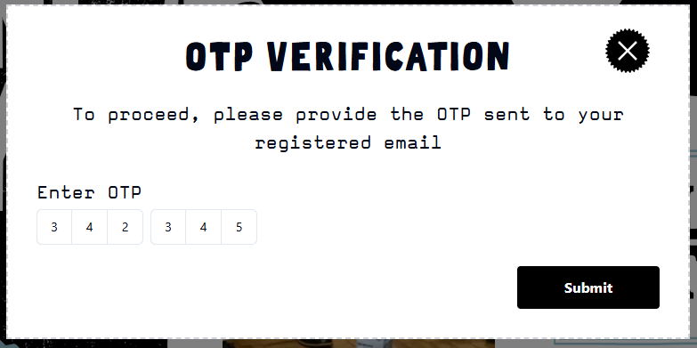

- Login Form :-

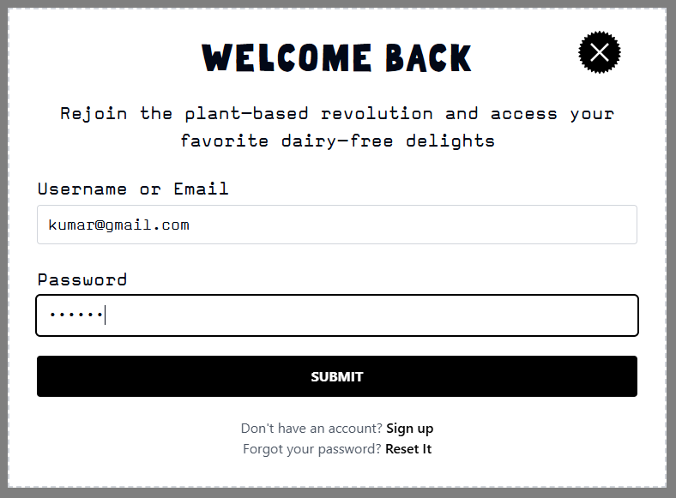

- ResetPassword Form :-
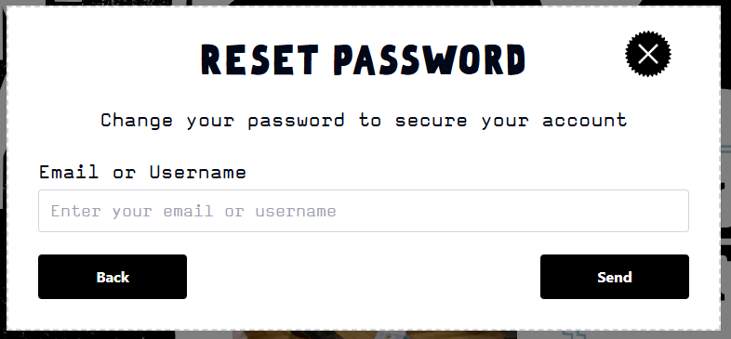

- Payment Form :-

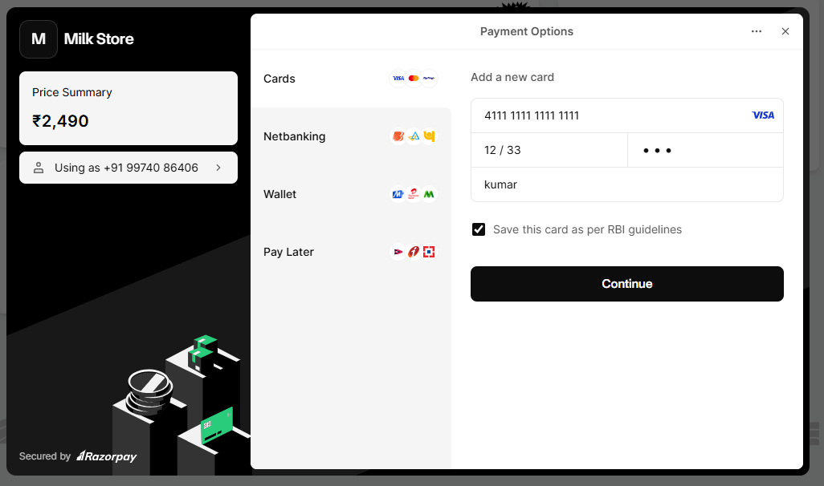

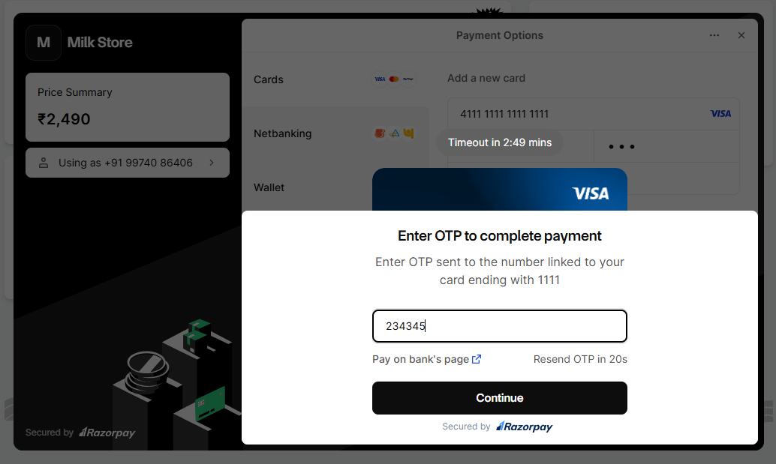

- For Admin :-
- Login Form :-

- AddProduct Form :-
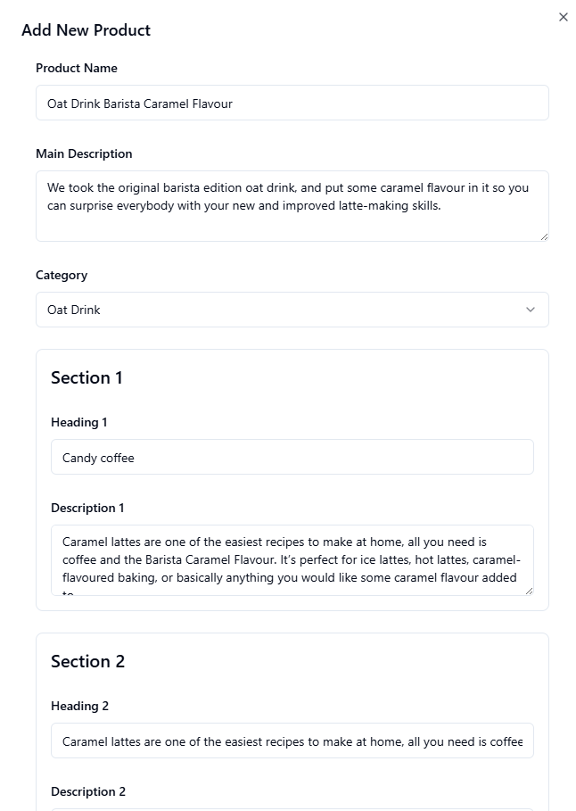
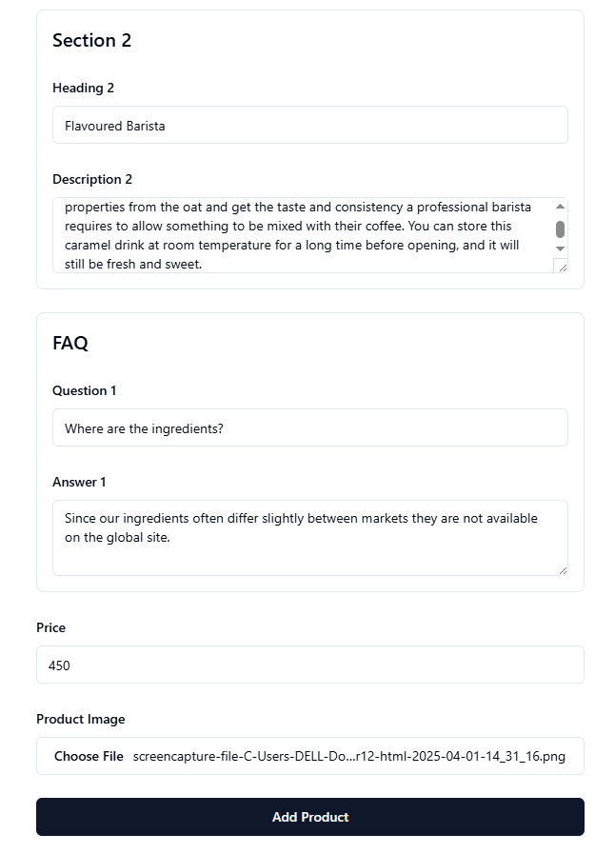

  - Output Design

- For User :-

- After Registration :-

- After Login :-

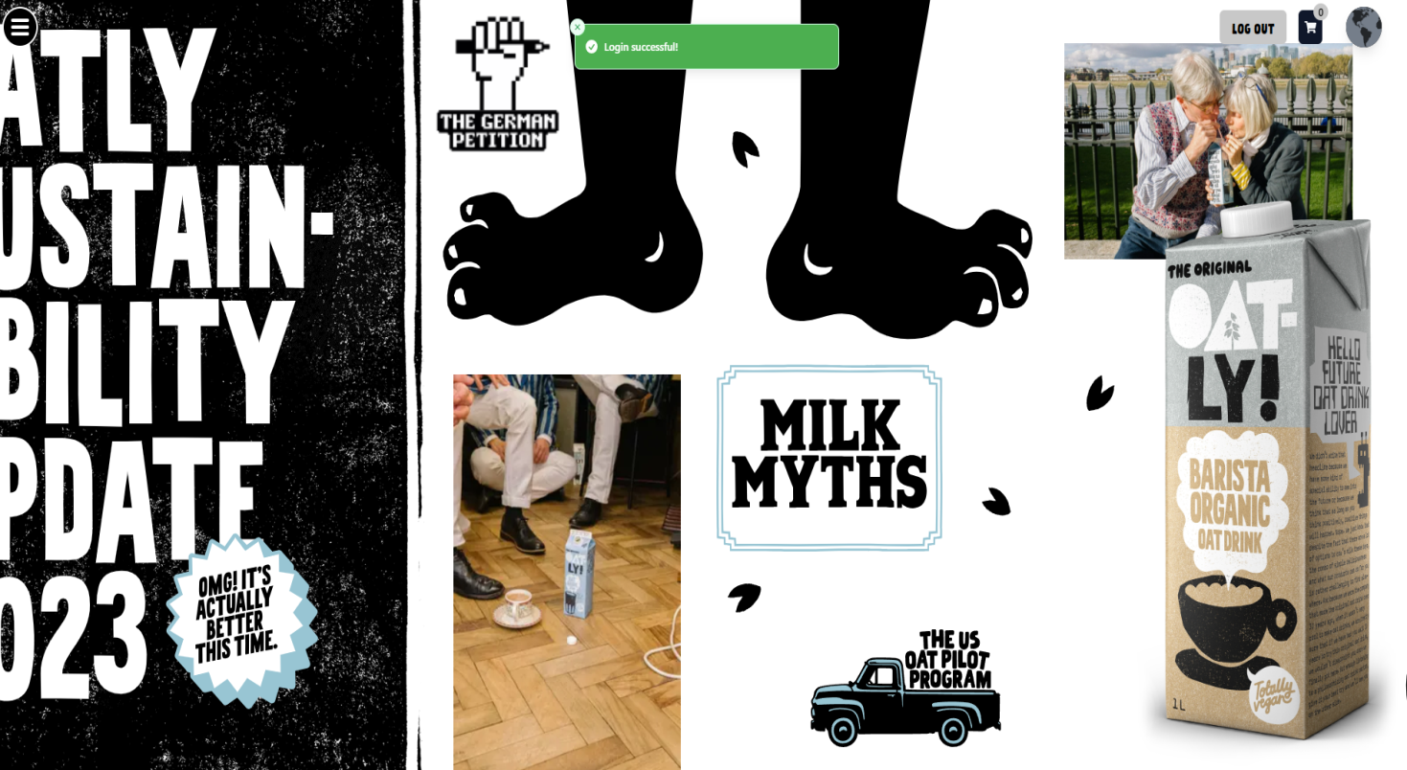

- For Admin :-

- After Login :-
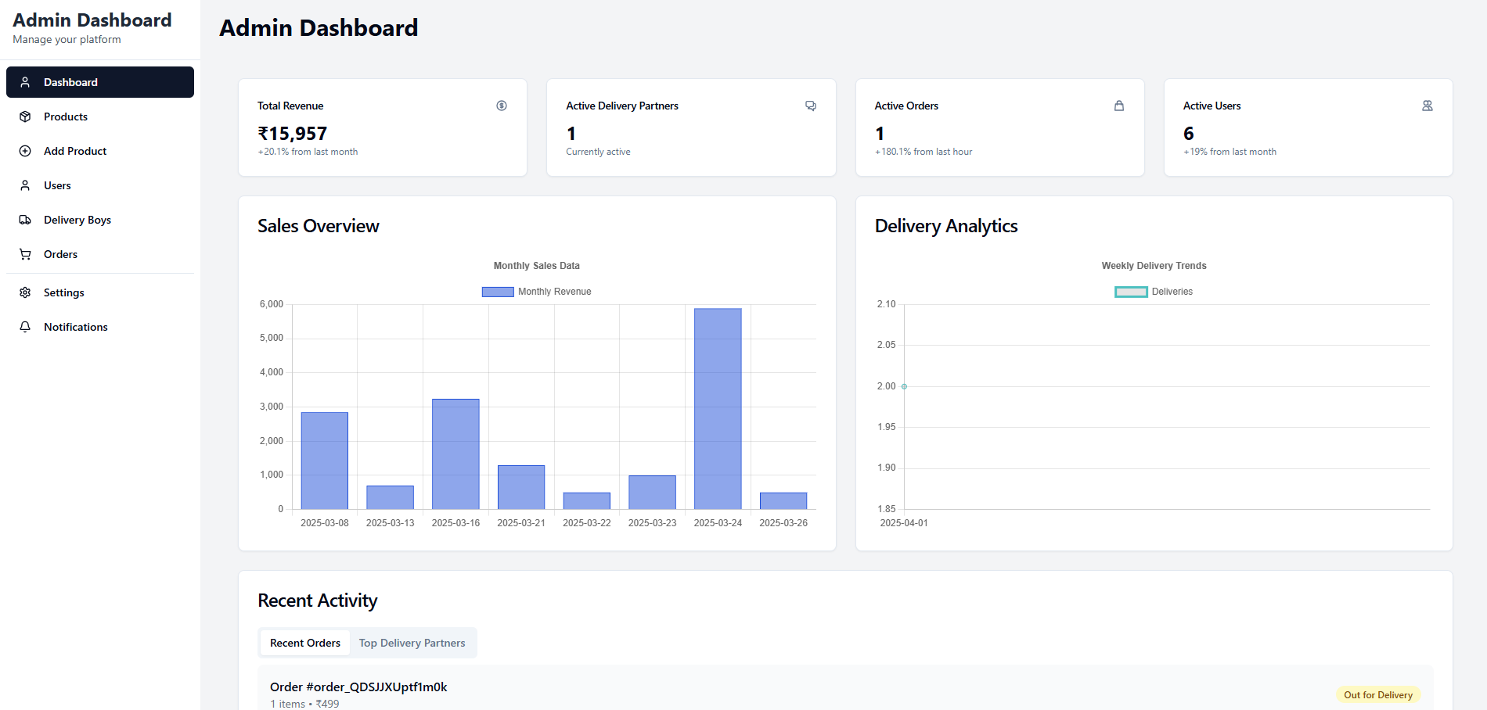

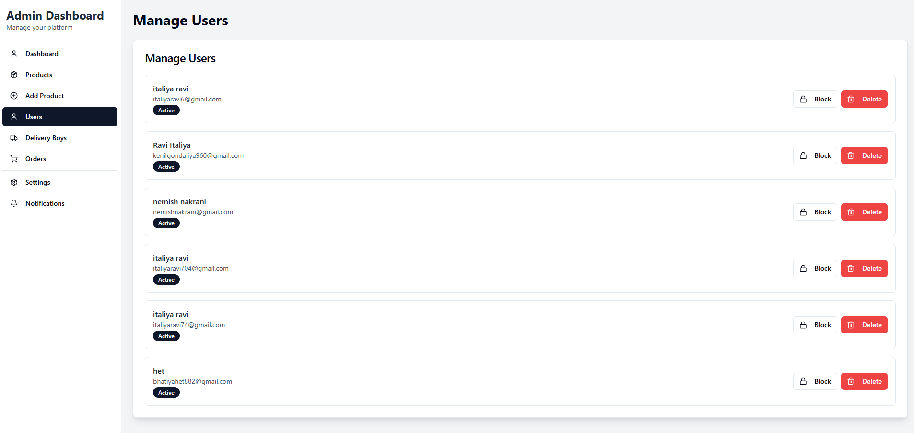

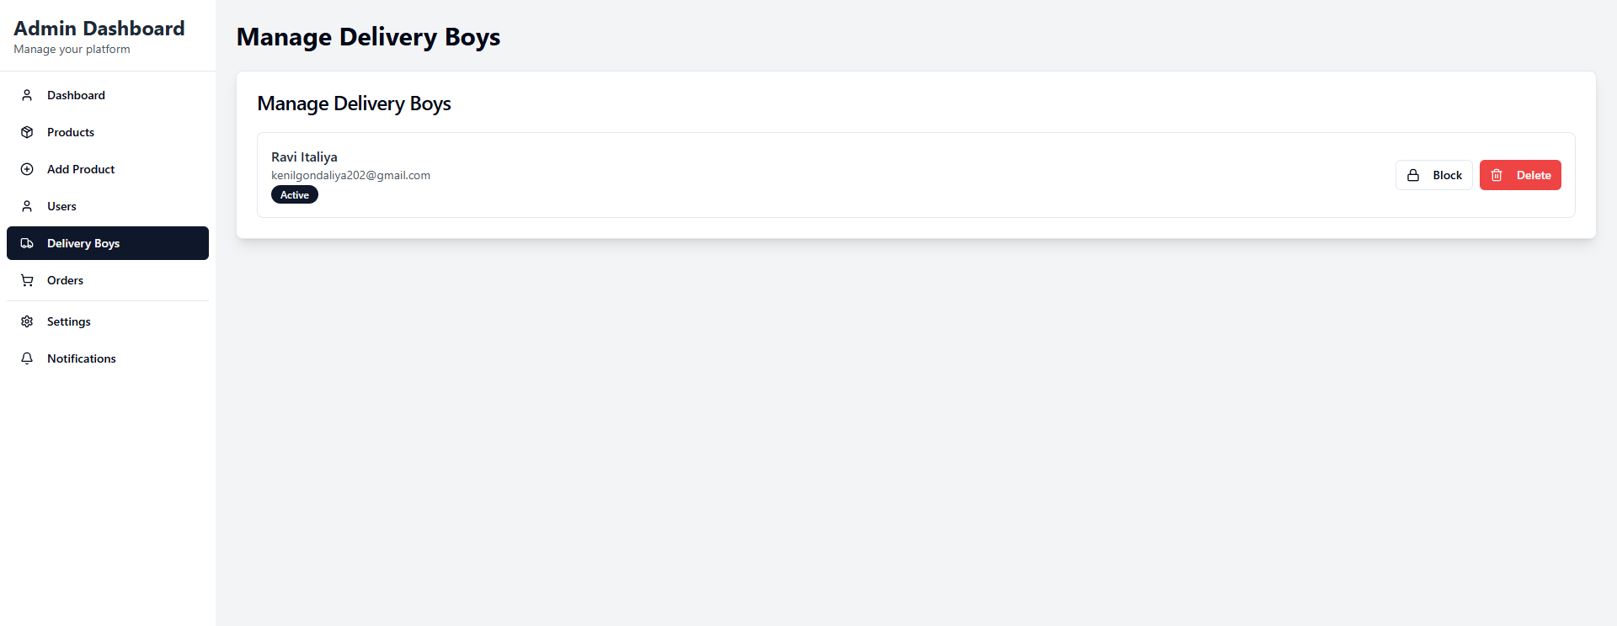

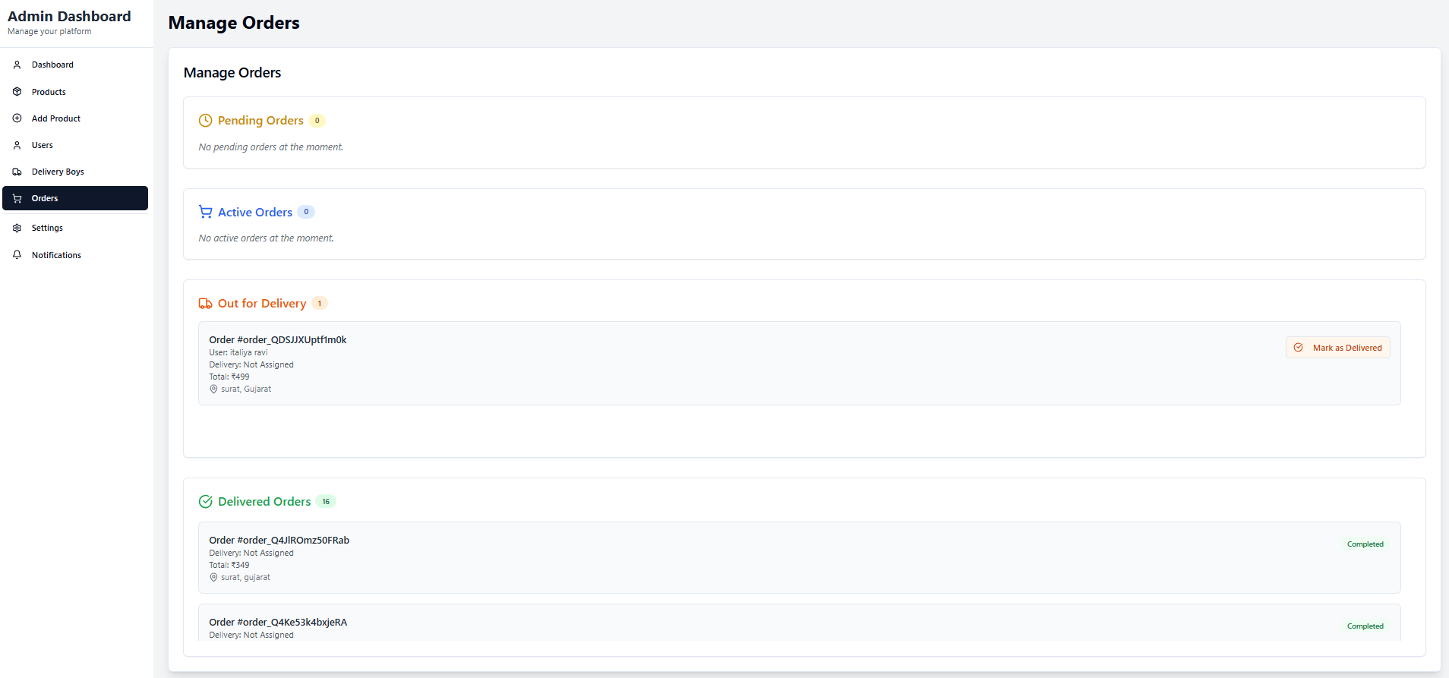

  - Screenshots Of the system

- Product Page :-
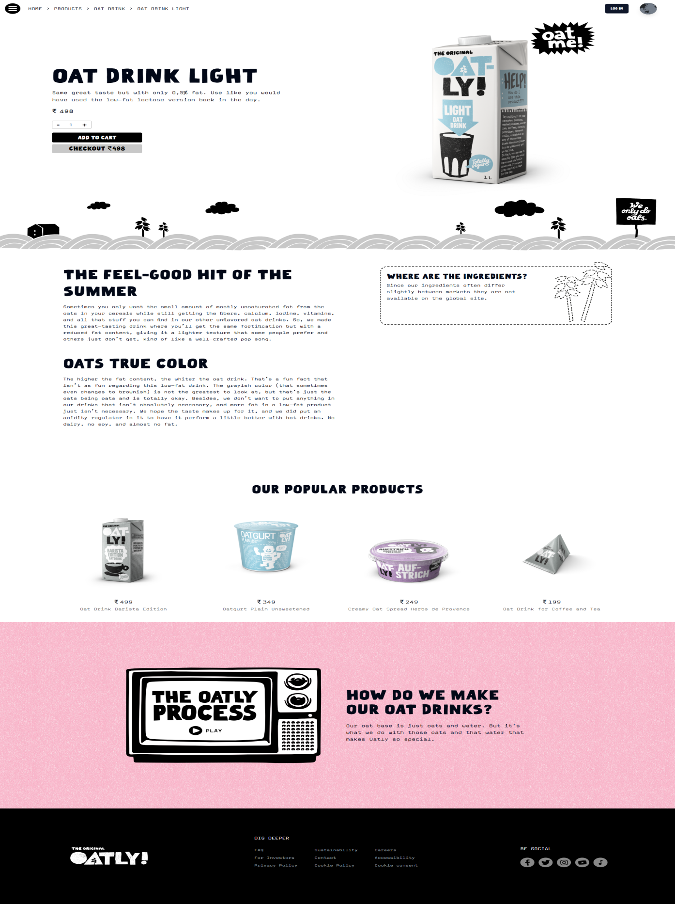
- AddToCart Page :-
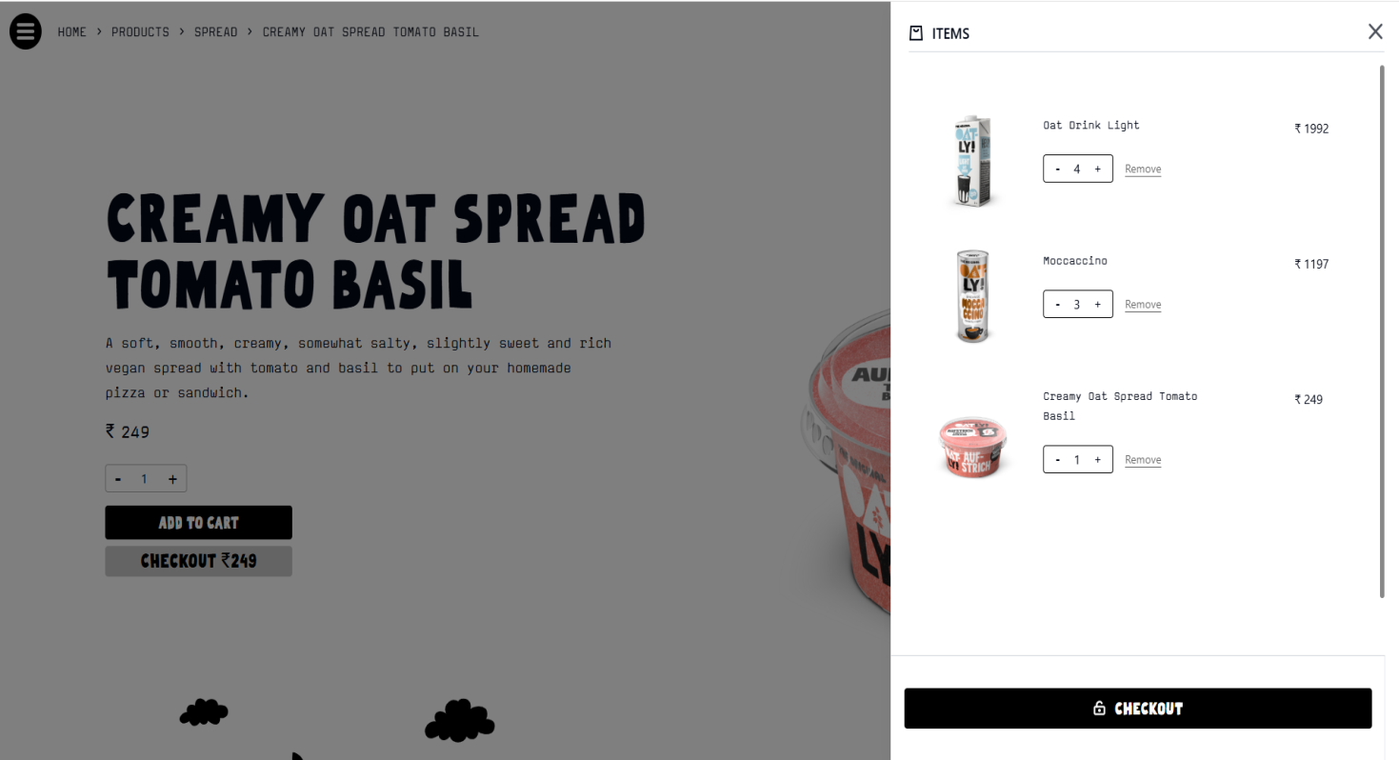

- ContactUs Page :-
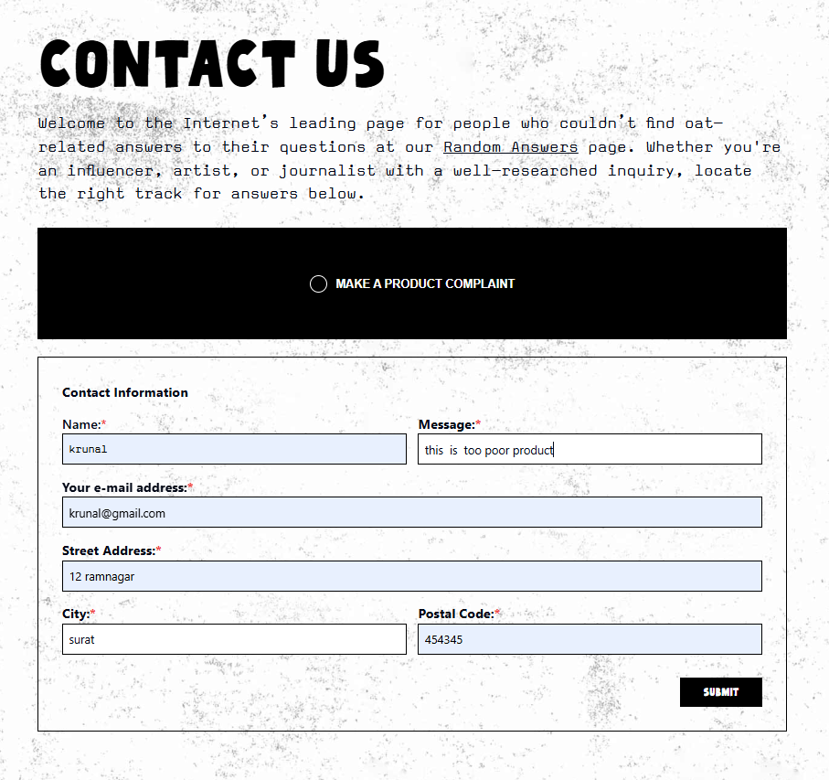
- Checkout Page :-
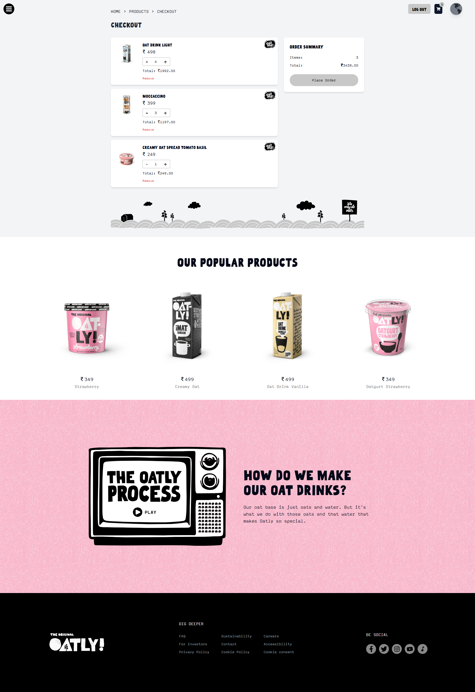
- UserProfile Page :-

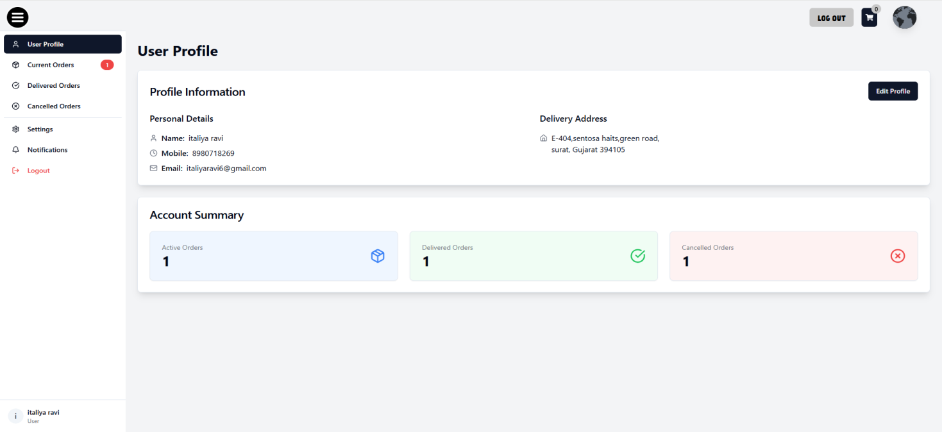

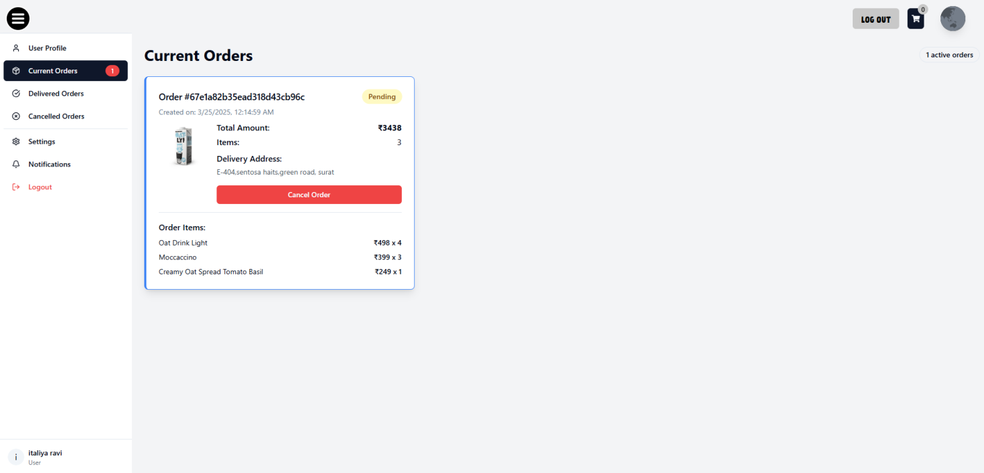

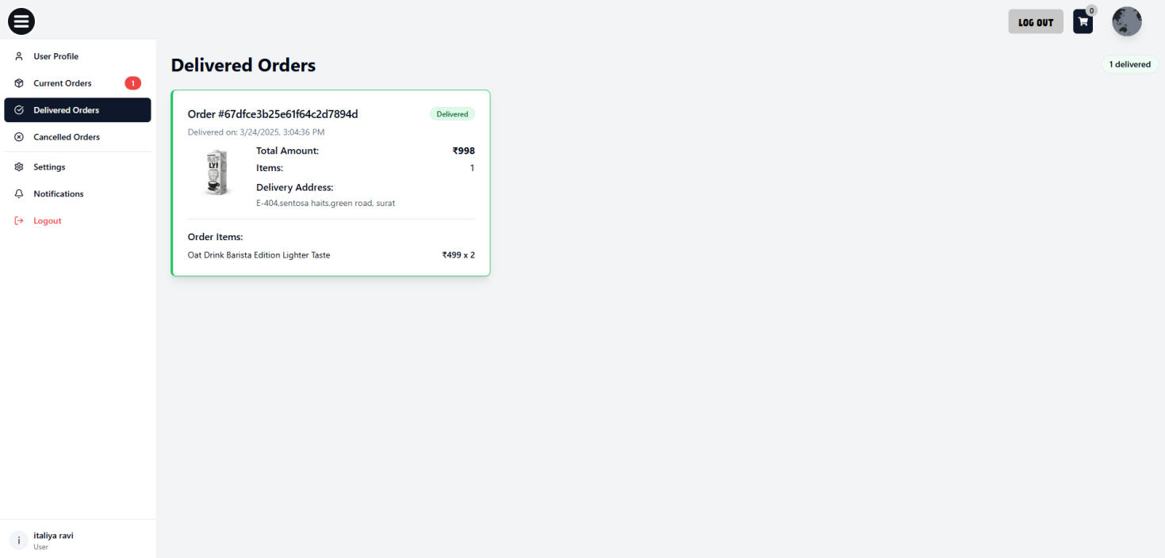

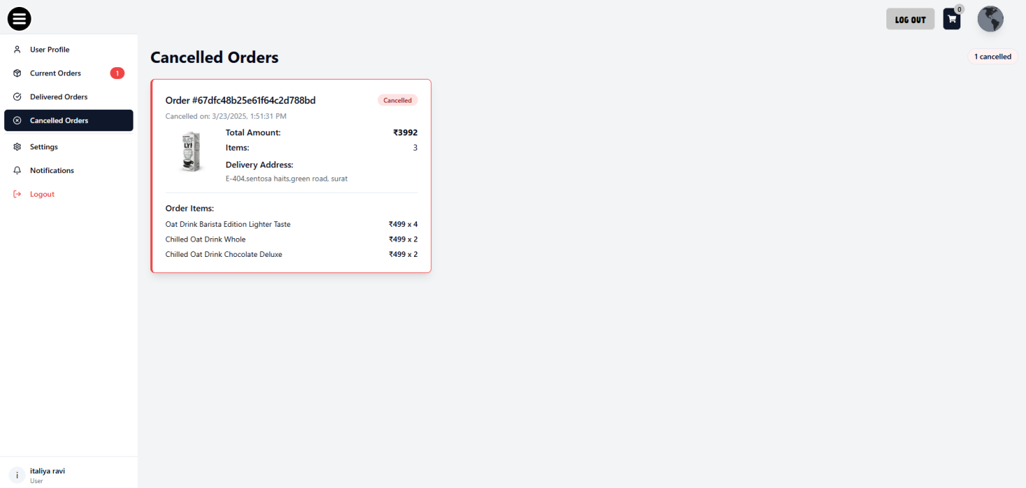

- DeliveryBoy Page :-

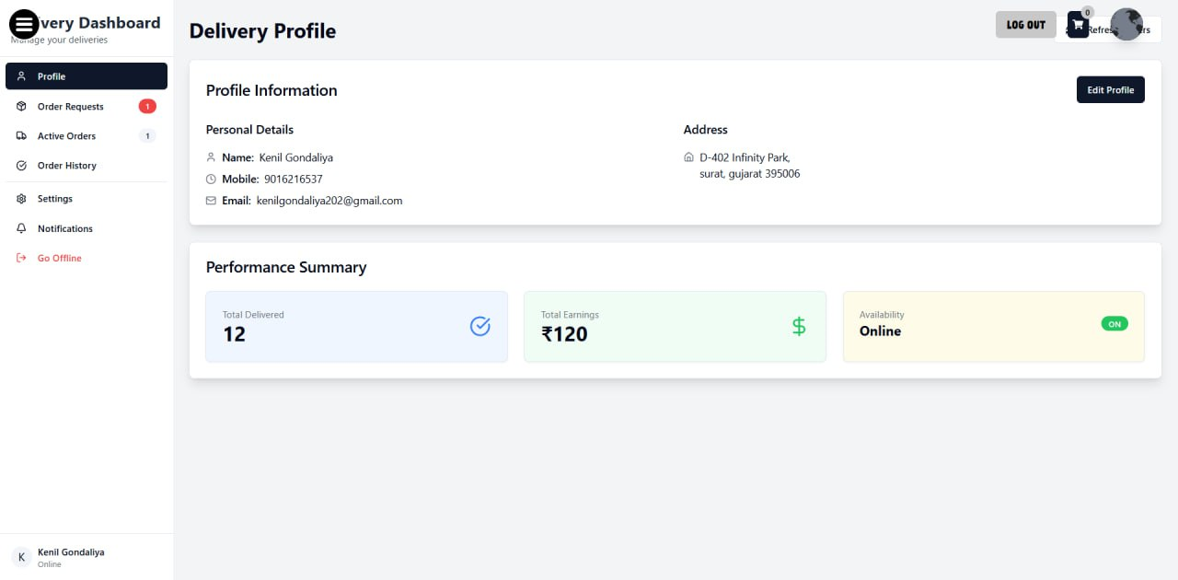

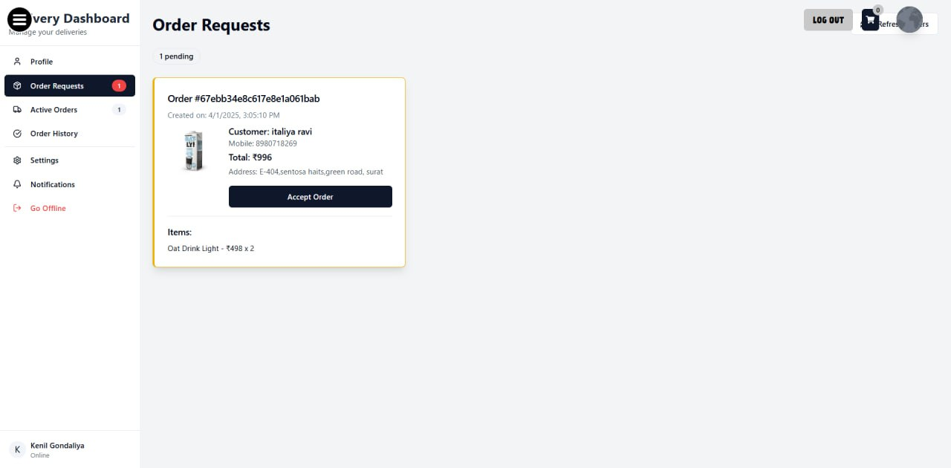

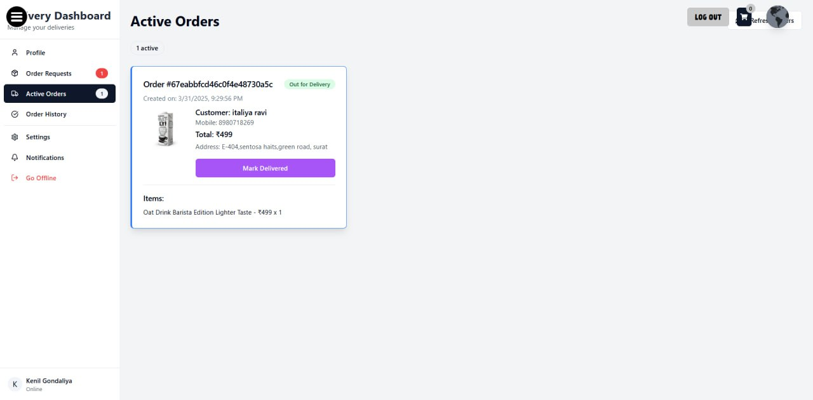

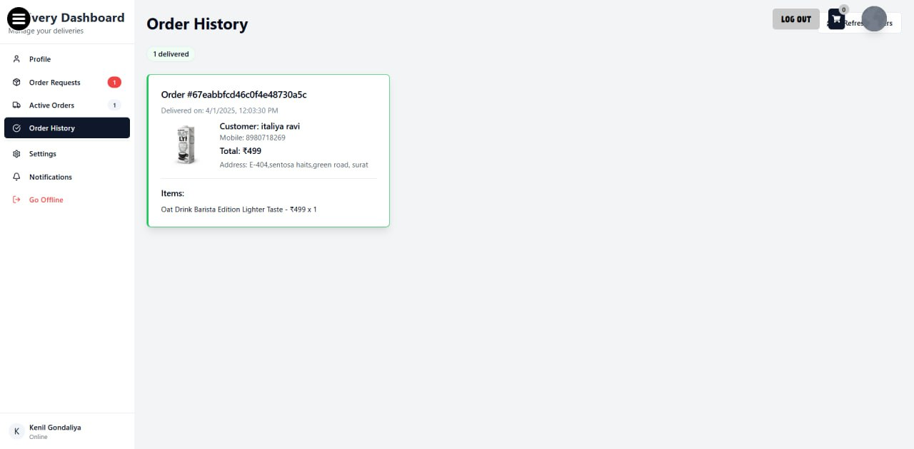
- Software Testing

Testing is essential to ensure the proper functioning of each module in the Oatly E-commerce Platform. It covers user features, admin controls, order management, payment processing, and delivery tracking. Various tests, including Unit Testing, Integration Testing, System Testing, and User Acceptance Testing (UAT), are conducted to ensure smooth operations, secure transactions, and accurate order fulfillment.

- Unit Testing :-

Case ID | Component | Test Case | Expected Result | Actual Result | Status
UT-001 | User Registration | Validate user fields: name, email, password, etc. | User is created successfully and saved in the database. | Works as expected | ✅ Passed
UT-002 | Login Functionality | Login with valid email and password | User is logged in and redirected to their dashboard. | Works as expected | ✅ Passed
UT-003 | Product Addition | Admin adds a new product with valid details | Product is successfully saved in the database. | Works as expected | ✅ Passed
UT-004 | Add to Cart | User adds product to the cart | Product is added to cart and reflected in the UI. | Works as expected | ✅ Passed
UT-005 | Checkout Process | User proceeds with checkout and enters payment details | Order is placed and payment is processed successfully. | Works as expected | ✅ Passed
UT-006 | Order Status Update | Delivery Boy marks order as "Out for Delivery" | Status updated and reflected in the customer's order list. | Works as expected | ✅ Passed
UT-007 | Payment Verification | User completes payment via Razorpay | Payment ID and signature verified successfully. | Works as expected | ✅ Passed
UT-008 | Order Completion | Delivery Boy marks order as "Delivered" | Status updated to "Dispatched" for the customer. | Works as expected | ✅ Passed

- Integration Testing :-

Case ID | Component | Test Case | Expected Result | Actual Result | Status
IT-001 | User Registration + Login | Register a new user and log in | User is registered, and login returns a valid token. | Works as expected | ✅ Passed
IT-002 | User + Product | User views all available products | API returns a list of available products. | Works as expected | ✅ Passed
IT-003 | Cart + Product | User adds products to the cart | Cart updates and displays added products. | Works as expected | ✅ Passed
IT-004 | Checkout + Payment | User places an order and completes payment via Razorpay | Payment is processed, and order status is "Pending." | Works as expected | ✅ Passed
IT-005 | Order + Delivery Boy | Order is assigned to a delivery boy | Delivery boy receives order details and can update status. | Works as expected | ✅ Passed
IT-006 | Order + Status Update | Delivery Boy marks order as "Out for Delivery" | Order status updates in both user and admin dashboards. | Works as expected | ✅ Passed
IT-007 | Order + Status Update | Delivery Boy marks order as "Delivered" | Order status updates to "Dispatched" for the user. | Works as expected | ✅ Passed
IT-008 | User + Profile Update | User updates their profile details | Profile updates successfully and reflects in the UI. | Works as expected | ✅ Passed

- System Testing :-

Case ID | Test Scenario | Test Case | Expected Result | Actual Result | Status
ST-001 | User Authentication | Register a new user and log in | User successfully registers and logs in | Works as expected | ✅ Passed
ST-002 | Product Listing | View all available products | Product list loads without errors | Works as expected | ✅ Passed
ST-003 | Cart Functionality | Add/remove products from the cart | Cart updates correctly | Works as expected | ✅ Passed
ST-004 | Checkout Process | Place an order and proceed to payment | Payment processes successfully via Razorpay | Works as expected | ✅ Passed
ST-005 | Order Tracking | Track order status from "Pending" to "Delivered" | Order status updates correctly | Works as expected | ✅ Passed
ST-006 | Live Order Tracking | User tracks real-time order location | Order location updates dynamically | Works as expected | ✅ Passed
ST-007 | Admin Dashboard | Admin manages users, orders, and deliveries | Admin can view and update all data | Works as expected | ✅ Passed

- User Acceptance Testing :-

Case ID | Test Scenario | Test Case | Expected Result | Actual Result | Status
UAT-001 | User Registration & Login | Users should be able to sign up and log in successfully | Registration and login process completes without errors | Works as expected | ✅ Passed
UAT-002 | Product Browsing & Search | Users can view/search for products | Products display correctly and search works fine | Works as expected | ✅ Passed
UAT-003 | Cart & Wishlist Management | Users can add/remove products to/from cart/wishlist | Cart and wishlist update correctly | Works as expected | ✅ Passed
UAT-004 | Checkout & Payment Processing | Users can place orders and complete payments | Payment is processed successfully via Razorpay | Works as expected | ✅ Passed
UAT-005 | Order Tracking & Status Update | Users can track order status from "Pending" to "Delivered" | Order status updates correctly | Works as expected | ✅ Passed
UAT-006 | Admin Management Panel | Admin can manage users, orders, and products | Admin dashboard functions correctly | Works as expected | ✅ Passed

- Limitations and Future Scope of Enhancement

- Limitations :-

- Lack of Real-Time Order Tracking :

Oatly provides only manual order status updates, but lacks real-time GPS tracking. This can cause uncertainty for customers as they cannot track the exact location of their orders. Adding live tracking with estimated delivery times would enhance transparency and user experience.

- Delayed Status Updates :

In the Oatly e-commerce platform, order tracking relies on manual status updates by the delivery personnel. This can lead to delays in reflecting real-time order progress, causing uncertainty for customers regarding their delivery status. A more automated tracking system could enhance user experience and transparency.

- Manual Order Status Updates :

The Oatly e-commerce platform requires delivery personnel to manually update order statuses, such as "Out for Delivery" and "Dispatched." This process can introduce delays or human errors, making it difficult for customers to get accurate real-time updates on their orders.

- Lack of Security Features:
The platform lacks robust security measures, making it vulnerable to cyber threats. Sensitive user data, including payment details, is not fully encrypted, increasing the risk of data breaches and unauthorized access. Strengthening security protocols is essential to ensure user trust and safety.

- No Automated Stock Management:
The platform does not have an automated inventory management system, leading to possible stock discrepancies. Without real-time stock updates, users may place orders for unavailable products, causing order cancellations and dissatisfaction. Implementing inventory automation would improve order accuracy and reliability.

- Future Scope Of Enhancement :-

- Enhanced Security Measures :-

Implementing enhanced security measures such as encryption, two-factor authentication (2FA), and secure payment gateways will protect user data and transactions from cyber threats, ensuring a safer experience and building trust among users.

- Real-Time Order Tracking :-

Incorporating GPS tracking will enable customers to track their orders in real-time, enhancing transparency, boosting customer satisfaction, and minimizing delivery-related concerns by providing accurate location updates.

- Automated Inventory Management :-

AI-driven inventory tracking will automate restocking, prevent stock shortages, and improve supply chain efficiency by providing accurate, real-time insights into product availability and demand forecasting.

- AI-Based Product Recommendations :-

Leveraging machine learning to analyze user behavior enables personalized product recommendations, enhancing user engagement, improving customer satisfaction, and driving higher sales through tailored shopping experiences.

- Improved Delivery Boy Management :-

Implementing route optimization and performance tracking will streamline delivery operations, ensuring timely deliveries, improving efficiency, and enhancing overall customer satisfaction.

- Chatbot for customer support :-
Implementing a chatbot for customer support will provide users with instant assistance, improve response times, and enhance customer satisfaction through efficient, automated interactions available 24/7.

Feedback and Ratings:
Allowing users to provide feedback and ratings will help improve product quality and user experience. It enables the platform to gather valuable insights and enhance services based on customer reviews.

9.References

- Technologies & Frameworks Used
- MERN Stack (MongoDB, Express.js, React.js, Node.js)
  - MongoDB Documentation: https://www.mongodb.com/docs/
  - Express.js Documentation: https://expressjs.com/
  - React.js Documentation: https://react.dev/
  - Node.js Documentation: https://nodejs.org/en/docs/
- State Management - Zustand
  - Zustand GitHub Repository: https://github.com/pmndrs/zustand
- Real-Time Communication - Socket.io
  - Socket.io Documentation: https://socket.io/docs/
- File & Media Management
  - Cloudinary Documentation: https://cloudinary.com/documentation
- Frontend UI & Styling
  - Tailwind CSS Documentation: https://tailwindcss.com/docs
  - ShadCN UI Library: https://ui.shadcn.com/docs
- Development & Deployment
  - GitHub Documentation: https://docs.github.com/
- API & Testing Tools
  - Postman API Testing: https://www.postman.com/
- General Web Development & Learning Resources
  - MDN Web Docs (JavaScript, HTML, CSS): https://developer.mozilla.org/
  - Stack Overflow (Troubleshooting & Coding Issues): https://stackoverflow.com/

