**Aim:** Estimate **DOA** (**D**irection **O**f **A**rrival) using **MU**ltiple **SI**gnal **C**lassification (**MUSIC**) algorithm.

Problem Statement:

Assume a uniform linear array (ULA) with M= 10 omnidirectional sensors placed along a line on x-axis. Assume that there are two uncorrelated narrow-band, coherent point sources (F1=F2= 2 GHz) lying on the X-Y plane, θ1=−10◦ and θ2= 20◦ (from the vertical Y-axis)in the far-field of the array. Let the inter-sensor spacing bed=λ2, where λ is the wavelength of the sources. Let the SNR of the two sources be 5 dB each. Assume that the sources are emit-ting normally distributed random signals. The sensor noise is assumed to be both temporally and spatially white Gaussian, and is uncorrelated with the signal. Take the total number of data snapshots as L= 4500. Using the MUltiple SIgnal Classification abbreviated as MUSIC algorithm, find the estimates of bearing θ1and θ2.

Experiment Setup and Explanation:

* A uniform linear array (ULA) with M = 10 omnidirectional sensors placed along a line on x-axis.
* Two uncorrelated narrow-band, coherent point sources (F1 = F2 = 2 GHz) lying on the X-Y plane, $θ_{1}=-10°$ and , $θ_{2}=20°$ (from the vertical Y-axis) in the far-field of the array.
* The inter-sensor spacing be d = $\frac{λ}{2}$, where $λ$ is the wavelength of the sources.
* Let the SNR of the two sources be 5 dB each. Assume that the sources are emitting normally distributed random signals.
* The sensor noise is assumed to be both temporally and spatially white Gaussian, and is uncorrelated with the signal.
* 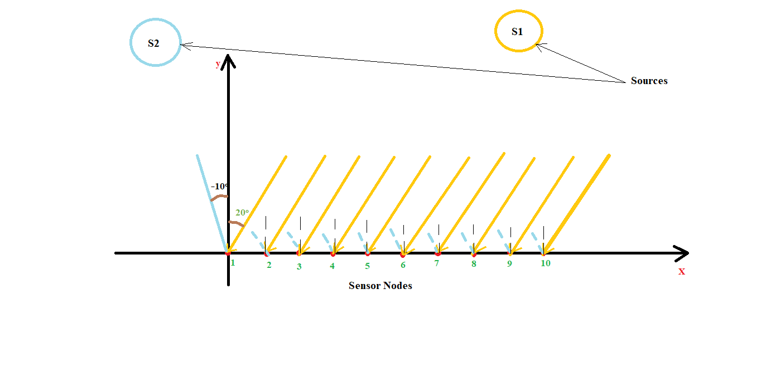Total number of data snapshots as L = 4500.

Fig 1. 10 Sensor Arrays

**Multiple SIgnal Classification(MUSIC) Algorithm :**

MUSIC method assumes that a signal vector **X** , consists of **p** complex exponentials, whose frequencies $ω$ are unknown, in the presence of Gaussian white noise, **n** as given by the linear model

**X = As + n**

Here A = [a(**1**),…a(**p**)] is an M × p Vandermonde matrix of steering vectors a($ω$) = [1,]T where $ω=\frac{2 π d sin⁡(θ)}{λ}$, λ is wavelength of input signal, d is distance between two consecutive sensor nodes. And **s** = [s1,…,sp]T is the amplitude vector. A crucial assumption is that number of sources **p**, is less than the number of elements in the measurement vector(Number of sensor nodes), **M** i.e. **p < M.**

The $M × M$ autocorrelation matrix of **x** is then given by

$$R_{x}=AR_{s}A^{H}+ σ^{2}I$$

Where $σ^{2}$ is the noise variance , I is $M × M$ identity matrix, and Rs is the **p $×$ p** autocorrelation matrix of **s.**

The autocorrelation matrix $R_{x}$ is traditionally estimated using sample correlation matrix

$\hat{R_{x}}= \frac{1}{N} XX^{H}$

N > M is the number of vector observations and X =[ x1,x2,…,xN]. Given the estimate of $R_{x}$, MUSIC estimates the frequency content of the signal or autocorrelation matrix using an eigenspace method.

Since $R_{x}$ is a Hermitian matrix, all of its M eigenvectors {**v**1, **v**2,…, **v**M} are orthogonal to each other. If the eigenvalues of $R_{x}$ are sorted in decreasing order, the eigenvectors corresponding to the **p** largest eigenvalues span the signal subspace **us.** The remaining

M – **p** eigenvectors correspond to eigenvalues equal to $σ^{2}$ and span the noise subspace **u**N, which is orthogonal to the signal subspace **u**s **u**N.

Any signal vector **e** that is from the signal subspace **e $∈$ u**s must be orthogonal to the noise subspace , **e $⏊$**  **u**N it must be that **e $⏊$** **v**i for all eigenvectors ${\left\{V_{i}\right\}}_{i=p+1}^{M}$ that spans the noise subspace. In order to measure the degree of orthogonality of **e** with respect to all **v**i, the MUSIC algorithm defines a squared norm

$$d^{2}={\left\|U_{N}^{H}e\right\|}^{2}=e^{H}U_{N}U_{N}^{H}e=\sum_{i=p+1}^{M}{{\left|e^{H}v_{i}\right|}^{2}}$$

Where the matrix **U**N =[**vp+1,..,v**M] is the matrix of the eigenvectors that span the noise subspace **u**N id **e $∈$ u**s , then d2 = 0 as implied by the orthogonality condition. Taking reciprocal of the squared norm expression creates sharp peaks at the signal frequencies. The frequency estimation function for MUSIC (or the pseudo-spectrum) is

$$\hat{P_{MU}}\left(e^{iω}\right)=\frac{1}{e^{H}U_{N}U_{N}^{H}e}=\frac{1}{\sum_{i=p+1}^{M}{{\left|e^{H}v_{i}\right|}^{2}}}$$

Where **v**i are noise eigenvectors and

$$e={[1 e^{iω} e^{i2ω} . . . e^{i(M-1)ω}]}^{T}$$

Is the candidate steering vector. The locations of the p largest peaks of the estimation function give the frequency estimates for the **p** signal components

$$\hat{ω}=\arg{\max_{ω}{\hat{P_{MU}}}}(e^{iω})$$

Pseudo Code :

STEP: 1 (Simulation):

* Taking f = 2 GHz, λ = c/f, d = λ / 2.
* Number of sensor node (M) = 10, Number of sources (p) = 2
* Number of Data snapshots K=4500
* Create Steering Vector matrix A,

A = [a(1),…a(p)];

a(i) =

* Generate random sinusoidal signal.

Sig(p,k) = ${[e}^{-iω(rn)}]$

where k= 1,2,..K,

rn= randn(p,k) random number generated matrix.

* Create uncorrelated white noise matrix.
$$n=randn(M,K)$$

* Create Data Matrix (X):

$$X = A*sig + n$$

STEP 2: [Estimation of DOA($θ$)][Implementation of MUSIC Algorithm]

* Calculate Covariance matrix R:
$$R=X × X^{H}$$

* Calculate Eigen decomposition of R and obtain Eigenvalues and corresponding Eigen vectors.
* Sort Eigenvalues in descending order and separate first (p) number of eigenvectors and other M-p eigenvectors.
* Now the eigenvectors belonging to Noise subspace will be orthogonal to steering or arrival vectors belonging to signal subspace. So, we can write for following MUSIC spectrum , the peak values will occur when the orthogonal norm of steering vector and null subspace vectors will become near to zero or very small.
$$\hat{P_{MU}}\left(e^{iω}\right)=\frac{1}{a^{H}E_{N}E_{N}^{H}a}$$

* And the peak angles will be at $ω$ **:**

$\hat{ω}=\arg{\max_{ω}{\hat{P_{MU}}}}(e^{iω})$

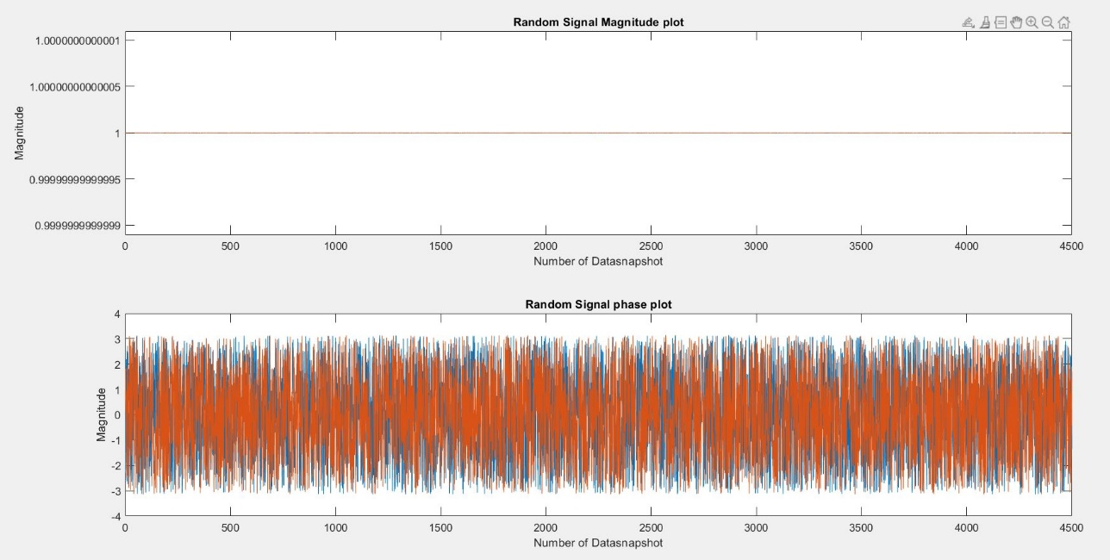Generated Signal Random Signal (Step 1):

Fig 2. Signal Generated by Source

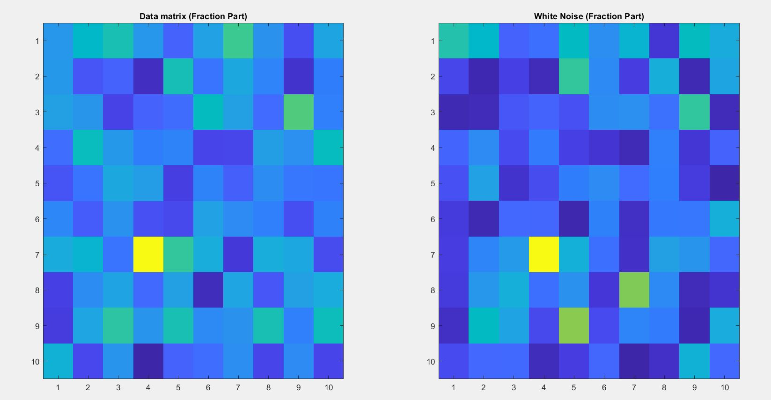Generated White Noise and Data matrix (Step 1):

Fig 3. White Noise and Data matrix Visualization

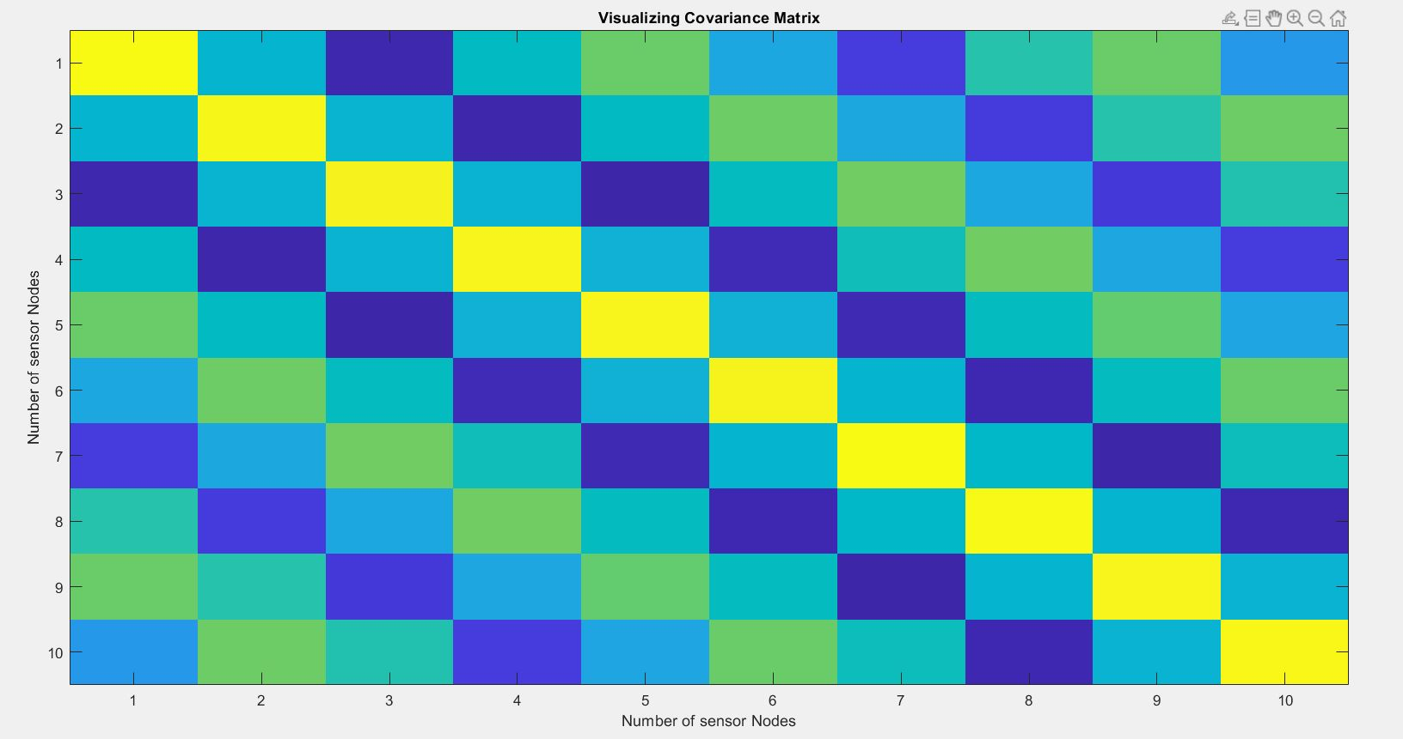Visualization Of Covariance Matrix:

Fig 4. Covariance Matrix

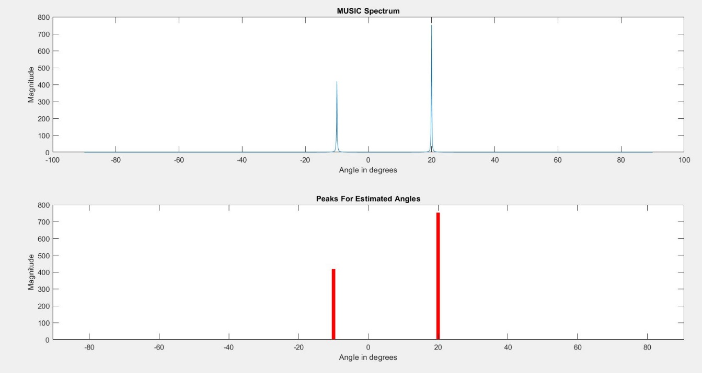MUSIC Spectrum (Step 2):

Fig 5. MUSIC Spectrum with Peaks for Estimated DOA(Direction of arrivals)

Discussions:

* MUSIC outperforms simple methods such as picking peaks of DFT spectra in the presence of noise, when the number of components is known in advance, because it exploits knowledge of this number to ignore the noise in its final report.
* Unlike DFT, it is able to estimate frequencies with accuracy higher than one sample, because its estimation function can be evaluated for any frequency, not just those of DFT bins. This is a form of super-resolution.
* Its chief disadvantage is that it requires the number of components to be known in advance, so the original method cannot be used in more general cases. Methods exist for estimating the number of source components purely from statistical properties of the autocorrelation matrix.
* A modified version of MUSIC, denoted as Time-Reversal MUSIC (TR-MUSIC) has been recently applied to computational time-reversal imaging. MUSIC algorithm has also been implemented for fast detection of the DTMF frequencies (Dual-tone multi-frequency signaling) in the form of C library - libmusic.
* MUSIC is a generalization of Pisarenko's method, and it reduces to Pisarenko's method when M=P+1. In Pisarenko's method, only a single eigenvector is used to form the denominator of the frequency estimation function; and the eigenvector is interpreted as a set of autoregressive coefficients, whose zeros can be found analytically or with polynomial root finding algorithms. In contrast, MUSIC assumes that several such functions have been added together, so zeros may not be present. Instead there are local minima, which can be located by computationally searching the estimation function for peaks.