Creating microservices using Jhipster

1. Service Registry:
   * + During startup time, all microservices are registered in this registry application with a specific name.
     + Code in “Microservice A” can trigger webservices of “Microservice B” just by mentioning the name of “Microservice B” instead of mentioning the IP address of the “Microservice B”.
     + Common examples are “Eureka”, “Consul”, “Zookeeper”.
     + As I am using JHipster in this case, I am using Jhipster Registry which is a flavor of Eureka config server.

|  |
| --- |
| **Console Commands** |
| * mkdir ~/microservices/ * cd ~/microservices/ * git clone <https://github.com/jhipster/jhipster-registry> * cd jhipster-registry * ./mvnw |

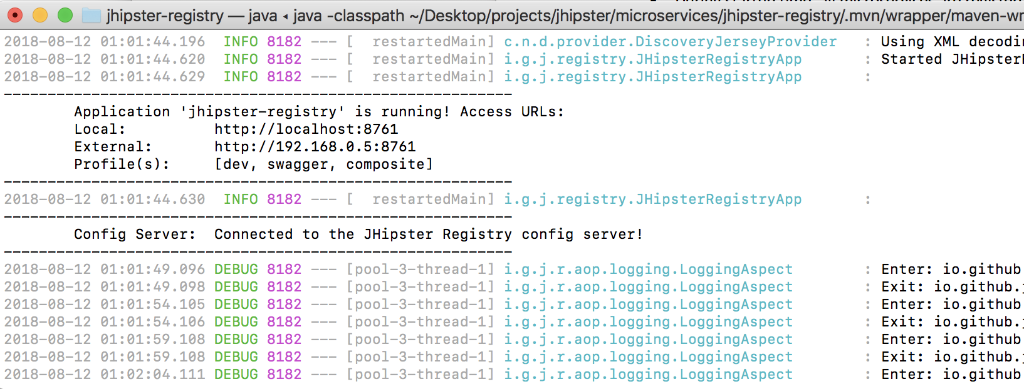

1. Microservice1 (savings account):
   * + During startup time, all microservices are registered in this registry application with a specific name.
     + Code in “Microservice A” can trigger webservices of “Microservice B” just by mentioning the name of “Microservice B” instead of mentioning the IP address of the “Microservice B”.
     + Common examples are “Eureka”, “Consul”, “Zookeeper”.
     + As I am using JHipster in this case, I am using Jhipster Registry which is a flavor of Eureka config server.

|  |
| --- |
| **Console Commands** |
| * mkdir ~/microservices/savings-acc * cd ~/microservices/savings-acc |
| * yo Jhipster   ? **Which *type* of application would you like to create?** Microservice application  ? **What is the base name of your application?** savingsaccount  ? **As you are running in a microservice architecture, on which port would like your server to run? It should be uniqu**  **e to avoid port conflicts.** 8081  ? **What is your default Java package name?** in.ravikalla.microservices.savingsaccount  ? **Which service discovery server do you want to use?** JHipster Registry (uses Eureka, provides Spring Cloud Config su  pport and monitoring dashboards)  ? **Which *type* of authentication would you like to use?** JWT authentication (stateless, with a token)  ? **Which *type* of database would you like to use?** SQL (H2, MySQL, MariaDB, PostgreSQL, Oracle, MSSQL)  ? **Which *production* database would you like to use?** Microsoft SQL Server  ? **Which *development* database would you like to use?** H2 with in-memory persistence  ? **Do you want to use the Spring cache abstraction?** Yes, with the Hazelcast implementation (distributed cache, for mu  ltiple nodes)  ? **Do you want to use Hibernate 2nd level cache?** Yes  ? **Would you like to use Maven or Gradle for building the backend?** Maven  ? **Which other technologies would you like to use?**  ? **Would you like to enable internationalization support?** No  ? **Besides JUnit and Jest, which testing frameworks would you like to use?** Cucumber  ? **Would you like to install other generators from the JHipster Marketplace?** No |
| yo jhipster:entity savingsaccount  Generating field #1  ? **Do you want to add a field to your entity?** Yes  ? **What is the name of your field?** accountnumber  ? **What is the type of your field?** Integer  ? **Do you want to add validation rules to your field?** Yes  ? **Which validation rules do you want to add?** Required  Generating field #2  ? **Do you want to add a field to your entity?** Yes  ? **What is the name of your field?** accountname  ? **What is the type of your field?** String  ? **Do you want to add validation rules to your field?** Yes  ? **Which validation rules do you want to add?** Required, Minimum length  ? **What is the minimum length of your field?** 1  Generating field #3  ? **Do you want to add a field to your entity?** Yes  ? **What is the name of your field?** amount  ? **What is the type of your field?** Double  ? **Do you want to add validation rules to your field?** Yes  ? **Which validation rules do you want to add?** Required, Maximum  ? **What is the maximum of your field?** 1000000000000  Generating field #4  ? **Do you want to add a field to your entity?** No  Generating relationships to other entities  ? **Do you want to add a relationship to another entity?** No  ? **Do you want to use separate service class for your business logic?** Yes, generate a separate service interface and  implementation  ? **Do you want to use a Data Transfer Object (DTO)?** [BETA] Yes, generate a DTO with MapStruct  ? **Do you want to add filtering?** Dynamic filtering for the entities with JPA Static metamodel  ? **Do you want pagination on your entity?** Yes, with infinite scroll |
| yo jhipster:entity transaction |
|  |
|  |