Scrum Process Flow - Team1 and Team3

Purpose
This document captures the end-to-end Agile delivery flow followed by Team1 and Team3, from Jira ticket assignment to production deployment.

Scope
- Teams: Team1, Team3
- Process window: Ticket implementation through release
- Systems involved: Jira, SCM, code review portal, shared file location, SIT, UAT, Production

Roles
- Developer
- Tech Lead
- Release Manager
- UAT Team

Artifacts and Locations
Artifact | Owner | Location / System
Technical design (white paper) | Developer | Ticket white paper
Code package | Developer | Shared Artifact Repository
Code comparison report | Developer | Shared Artifact Repository
Code review request | Developer | Code Review Portal
Unit testing report | Developer | Code Review Portal
Release Management branch/item (RM) | Tech Lead | SCM
Release notes for production | Tech Lead | Release documentation

Team1 Process Steps
- Jira ticket is assigned to the developer.
- Developer prepares the technical design and updates the ticket white paper.
- Developer sends the technical design to the Tech Lead for review.
- Tech Lead reviews the technical design.
- If technical design updates are requested, the developer revises and resubmits.
- After technical design approval, the developer starts implementation.
- Before implementation or modification, the developer checks out the latest production version from SCM.
- Developer implements the required changes on top of that production baseline.
- Developer places the updated code in the Shared Artifact Repository.
- Developer places the code comparison report in the Shared Artifact Repository.
- Developer raises a code review request in the Code Review Portal and assigns it to the Tech Lead.
- Developer performs unit testing and prepares the unit testing report.
- Developer uploads the unit testing report to the Code Review Portal and informs the Tech Lead.
- Tech Lead reviews code changes and shares comments if fixes are needed.
- If code fixes are needed, developer updates code, refreshes artifacts/reports, and resubmits for review.
- Tech Lead reviews unit test results and shares comments if updates are needed.
- If unit test updates are needed, developer updates tests/report and resubmits.
- Once code review and unit testing are approved, the Tech Lead proceeds with release preparation.
- For each release, the Tech Lead creates RM in SCM and checks in approved code.
- If merge conflicts occur with other projects in the same release, Tech Leads coordinate and resolve conflicts.
- Tech Lead and Release Manager build and deploy to SIT for SIT testing.
- After SIT completion, Tech Lead and Release Manager deploy the same code to UAT for QA testing.
- After all release tickets are tested and approved by UAT, Tech Lead prepares production release notes.
- Release Manager secures required release approvals and deploys RM changes to production on release day.

Process Diagram (Decision Flow)

Process Diagram (Decision Flow)
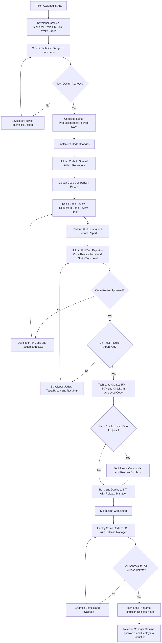

Role Swimlane (RACI-style Flow)

Role Swimlane (RACI-style Flow)
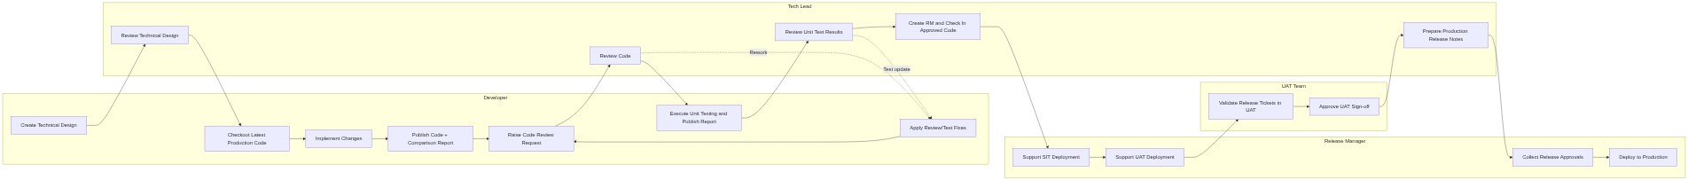

Control Gates
- Gate 1: Technical design approval by Tech Lead before coding.
- Gate 2: Code review approval by Tech Lead before release preparation.
- Gate 3: Unit test approval by Tech Lead before RM check-in.
- Gate 4: UAT approval for all release tickets before production release.
- Gate 5: Release approvals completed by Release Manager before production deployment.

Notes
- Team3 follows the same process as Team1 except Team3 does not use technical design or ticket white paper activities.

Team3 Process (Variant)

Team3 Difference Summary
- No technical design document activity.
- No ticket white paper update.
- No technical design review/approval gate.
- All remaining development, review, test, release, and deployment steps are the same as Team1.

Team3 Artifacts and Locations
Artifact | Owner | Location / System
Code package | Developer | Shared Artifact Repository
Code comparison report | Developer | Shared Artifact Repository
Code review request | Developer | Code Review Portal
Unit testing report | Developer | Code Review Portal
Release Management branch/item (RM) | Tech Lead | SCM
Release notes for production | Tech Lead | Release documentation

Team3 Process Steps
- Jira ticket is assigned to the developer.
- Before implementation or modification, the developer checks out the latest production version from SCM.
- Developer implements the required changes on top of that production baseline.
- Developer places the updated code in the Shared Artifact Repository.
- Developer places the code comparison report in the Shared Artifact Repository.
- Developer raises a code review request in the Code Review Portal and assigns it to the Tech Lead.
- Developer performs unit testing and prepares the unit testing report.
- Developer uploads the unit testing report to the Code Review Portal and informs the Tech Lead.
- Tech Lead reviews code changes and shares comments if fixes are needed.
- If code fixes are needed, developer updates code, refreshes artifacts/reports, and resubmits for review.
- Tech Lead reviews unit test results and shares comments if updates are needed.
- If unit test updates are needed, developer updates tests/report and resubmits.
- Once code review and unit testing are approved, the Tech Lead proceeds with release preparation.
- For each release, the Tech Lead creates RM in SCM and checks in approved code.
- If merge conflicts occur with other projects in the same release, Tech Leads coordinate and resolve conflicts.
- Tech Lead and Release Manager build and deploy to SIT for SIT testing.
- After SIT completion, Tech Lead and Release Manager deploy the same code to UAT for QA testing.
- After all release tickets are tested and approved by UAT, Tech Lead prepares production release notes.
- Release Manager secures required release approvals and deploys RM changes to production on release day.

Team3 Diagram (Decision Flow)

Team3 Diagram (Decision Flow)
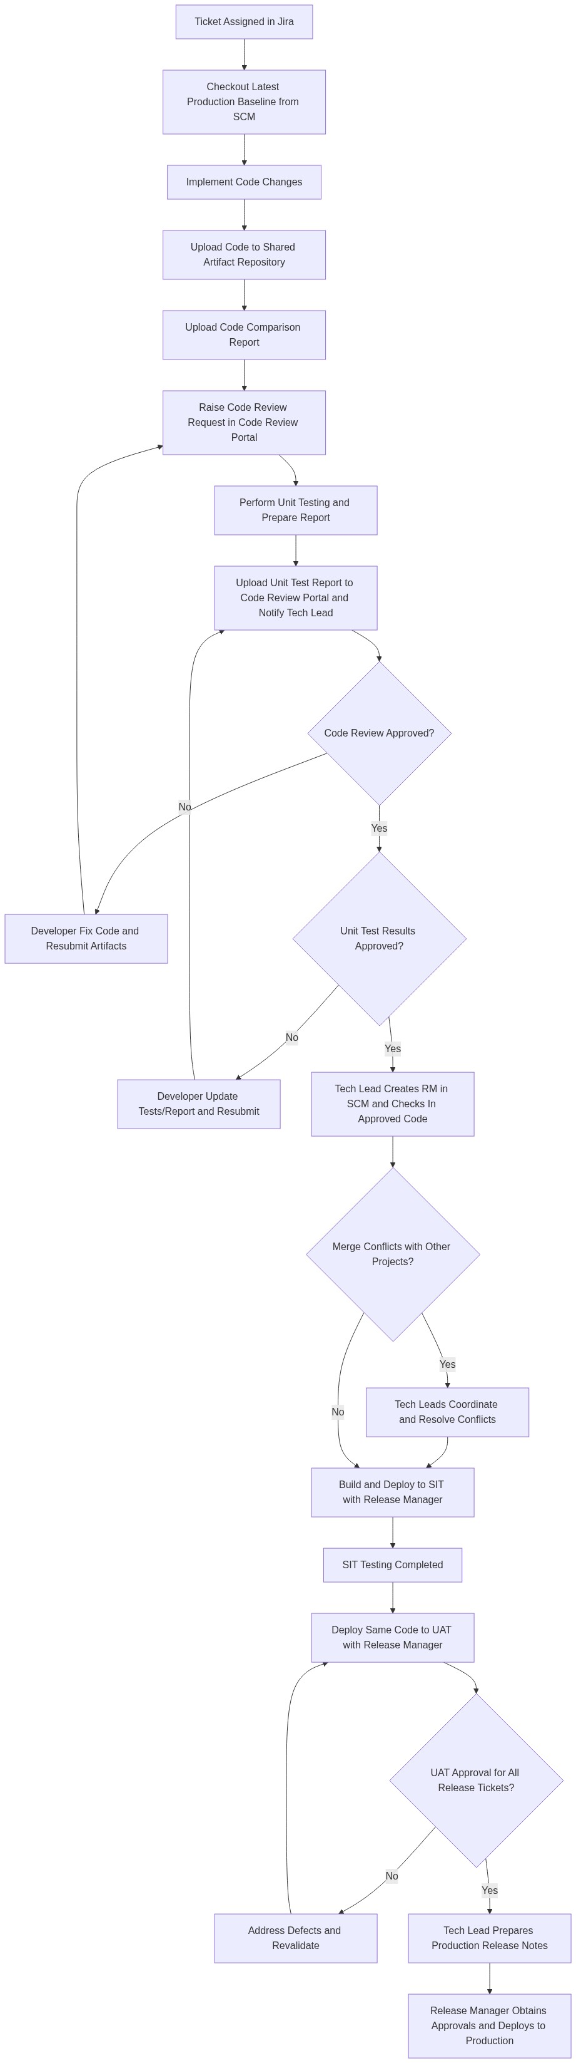

Team3 Role Swimlane (RACI-style Flow)

Team3 Role Swimlane (RACI-style Flow)
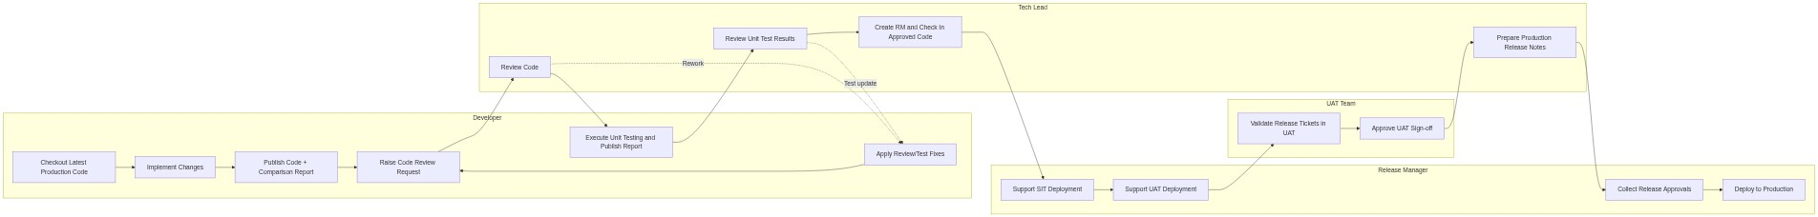

Team3 Control Gates
- Gate 1: Code review approval by Tech Lead before release preparation.
- Gate 2: Unit test approval by Tech Lead before RM check-in.
- Gate 3: UAT approval for all release tickets before production release.
- Gate 4: Release approvals completed by Release Manager before production deployment.

