################
#Technical requirements (supports on both linux, windows)
################
- Install mysql workbench,
- Install nodejs
- Install postman

################
#Instructions for running and building the db and application
################

Logical model-
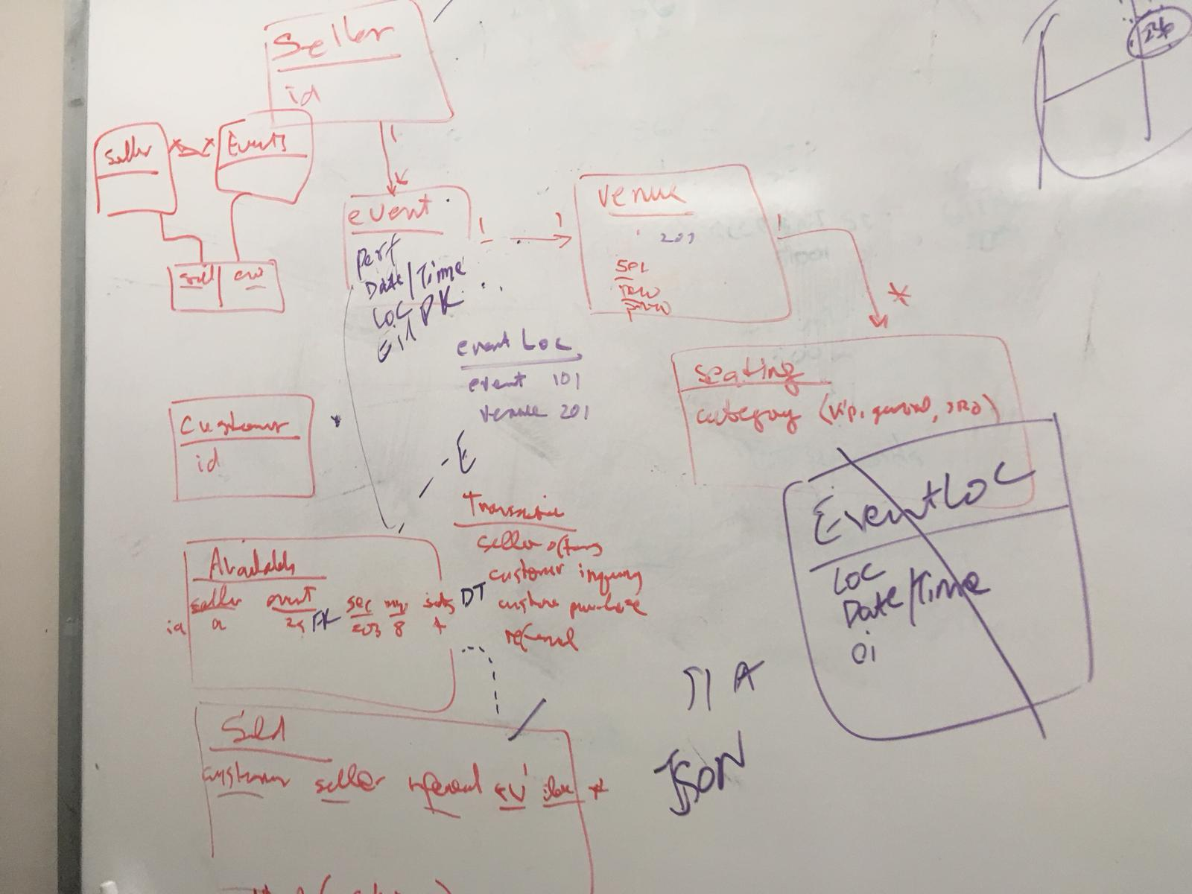

Data model-
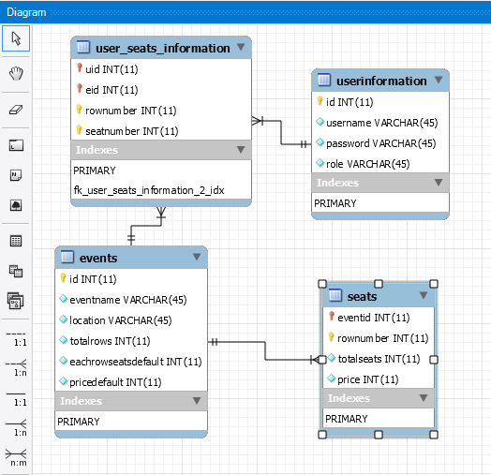

Steps-
- Execute the queries from backup.sql (or have splitted these tables individually like table_events.sql, table_seats.sql, table_user, table_user_seat.sql) for creating the tables – events, seats, userInformation, and user_seats_information.
- Execute the queries in the storedprocedures from allocate_seat.sql, get_availableseats.sql, update_events.sql, and update_user.sql
- Run npm install from terminal or command prompt
- Run the server.js script on terminal or command prompt, make sure the file has .js extension else rename it with the extension.
- Run the APIs on Postman,
Example-

POST:
#create user – seller and customer
http://localhost:3001/userCreate
PARAMS (PARAMETERS):
JSON(application/json)
BODY:
{
"username": "sell1",
"password": "1",
"role": "seller"
}
STATUS:
[
{
"@result": "Success"
}
]

#create event (security-authentication provided such that only seller can create a event)
POST:
http://localhost:3001/eventCreate?username=sell1&password=1
PARAMS (PARAMETERS):
JSON(application/json)
BODY:
{
"eventname": "blackhawks",
"location": "chicago",
"totalrows": 998,
"seats": 1,
"price": 42
}
STATUS:
[
{
"@result": "Success"
}
]
If you execute the same parameters again, then, STATUS is,
[
{
"@result": "Eventname and location already exist"
}
]

#customer allocates a seat or seats
POST:
http://localhost:3000/allocateSeat?username=cust1&password=1
PARAMS (PARAMETERS):
JSON(application/json)
BODY:
{
"eventname": "blackhawks",
"location": "chicago",
"rownumber": 406,
"seatnumber": 2
}
STATUS:
[
{
"@result": "Allocated"
}
]

#customer (and seller) can check the available seats
POST:
http://localhost:3000/ availableSeats?username=sell1&password=1&eventname=blackhawks&location=chicago
PARAMS (PARAMETERS):
JSON(application/json)
BODY:
{
"eventname": "blackhawks",
"location": "chicago",
}
STATUS:
[
{
Total avilableseats": 406
}
]

#######################
#Tasks (pilot) tried implementing:
#######################
- Implemented datetime for eid (event) and store the purchase_time for customer
- Allocating the total revenue for seller from the seats purchased by customers for an event
- Designed tasks initially with seller, events, customers and seat_availability tables with 2Normalization-factor
- Implemented the referred-by option when customer is creating account and password.

#################
#To do tasks:
#################
- Implement datetime for an event
- List events for a given date range
- Implementation of Refered-by

