NLP Web Service Documentation

This webservice includes a total of 9 endpoints:

|  |  |  |  |  |
| --- | --- | --- | --- | --- |
|  |  |  |  |  |
| Path | Page | Input | Request Type | Description |
| / | Home | N/A | GET | Users will see a “welcome” message once they enter the api home page |
| /url/content | Get URL Text | URL | GET | Users input a url and api scrapes the web content of the url provided |
| /url/entities | GET URL Entities | URL | GET | Api returns the unique entities found in the URL provided |
| /url/entity-text | GET URL Entity Text | URL, Entity | GET | Api returns the text and number of times the text appears for the entity provided by the user in the specified URL |
| /add | Add URL Data | URL | POST | Adds the data extracted from the URL into the database. Data points captured: url, entity, text. If more than one entity exists in the webpage, a record is created for each entity. Eg:   |  |  |  | | --- | --- | --- | | URL | Entity | Texts | | URL 1 | Entity 1 | Text 1, Text 2 | | URL 1 | Entity 2 | Text 3, Text 4, Text 5 | |
| /database | View Database | N/A | GET | Users can view the current version of the database |
| /database/entities | Extract Entities | URL | GET | Users input a URL and database will return records containing entities from the URL specified |
| /database/entity-texts | Extract Entity Text | URL, Entity | GET | Database will return records containing the texts from the entity and url specified by the user |
| /upload | Add Data from File | File | POST | Future implementation – for users to have an option of analyzing data from either a URL or a file format |

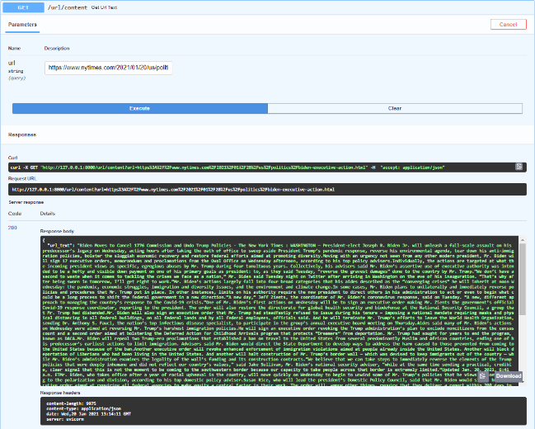Screenshots

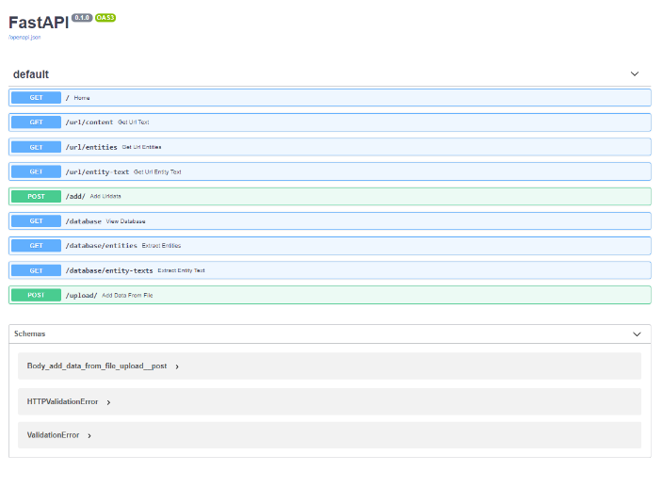Available endpoints for webservice Get URL page content

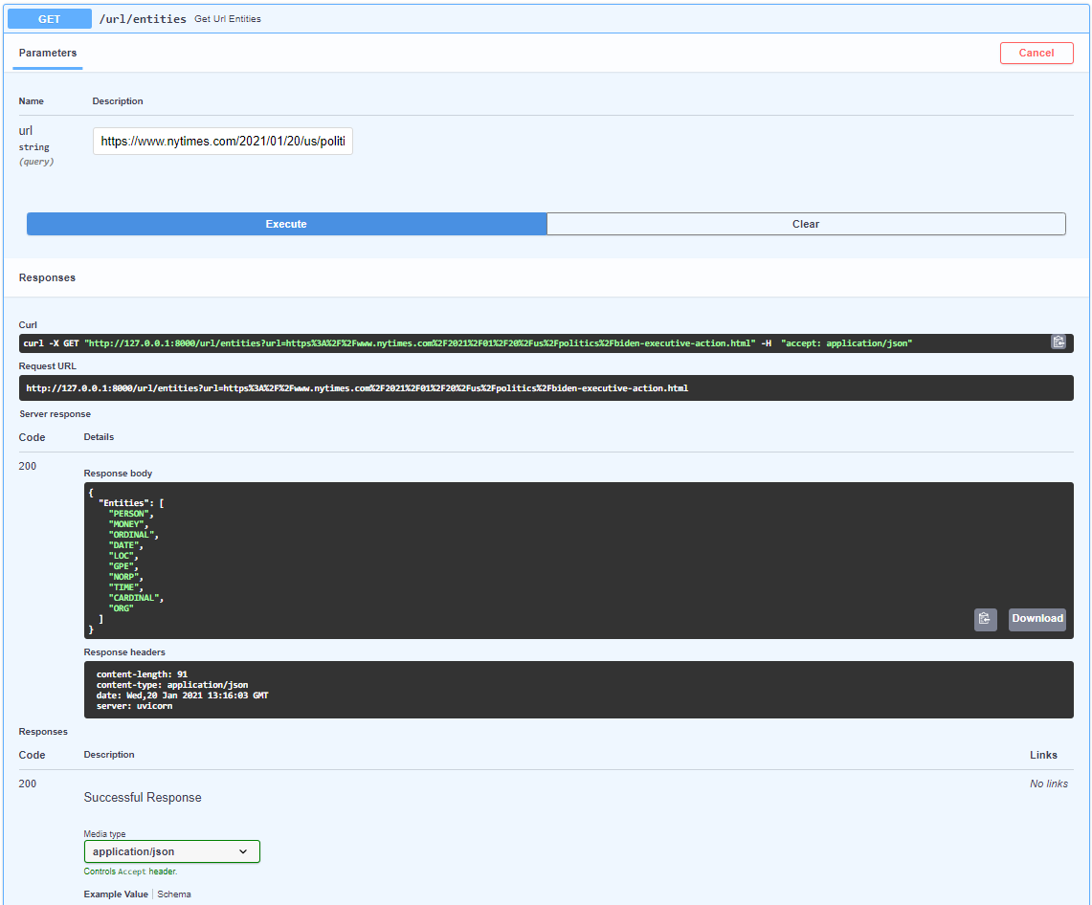

Get all the unique entities found in the webpage

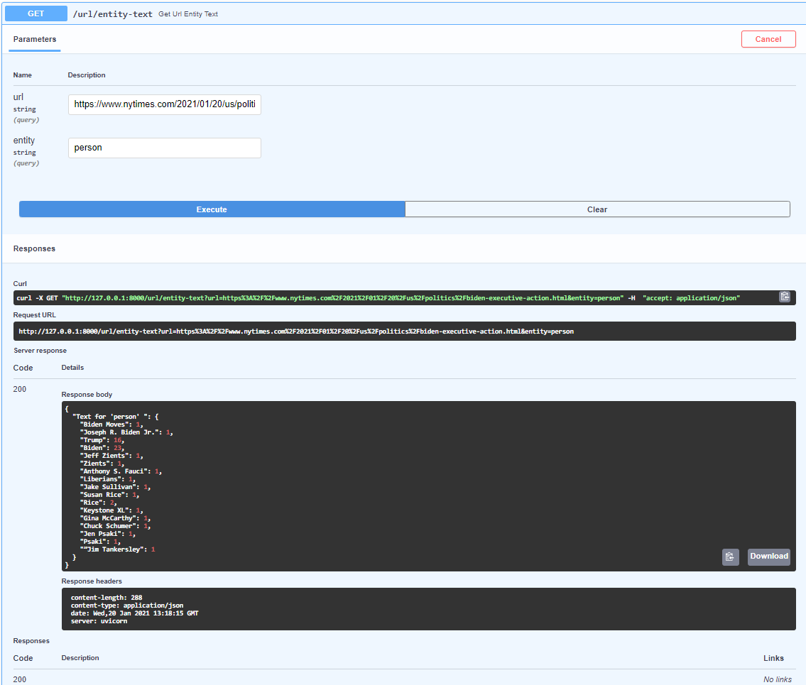

Get texts for Entity and URL specified. Texts and number of times each text appear on the webpage is retrieved.

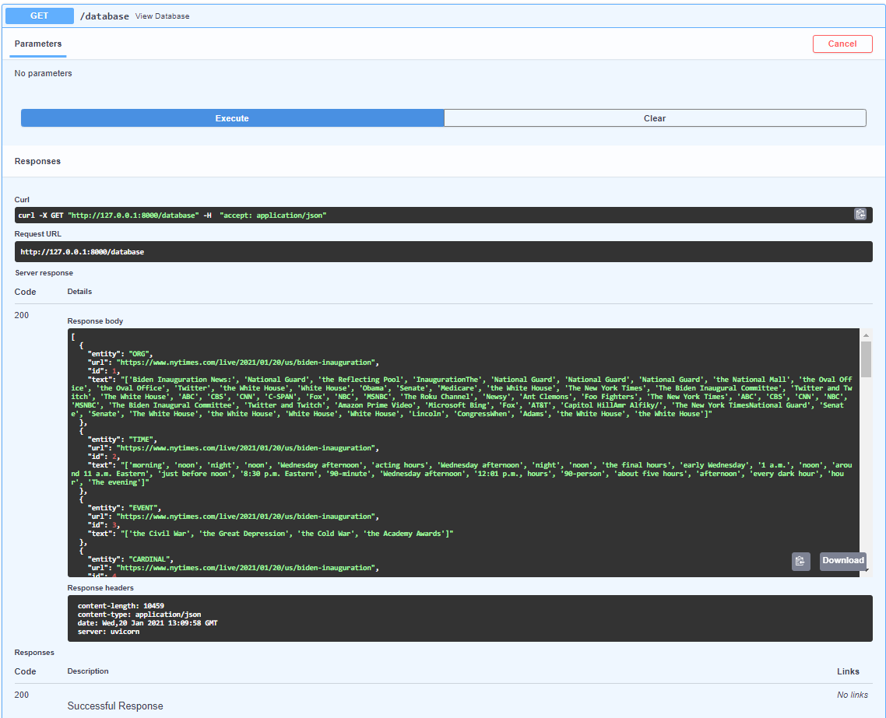

View current version of the database

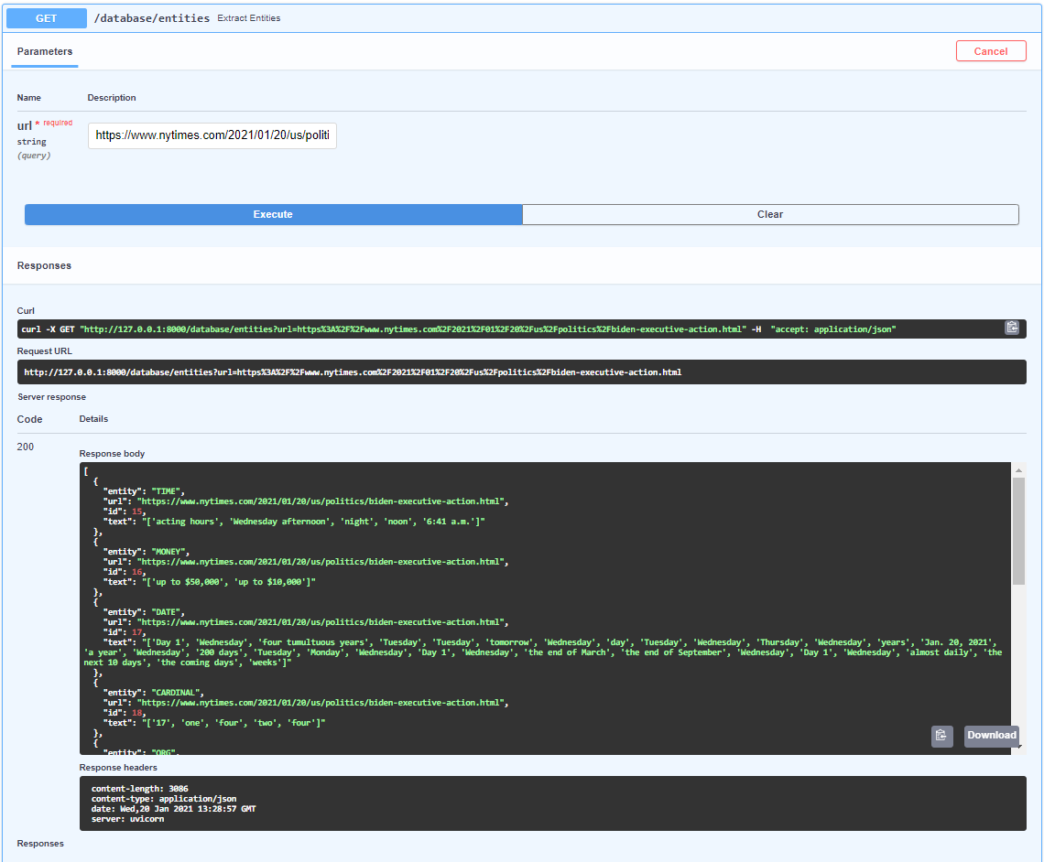

Get records of all the entities found in the URL specified

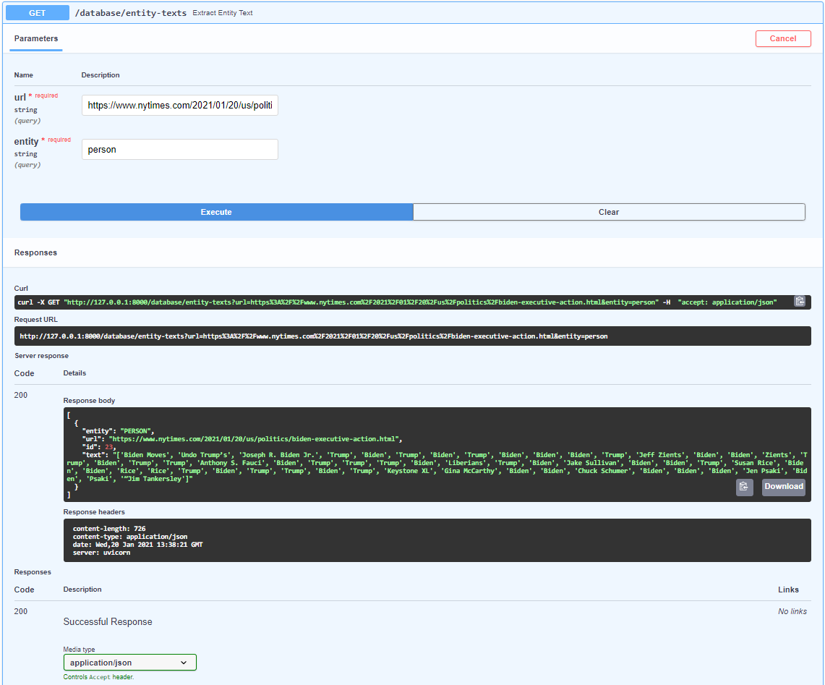

Get records of all the texts found that matches the entity specified.