Storyboard- Crystals

Intro
Miners are working in cave mining crystals. UFO comes in and steals all crystals. Space girl flies in and miners tell her that alien stole crystals. Space girl flies to see Iris and kittens and tells her what happened (Alien took 25 crystals) and asks her to help.(help icon)
Signer in corner signs “ Oh No, the alien stole all the power crystals. The power crystals are in ufos now. Inside the ufos are alligators, spiders , snakes and bad cats guarding the power crystals. You must tell Iris where the bad animal is. Iris will get the power crystals back. Good luck”.
Iris’ rocket plane rolls in Iris and kittens get in takes off.
1

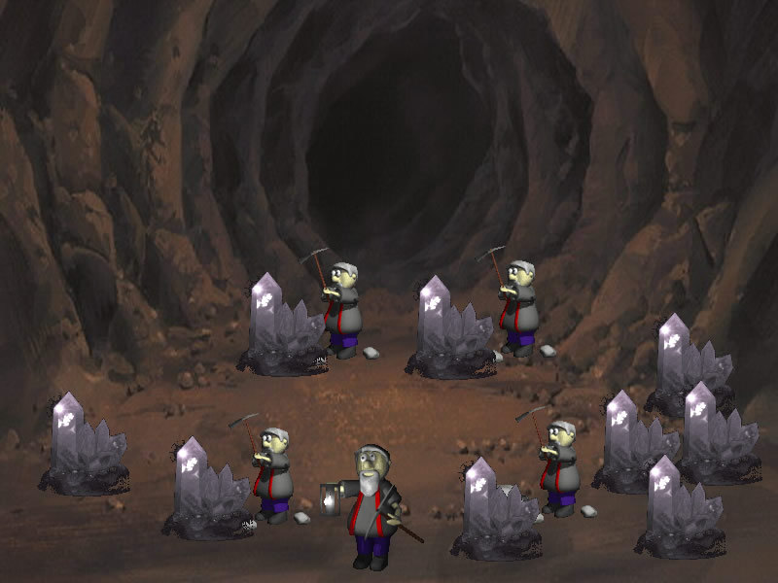2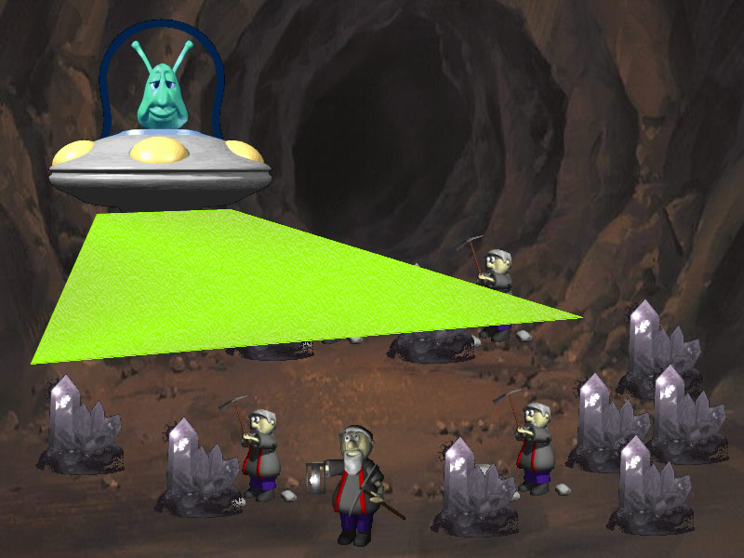
3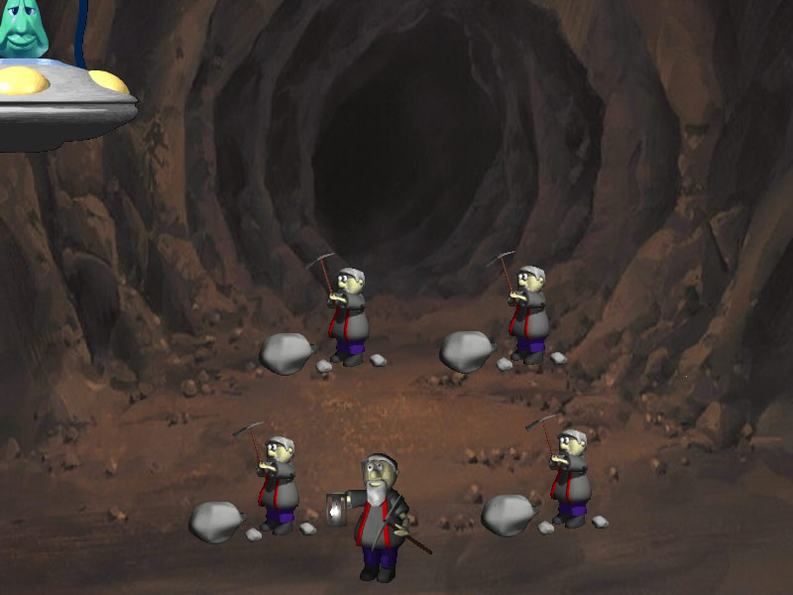4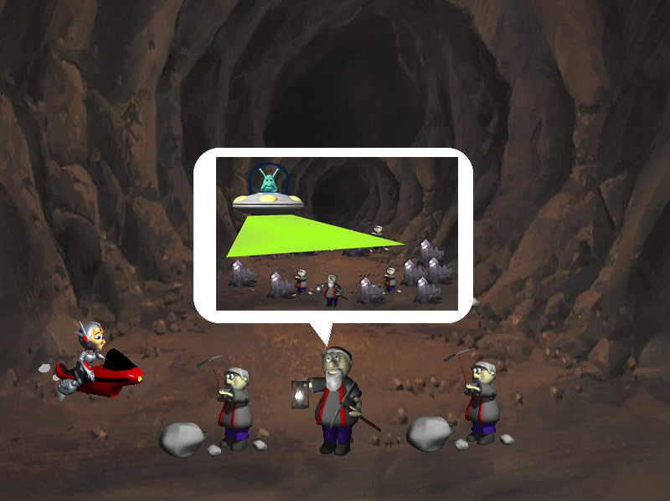
5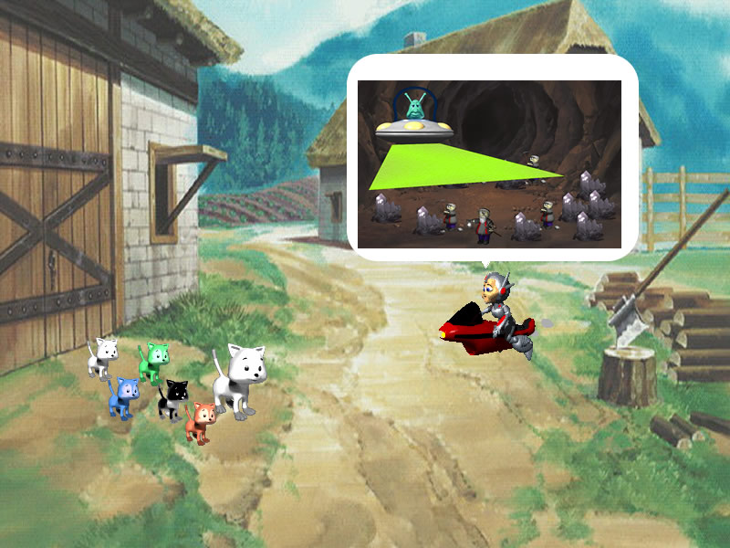6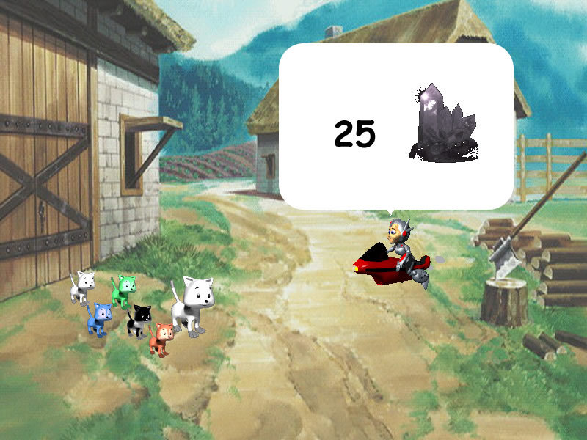
7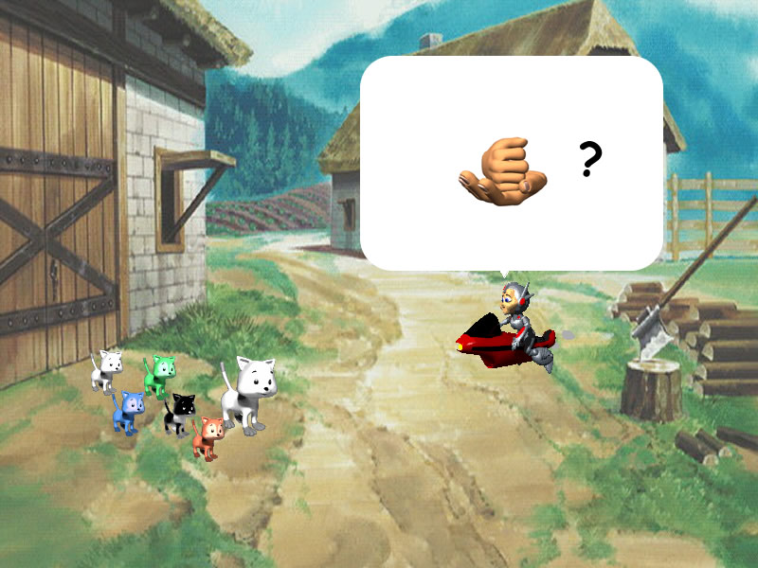8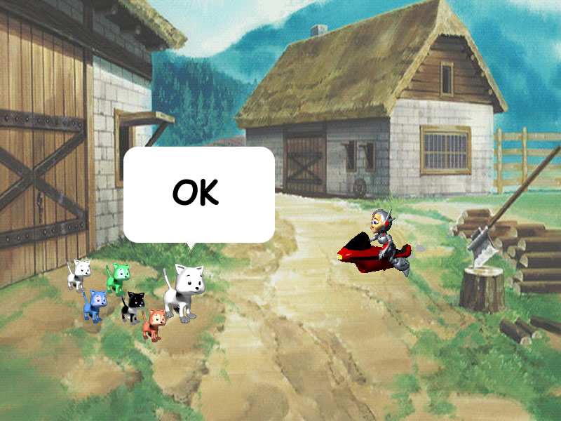
9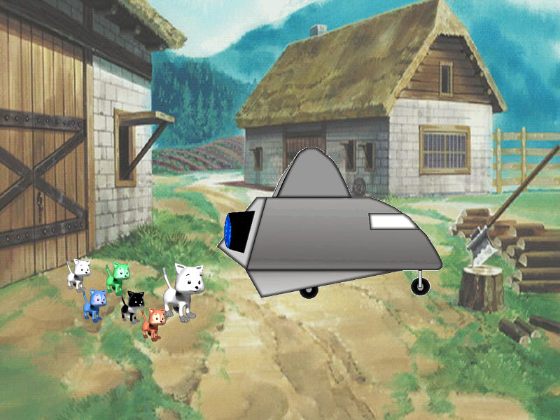10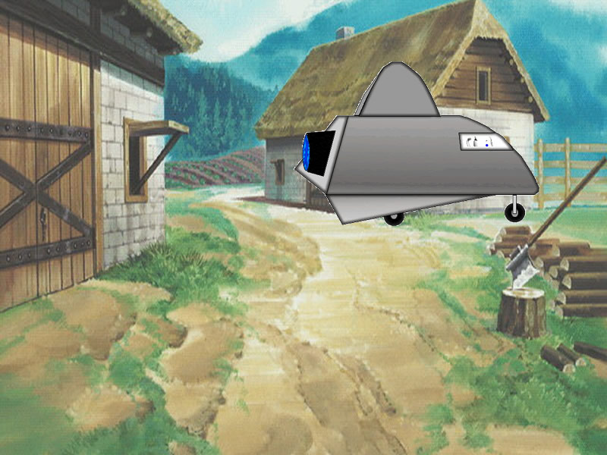

Space game
Have help video to side (crystals intro 2_copycat.mov) that plays first time kids see the space game that says

Iris flies rocketplane through space avoiding and exploding metors to find ufo.(This should last about 15 seconds) When a meteor touches the rocketplane the meteor expodes and the rocketplane moves down about ½ inch.
When Iris lands on the ufo switch to room scene(really inside the UFO)
After kids get Crystal swicth back to space game
1
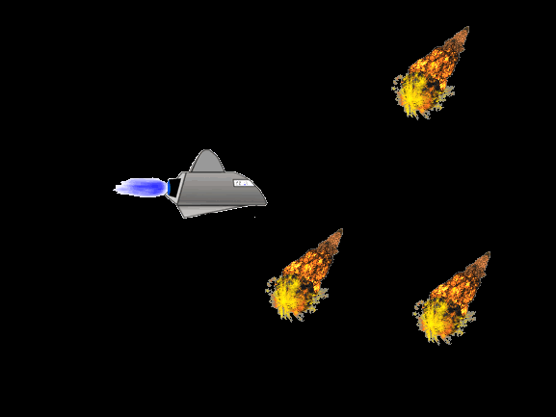2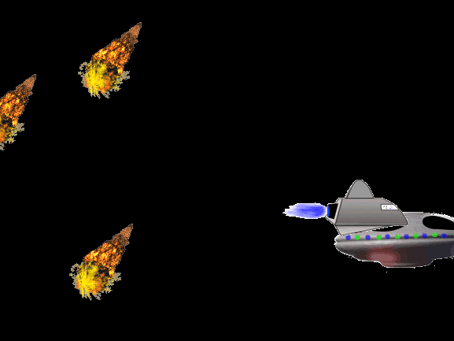

Room scene
When Iris enters room she will do magic and freeze the alien inside the ufo. Then, kids can see who protects a power crystal (e.g., blue alligator) Kids tell Iris. If kids are wrong a question mark appears above her head. If correct Iris does magic to poof villain (turns it to a robot dog(in villains folder)) and gets power crystal. Power crystal flies over to score area and score increases by one . Scene switches back to space game.
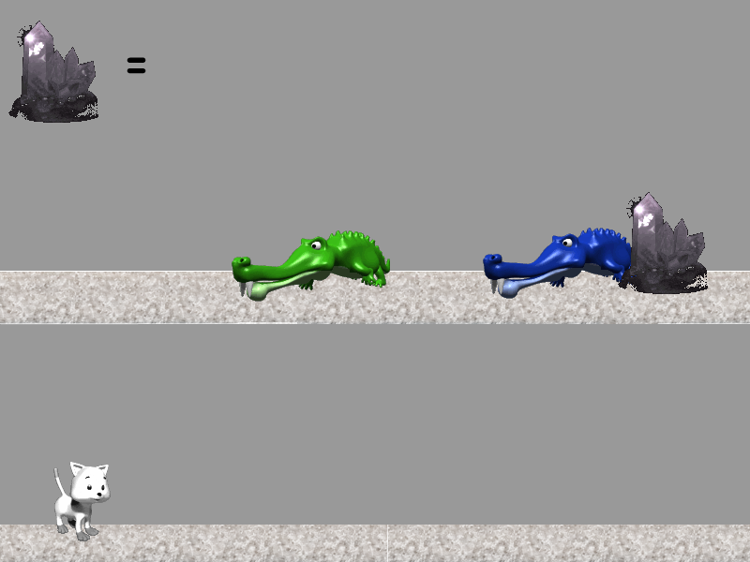

Pirate Scene
Occasionally when Iris enters a room she will be in a pirate scene. As she sits in her rocketplane on top of ufo an alien in a ufo comes from behind and steals 5 power crystals from the rocket plane then flies off. . (Make this animation) Scene then switches back to space game

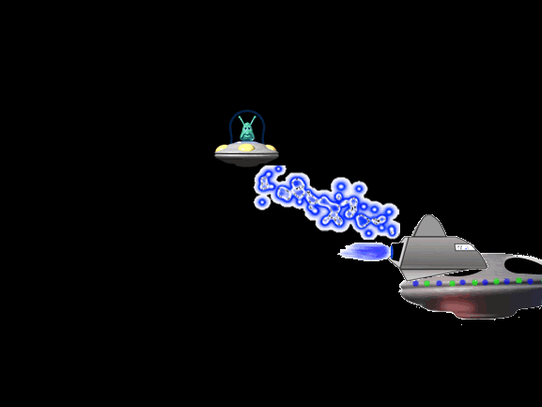

Bonus Room
There are 5 power crystals to be gotten to make up for the 5 the pirate stole.
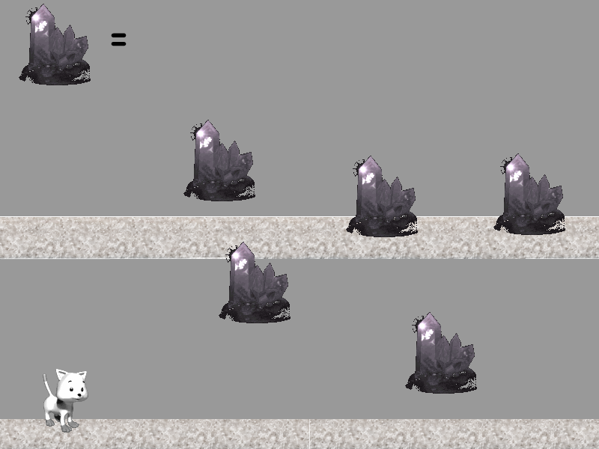

After Bonus room the Pirate room will appear or vice-versa so score is not affected. The rooms cancel each other out. After 5 crystals go to score have treasure chest fade out

No power crystal room
Have a room where there are no villains or power crystals. It will simply be an animation in which Iris looks puzzled (? In thought bubble) and then goes out.
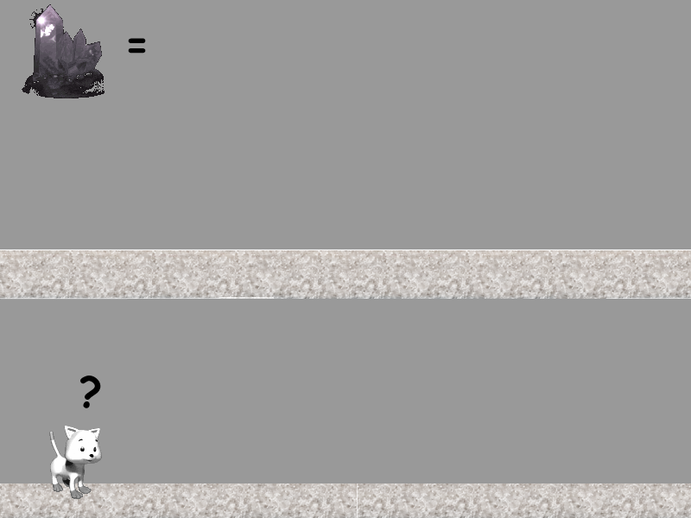

Game end
When kids have 25 power crystals they go to the mine to return the crystals to the miners and the space girl. Show a thought bubble from miners and girl with ILY.

