Storyboard- SeaHunt

Intro
Iris and kittens are asleep in water scene. Pirate goes by in rowboat and kittens disappear. Parrot flies through and drops treasure chest. Treasure chest pops open and PirateCat says in speech bubble “25 (pic of coins)”. Treasure chest shuts and fades out. Signer in corner signs “ Oh No, GhostPirate has stolen the kittens. He wants 25 gold coins to give the kittens back. Please help Iris collect 25 gold coins. The gold coins are in sunken ships. Inside the sunken ships are alligators, spiders , snakes and bad cats guarding the gold coins. You must tell Iris where the bad animal is. Iris will torpedo the villain and get the gold coin. Good luck”.
Iris’ submarine surfaces Iris gets in and dives in the water 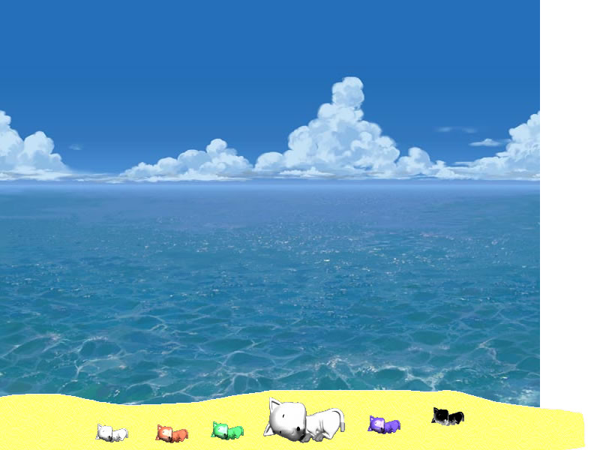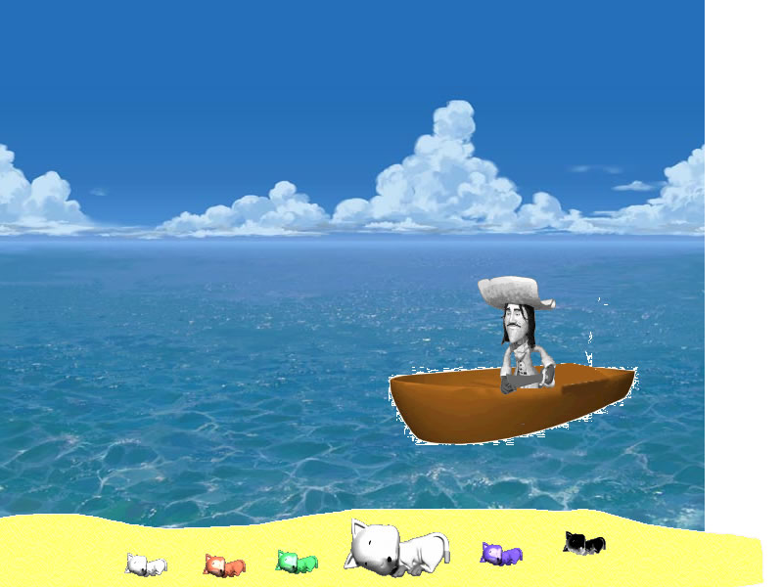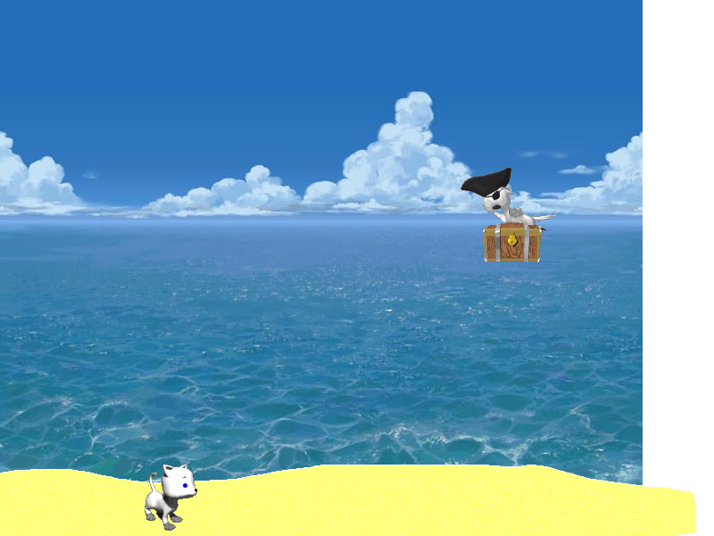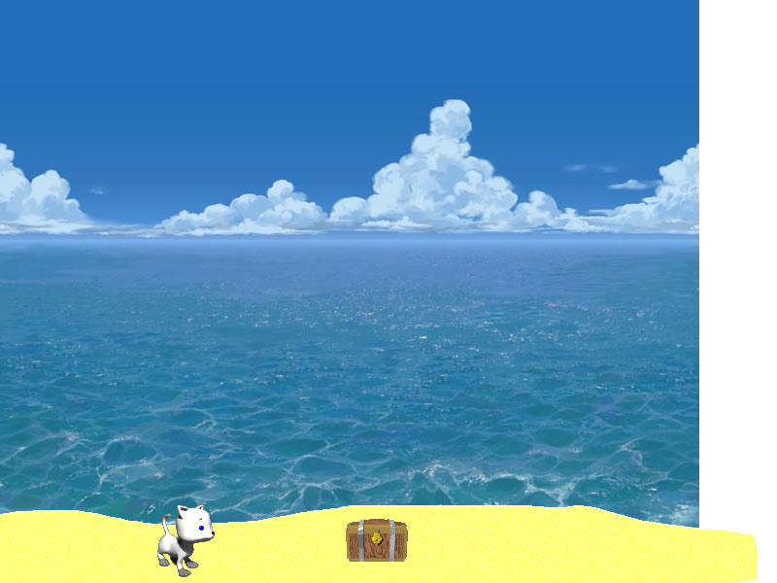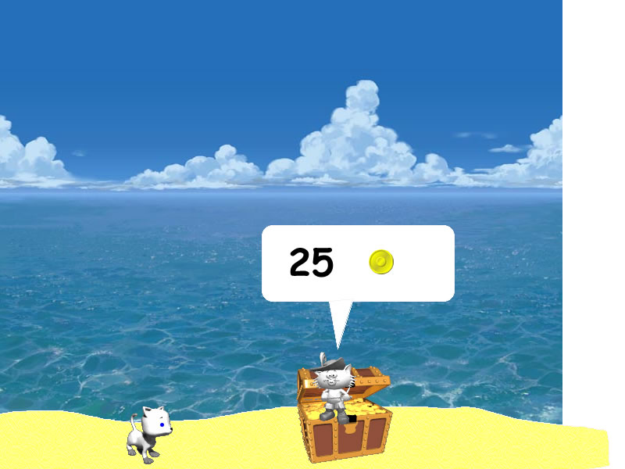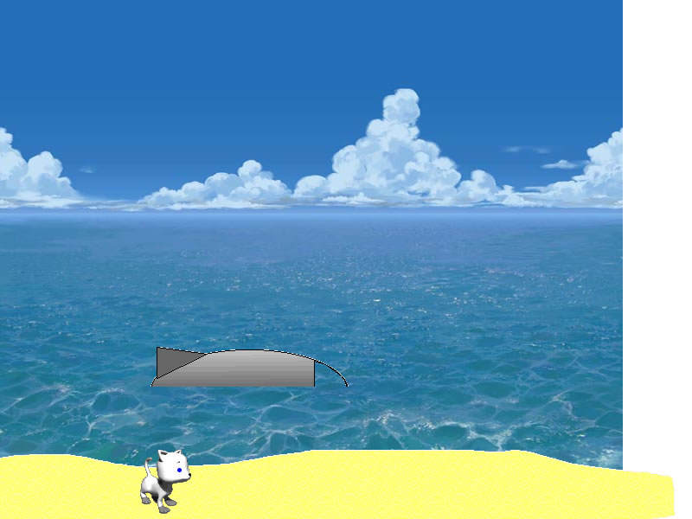
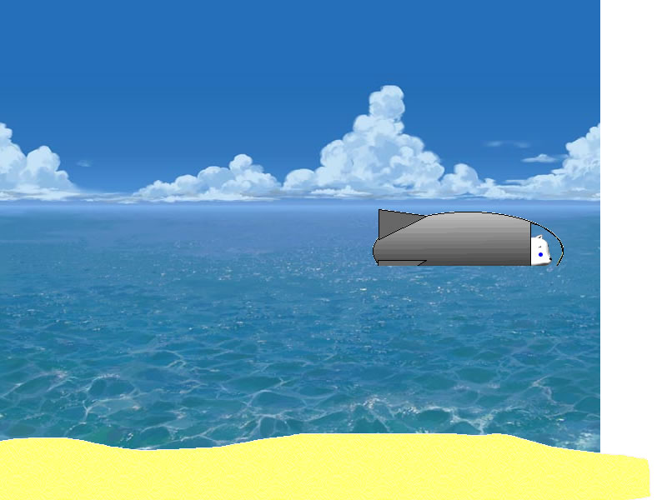

Submarine game
Have help video to side (sea hunt intro 2_copycat.mov) that plays first time kids see the submarine game that says

Iris flies submarine through water avoiding jellyfish to find sunken ship.(This should last about 15 seconds) When a jellyfish touches the sub it is electrified.
Sub reaches a sunken ship and enters through a hole then switch to room scene
(There needs to be 20 different sunken ships.(hjh will make them) )After kids get coin Iris goes out of sunken ship to find
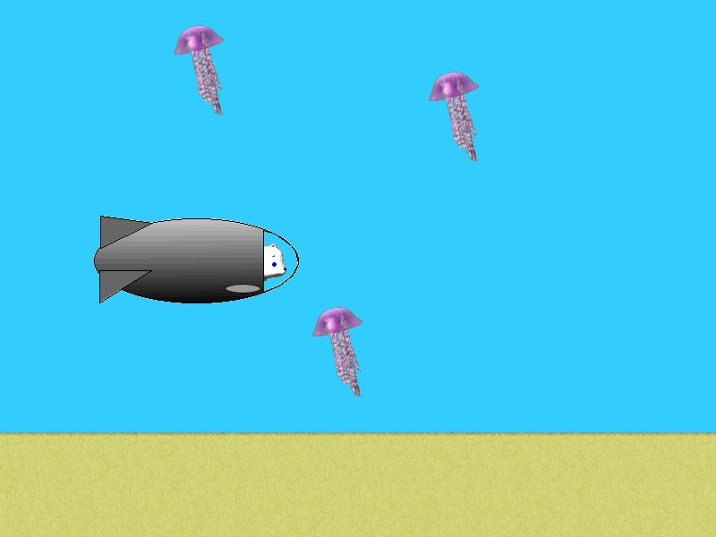
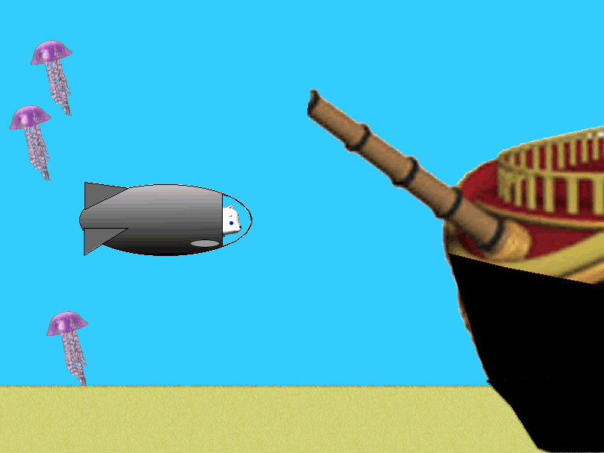
Scene switches to room scene
Room scene
When Iris enters room Kids can see who protects a gold coin (e.g., blue alligator) Kids tell Iris. If kids are wrong a question mark appears above her head. If correct Iris fires torpedo to poof villain (turns it to mermaids(in villains folder)) and gets gold coin. Gold coin flies over to score area and score increases by one . Iris goes forward out hole in ship to right 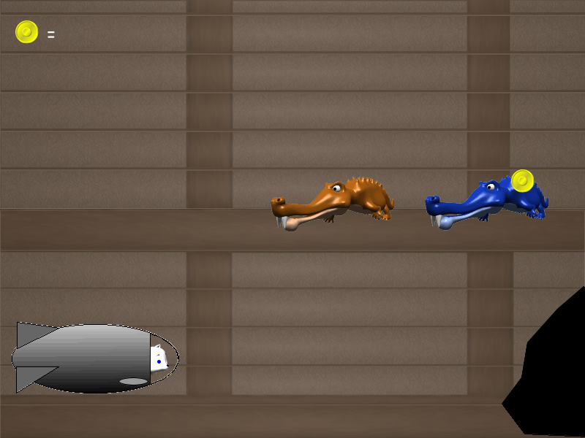.

Pirate Room
Occasionally when Iris enters a room she will be in a pirate scene. Iris shoots torpedo at Pirate parrot but BadCat shoots down torpedo with canon ball while parrot takes (maybe -5) gold coins which will be subtracted from total. When this is done the bad guys fade out and Iris goes out of sunken ship. (Make this animation)
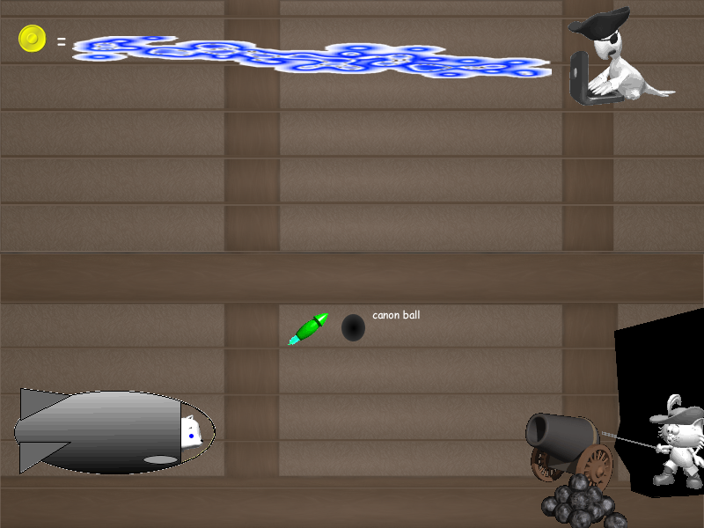

Bonus Room
There are 5 gold coins to be gotten to make up for the 5 the pirate stole.
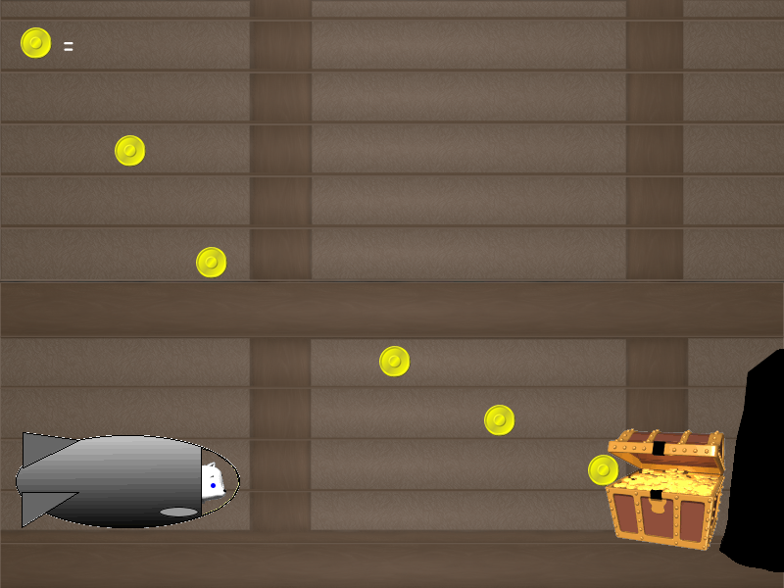

After Bonus room the Pirate room will appear or vice-versa so score is not affected. The rooms cancel each other out. After 5 coins go to score have treasure chest fade out

No gold coin room
Have a room where there are no villains or gold coins. It will simply be an animation in which Iris looks puzzled (? In thought bubble) and then goes out.
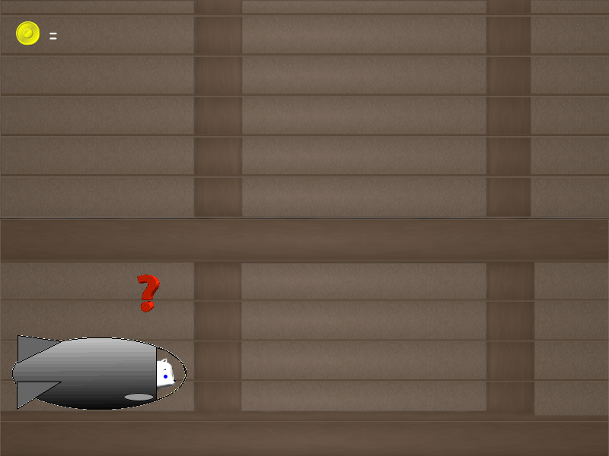

Game end
When kids have 25 gold coins they go to the kidnappers hideout to rescue the kittens and pull a “Puss in boots” trick so that the kittens go free and Iris keeps the gold coins. She turns the bad guys into mermaidses. Then fade to closing scene of Iris and kittens with ILY.

