**IBM – Coursera**

**Applied Data Science Specialization**

**Capstone project - The Battle of Neighborhoods (Week 4)**

**Correlation between neighborhood real estate price and its surrounding venues**

Table of content:

**I.** **Introduction:** 2

**II.** **Data description:** 3

**III.** **Methodology:** 5

**IV.** **Results:** 5

**V.** **Discussion:** 5

**VI.** **Conclusion:** 5

1. **Introduction:**

This report is for the final course of the IBM Data Science Professional Certificate. This is a 9-course package created by IBM in collaboration with Coursera. The problem is to analyze a real time problem with the tools learned in the course. The use of Foursquare API and mapping process, the use of correlations, training and testing the models to analyze any problem with limited or with huge data sets. The problem and the analysis approach are left for the learner to decide, with a requirement of leveraging the Foursquare location data to explore and/or compare neighborhoods or cities of your choice or to come up with a problem that you can use the Foursquare location data to solve for the client or a group of people who are interested in your project.

The main goal will be exploring the neighborhoods of New York city in order to extract the correlation between the real estate value and its surrounding venues.

The idea comes from the process of, any family searching a home to stay after moving to another city. It is common that the owners or agents advertise their properties are closed to some kinds of venues like supermarkets, restaurants, public transport, hospital, school or coffee shops, etc.; showing the “convenience” of the location in order to raise their house’s value to sale or rent.

So, can the surrounding venues affect the price of a house? If so, what types of venues have the most affect, both positively and negatively?

The target audience for this report are:

* Potential buyers who can roughly estimate the value of a house based on the surrounding venues and the average price.
* People who are looking for rented home after moving to another city.
* Real estate makers and planners who can decide what kind of venues to put around their products to maximize selling price.
* Houses sellers who can optimize their advertisements.
* And of course, to this course’s instructors and learners who will grade this project. Or to anyone who catch this shared on the social media showing that I can use Python data science tools.

1. **Data description:**

New York city neighborhoods were chosen as the observation target due to the following reasons:

* The availability of real estate prices. Though very limited.
* The diversity of prices between neighborhoods. For example, a 2-bedrooms condo in Central Park West, Upper West Side can cost $4.91 million on average; while in Inwood, Upper Manhattan, just 30 minutes away, it's only $498 thousands.
* The availability of geo data which can be used to visualize the dataset onto a map.

The type of real estate to be considered is 2-bedroom condo, which is common for most normal nuclear families.

The dataset will be composed from the following two main sources:

* CityRealty which provides the neighborhoods average prices. <https://www.cityrealty.com/nyc/market-insight/features/get-to-know/average-nyc-condo-prices-neighborhood-june-2018/18804>
* FourSquare API which provides the surrounding venues of a given coordinates.

The process of collecting and clean data:

* Scrap the CityRealty webpage for a list of New York city neighborhoods and their corresponding 2-bedroom condo average price.
* Find the geographic data of the neighborhoods. Both their center coordinates and their border.
* For each neighborhood, pass the obtained coordinates to FourSquare API. The “explore” endpoint will return a list of surrounding venues in a pre-defined radius.
* Count the occurrence of each venue type in a neighborhood. Then apply one hot encoding to turn each venue type into a column with their occurrence as the value.
* Standardize the average price by removing the mean and scaling to unit variance.

The result dataset is a 2 dimensions data frame (Figure 1):

* Each row represents a neighborhood.
* Each column, except the last one, is the occurrence of a venue type. The last column will be the standardized average price.

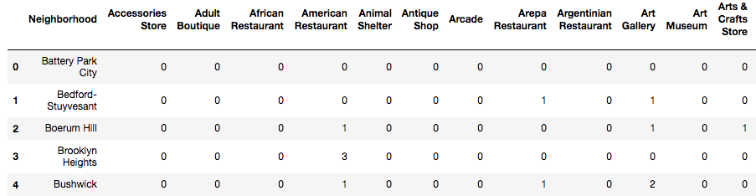

Figure 1- Final dataset

The dataset has 50 samples and more than 327 features. The number of features may vary for different runs due to FourSquare API may returns different recommended venues at different points in time.

The number of features is much bigger than the number of samples. This will cause problem for the analysis process. Detail and counter-measurement will be discussed further in the next sections.

1. **Methodology:**

To be prepare.

1. **Results:**

To be prepare.

1. **Discussion:**

To be prepare.

1. **Conclusion:**

To be prepare.