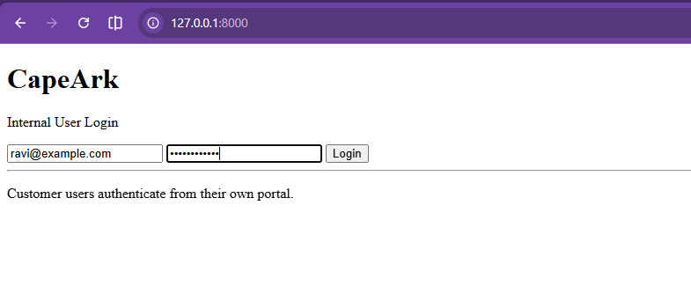
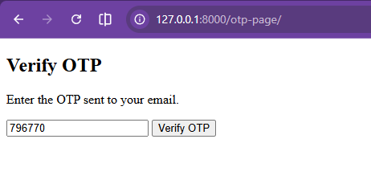
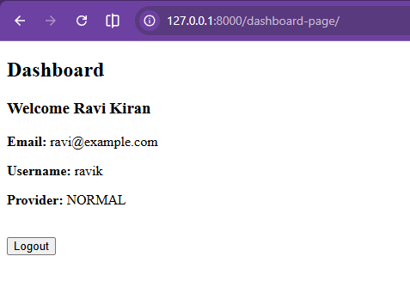
Post Logout
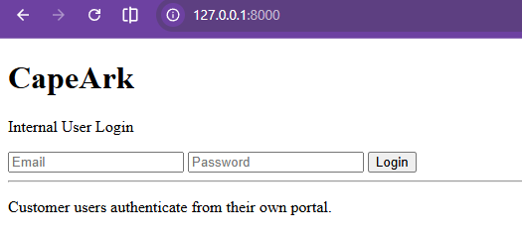
Django Admin – User details
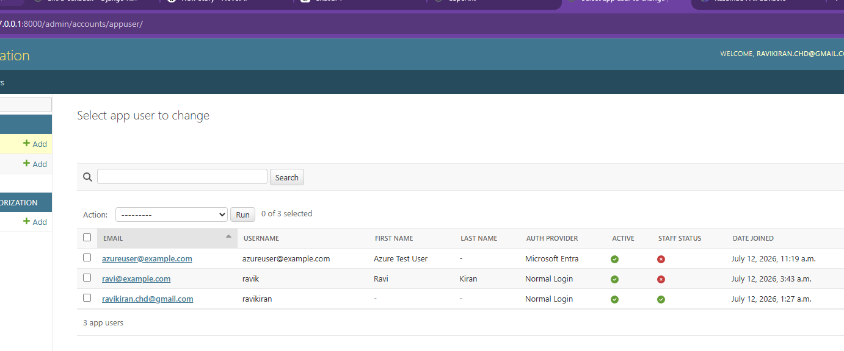
Mock Entra
http://127.0.0.1:8000/api/auth/entra/start
will redirect to
http://127.0.0.1:8000/api/auth/entra/callback/?code=mock-auth-code-123&state=mock-state-123
