Submitted by: RAVIKIRAN GOUD
IT Ticket Analysis | 97,498 tickets · 50 IT agents · 01-Jan-2016 to 31-Dec-2020 | Accompanying workbook: IT_Tickets_Analysis_RaviKiranGoud.xlsx

OBJECTIVE QUESTIONS

Question 1: What is the total no. of attributes present in the data?

Solution:

Final Answer (if any):
16 attributes in total — 10 in the Tickets sheet and 6 in the IT Agents sheet.

Approach (if any):
Counted the column headers of both source sheets.
• Tickets sheet (10): ID Ticket, Fecha, Employee ID, Agent ID, Request Category, Issue Type, Severity, Priority, Resolution Time (Days), Satisfaction Rate.
• IT Agents sheet (6): Agent ID, Full Name, Email, Year of Birth, Month of Birth, Day of Birth.
• Formula used: =COLUMNS(Tickets[#Headers]) → 10 and =COLUMNS(IT_Agents[#Headers]) → 6.

Charts & Tables (if any):
- Table / Chart Name:
Not applicable
- Description:
This is a structural count of the dataset; no chart is required.

Question 2: Which columns have inconsistent or missing values, and what is the count of such values?

Solution:

Final Answer (if any):
There are NO missing or blank values and no duplicate records anywhere in the data. The inconsistencies are 3 spelling errors across two categorical columns, affecting 34,602 records in total: Severity “3 - Mayor” (4,836 records) should be “3 - Major”; Severity “0 - Unclasified” (356 records) should be “0 - Unclassified”; and Priority “0 - Unassiged” (29,410 records) should be “0 - Unassigned”.

Approach (if any):
Checked for blanks with =COUNTBLANK() across both sheets — both returned 0.
• Checked for duplicate ticket IDs with =COUNTA(CleanData[ID Ticket])-SUMPRODUCT(1/COUNTIF(...)) — returned 0.
• Checked referential integrity: every Agent ID in Tickets exists in IT Agents — 0 orphans.
• Listed the distinct values of each categorical column, which exposed the three misspelt labels, and counted each with =COUNTIF().
• All three were corrected into clean Severity and Priority columns on the Cleaned Data sheet, with the original columns retained alongside them for traceability.
• ADDITIONAL FINDING — the Full Name column in the IT Agents sheet is also inconsistent, which is easy to miss because the column contains no blanks at all. 14 of the 50 names are defective: 7 are incomplete or malformed (JesusGrajeda, EstuardoTorres, A. Trejo, Javier D., Darwin E., Lorena, Melinda) and 7 more are reversed or carry stray punctuation (for example “Mata Lucero” against lucero.mata@…, and “Lopez Moran.”). Every name was rebuilt from the Email column, which is the only consistently formatted identifier in that sheet.

Charts & Tables (if any):
- Table / Chart Name:
Cleaned Data — data quality summary
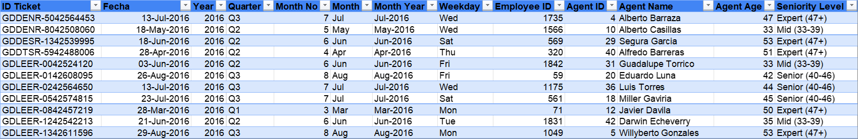
- Description:
Sample of the Cleaned Data sheet showing the corrected Severity (Clean) and Priority (Clean) columns alongside the original values.

Question 3: What is the average daily ticket volume over time?

Solution:

Final Answer (if any):
53 tickets per day on average.

Approach (if any):
Counted all tickets (97,498) and divided by the number of days between the earliest and latest ticket date (1,827 days, 01-Jan-2016 to 31-Dec-2020), then rounded.
• Formula used: =ROUND(COUNTA(CleanData[ID Ticket])/(MAX(CleanData[Fecha])-MIN(CleanData[Fecha])+1),0)
• 97,498 ÷ 1,827 = 53.4, which rounds to 53 tickets per day.

Charts & Tables (if any):
- Table / Chart Name:
Q-3 I Objective — Tickets per Year
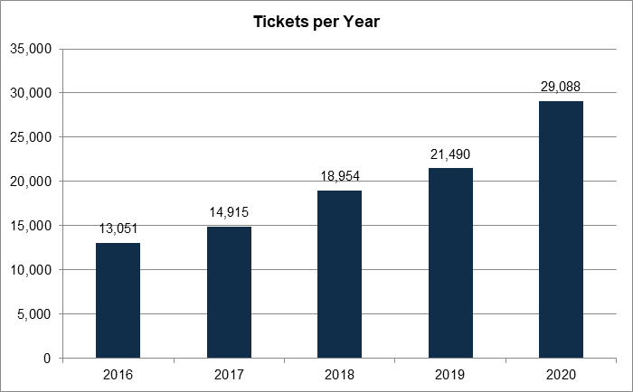
- Description:
Pivot table of ticket count by year with a column chart, showing how the daily average has risen over the five-year period.

Question 4: What is the distribution of ticket categories (e.g., Login Access, System, Software)?

Solution:

Final Answer (if any):
System 39,002 (40.0%) | Login Access 29,193 (29.9%) | Software 19,570 (20.1%) | Hardware 9,733 (10.0%) | Grand Total 97,498.

Approach (if any):
Built a pivot table with Request Category as the row field and Count of ID Ticket as the value field.
• Mapped a pie chart onto the pivot table to visualise each category's share of the total.
• System alone accounts for 40% of all tickets, making it the largest single source of IT workload.

Charts & Tables (if any):
- Table / Chart Name:
Q-4 I Objective — Distribution of Tickets by Category
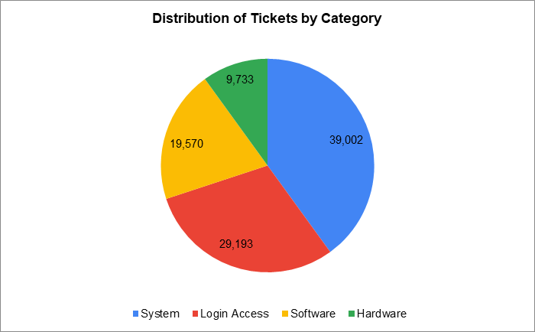
- Description:
Pie chart of ticket volume by request category, showing System at 40% and Hardware at only 10% of total volume.

Question 5: How many tickets has each agent handled?

Solution:

Final Answer (if any):
Workload is remarkably even: every agent handled between 1,856 and 2,027 tickets, averaging 1,950 — a spread of just 9%. Aurelio Tanori handled the most (2,027) and Griselda Galindo the fewest (1,856).

Approach (if any):
Built a pivot table with Agent Name as the row field and Count of ID Ticket as the value field, sorted from highest to lowest.
• The agent's name is resolved from the Agent ID using VLOOKUP against the IT Agents sheet — this is live in column K of the Tickets sheet.
• Formula used: =VLOOKUP($D2,'Cleaned Data'!$J:$K,2,0)
• This even distribution matters for the investment question: it shows the team has no capacity or allocation problem, so any difference in performance between agents is genuine rather than an artefact of unequal workload.

Charts & Tables (if any):
- Table / Chart Name:
Q-5 I Objective — Tickets Handled by Agent
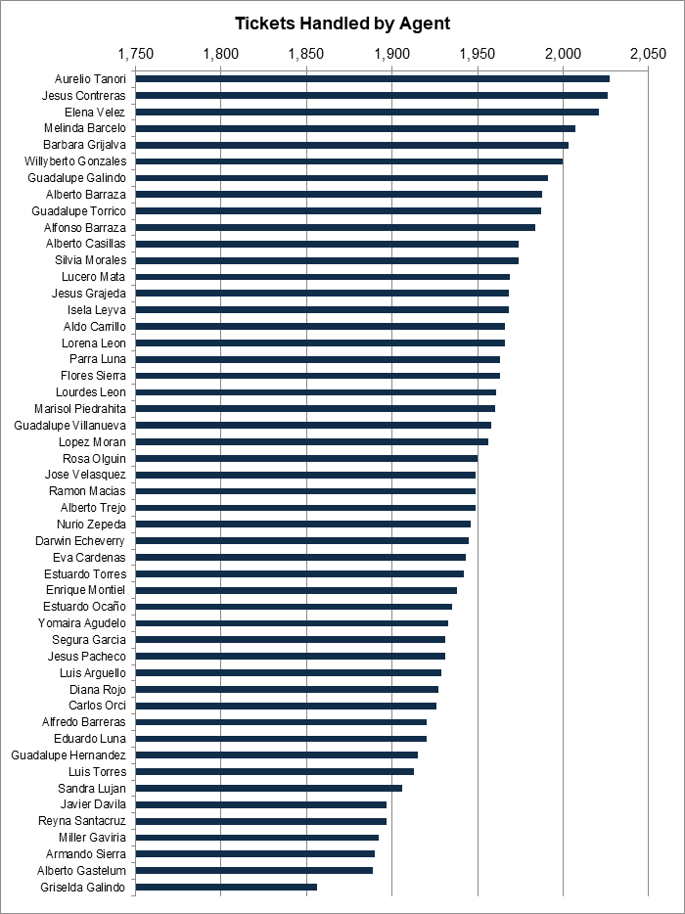
- Description:
Pivot table and bar chart of ticket count for all 50 agents, showing how tightly clustered the workload is.

Question 6: How can you extract the domain from the email addresses in the IT Agents sheet?

Solution:

Final Answer (if any):
fp20analytics — extracted with MID and FIND. All 50 agents share the same domain name (the full domain is fp20analytics.com).

Approach (if any):
Formula used: =MID(C2,FIND("@",C2)+1,FIND(".",C2,FIND("@",C2)+1)-FIND("@",C2)-1)
• FIND("@",C2) locates the position of the @ character in the email address.
• MID() then starts one character after the @ and returns the text from there.
• The length is the position of the dot that FOLLOWS the @, minus the position of the @, minus one — which stops the result just before the '.com' extension.
• IMPORTANT — the third argument of FIND (start_num) is what makes this work on this dataset. Every email here has a dot inside the local part (for example lucero.mata@fp20analytics.com), so a plain FIND(".",C2) returns that first dot, which sits BEFORE the @. That gives a negative length and a #VALUE! error on all 50 rows. Passing FIND("@",C2)+1 as start_num makes FIND search only from just past the @, so it finds the dot separating the domain name from its extension.
• A distinct count over the extracted column confirms a single domain across all 50 agents.

Charts & Tables (if any):
- Table / Chart Name:
Q-6 I Objective — Email Domain extraction
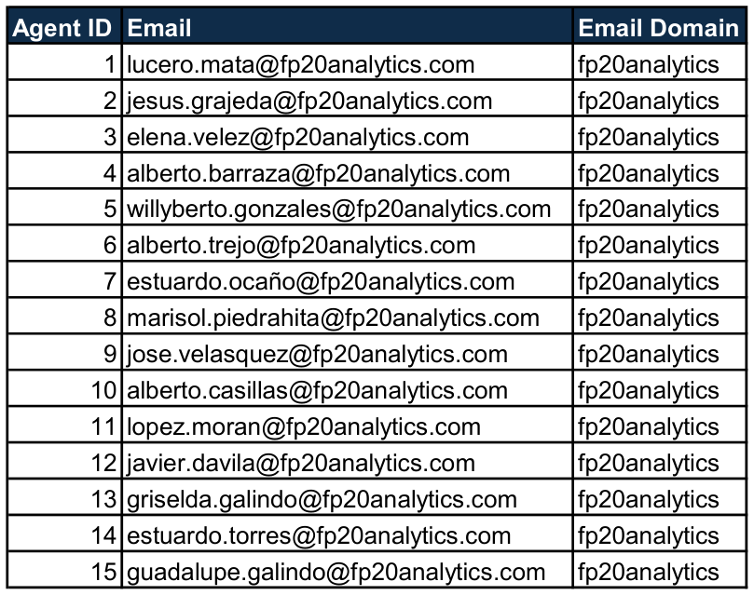
- Description:
Table showing each agent's email address alongside the domain name returned by the MID/FIND formula, with the .com extension removed.

Question 7: How can you find the full name of an agent given their Agent ID?

Solution:

Final Answer (if any):
Using VLOOKUP against the IT Agents sheet. For example, Agent ID 19 returns Alfonso Barraza (alfonso.barraza@fp20analytics.com).

Approach (if any):
Formula used: =VLOOKUP($D2,'Cleaned Data'!$J:$K,2,0)
• The Agent ID is the lookup value, the IT Agents table is the lookup range, the column index returns the name, and FALSE/0 forces an exact match.
• This is live in column K of the Tickets sheet (“Agent Name (objective question 7)”), so every one of the 97,498 tickets carries the agent's name resolved from their ID.

Charts & Tables (if any):
- Table / Chart Name:
IT Agents sheet
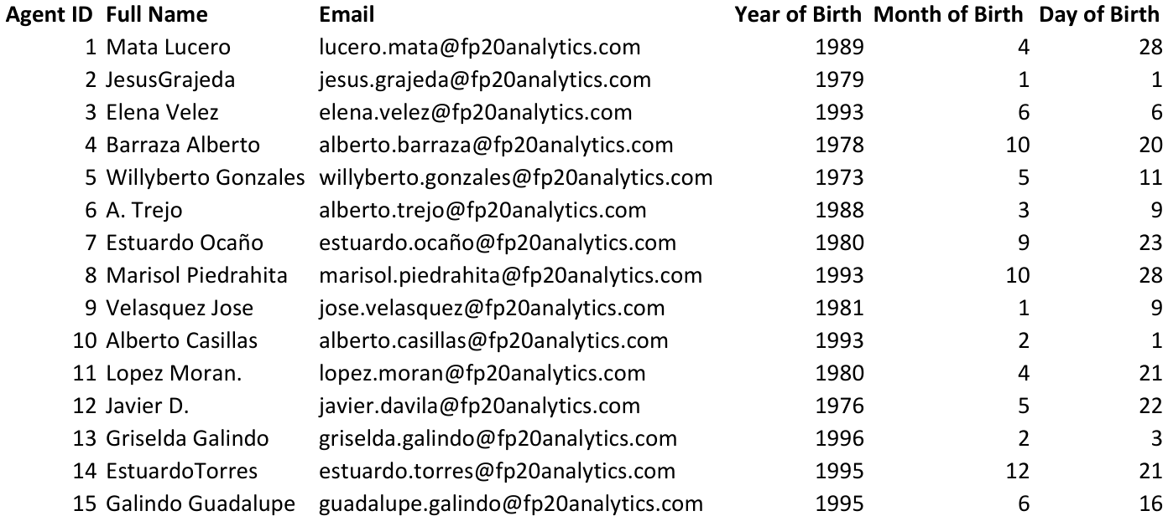
- Description:
The lookup table VLOOKUP resolves against, keyed on Agent ID.

Question 8: What is the count of each issue type (e.g., IT Error, IT Request)?

Solution:

Final Answer (if any):
IT Request = 73,220 tickets (75.1%) and IT Error = 24,278 tickets (24.9%).

Approach (if any):
Built a pivot table with Issue Type as the row field and Count of ID Ticket as the value field.
• Three out of every four tickets are service requests rather than genuine faults. This is directly relevant to the investment decision, because requests are far more automatable than errors and are the natural target for a self-service portal.

Charts & Tables (if any):
- Table / Chart Name:
Q-8 I Objective — Ticket Count by Issue Type
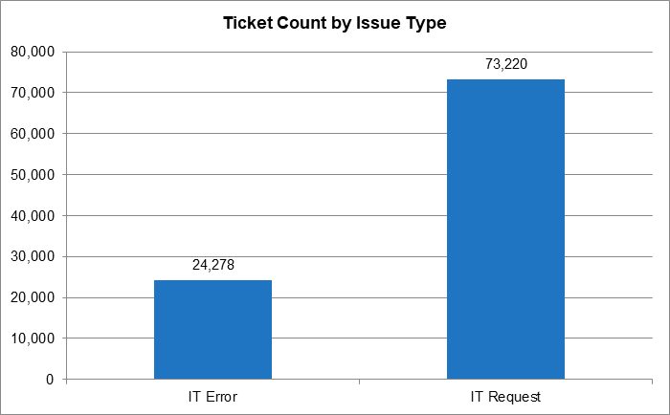
- Description:
Column chart comparing IT Request against IT Error volume.

Question 9: What is the average resolution time for tickets?

Solution:

Final Answer (if any):
4.55 days, i.e. an average of roughly 4.5 days per ticket. The median is 4 days, the maximum is 21 days, and 25,071 tickets (25.7%) are closed the same day they are raised.

Approach (if any):
Formula used: =ROUND(AVERAGE(CleanData[Resolution Time (Days)]),2)
• Functions used: AVERAGE() to compute the mean and ROUND() to present it to two decimals.
• MEDIAN() and MAX() were used as cross-checks, and the same-day count was derived with SUM() over a flag column.
• A quarter of all tickets resolving on the same day pulls the mean below the middle of the range, which is why the median and mean are close but the distribution is skewed.

Charts & Tables (if any):
- Table / Chart Name:
Q-9 I Objective — Avg Resolution Time by Category
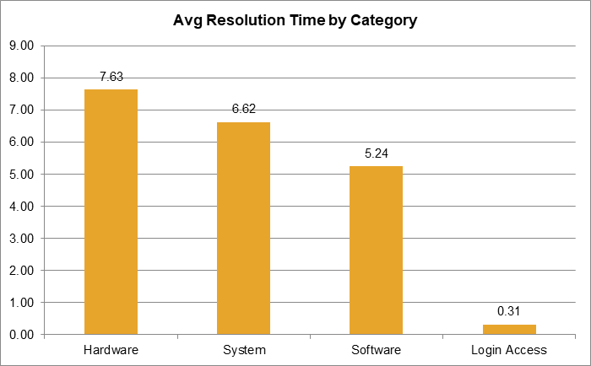
- Description:
Pivot table and column chart breaking the overall 4.55-day average down by request category, revealing a very wide spread behind that single figure.

Question 10: How has the volume of tickets changed over time?

Solution:

Final Answer (if any):
Ticket volume has grown continuously and steeply — it more than doubled, rising from 13,051 tickets in 2016 to 29,088 in 2020, an increase of 122.9%.

Approach (if any):
Built pivot tables of ticket count by Year and by Year/Quarter, plotted as line charts.
• Year-on-year growth: 2017 +14.3%, 2018 +27.1%, 2019 +13.4%, 2020 +35.4%.
• Every single year is higher than the one before it, and 2020 showed the sharpest acceleration, with December 2020 the busiest single month on record.
• There is no year in which demand fell, so this is sustained structural growth rather than a seasonal spike.

Charts & Tables (if any):
- Table / Chart Name:
Q-10 I Objective — Volume of Tickets Over Time
Q-10 I Objective — Quarterly Ticket Volume
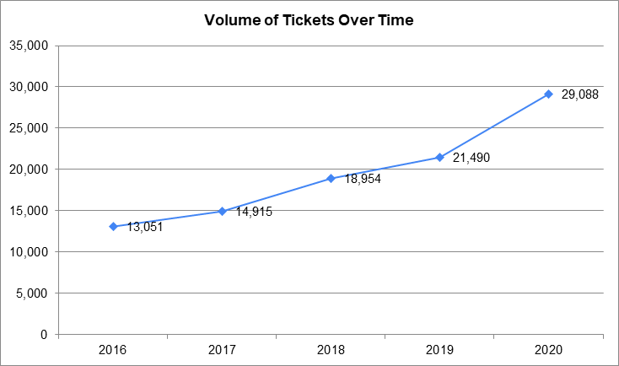
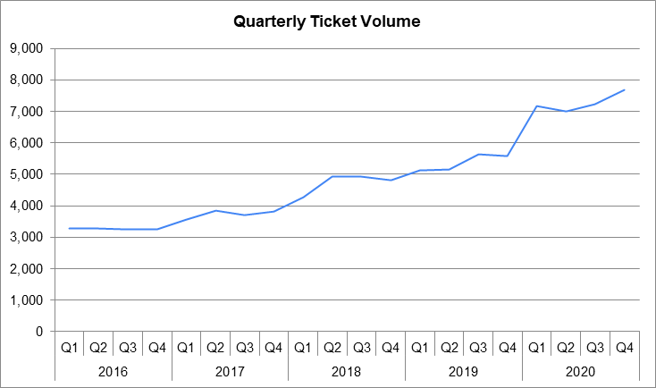
- Description:
Line chart of annual ticket volume from 2016 to 2020, showing continuous growth.
Quarterly view of the same trend, confirming growth is steady rather than driven by one unusual quarter.

Question 11: What is the average age of the IT agents?

Solution:

Final Answer (if any):
41 years is the average age of the 50 IT agents (youngest 29, oldest 54).

Approach (if any):
The date of birth was first assembled from the three separate birth columns using DATE().
• Age in whole years was then measured against TODAY() using DATEDIF().
• Formula used: =DATEDIF(DATE(D2,E2,F2),TODAY(),"Y")
• The ages were averaged with AVERAGE() and presented with ROUND(): =ROUND(AVERAGE(G13:G62),0)
• Because the Age column uses TODAY() it stays current as the workbook ages. Measured instead at the end of the data window (31-Dec-2020), the average age was 35.9 years.

Charts & Tables (if any):
- Table / Chart Name:
Q-11 I Objective — Agent age calculation
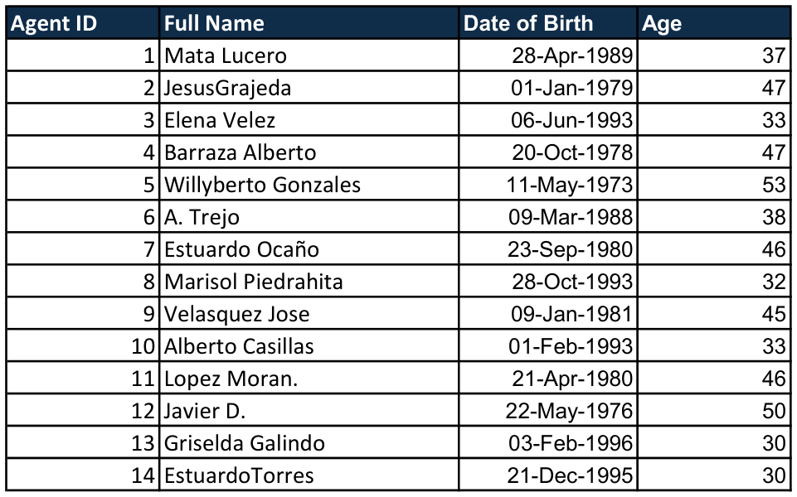
- Description:
Table showing each agent's constructed date of birth and the age returned by DATEDIF.

Question 12: Is there a correlation between the severity of issues and the resolution time?

Solution:

Final Answer (if any):
The correlation is −0.040536 — a very weak negative correlation, meaning there is effectively no linear relationship between the severity of an issue and how long it takes to resolve. Severity has almost no bearing on resolution time.

Approach (if any):
A numeric Severity Level (0 = Unclassified through 4 = Urgent) was derived from the Severity label so that a correlation could be calculated against a text field.
• Formula used: =CORREL(CleanData[Severity Level],CleanData[Resolution Time (Days)])
• INTERPRETATION — a value this close to zero means severity and resolution time move almost independently. More seriously, what little relationship exists runs the WRONG WAY: the supporting pivot shows Urgent tickets closing fastest at 2.00 days while ordinary Normal tickets take the longest at 4.66 days, and Major tickets (3.91 days) are also resolved faster than Normal ones.
• In a healthy triage process severity and speed would move together and this correlation would be strongly negative. This is direct evidence that prioritisation in the current ticketing tool is not working as intended, and it becomes a central plank of the investment recommendation in subjective questions 1 and 4.

Charts & Tables (if any):
- Table / Chart Name:
Q-12 I Objective — Severity vs Avg Resolution Time
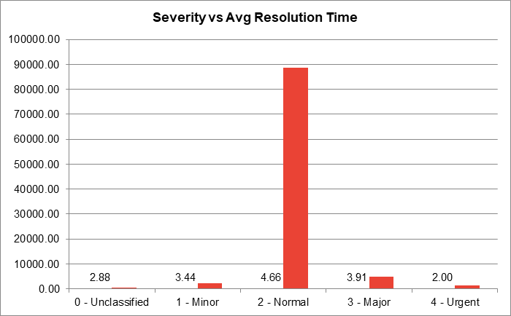
- Description:
Column chart of average resolution time by severity level, showing the inversion: Normal tickets are the slowest of all.

Question 13: How many categorical columns are there in the data? [Search about categorical and continuous data, and try to answer this question]

Solution:

Final Answer (if any):
9 categorical columns across the two sheets under the assumptions stated below — 4 label columns in Tickets (Request Category, Issue Type, Severity, Priority), 1 discrete rating scale (Satisfaction Rate), and 4 in IT Agents (Full Name, Email, Month of Birth, Year of Birth). Counting the derived and binned fields as well takes the total to 13.

Approach (if any):
DEFINITION — categorical data places each record into a named group or label and cannot be used meaningfully in arithmetic (you cannot average 'Hardware'). Continuous data is numeric and can take any value in a range, so sums and averages are meaningful.
• ASSUMPTION 1 — a discrete rating scale is treated as categorical (ordinal). Satisfaction Rate only ever takes the five values 1 to 5, and the gap between 4 and 5 is not guaranteed to equal the gap between 1 and 2, so it is an ordered category rather than a true measurement. It is still averaged in this project, which is standard practice, but it is counted as categorical here.
• ASSUMPTION 2 — date-part and identifier fields on the IT Agents sheet are categorical. Month of Birth (1 to 12) and Year of Birth are stored as numbers but only ever act as groups; averaging them is meaningless. Full Name and Email are nominal text labels.
• ASSUMPTION 3 — a continuous field becomes categorical once binned. Resolution Time (Days) is continuous in its raw form, but the derived Resolution Bucket (Same day / 1-2 / 3-5 / 6-10 / 11+) is categorical, as is the Seniority Level banded from agent age.
• TICKETS SHEET — Request Category (nominal, 4 values); Issue Type (nominal, 2); Severity (ordinal, 5); Priority (ordinal, 4); Satisfaction Rate (ordinal rating, 5).
• IT AGENTS SHEET — Full Name (nominal, 50); Email (nominal, 50); Month of Birth (ordinal, 12); Year of Birth (ordinal, 24 distinct values).
• DERIVED DURING CLEANING, taking the count to 13 — Email Domain, Resolution Bucket, Seniority Level and Agent Name are all categorical fields created on the Cleaned Data sheet and used throughout the dashboard.
• NOT CATEGORICAL — Resolution Time (Days) in its raw form is continuous; Fecha is a date; and ID Ticket, Employee ID and Agent ID are identifiers that happen to be stored as numbers but are never analysed as quantities.
• Severity and Priority are ordinal rather than nominal because their categories carry a meaningful rank order (Minor to Normal to Major to Urgent). That is exactly why a numeric Severity Level could legitimately be derived to make the correlation in question 12 possible.

Charts & Tables (if any):
- Table / Chart Name:
Cleaned Data — categorical and derived fields
- Description:
The Cleaned Data sheet, showing the categorical columns carried through from the source alongside the derived ones (Severity (Clean), Priority (Clean), Resolution Bucket and Seniority Level).

SUBJECTIVE QUESTIONS

Question 1: If there is an investment, should it be used to hire more IT agents, improve training programs, or upgrade ticket management software?

Analysis: Perform a cost-benefit analysis using ticket resolution and satisfaction metrics.

Solution:

Approach:
A cost-benefit analysis compares the total expected cost of each option against its total expected benefit, so the option delivering the most value per rupee can be identified. Each of the three options was scored against the two metrics the business actually cares about — resolution time and satisfaction rate — using evidence drawn from this dataset rather than general assumptions.
• OPTION 1 — HIRE MORE IT AGENTS. Cost: HIGH and recurring (salaries, benefits, recruitment, infrastructure). Evidence: workload is already almost perfectly level — all 50 agents handled 1,856–2,027 tickets, averaging 1,950, a spread of only 9%. Impact on resolution time: LOW. Impact on satisfaction: LOW. Time to impact: 3–6 months.
• OPTION 2 — IMPROVE TRAINING PROGRAMMES. Cost: MODERATE and one-off (course design plus agent time away from the queue). Evidence: satisfaction varies hugely by agent on identical workloads — Agent 19 averages 3.04 while Agent 34 averages 4.60, a 1.56-point gap; resolution time ranges from 3.60 to 5.55 days. Impact on resolution time: MEDIUM-HIGH. Impact on satisfaction: HIGH. Time to impact: 1–3 months.
• OPTION 3 — UPGRADE TICKET MANAGEMENT SOFTWARE. Cost: HIGH up-front (licensing, migration, customisation, retraining). Evidence: 29,410 tickets (30.2%) were never assigned a priority, and severity correlates −0.04 with resolution time, so triage and routing are demonstrably broken; volume also grew 123% in five years. Impact on resolution time: HIGH in the long run. Impact on satisfaction: MEDIUM. Time to impact: 6–18 months.
• TRACEABILITY — every figure quoted in the table above is derived on the Q-1 I Subjective sheet rather than typed in: an Agent Name pivot with live MIN, MAX and AVERAGE formulas produces the 1,856-2,027 range and the 9.2% spread; a Priority pivot read with GETPIVOTDATA produces the 29,410 unassigned tickets and their 30.2% share; and a live CORREL produces the -0.0405 severity-to-resolution correlation.

Charts & Tables:
- Table / Chart Name:
Q-1 I Subjective — Cost-Benefit Analysis table
Q-1 I Subjective — Volume, Resolution Time and Satisfaction by Category
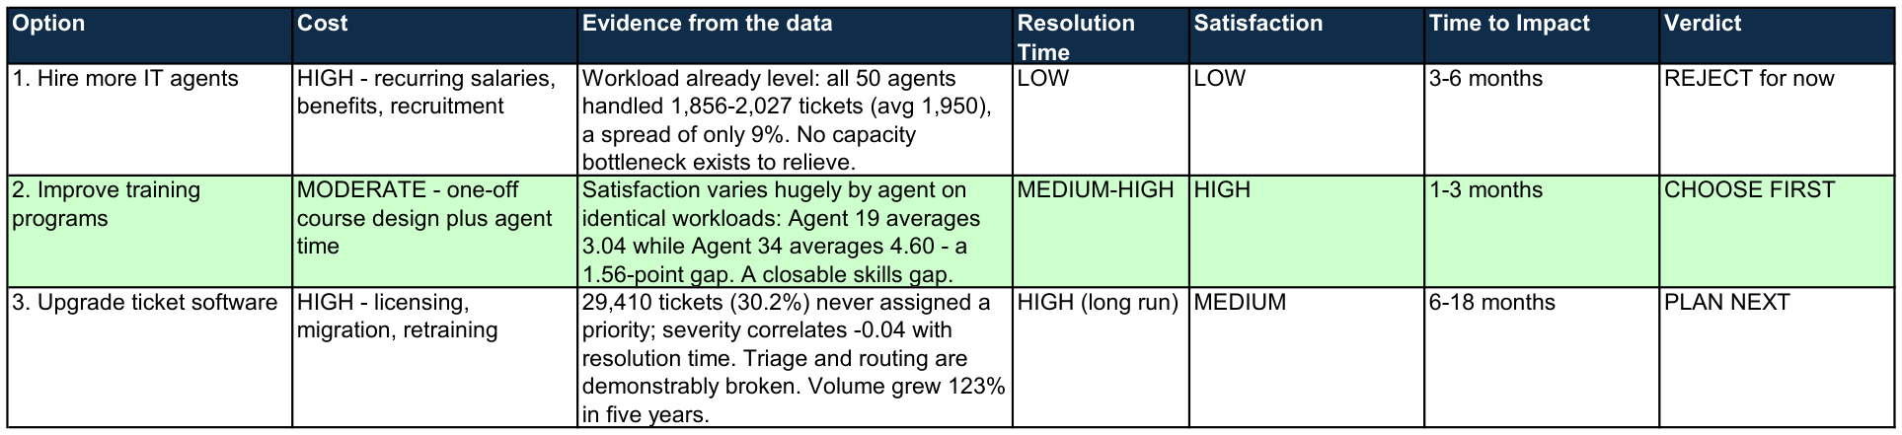
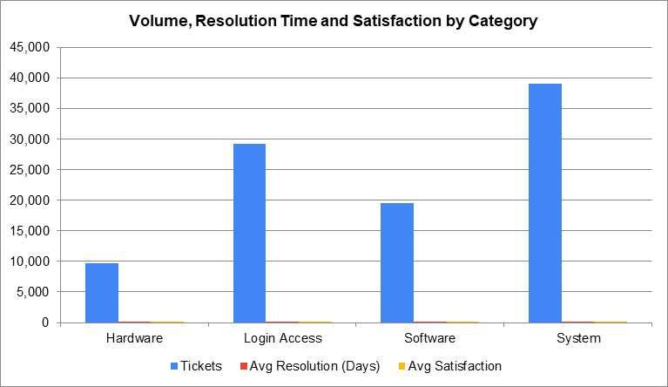
- Description:
The three investment options scored side by side on cost, evidence, impact and time to impact, with the recommended option highlighted.
Pivot table and chart underpinning the cost-benefit scoring, showing where volume and delay actually sit.

Insights:
This is not a capacity problem. Workload per agent varies by only 9% across all 50 agents, so adding people would add permanent cost without removing a bottleneck.
• It is a consistency problem. Two agents carrying identical caseloads differ by 1.56 points of satisfaction and nearly two days of resolution time — a gap that training can close.
• It is also a tooling problem. 30.2% of tickets carry no priority at all and Urgent work is resolved faster than Normal work, which no amount of training can fix.

Recommendations:
SHORT TO MEDIUM TERM — invest in TRAINING first. It offers the highest return per rupee, at moderate one-off cost, and the result is measurable within a quarter. Lifting the weakest quartile of agents to the current team median is effectively free capacity and better service at the same headcount.
• MEDIUM TO LONG TERM — fund the TICKET MANAGEMENT SOFTWARE UPGRADE as the second phase. Training cannot fix a tool that lets 30% of tickets through with no priority. With volume up 123% in five years and still accelerating, automation and correct routing are what make the operation scalable.
• HOLD ON HIRING. Revisit it only once both of the above are complete and volume per agent genuinely exceeds capacity.

Question 2: Which agents need additional training based on their performance metrics?

Analysis: Identify agents with the lowest satisfaction ratings and longest resolution times.

Solution:

Approach:
Agents were ranked on the two performance metrics available — average satisfaction rating and average resolution time — using a pivot table with Agent Name as the row field. Because every agent handles a near-identical caseload of 1,856-2,027 tickets, these averages are directly comparable with no volume adjustment, which is what makes the comparison trustworthy.
• COMBINED METRIC — ranking on either measure alone produces two different top-5 lists, so a combined score was calculated for every agent: Average Satisfaction divided by Average Resolution Time. A low ratio means the agent is both slower AND less well rated, which is the strongest single case for training. It is computed live in column E alongside the agent pivot on the Q-2 I Subjective sheet.
• BALANCED TRAINING PRIORITY, lowest combined ratio first: Alfonso Barraza 0.609 (3.04 satisfaction, 5.00 days); Lorena Leon 0.658 (3.63, 5.51); Nurio Zepeda 0.668 (3.61, 5.41); Elena Velez 0.672 (3.62, 5.38); Alberto Trejo 0.675 (3.59, 5.32). For contrast the best performer, Diana Rojo, scores 1.264 — more than double the weakest.
• CORRELATION CHECK — the correlation between each agent's average satisfaction and their average resolution time is -0.40, a moderate negative relationship. This is an important correction to the simpler reading: although the two top-5 lists do not overlap, the problems are NOT independent. Across the team as a whole, slower agents do tend to be rated lower, which is precisely why the combined ratio is a fairer selection basis than either list on its own.
• LOWEST AVERAGE SATISFACTION (team average 4.10): Alfonso Barraza (ID 19) 3.04; Alberto Trejo (ID 6) 3.59; Sandra Lujan (ID 25) 3.60; Nurio Zepeda (ID 28) 3.61; Elena Velez (ID 3) 3.62.
• LONGEST AVERAGE RESOLUTION TIME (team average 4.55 days): Jesus Contreras (ID 39) 5.55; Estuardo Ocano (ID 7) 5.52; Lorena Leon (ID 22) 5.51; Ramon Macias (ID 50) 5.45; Lucero Mata (ID 1) 5.45.
• TICKET-TYPE BREAKDOWN — a Request Category pivot on the same sheet shows where the technical training should be aimed: Hardware 7.63 days and System 6.62, against Software 5.24 and Login Access 0.31.

Charts & Tables:
- Table / Chart Name:
Q-2 I Subjective — Combined performance metric (Satisfaction / Resolution)
Q-2 I Subjective — Agents needing training
Q-2 I Subjective — Avg Satisfaction by Agent (lowest first)
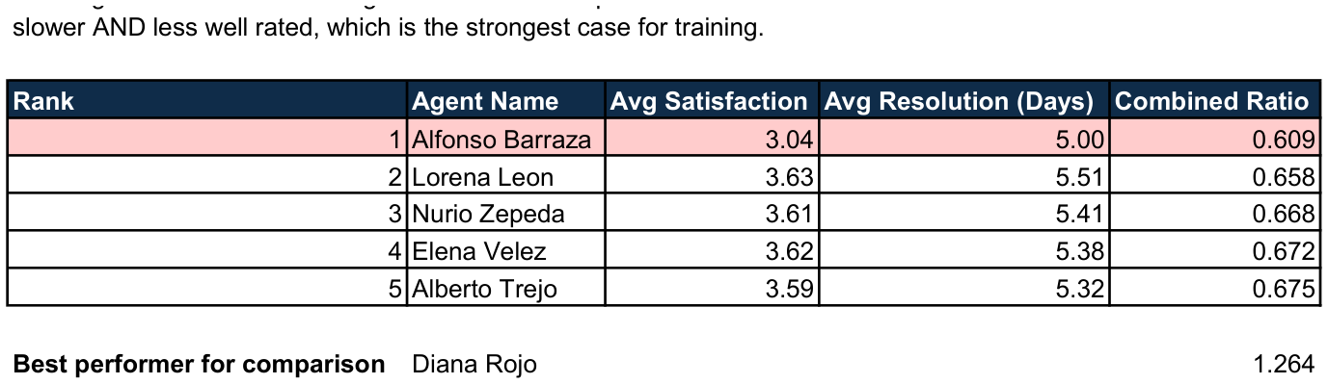
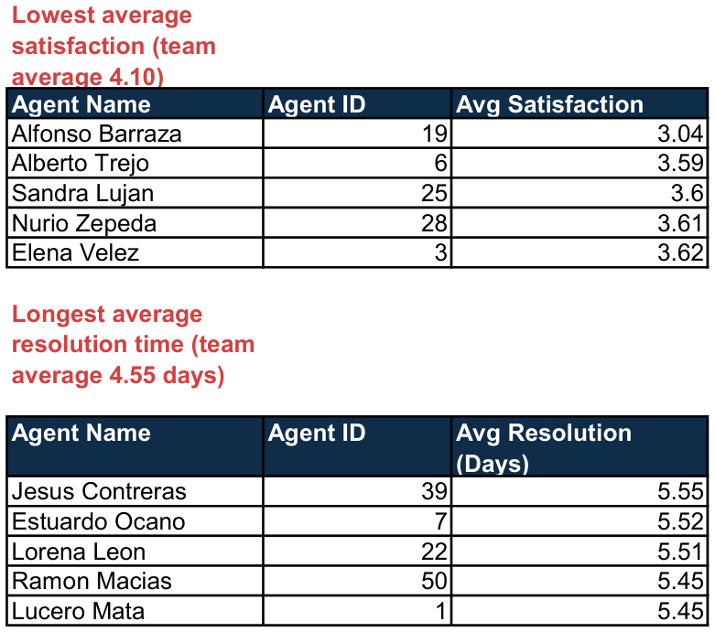
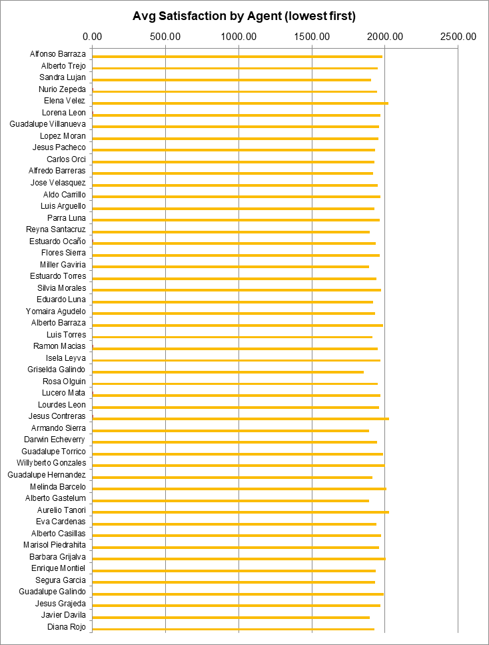
- Description:
The balanced training priority list, ranked by the combined ratio, with the best performer shown for comparison. Computed live from the agent pivot on the sheet.
The two ranked tables (lowest average satisfaction and longest average resolution time), each with the gap against the team average.
Bar chart of all 50 agents ranked by average satisfaction, making the size of the gap between the weakest and the rest immediately visible.

Insights:
The combined ratio identifies a better-balanced training list than either single metric. Alfonso Barraza is worst on every measure, but Lorena Leon and Elena Velez only rise into the priority five once both dimensions are weighed together.
• The two problems are related, not independent: the agent-level correlation between satisfaction and resolution time is -0.40, so slower agents do tend to be rated lower.
• Even so, the extreme top-5 lists do not overlap, which means the right remedy still differs by individual. The ratio tells you who to train; the two component metrics tell you what to train them on.
• Agent 19 at 3.04 sits 1.06 points below the team average and has the lowest combined ratio of all 50 agents — the clearest single training priority in the organisation.
• The gap is not explained by workload (all agents within 9%), nor by age or seniority (see subjective question 8) — it is individual, so it responds to individual coaching.

Recommendations:
PRIORITY 1 — coach the five lowest combined-ratio agents first (all below 0.68, against a team best of 1.264). Alfonso Barraza is the clearest case and should be first.
• Split the programme by cause, using the component metrics: soft-skills training (communication, empathy, expectation-setting, post-resolution follow-up) for those weak on satisfaction, and technical and process training for those weak on speed.
• Aim the technical training at Hardware and System tickets specifically — the category pivot on this sheet shows those two run at 7.63 and 6.62 days against 0.31 for Login Access, so that is where an agent's time is actually lost.
• Pair both groups with the proven top performers — Diana Rojo (ratio 1.264) and Jesus Grajeda (1.244) — as mentors, so best practice spreads internally at no extra cost.
• THRESHOLD AND REVIEW — re-measure the combined ratio one quarter after training and target every agent above 0.75, which would lift the bottom five to roughly the current team median.

Question 3: Do certain categories of requests have longer resolution times?

Analysis: Analyze the resolution times by request category.

Solution:

Approach:
Built a pivot table of average Resolution Time by Request Category, alongside ticket volume and average satisfaction for the same categories.
• Cross-checked the result against the severity correlation from objective question 12 (−0.04) to establish which field actually drives resolution time.
• Average resolution time by category: Hardware 7.63 days; System 6.62 days; Software 5.24 days; Login Access 0.31 days.

Charts & Tables:
- Table / Chart Name:
Q-3 I Subjective — Request Category vs Avg Resolution Time
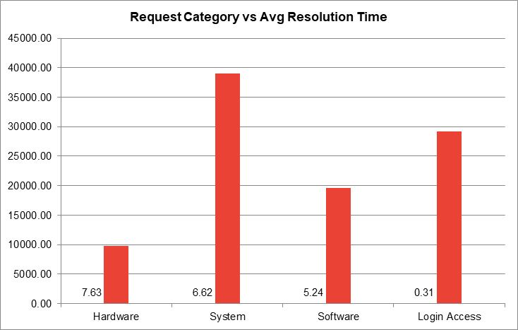
- Description:
Column chart of average resolution time by request category, showing the 25-fold gap between Hardware and Login Access.

Insights:
Yes — dramatically so. Hardware tickets average 7.63 days while Login Access closes in 0.31 days, a 25-fold difference between the slowest and fastest category.
• This is the single strongest driver of resolution time in the entire dataset. For comparison, severity — the field that is supposed to govern urgency — correlates with resolution time at just −0.04. Category, not severity, determines how long a ticket takes.
• System is the most important target by absolute impact: at 39,002 tickets (40% of all volume) and 6.62 days, it carries by far the largest pool of recoverable delay.
• Login Access proves that automation works in this organisation — 29,193 tickets resolved almost instantly.

Recommendations:
Learn from the Login Access success: identify the automation or self-service path that makes it fast and port that pattern to other categories.
• Focus on Hardware and System, which together hold 48,735 tickets at 6.6–7.6 days each — specialist technical training, dedicated expert teams, better spare-parts and asset management, and vendor SLAs on repair turnaround.
• Prioritise System specifically because of its high volume: even a small percentage improvement there outweighs a large improvement on Hardware.

Question 4: How effective are the current software tools in managing IT tickets?

Analysis: Evaluate performance metrics before and after the implementation of new tools.

Solution:

Approach:
The dataset contains no before/after marker for a tool implementation, so a true pre/post comparison is not possible. Instead the current tool was judged on the operational signatures it leaves in the data — whether tickets are correctly prioritised, whether urgency drives speed, and whether the process captures what it should.
• Built pivot tables of average resolution time by severity and of ticket volume by priority, and re-used the severity/resolution correlation from objective question 12.

Charts & Tables:
- Table / Chart Name:
Q-4 I Subjective — Severity vs Avg Resolution Time (the inversion)
Q-4 I Subjective — Priority vs Ticket Volume (30% unassigned)
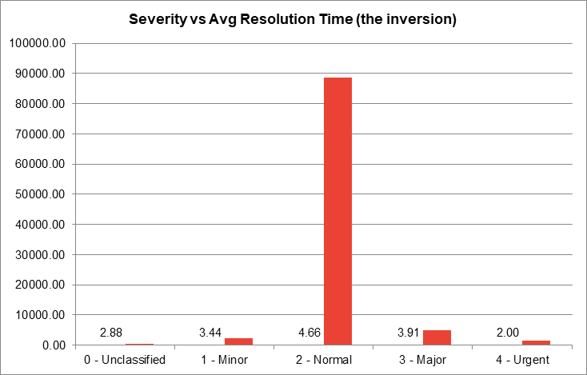
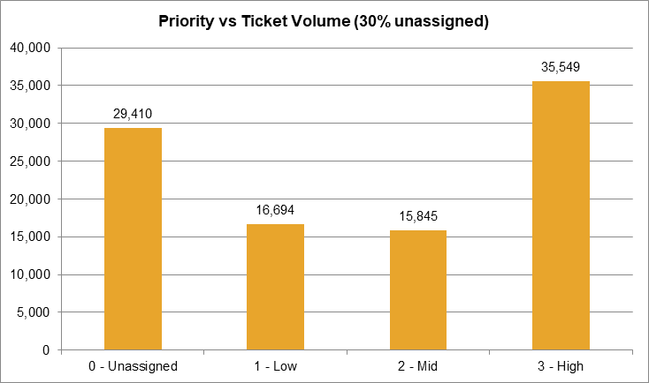
- Description:
Column chart showing Normal tickets resolving more slowly than Major and Urgent ones — the opposite of what correct triage would produce.
Column chart of ticket volume by priority, showing 29,410 tickets logged with no priority assigned at all.

Insights:
FAILURE 1 — PRIORITISATION IS INVERTED. Urgent tickets resolve in 2.00 days and Major in 3.91 days, but ordinary Normal tickets take 4.66 days, the slowest of any severity. The severity-to-resolution correlation is −0.04, effectively zero. Either the routing rules are misconfigured, or agents are bypassing them.
• FAILURE 2 — INCOMPLETE DATA CAPTURE. 29,410 tickets (30.2% of everything logged) carry a priority of “Unassigned”. Nearly one ticket in three enters the queue with no direction at all, which makes correct sequencing impossible. This is a straightforward configuration fault: the tool permits a ticket to be created without a mandatory priority.
• FAILURE 3 — NO PROTECTION AGAINST COMPLEXITY. Hardware sits at 7.63 days and System at 6.62 days, with no evidence over five years of escalation paths or specialist routing pulling those numbers down — the yearly average has stayed flat at roughly 4.5 days throughout, even as volume more than doubled.
• WHAT IS WORKING — the tool handles routine, high-volume, low-complexity work very well. Login Access at 0.31 days across 29,193 tickets indicates effective automation on that path, and satisfaction held between 3.98 and 4.16 while volume doubled, so the tool is not obstructing service quality. The problem is confined to prioritisation, mandatory field capture and complex-ticket routing.

Recommendations:
Make priority a mandatory field at ticket creation — no ticket should be creatable without one. This alone addresses 30% of the queue and is the cheapest fix available.
• Rebuild the prioritisation and SLA rules so that severity genuinely drives sequencing, then track the severity-to-resolution correlation as a standing health metric; it should move firmly negative.
• Add automated routing of Hardware and System tickets to specialists, with escalation triggers on ageing tickets.
• Conduct a workflow deep-dive on Hardware, System and Software to find the specific bottlenecks behind their multi-day resolution times.

Question 5: How has the performance of the IT support team changed over time (e.g., monthly or quarterly)?

Analysis: Trend analysis using time series charts.

Solution:

Approach:
Time-series analysis of average resolution time and average satisfaction rate by quarter across the full five years, using pivot tables grouped by Year and Quarter and plotted as line charts.
• Yearly averages: resolution time 4.55, 4.53, 4.56, 4.52, 4.59 days for 2016 to 2020; satisfaction 3.98, 4.07, 4.09, 4.12, 4.16 over the same period, against volume rising from 13,051 to 29,088 tickets.

Charts & Tables:
- Table / Chart Name:
Q-5 I Subjective — Quarterly Average Resolution Time
Q-5 I Subjective — Quarterly Average Satisfaction Rate
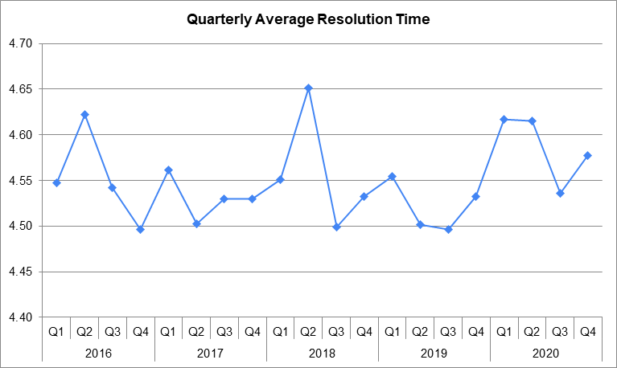
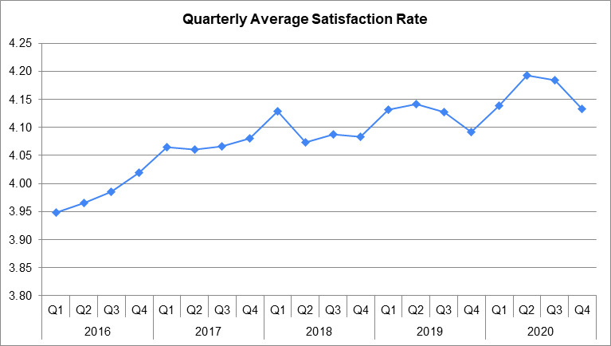
- Description:
Time-series chart of average resolution time by quarter, showing a flat trend across the whole period.
Time-series chart of average satisfaction by quarter, showing a gradual upward trend.

Insights:
RESOLUTION TIME HAS HELD FLAT UNDER A DOUBLING WORKLOAD. Yearly averages moved only between 4.52 and 4.59 days while annual volume rose 123%. Absorbing that much extra work with no deterioration in speed is a genuine operational achievement.
• SATISFACTION HAS IMPROVED STEADILY, rising every single year from 3.98 to 4.16. Service quality is getting better even as demand accelerates.
• Taken together these two facts argue strongly that the team is not yet capacity-constrained — which is the single most important input to the investment decision in subjective question 1.

Recommendations:
Because neither speed nor satisfaction is degrading, there is no performance emergency to spend money on. Investment should therefore go to raising the weakest agents to the team standard and to fixing the tool's prioritisation defects, rather than to emergency hiring.
• Monitor the forward-looking risk: if volume keeps compounding at 2020's +35% rate, this flat performance will eventually break. That is what makes the software upgrade a medium-term necessity rather than an optional extra.
• Preserve what is driving the rising satisfaction — identify which aspects of the interaction users value and protect them while streamlining for speed.
• Forecast demand against the trend line and reassess staffing and skill mix annually.

Question 6: If we invest more on tech (Hardware, software, etc), do you think it will improve the ticket resolution times and employee satisfaction?

Analysis: Use historical data to project potential improvements.

Solution:

Approach:
Used the historical data to size the addressable delay by category, benchmarked against Login Access, which already achieves near-instant resolution through automation on comparable volume.
• Also tested the assumed link between speed and satisfaction directly, by correlating resolution time against satisfaction rate and by comparing satisfaction across categories with very different resolution times.

Charts & Tables:
- Table / Chart Name:
Q-6 I Subjective — Category: Volume, Resolution Time and Satisfaction
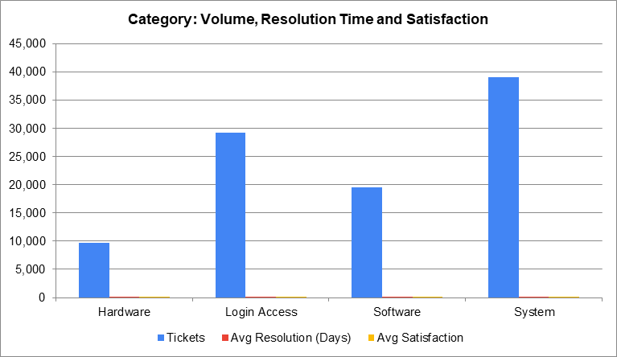
- Description:
Combined view of ticket volume, average resolution time and average satisfaction by category, used to size the potential gain from technology investment.

Insights:
PROJECTION ON RESOLUTION TIME — the addressable delay is concentrated and measurable. System (39,002 tickets at 6.62 days) and Hardware (9,733 at 7.63 days) together hold 48,735 tickets averaging about 6.8 days, against a Login Access benchmark of 0.31 days. Closing even a third of that gap on System alone — from 6.62 to roughly 4.4 days — would pull the company-wide average from 4.55 to approximately 3.7 days, an improvement of about 19%, without hiring a single additional agent.
• CAUTION ON SATISFACTION — satisfaction is almost completely insensitive to speed in this dataset. The correlation between resolution time and satisfaction rate is −0.004, essentially zero, and satisfaction sits at 4.09–4.11 across every single category despite resolution times ranging from 0.31 to 7.63 days. Users rate a Hardware ticket that took over a week just as highly as an instant password reset. Faster resolution should therefore NOT be expected to lift satisfaction scores on its own.
• WHAT DOES MOVE SATISFACTION is the agent handling the ticket — scores range from 3.04 to 4.60 across agents on identical caseloads, a far larger spread than category or speed produces. Technology buys throughput and scale; training buys satisfaction. They are different levers for different outcomes and should be chosen deliberately.

Recommendations:
Self-service portal for Login Access (29,193 tickets a year) — automated password resets and account unlocks move resolution from 0.31 days to instant and remove those tickets from the queue entirely.
• Remote diagnostic tools and a robust, searchable knowledge base for System and Software — the largest recoverable delay pool in the operation.
• Better IT asset management, spare-parts inventory and vendor repair SLAs for Hardware, where the 7.63-day average is logistics-bound rather than skill-bound.
• Ticket management software with intelligent routing and workload balancing, to protect the flat performance trend as volume continues to grow.
• Set expectations honestly with the board: this programme should be justified on throughput, scalability and reduced downtime — not on a promised jump in satisfaction scores.

Question 7: What are the key performance metrics for IT agents, and how can they be improved, do we need to fire any agents?

Analysis: Define and analyze metrics such as average handling time, satisfaction scores, and number of tickets resolved.

Solution:

Approach:
Defined the key performance metrics available in the data, then built an agent scorecard pivot comparing all 50 agents on each metric simultaneously.
• METRIC 1 — Average Satisfaction Rate: the user's verdict on the agent, 1 to 5, higher is better. Team average 4.10, range 3.04 to 4.60.
• METRIC 2 — Average Resolution Time (Days): efficiency, lower is better. Team average 4.55 days, range 3.60 to 5.55.
• METRIC 3 — Tickets Handled: productivity and workload. Team average 1,950, range 1,856 to 2,027.
• METRIC 4 — Reopen or escalation rate would materially improve this assessment but is not captured in the dataset; it should be added to the ticketing tool so that quality of fix can be measured, not just speed.

Charts & Tables:
- Table / Chart Name:
Q-7 I Subjective — Agent Scorecard
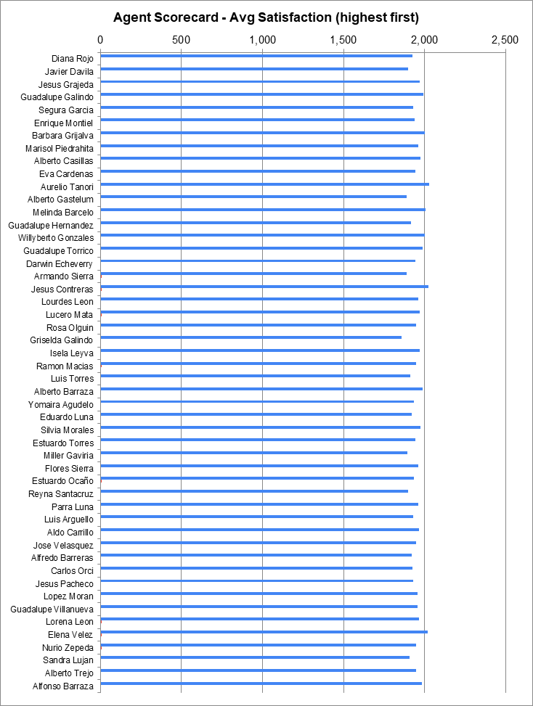
- Description:
Pivot table and bar chart ranking all 50 agents on tickets handled, average resolution time and average satisfaction.

Insights:
DO WE NEED TO FIRE ANY AGENTS? No — and the data argues against it clearly.
• Every one of the 50 agents handled between 1,856 and 2,027 tickets, so nobody is failing to do the work.
• The weakest satisfaction score, 3.04, is still above the mid-point of the scale, and the slowest agent at 5.55 days is under one day off the team average of 4.55. There are no outliers of the kind that would justify dismissal.
• This is a tightly clustered team with a coaching gap, not a performance crisis. Dismissal would remove roughly 2,000 tickets a year of working capacity and damage team morale in order to solve a problem that training addresses at a fraction of the cost.

Recommendations:
For low satisfaction rates — communication and empathy coaching, expectation-setting, post-resolution follow-up, and structured user feedback shared back to the agent constructively.
• For long resolution times — targeted training on Hardware and System troubleshooting, diagnostic tooling, knowledge-base discipline and time management across the queue.
• For productivity — mentoring pairs between the top and bottom quartile, and monthly one-to-one metric reviews with team leads.
• Add reopen-rate tracking to the ticketing tool so that quality of fix becomes measurable.
• Dismissal should be considered only after documented, targeted training and coaching has been delivered and the agent still performs consistently and significantly below the team standard over a sustained review period.

Question 8: How do employee demographics (e.g., department, seniority) impact satisfaction and ticket outcomes?

Analysis: Segment analysis using filters and pivot tables.

Solution:

Approach:
The dataset holds no department or seniority field for the employees raising tickets — only an Employee ID. Demographic analysis is therefore performed on the IT AGENTS, for whom date of birth is available.
• Agent age was derived with DATE and DATEDIF, banded into four seniority levels, and outcomes segmented with pivot tables and cross-tabulated against request category.
• A 50-row agent-level table was then built on the Q-8 I Subjective sheet — name rebuilt from the email address, age from the three birth columns, and satisfaction and ticket counts aggregated from the Cleaned Data table with AVERAGEIFS and COUNTIFS — so that both the individual spread and the band spread are derived on the sheet itself rather than quoted from elsewhere.

Charts & Tables:
- Table / Chart Name:
Q-8 I Subjective — Individual vs demographic spread
Q-8 I Subjective — Why band totals differ
Q-8 I Subjective — Seniority Level vs Performance Metrics
Q-8 I Subjective — Avg Resolution Time by Seniority and Category
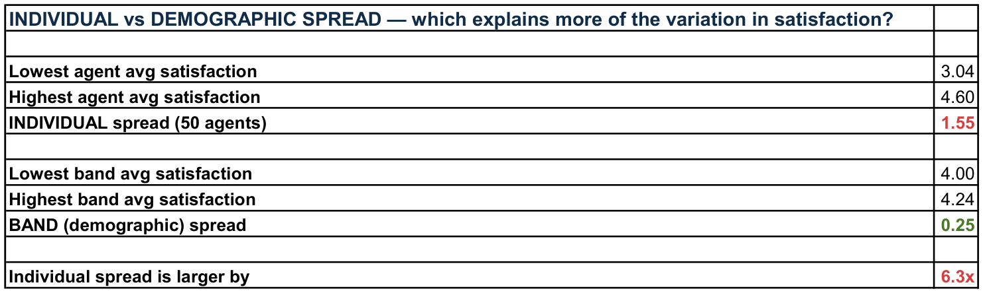
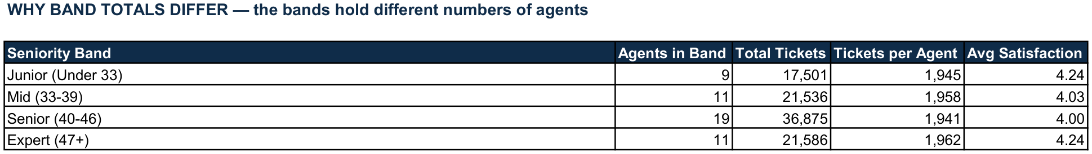
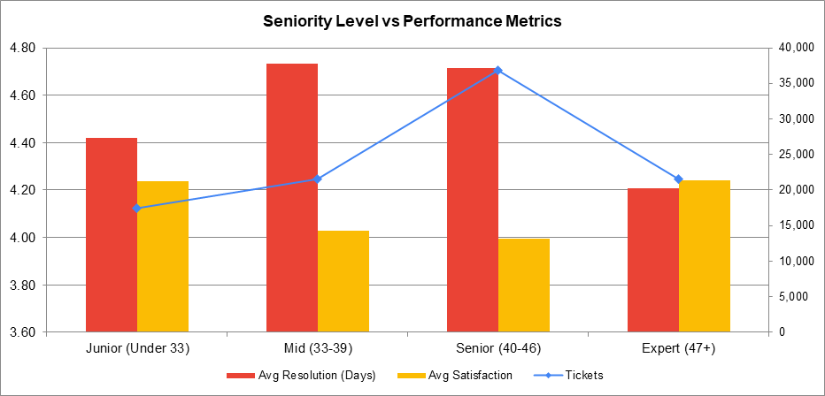
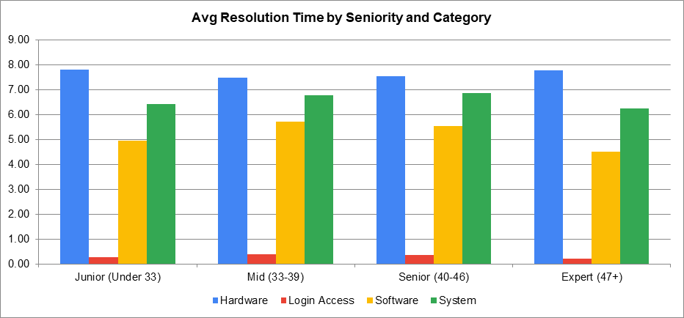
- Description:
Live comparison of the agent-level satisfaction spread against the seniority-band spread, showing individual variation is about six times larger.
Agents per band, total tickets and tickets per agent, showing that the 17,501 to 36,875 range in band totals is driven by band size, not by uneven workload.
Segment analysis across the four seniority bands, ordered by age. Average resolution time and average satisfaction are plotted as bars on the left axis; ticket volume sits on a secondary right-hand axis so all three remain readable despite the difference in scale.
Cross-tabulation showing that Hardware is the slowest category for every seniority band.

Insights:
DEMOGRAPHICS EXPLAIN LITTLE, BUT NOT NOTHING. Average satisfaction across the four seniority bands spans 0.25 of a point — Junior 4.24 and Expert 4.24 at the top, Mid 4.03 and Senior 4.00 at the bottom. Average resolution time spans about half a day, from Expert at 4.21 days to Mid at 4.73.
• INDIVIDUAL VARIATION IS FAR LARGER. Across the 50 agents individually, average satisfaction runs from 3.04 to 4.60 — a spread of 1.55 points, roughly six times the 0.25-point spread between age bands. Both figures are calculated live on this sheet (cells B107 and B111), so the comparison is reproducible.
• BAND TOTALS DIFFER BECAUSE THE BANDS ARE DIFFERENT SIZES, NOT BECAUSE OF WORKLOAD. Total tickets per band range from 17,501 (Junior, 9 agents) to 36,875 (Senior, 19 agents). Divided by the number of agents in each band the figures are almost identical — 1,941 to 1,962 tickets per agent. It is workload PER AGENT that is even, not the band totals.
• The middle bands are the weaker ones: Mid (33-39) and Senior (40-46) carry both the lowest satisfaction and the slowest resolution times, while the youngest and the most experienced bands perform best. The pattern is real but small, and it is not a clean age gradient.
• Across every seniority band, Hardware remains the slowest category and Login Access the fastest. A problem that persists uniformly across all experience levels is a process and logistics problem, not a skills problem.
• SCOPE LIMITATION — because department and seniority are not captured for the employees raising tickets, the organisation cannot currently tell which business units generate the most IT load.

Recommendations:
PRIORITY 1 — target coaching at named individuals on measured performance, not at demographic groups. With individual variation roughly six times the band variation, an age-band programme would miss most of the available opportunity.
• PRIORITY 2 — review Mid (33-39) and Senior (40-46) as a group, since both sit at about 4.0 satisfaction and above 4.7 days. Suggested threshold: any band falling below 4.00 satisfaction or above 5.00 days triggers a group review.
• Use the strongest performers — Diana Rojo and Jesus Grajeda — as mentors and knowledge-base authors, regardless of their age band.
• Fix Hardware delay through asset management, spare-parts stock and vendor SLAs rather than agent training, since it affects all experience levels equally.
• Capture department and seniority for the employees RAISING tickets. Without it, future investment decisions cannot be targeted at the business units generating the demand.

Question 9: Identify the trends for IT support operations based on ticket volumes and satisfaction, and mention the peak and stable times?

Analysis: Use pivot tables and charts to identify peak and off-peak hours.

Solution:

Approach:
Built pivot tables of ticket volume and average satisfaction by month, by year and by day of week, in order to separate the seasonal cycle from the underlying growth trend.
• Note on the brief: the dataset records only the ticket date, with no timestamp, so peak and off-peak HOURS cannot be derived. The analysis is therefore performed at monthly, yearly and day-of-week granularity, which is the finest resolution the data supports.

Charts & Tables:
- Table / Chart Name:
Q-9 I Subjective — Seasonality: Ticket Volume by Month
Q-9 I Subjective — Ticket Volume by Day of Week
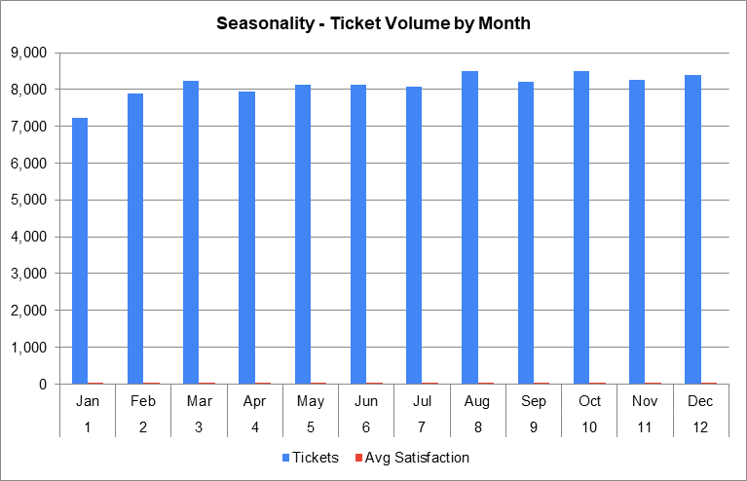
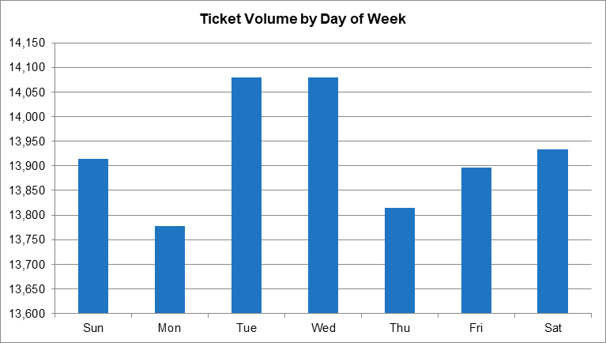
- Description:
Five-year average ticket volume by calendar month, with average satisfaction plotted alongside it.
Ticket volume split by day of week, showing an almost perfectly flat distribution.

Insights:
OVERALL TREND — demand has grown relentlessly: 13,051 tickets in 2016 rising to 29,088 in 2020, up 122.9%, with every year higher than the last and 2020 accelerating hardest at +35.4%. Satisfaction improved in parallel from 3.98 to 4.16.
• PEAK TIMES — on a five-year average the busiest months are October (1,699 tickets), August (1,698), December (1,680) and November (1,651). The strongest sustained pressure runs from August through December, and December 2020 is the single busiest month in the entire dataset.
• STABLE / OFF-PEAK TIMES — January is consistently the quietest month (1,448 tickets on average), followed by February (1,580) and April (1,587). January to April is the calmest stretch of the year.
• DEMAND IS FLAT ACROSS THE WEEK — tickets are distributed almost perfectly evenly across all seven weekdays (13,778–14,080 per day of week, a spread under 2.2%), including weekends. There is no weekday peak to staff against, so shift optimisation offers no meaningful saving here.
• IMPORTANT CAVEAT — because of the underlying growth, an “off-peak” month in 2020 still carries more volume than a peak month in 2016. Capacity planning must be done against the trend line, not against last quarter.

Recommendations:
Staff up and freeze non-essential change from August to December, the sustained peak.
• Run training programmes, system upgrades, documentation sprints and strategic planning in the January-to-April lull, when reactive demand is at its lowest.
• Launch proactive IT health checks and push self-service adoption in June and July, immediately ahead of the autumn surge.
• Plan capacity against the growth trend — budget for roughly 35% more volume year on year rather than for last year's actuals.
• Add a timestamp to ticket creation in the ticketing tool, so that peak-hour analysis and intraday rostering become possible in future.

Question 10: What metrics should be included in the final dashboard to provide a comprehensive view of call center performance and guide investment decisions?

Solution:

Approach:
The dashboard was designed around the questions management actually needs to answer, rather than around the fields that happen to exist in the data. It sits on a single Dashboard sheet driven by three shared slicers, so that every element filters together, and uses one uniform colour scheme across every chart so the eye compares values rather than colours.
• KPI CARDS (4) — Total Tickets, Average Resolution Time, Average Satisfaction Rate and Same-Day Resolution Rate, giving the overall scale and health of IT support at a glance.
• SCALE AND MIX (4 charts) — Ticket Volume by Category, Ticket Volume Trend by Year, Tickets by Severity and Ticket Volume by Priority. These show where the workload sits, how fast it is growing, and how it is classified on intake.
• EFFICIENCY (4 charts) — Average Resolution Time by Category; Average Resolution Time by Category, Quarter-wise; Severity vs Average Resolution Time; and Age Group by Satisfaction Rate. These isolate where delay accumulates, whether it is worsening over the quarters, whether triage is working, and whether agent age explains any of it.
• DISTRIBUTION AND TREND (4 charts) — Distribution of Tickets by Satisfaction Score, Distribution of Tickets by Resolution Time, Quarterly Average Satisfaction Rate and Quarterly Average Resolution Time. These show the shape of the data rather than just its averages, which matters because both satisfaction and resolution time are heavily skewed.
• SLICERS (3) — Year, Request Category and Priority, stacked in a panel down the left-hand side and connected to all 13 pivot tables on the sheet.

Charts & Tables:
- Table / Chart Name:
Dashboard — full management dashboard
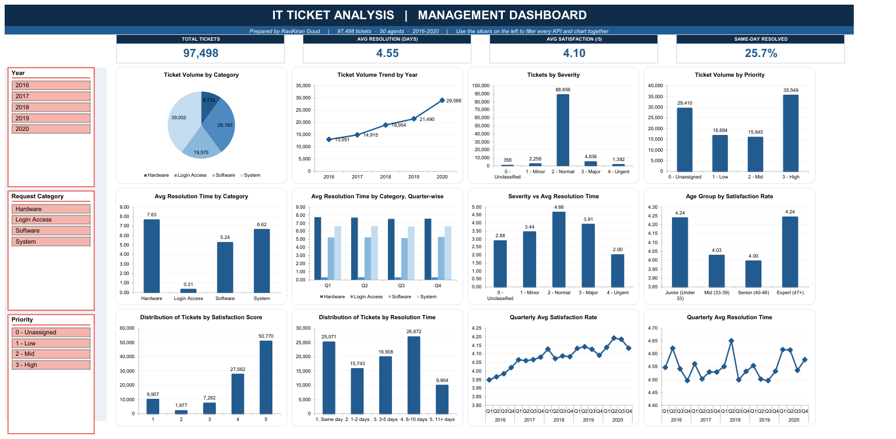
- Description:
The complete Dashboard sheet: a centred title banner, four KPI cards, three slicers (Year, Request Category and Priority) in a left-hand panel, and twelve charts in a 4 x 3 grid rendered in a single uniform colour scheme. All thirteen pivot tables share one cache, so any slicer selection filters every KPI card and chart simultaneously.

Insights:
Each metric maps to a specific investment decision: volume and growth justify the software upgrade; the severity and priority charts prove the triage failure; resolution time by category and quarter shows where to target it; and the satisfaction distribution demonstrates there is no service-quality emergency.
• The two distribution charts are the most revealing additions. Satisfaction is not evenly spread — 50,770 tickets score 5 and only 1,977 score 2 — so the 4.10 average hides a strongly bimodal picture. Resolution time is similarly skewed: 25,071 tickets close the same day while 9,904 take 11 days or more.
• The quarter-wise view of resolution time by category confirms the category gap is structural, not a one-off: Hardware and System sit above 6 days in every single quarter, and Login Access below half a day in every single quarter.
• Age Group by Satisfaction Rate settles a question the raw agent ranking cannot: the spread across age bands is only about 0.24 of a point, against 1.56 points between individual agents. The performance gap is individual, not demographic.
• The slicers matter as much as the charts. Year, Request Category and Priority are wired to every pivot table, so any combination — for example 2020 + Hardware + Unassigned — isolates the slowest, least-governed segment of the queue and every element responds together.

Recommendations:
Use the Year slicer to compare like with like when assessing performance, since absolute volumes are not comparable across years.
• Track the severity-to-resolution correlation and the unassigned-priority count as standing health metrics for the ticketing tool; both should improve measurably once the configuration fixes are made.
• Watch the Distribution of Tickets by Resolution Time chart rather than the average when judging the impact of the technology investment — success looks like the 11+ day bar shrinking, which an average can easily mask.
• Review the agent scorecard on the Q-7 I Subjective sheet quarterly to check whether the training investment is closing the satisfaction gap.
• Add reopen rate and a ticket-creation timestamp to the source data so that quality of fix and peak-hour demand can be added to this dashboard in future.

