Synergy Project Resource Manager

Software Technical Design
Document Version 6.0



© Copyright 2010 - 2026 Team Synergy. The information disclosed in this document, including all designs and related materials, is the property of Synergy Group.

To allow for design and specification improvements, the information in this document is subject to change at any time, without notice. Reproduction of this document or portions thereof without prior written approval of Synergy Group is prohibited.

Document Revision History

Version | Date | Author(s) | Remarks
1.0 | 22/Jan/2011 | Srimal Andrahennadi | Creation
2.0 | 23/Jan/2011 | Srimal Andrahennadi | Adding architectural design, formatting
3.0 | 25/Jan/2011 | Chandu Udayanga | Adding database diagram, class diagram
4.0 | 28/Jan/2011 | Srimal Andrahennadi | Adding Implementation aspects, UI design
4.1 | 30/Jan/2011 | Chanaka Weerawarhana | Review Architecture
4.2 | 30/Jan/2011 | Virath Liyanage | Review DB design
5.1 | 05/Feb/2011 | Buddhika Jayaweera | Update UI design
5.2 | 08/Feb/2011 | Naleen Kannangara | Review comments incorporation
6.0 | 14/Feb/2011 | Srimal Andrahennadi | Update technical design

Table of Contents

1 Introduction 4
1.1 Purpose of the Document 4
1.2 Purpose of the Product 4
1.3 Product Scope 4
1.4 Definitions, Acronyms and Abbreviations 5

2 TECHNOLOGY DETAILS 5
2.1 Software Technology 5

3 ARCHITECTURAL DESIGN 6
3.1 High Level Architecture 6

4 SYSTEM DESIGN 7
4.1 Class Diagram 7
4.2 Implementation Aspects 8

5 DATABASE DESIGN 9
5.1 ER Modeling 9

6 USER INTERFACE DESIGN 10
6.1 UI Aspects 10
6.2 UI Theme 11

1. Introduction

1.1 Purpose of the Document

The purpose of this document is to elaborate the technical design of the Project Resource Management System to SLIIT - SynergyPRM.

1.2 Purpose of the Product

The purpose of the Project Resource Manager system is to provide facilities to mange project resources using a web based system.

1.3 Product Scope

SynergyPRM facilitates the responsible parties of the project (ex: project managers, team leaders, top management, etc.) to efficiently and effectively manage and control project resources. As a web based system it enhances the flexibility of interacting among users of the system.

The SPRM features are,

- User Management
- Project View
- Resource Booking
- Resource Calendar

Please refer Software Requirement Specification for more details.

1.4 Definitions, Acronyms and Abbreviations

Following abbreviations are used in the document.
SLIIT | Sri Lanka Institute of Information Technology
SPRM | Synergy Project Resource Manager
SRS | Software Requirements Specification
STD | Software Technical Design
DAO | Data Access Object
UI | User Interface
API | Application Programming Interface
LING | Language Integrated Queries
MVC | Model View Controller (Architecture)
ASP | Active Server Pages

2. Technology Details

2.1 Software Technology

The system to be implemented basically using Microsoft technologies. A technology for each aspect is stated below.

System Development: ASP.NET MVC 2, C#.NET, ADO.NET (.NET Framework 3.0), LINQ

Backend/ Database: MS SQL Server 2008

Development Environment: Visual Studio 2008 on Windows XP/ Windows 7

Web Server: IIS 7

Deployment Environment: Windows XP/ Windows Server 2008

3. Architectural Design

This section will demonstrate the architectural design of the system in various aspects.

3.1 High Level Architecture

The system will be designed with layered architecture while thinking in terms of business integration and extensibility. Following diagram illustrates the layered architecture for the system.

Application Logic & Processing
Web Based UIs

Services
Interfaces for other Systems
Business Services
Data Access and Persistence
Database

Figure 1: Layered Architecture of the System with emphasis on Service Orientation

There will be three layers on top of the database. Those are data access & persistence layer, application logic & processing and business service layer. Business service layer will provide a unified business service interface for top layers.

On top of the business service layer there are three other layers dedicated for various purposes. Web UI layer will provide a rich UIs for SynegyPRM and there will be interfaces for other systems. Also there are service interfaces and service API for external systems. Those will help to integrate the system for future requirements while ensuring the extensibility and interoperability.

4. System Design

In this section system design will be explained with relevant to various design aspects.

4.1 Class Diagram

Following is the class diagram for SynergyPRM. Relevant classes, their attributes and operations are elaborated.

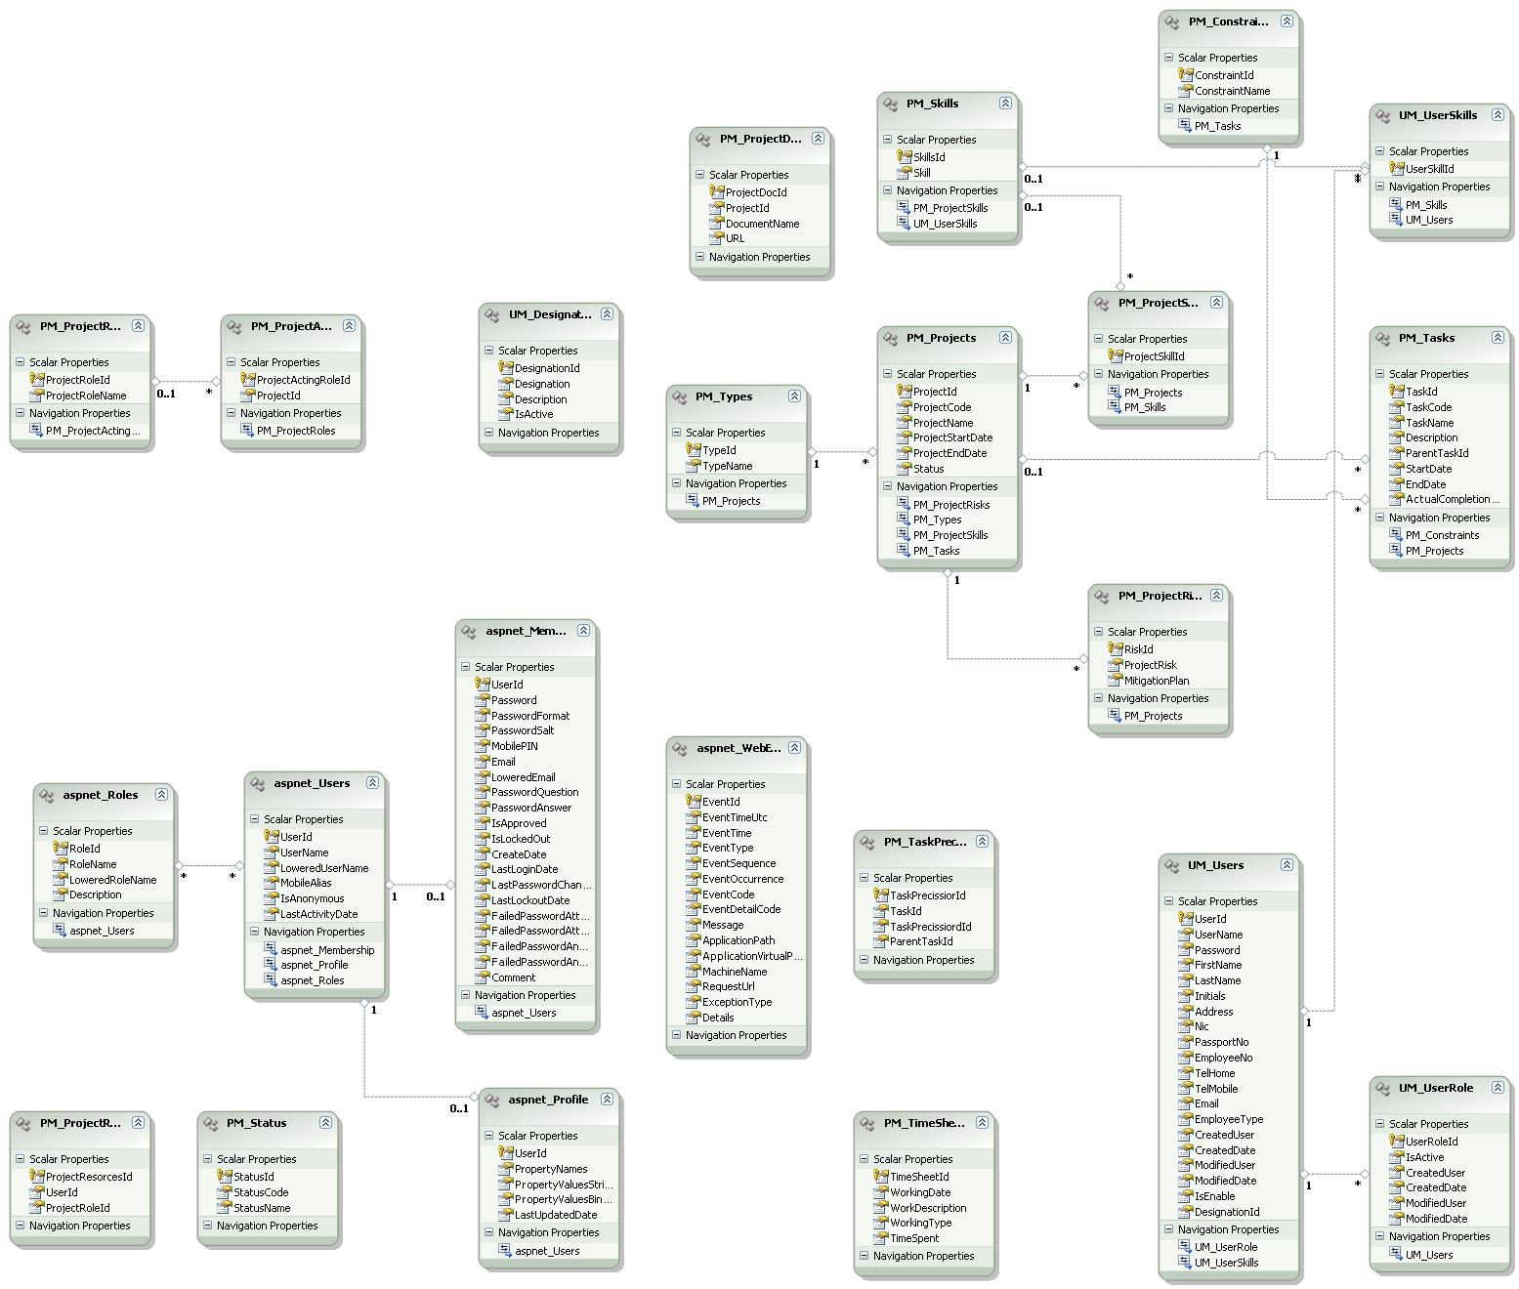

Figure 2: Class Diagram for SynergyPRM

There will be several types of classes including helper classes, utility classes with extensible structure in order to maximize the advantage or object oriented concepts and patterns.

4.2 Implementation Aspects

The system will be developed using ASP.NET MVC 2 in order to exploit the flexible and powerful framework features. The project implementation architecture will be a typical MVC implementation.

Following diagram shows the solution architecture for the system using Visual Studio 2008 IDE.

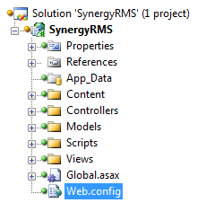

Figure 3: Solution Architecture for the system (in VS 2008 with ASP.NET MVC 2)

5. Database Design

This section illustrates the requirements with UML Use Case diagrams.

5.1 ER Modeling

In any system database is one of the most important part and database design will determines the smooth functionality and optimized operations of the system. Following ER diagram shows the database schema for SynergyPRM.

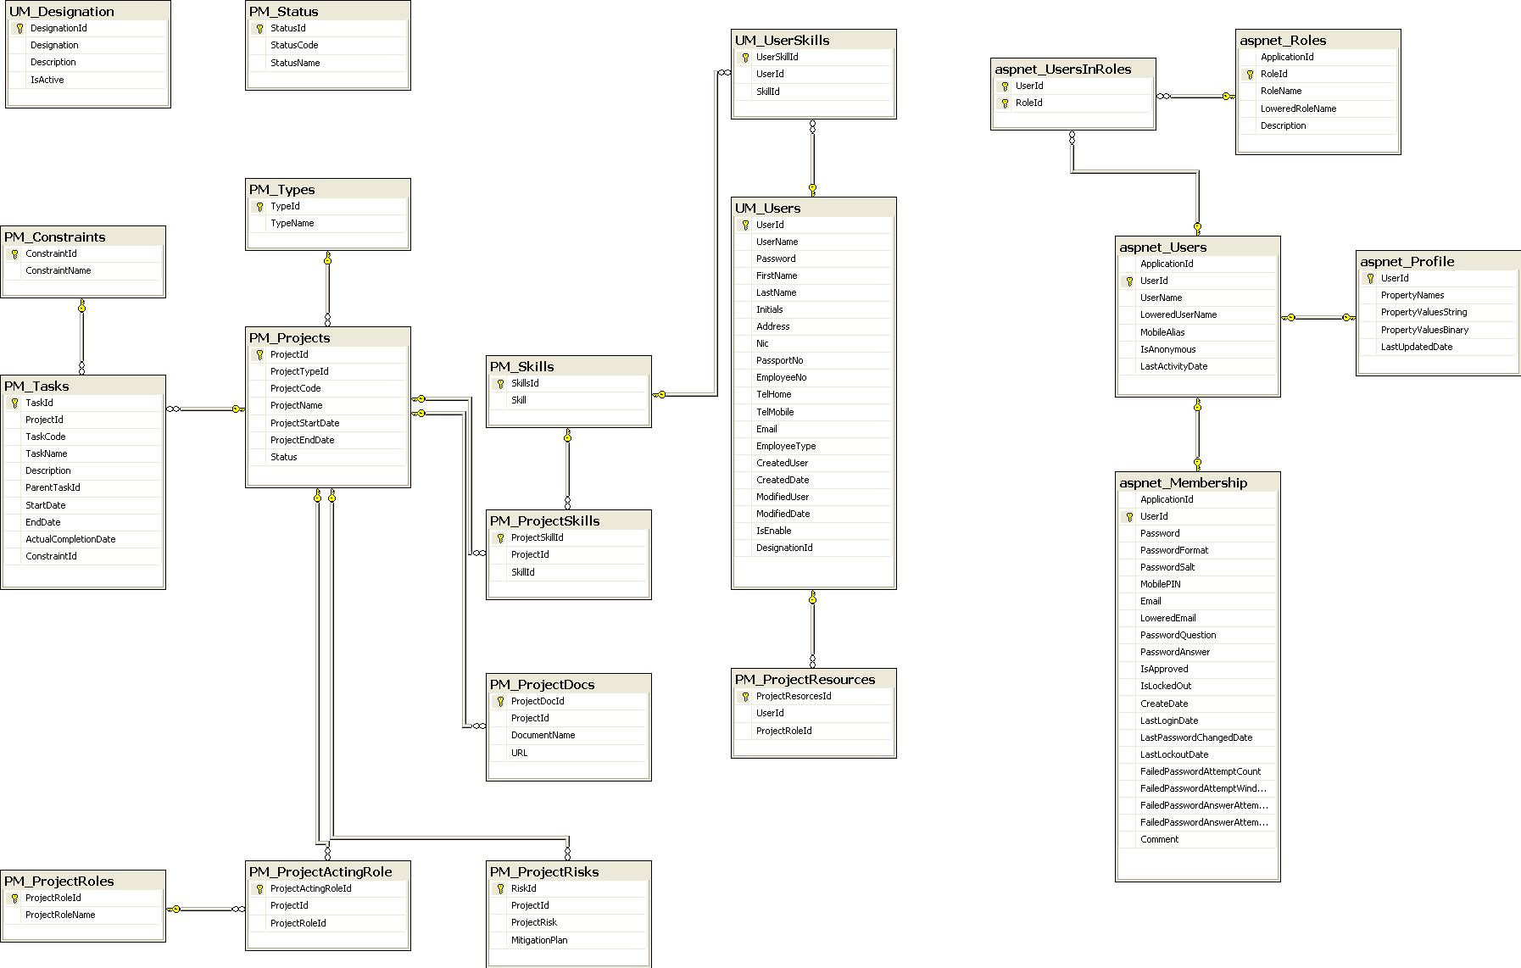

Figure 4: Database Diagram for SynergyPRM

6. User Interface Design

This section illustrates the details of user interface designing.

6.1 UI Aspects

Obviously the end user will experience and interact only with the UI of the system. Therefore, providing an easy to use, rich UI is very important. Also it should be optimized by eliminating unnecessary delays for the loading while providing simple, consistent, informative layout.

ASP.NET can be readily used to come up with such web based UIs by exploiting a set of outstanding features. Those will be including,

- Using ASP.NET master pages for providing a consistent layout and placing content pages inside the master page

- Use a set of common, reusable UI controls

- Personalize the web UIs with themes

Following figure shows the expected design for web based UIs.

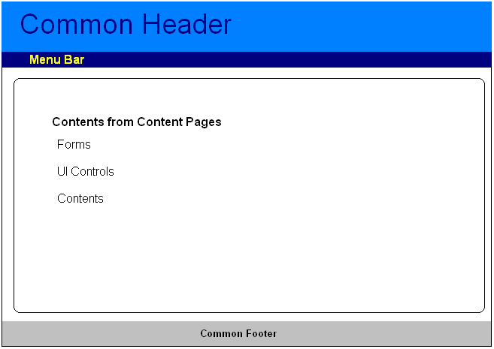

Figure 5: UI Design Approach with Master Pages

Following figure shows a sample UI of the system.

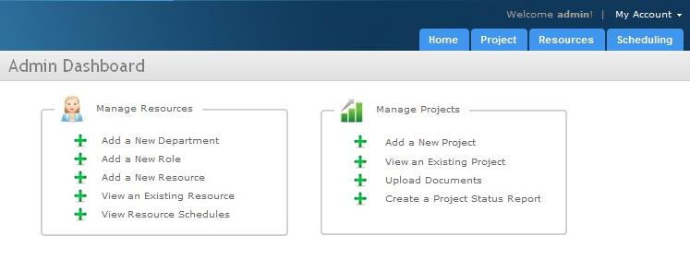
Figure 6: A Sample UI of the System

6.2 UI Theme

Even though this is a web application, initial UI pages (home page) will be designed to feel the experience of a desktop application with rich UI features.

A UI theme similar to Windows 7 will be used to achieve this.

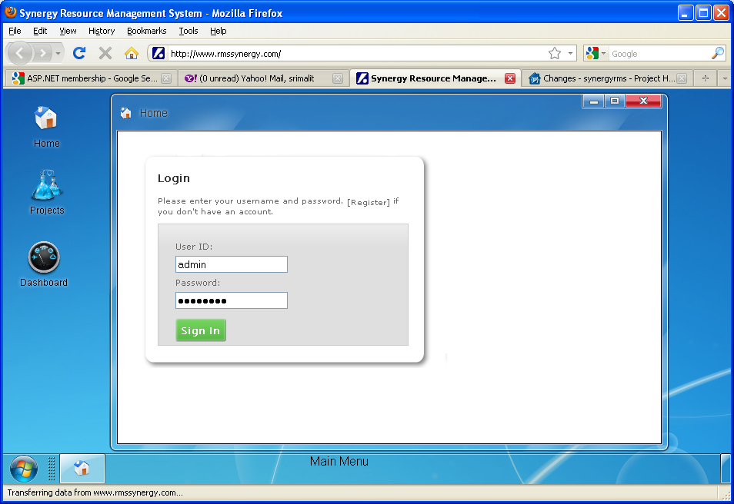

Figure 7: Home page of SynergyPRM with the theme

