Synergy Project Resource Manager

Software Requirements Specification
Document Version 3.0



© Copyright 2010 - 2026 Team Synergy. The information disclosed in this document, including all designs and related materials, is the property of Synergy Group.

To allow for design and specification improvements, the information in this document is subject to change at any time, without notice. Reproduction of this document or portions thereof without prior written approval of Synergy Group is prohibited.

Document Revision History

Version | Date | Author(s) | Remarks
1.0 | 15/Dec/2010 | Nalin Kannangara | Creation of initial draft
2.0 | 22/Dec/2010 | Buddika Jayaweera | Review
3.0 | 04/Jan/2011 | Srimal Andrahennadi | Adding Use Cases, formatting

Table of Contents

1 Introduction 4
1.1 Purpose of the Document 4
1.2 Purpose of the Product 4
1.3 Product Scope 4
1.4 Definitions, Acronyms and Abbreviations 4

2 FUNCTIONAL REQUIREMENTS 5
2.1 User Management 5
2.2 Project View 6
2.3 Resource Booking 6
2.3 Resource Calendar 6

3 NON-FUNCTIONAL REQUIREMENTS 8

4 REQUIREMENTS MODELING 9

1. Introduction

1.1 Purpose of the Document

The purpose of this document is to present the specification of software requirements of the Project Resource Management System to SLIIT.

1.2 Purpose of the Product

The purpose of the Project Resource Manager system is to provide facilities to mange project resources using a web based system.

1.3 Product Scope

SPRM facilitates the responsible parties of the project (ex: project managers, team leaders, top management, etc.) to efficiently and effectively manage and control project resources. As a web based system it enhances the flexibility of interacting among users of the system.

The SPRM features are,

- User Management
- Project View
- Resource Booking
- Resource Calendar

1.4 Definitions, Acronyms and Abbreviations

Following abbreviations are used in the document.
SLIIT | Sri Lanka Institute of Information Technology
SPRM | Synergy Project Resource Manager
SRS | Software Requirements Specification

2. Functional Requirements

Functional requirements of the system can be categorized in to the following categories

- User Management
  - User Login information
  - Employee Type (Contract, Permanent, Graduate, Intern, etc)
  - Start and End Dates
  - Skill set

- Project View
  - Project List
  - Project Description including, Type, Start and End Dates

- Resource Booking
  - Ability to search the resource availability based on skills
  - Ability to book resources (Make resource requests)
  - Ability of approving the requests by the resource owner (usually functional head)

- Resource Calendar
  - Graphically Display the resource booking
  - Gantt Chart views based on per resource and per project grouping

2.1 User Management

User management facilitates managing user of the system and project. Users of the system are entered into the system through a logging interface in order to control access levels of users for the system.

System logging function will allow users to login into the SPRM system using a combination of User name and Password. User credentials will be validated to determine whether access will be granted or access will be denied.

SPRM Security/controls features and functions for user management

- Unique user ids
- Encrypted Passwords for Sign -on validation
- Role Assignment
- Audit trail logging
- Restrict password to strong password
- Password creation and cancellation/Termination

2.2 Project View

Project view enables users to view the descriptions of entire ongoing projects, a particular project graphically and it also facilitates to see in depth details of a particular project such as project tasks, relevant dates of those tasks, allocated resources.

SPRM Security/controls features and functions for project view

- Unique project IDs
- Role base access

2.3 Resource Booking

Resource booking enables users to manage project resources. It provides the ability to search the resource availability based on employees’ skills. Resources can be obtained from the existing employees according to the appropriate skills of employees.

When resources are needed for a particular project resource request can be made. Then that resource request is sent for approval. Then the system enables appropriate party to accept or reject the resource request. Once the resource is accepted it can be allocate for the related project.

It is also able to send a feed back with a description for the appropriate resource request.

2.4 Resource Calendar

Resource calendar facilitates users to graphically view the resource booking and resource allocation of projects. It provides a view of the entire ongoing projects. When a particular project is selected it is possible to see the allocated resources for that particular project.

When a particular resource is selected it is possible to see the description of that resource. It shows how and in which projects that resource has been allocated.

Then it helps project managers to check the resource allocation on projects and the availability of that resource for other projects.

Overall Functional requirements of SPRM

ID | Description
1 | Shall be able to insert Users
2 | Shall be able to amend Users
3 | Shall be able to delete users
4 | Shall be able to Provide users login system
5 | Shall be able to Provide authentication and authorization of users
6 | Shall be able to Insert employee details
7 | Shall be able to Categorize employee types
8 | Shall be able to Insert employee skill sets
9 | Shall be able to Amend employee details
10 | Shall be able to Delete employee details
11 | Shall facilitate to browse employee details
12 | Ability to extract employee leave information from external system
13 | Ability to authenticate users using existing system
14 | Shall be able to created projects
15 | Shall be able to view projects
16 | Shall be able to keep project description
17 | Shall be able to amend projects
18 | Shall be able to allocate resources to projects
19 | Shall be able to delete projects
20 | Shall be able to attach special remarks/notes on projects
21 | Shall be able to search the resource availability based on skills
22 | Shall be able to Able to book resources (make resource request)
23 | Shall be able to approve the requests by the resource owner (usually projects lead)
24 | Shall be able to make resource sharing among projects
25 | Shall be able to amend resources
26 | Shall be able to Graphically Display the resource booking
27 | Shall be able to provide Gantt Chart views based on per resource and per project grouping
28 | Shall facilitate to browse project history
29 | Shall be able to send notification mails
30 | Shall be able to keep feedback information
31 | Should be able to generate summarized reports to management
32 | Shall be able to generate reports in csv format
33 | Should be able to provide the decision-making support
34 | Should be able to create distinct accounts with different system access privileges

3. Non-Functional Requirements

Overall Non-Functional requirements of SPRM

ID | Description
1 | Shall be able to provide a user friendly GUI
2 | Shall make use of existing software & hardware
3 | Shall run server side operations on windows server 2008 OS and IIS7
4 | Shall run client side operations on IE7 or above or FireFox 2.0 or above
5 | Shall facilitate to access records concurrently
6 | Should run as a multi user system with using web browser for client side interfaces
7 | Should provide a flexible and reliable backup system
8 | Should provide a flexible recovery mechanism
9 | Should take resources as minimum as possible
10 | Should provide proper security

4. Requirements Modeling

This section illustrates the requirements with UML Use Case diagrams.

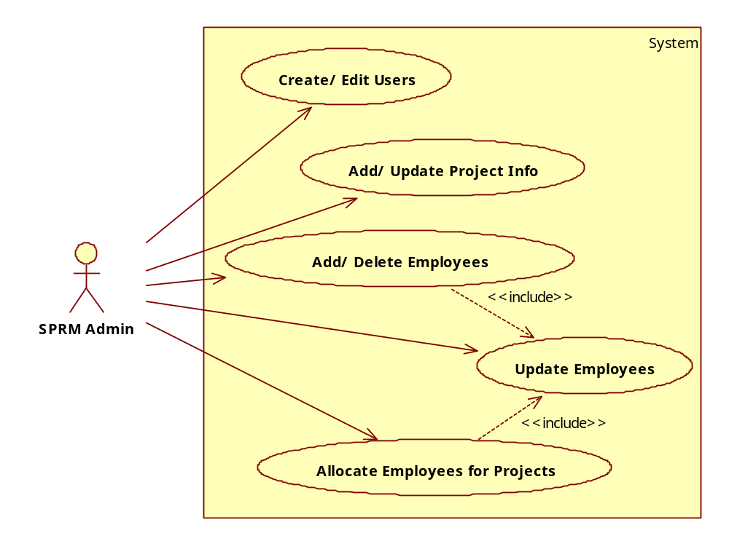
Figure 1: Use Cases for SPRM Admin
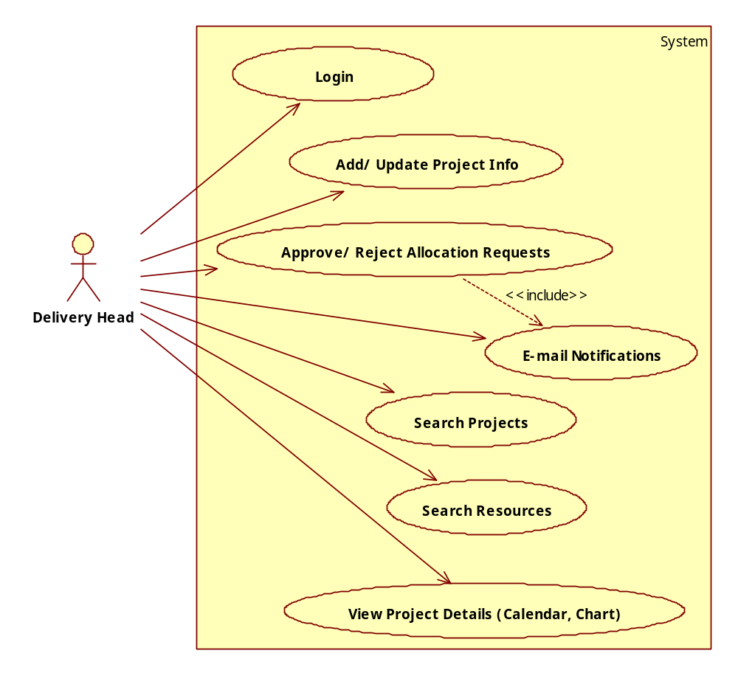
Figure 2: Use Cases for Delivery Head

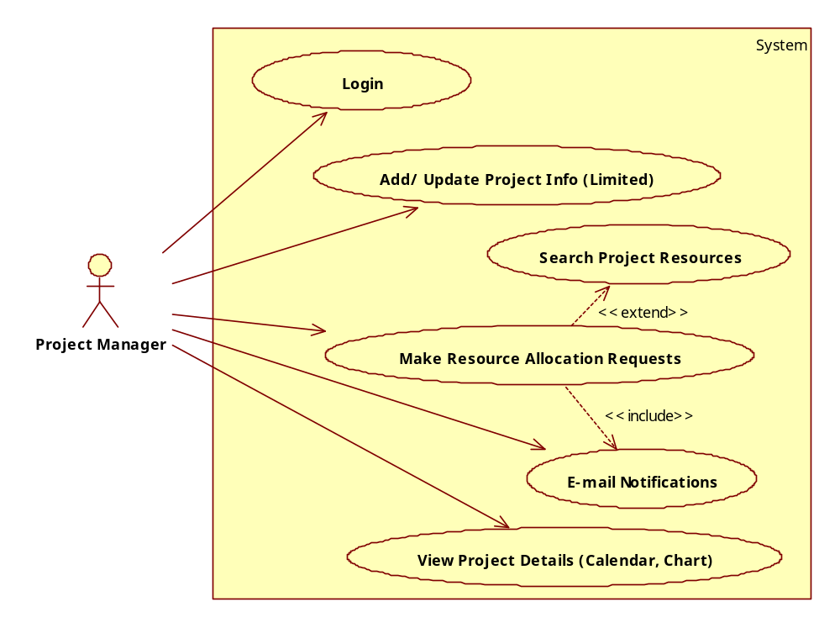
Figure 3: Use Cases for Project Managers

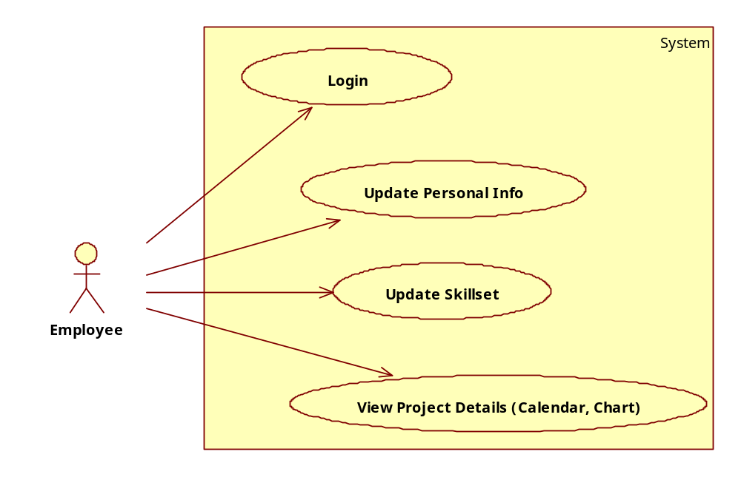
Figure 4: Use Cases for Employees

