1. Get locations based on category API

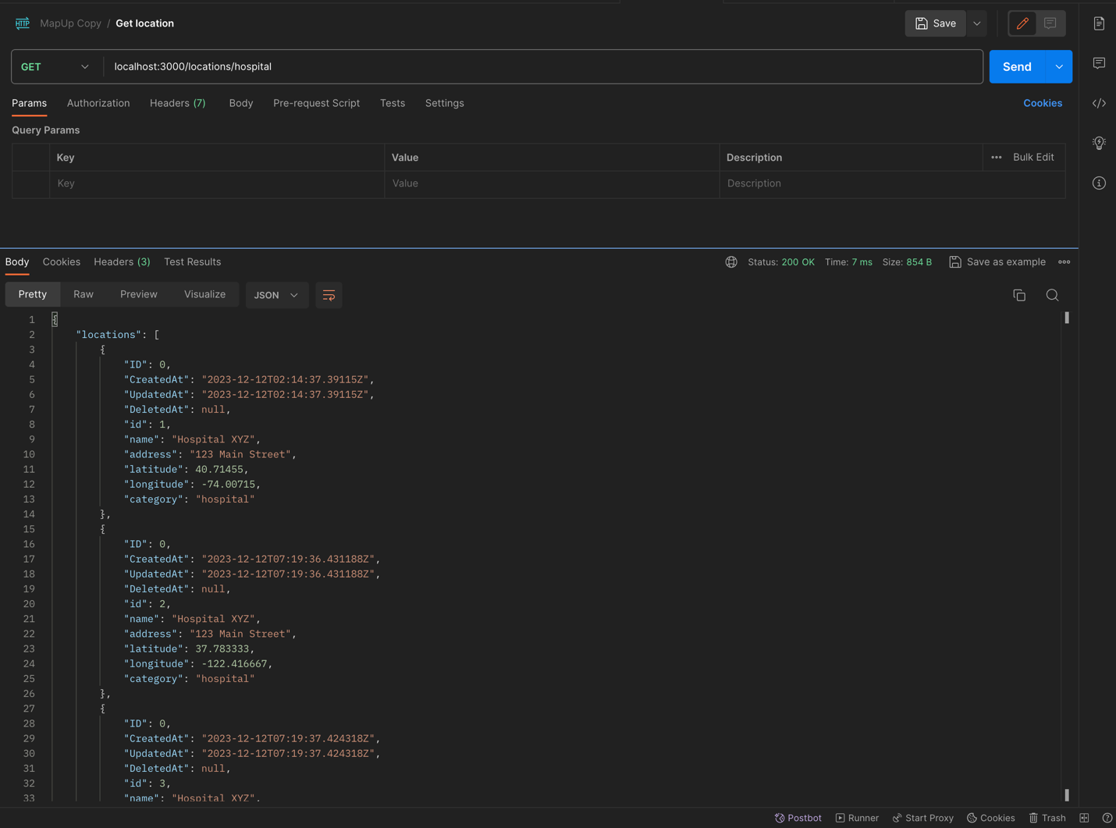

1. Create Location API

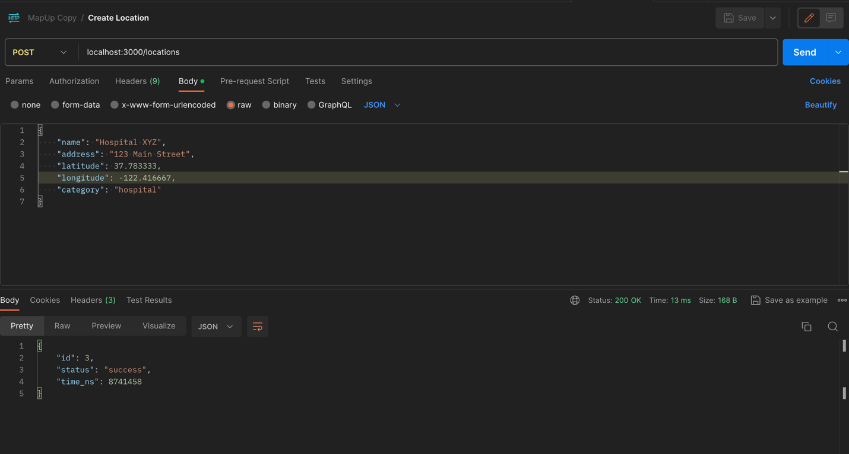

1. Search for location.

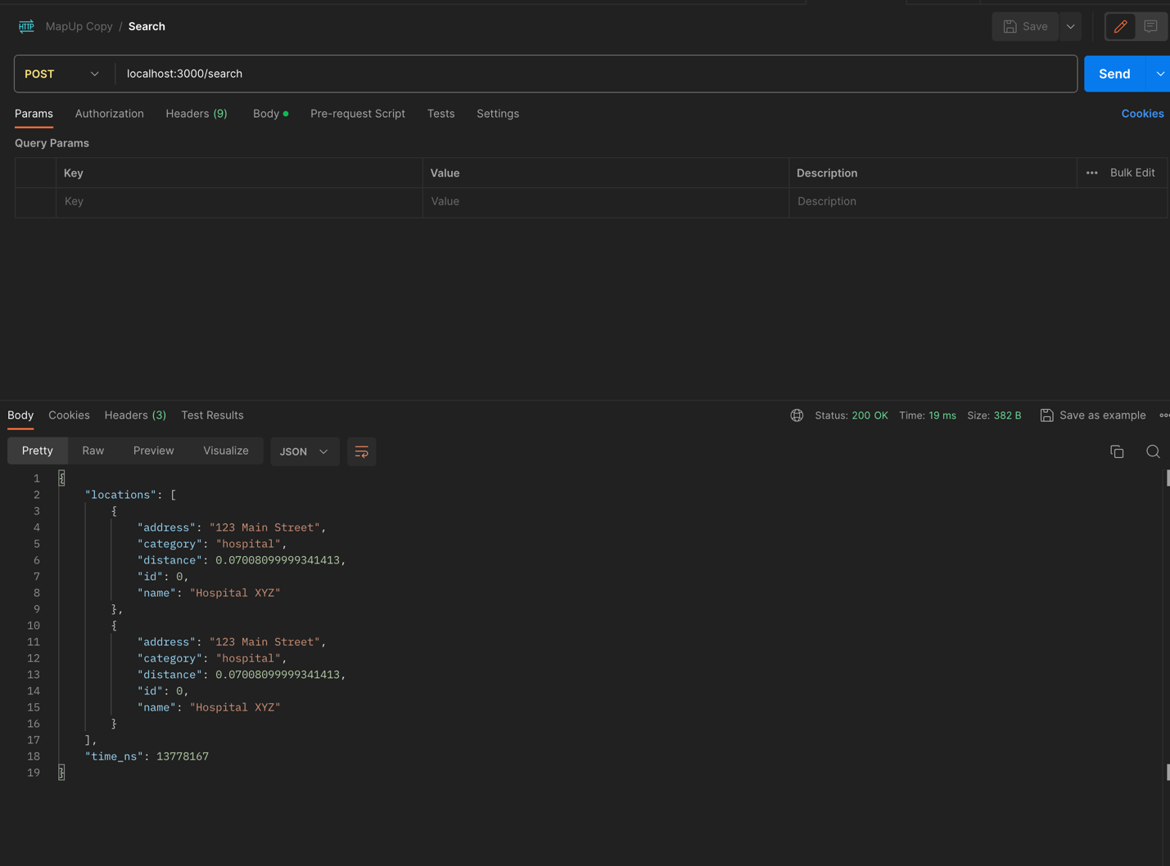

1. Trip Cost API

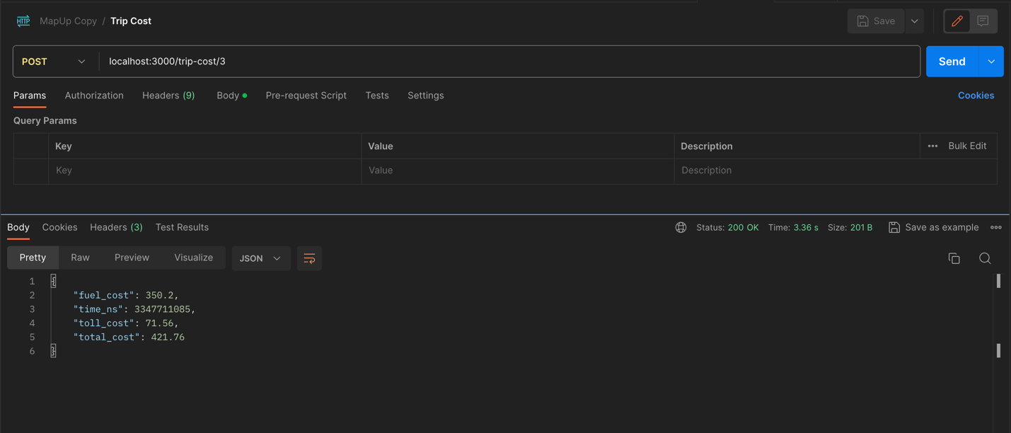

1. Railway app where the go server is deployed

