Command -pwd

It displays the current working location or directory of the user



Ls -l



Ls- al

Formatted listing with hidden files

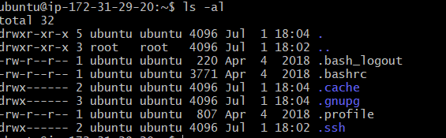

Ls -lt

Sorting the Formatted listing by time modification.



cd- change to home directory

PS (i.e., process status) command is used to provide information about the currently running processes, including their process identification numbers (PIDs).

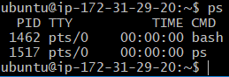

$ touch: created a file named 15.java and added content in the file.

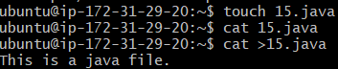

More command: This command Outputs the contents of the file



Top: Displays all the running process.

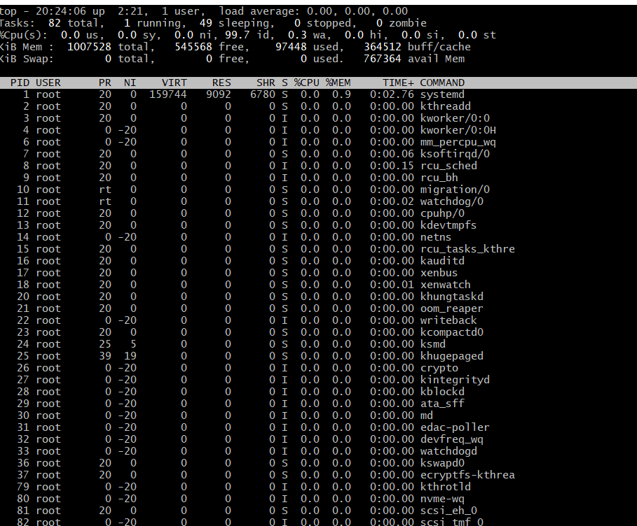

Touch and Cat command: touch is used to create a file and cat command is used to display the content of the file.



rm file: remove the file

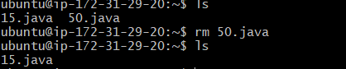

Cal command: Shows this month's calendar

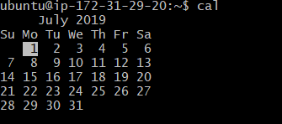

W : Display who is on line

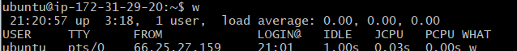

Whoami:

whoami commands who you are logged in as



df Shows the disk usage

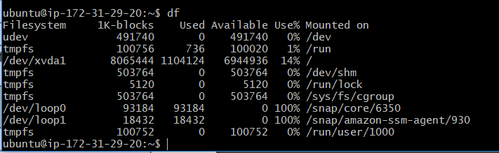

du: Show directory space usage

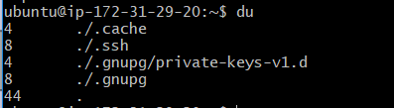

Free: Shows the memory and swap usage

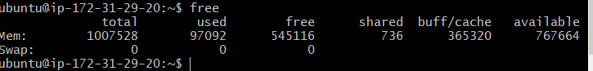

Dig domain: Get DNS information for domain

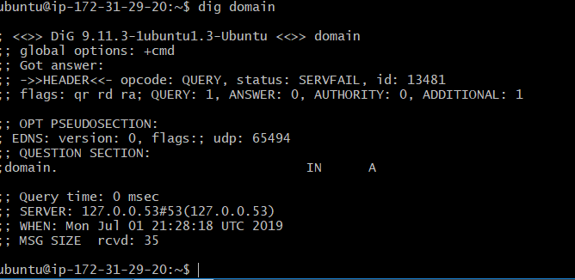

Uname -a

Shows kernel information

