

SUMMER INTERNSHIP EMBEDDED C

*AYYAPU REDDY DANDE*

*BU21EECE0100105*

**TASK 12**

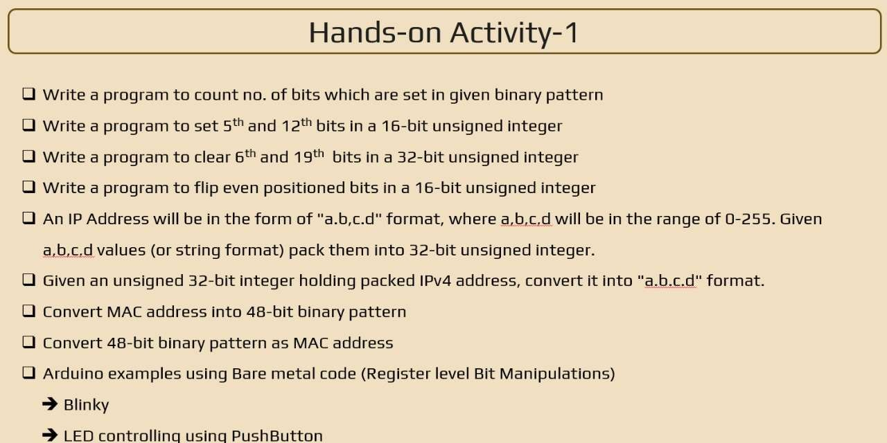

### Q1) Write a program to count no. of bits which are set in given binary pattern.

#include <stdio.h>

int countSetBits(int n) {

int count = 0; while (n) {

count += n & 1; n >>= 1;

}

return count;

}

int main() { int num;

printf("Enter an integer: "); scanf("%d", &num);

int setBits = countSetBits(num);

printf("Number of set bits in %d is %d\n", num, setBits); return 0;

}

### Q2) Write a program to set 5th and 12th bit in a 16-bit unsigned integer.

#include <stdio.h> int main()

{

unsigned short int value = 0;

unsigned short int mask = (1 << 4) | (1 << 11); value |= mask;

printf("The value after setting the 5th and 12th bits is: %u\n", value); return 0;

}

### Q3) Write a program to clear 6th and 19th bit in a 32-bit unsigned integer.

#include <stdio.h>

unsigned int clearBits(unsigned int num) { unsigned int mask = ~((1 << 5) | (1 << 18));

return num & mask;

}

int main() { unsigned int num;

printf("Enter a 32-bit unsigned integer: "); scanf("%u", &num);

unsigned int result = clearBits(num);

printf("Result after clearing the 6th and 19th bits: %u\n", result); return 0;

}

### Q4) Write a program to flip even positioned bits in a 16-bit unsigned integer

#include <stdio.h>

unsigned short ﬂipEvenBits(unsigned short num) { unsigned short mask = 0x5555;

return num ^ mask;

}

int main() {

unsigned short num;

printf("Enter a 16-bit unsigned integer: "); scanf("%hu", &num);

unsigned short result = ﬂipEvenBits(num);

printf("Result after ﬂipping the even-positioned bits: %hu\n", result); return 0;

}

### Q5) An IP Address will be in the form of "a.b.c.d" format, where a,b,c,d will be in the range of 0-255. Given a,b,c,d values (or string format) pack them into 32-bit unsigned integer.

#include <stdio.h>

unsigned int packIP(unsigned char a, unsigned char b, unsigned char c, unsigned char d) { return (a << 24) | (b << 16) | (c << 8) | d;

}

int main() {

unsigned char a = 192; unsigned char b = 168; unsigned char c = 1; unsigned char d = 100;

unsigned int packedIP = packIP(a, b, c, d); printf("Packed IP address: 0x%X\n", packedIP);

return 0;

}

### Q6) Given an unsigned 32-bit integer holding packed IPv4 address, convert it into "a.b.c.d" format.

#include <stdio.h> int main() {

unsigned int packed_ip = 0xC0A80164; unsigned char a = (packed_ip >> 24) & 0xFF; unsigned char b = (packed_ip >> 16) & 0xFF; unsigned char c = (packed_ip >> 8) & 0xFF; unsigned char d = packed_ip & 0xFF;

printf("The unpacked IP address is: %u.%u.%u.%u\n", a, b, c, d); return 0;

}

### Q7) Convert MAC address into 48-bit binary pattern

#include <stdio.h> #include <stdlib.h>

unsigned long long convertMACAddress(const char *mac) { unsigned int bytes[6];

if (sscanf(mac, "%x:%x:%x:%x:%x:%x", &bytes[0], &bytes[1], &bytes[2], &bytes[3], &bytes[4], &bytes[5]) != 6) {

fprintf(stderr, "Invalid MAC address format.\n"); exit(EXIT_FAILURE);

}

unsigned long long macBinary = 0; for (int i = 0; i < 6; ++i) {

macBinary = (macBinary << 8) | (bytes[i] & 0xFF);

}

return macBinary;

}

int main() {

char macString[18];

printf("Enter MAC address in the format XX:XX:XX:XX:XX:XX: "); if (scanf("%17s", macString) != 1) {

fprintf(stderr, "Failed to read MAC address.\n"); return EXIT_FAILURE;

}

unsigned long long macBinary = convertMACAddress(macString); printf("MAC address in 48-bit binary pattern: %012llx\n", macBinary); return 0;

}

Q8) **Convert 48-bit binary pattern as MAC address**

#include <stdio.h> #include <stdlib.h>

void binaryToMac(const char* binary) { unsigned int bytes[6] = {0};

for (int i = 0; i < 48; ++i) {

bytes[i / 8] = (bytes[i / 8] << 1) | (binary[i] - '0');

}

printf("MAC Address: %02X:%02X:%02X:%02X:%02X:%02X\n",

bytes[0], bytes[1], bytes[2], bytes[3], bytes[4], bytes[5]);

}

int main() {

const char* binary_pattern = "101010101011101111001100110111011110111111111111"; binaryToMac(binary_pattern);

return 0;

}

# Task 14

## bare metal blinky using arduino1

#define F_CPU 16000000UL #include <avr/io.h> #include <util/delay.h>

int main(void)

{

// Set pin 7 (PD7) as an output DDRD |= (1 << PD7);

while (1)

{

PORTD |= (1 << PD7);

_delay_ms(1000); PORTD &= ~(1 << PD7);

_delay_ms(1000);

}

return 0;

}

## bare metal push button1

#define F_CPU 16000000UL #include <avr/io.h> #include <util/delay.h>

const uint8_t buttonPin = PD2; const uint8_t ledPin = PB5; uint8_t buttonState = 0;

void setup() {

DDRD &= ~(1 << buttonPin); PORTD |= (1 << buttonPin); DDRB |= (1 << ledPin);

}

int main(void) { setup();

while (1) {

buttonState = PIND & (1 << buttonPin); if (buttonState) {

PORTB |= (1 << ledPin);

} else {

PORTB &= ~(1 << ledPin);

}

_delay_ms(10);

}

return 0;

}

# Task 15

## Analog Read (Potentiometer)

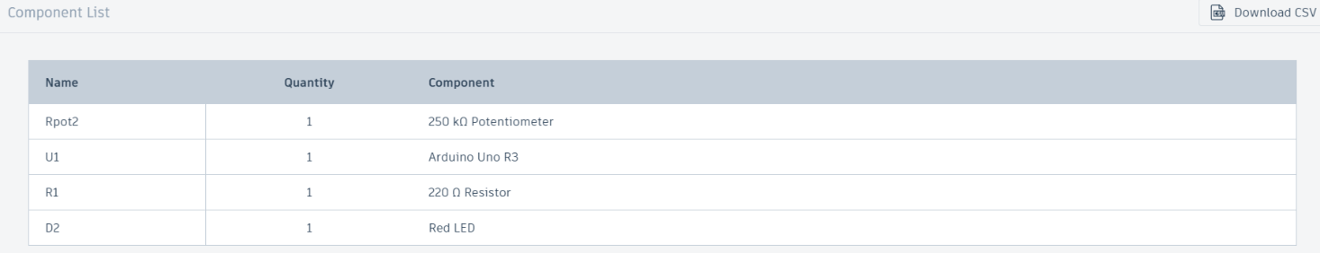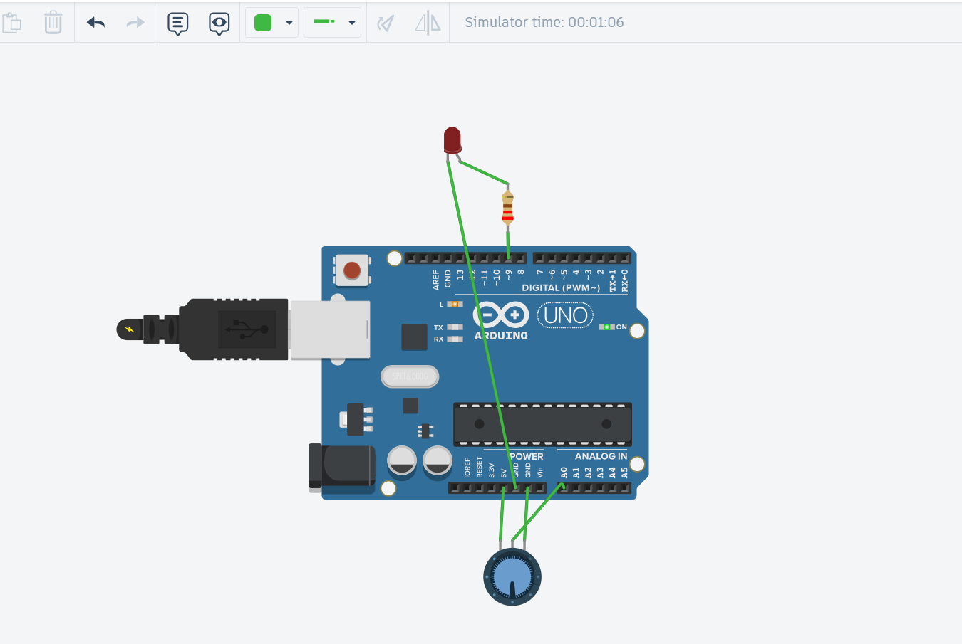

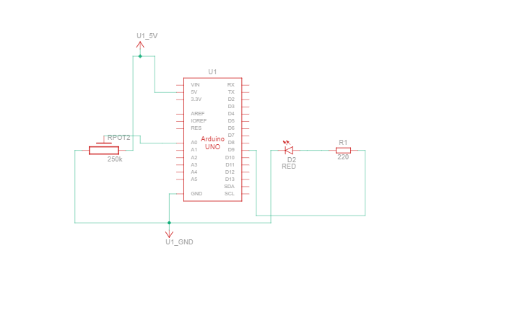

// Constants for pin assignments

const int potPin = A0; // Pin where the potentiometer is connected const int ledPin = 9; // Pin where the LED is connected

// Variable to store the potentiometer value int potValue = 0;

void setup() {

// Initialize the LED pin as an output pinMode(ledPin, OUTPUT);

}

void loop() {

// Read the value from the potentiometer potValue = analogRead(potPin);

// Map the potentiometer value to the PWM range (0-255) int ledValue = map(potValue, 0, 1023, 0, 255);

// Set the brightness of the LED analogWrite(ledPin, ledValue);

// Small delay to smooth out the reading delay(10);

}

## Analout Output(fading)

const int ledPin = 9; // Pin where the LED is connected

void setup() {

// Initialize the LED pin as an output pinMode(ledPin, OUTPUT);

}

void loop() {

// Fade in from 0 to 100^6

for (int brightness = 0; brightness <= 100^6; brightness++) { analogWrite(ledPin, brightness); // Set the brightness delay(10); // Wait for 10 milliseconds

}

// Fade out from 100^6 to 0

for (int brightness = 100^6; brightness >= 0; brightness--) { analogWrite(ledPin, brightness); // Set the brightness delay(10); // Wait for 10 milliseconds

}

}

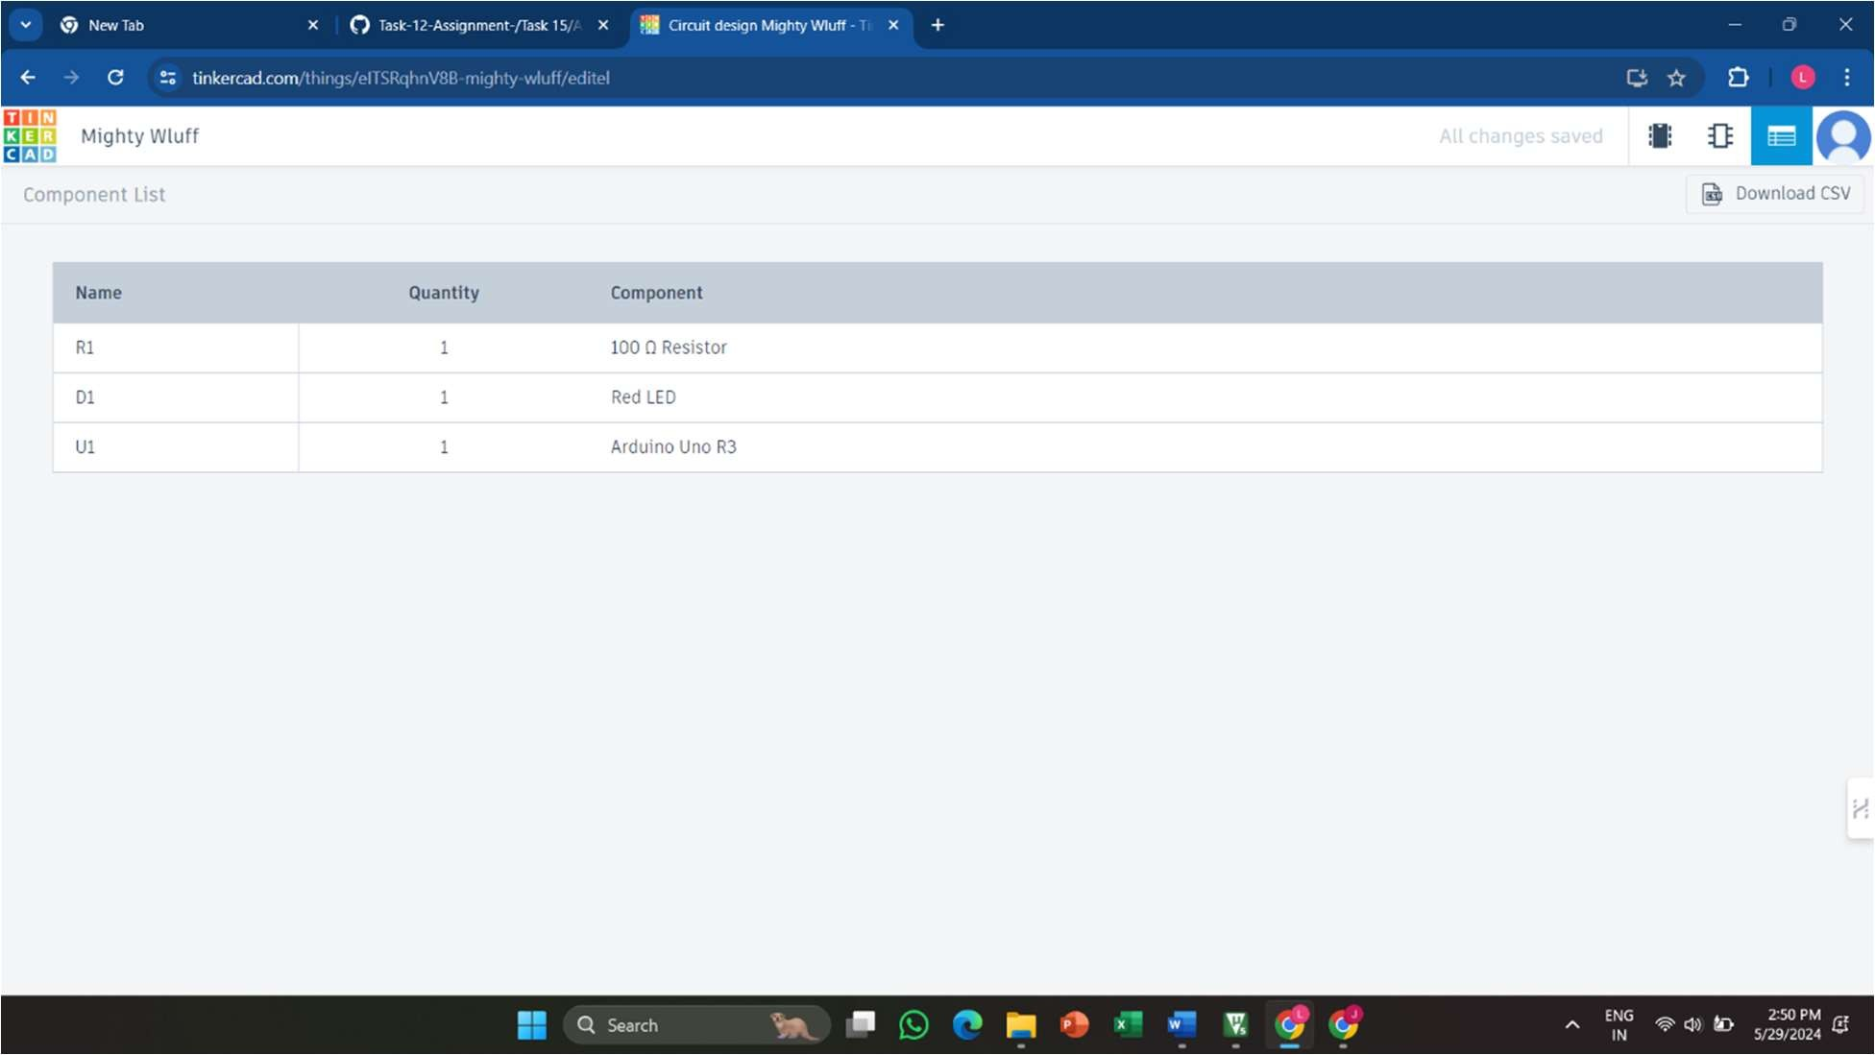

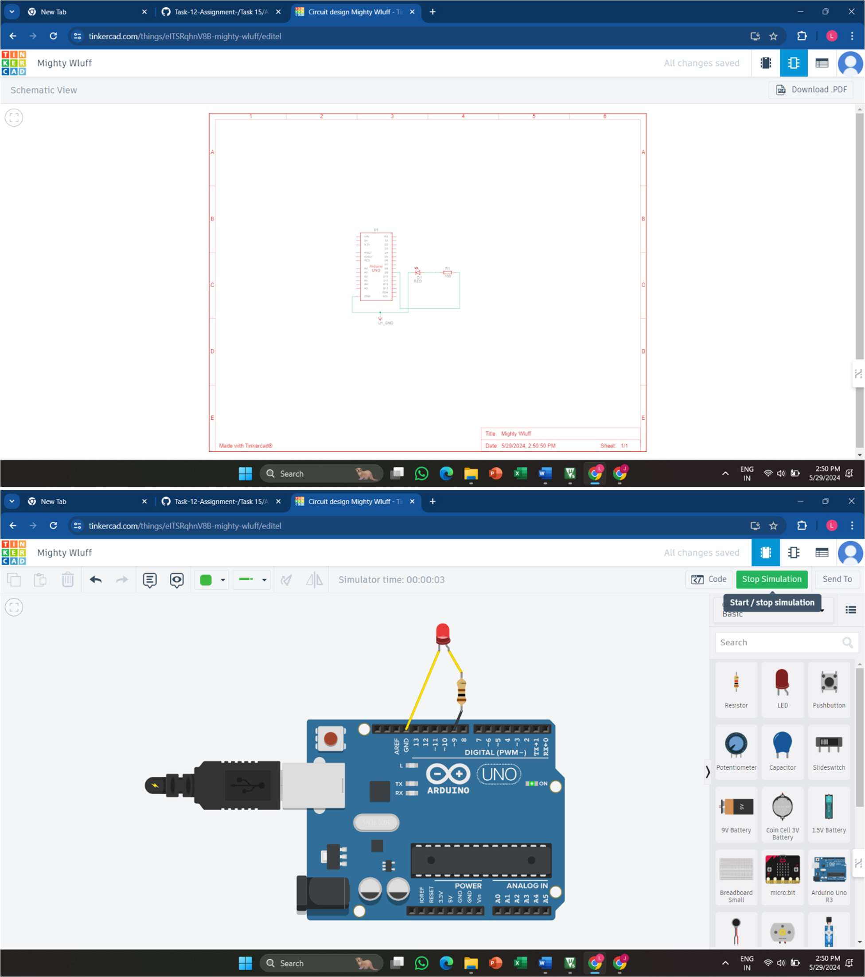

## Digital Input using Interrupt

const int buttonPin = 2; // Pin where the push button is connected volatile bool buttonPressed = false; // Flag to indicate button press

void setup() {

pinMode(buttonPin, INPUT); // Set the button pin as input

attachInterrupt(digitalPinToInterrupt(buttonPin), buttonPressISR, RISING); // Attach interrupt on rising edge

Serial.begin(9600); // Initialize serial communication

}

void loop() {

if (buttonPressed) {

Serial.println("Button Pressed!"); // Print message when button is pressed buttonPressed = false; // Reset the ﬂag

}

}

void buttonPressISR() {

buttonPressed = true; // Set the ﬂag to indicate button press

}

