# Analysis Of World Bank Dataset Based on Various Factors

The report contains the analysis details which provide the analysis of world bank dataset by various factors the report provide the correlation between the indicators which show the result along with output. There is also analysis done in the report which are important to understand the dataset and their different result.

# Correlation of Indicators

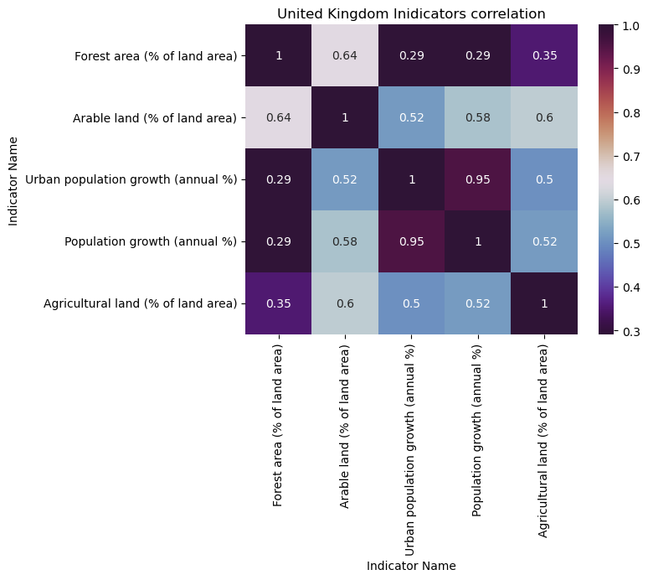

Figure 1 Correlation between Indicators.

The above image illustrates the correlation between the Indicators of the selected dataset where the representation is visualized with the mapping of the heatmap for effective relation between the selected dataset. As per the image, it can be stated that the Population growth (annual %) and the Urban population growth (annual %) have the highest relation between them as they have a correlation value of 0.95 which is near 1 so it can be stated they have good relations. This is the correlation of United Kingdom country indicators.

# Bar Chart

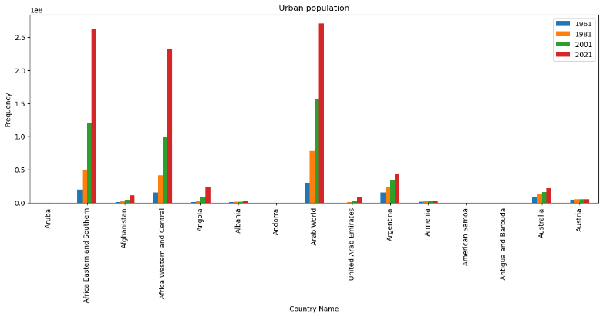

Figure 2 Bar Chart representation of the Urban population of a different country.

Bar graph representation is shown in the above image where the data are dependent upon the Urban population of the selected countries with the data of 4 years which are 1961, 1981, 2001, and 2021. From the above, there is assumed that the countries which have their urban population and growth have increased their urban population with the increase over the years but those who don’t have urban populations they hadn’t increased their urban population so their data is not represented. From the analysis of the above image, it can be stated that the African Eastern Southern and Arab World countries has a high urban population in 2021 as per the data.

# Bar Horizontal Chart

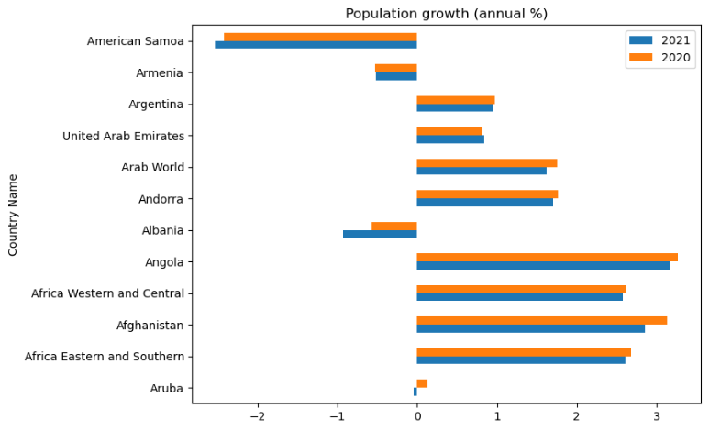There is represented the data with the use of barh which states for bar horizontal chart representation where different countries' data are represented with the stacked bars where data of two years are represented which are 2020 (represented as orange color) and 2021 (represented as blue color). The data is dependent upon the indicator of Population growth. Through this, it is viewed that the American Samoa population's annual percentage is decreasing as it has a high amount of data representation in minus frequency. There is also seems that the other countries also have decreased their annual population growth as compared to 2020 in 2021.

# Area Chart

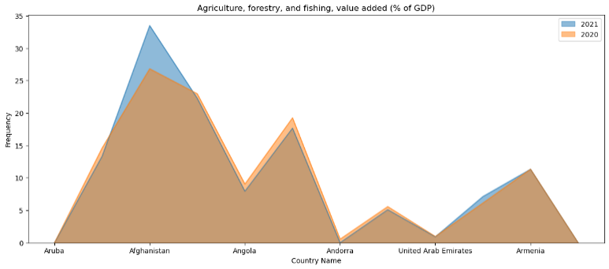

Figure 3 Representation in the form of an Area chart.

The above is the data related to the indicator name of Agriculture, forestry, and fishing, with the value added of percentage in the countries' GDP. There is a comparison between the two years of the data related to the proposed indicator of 2020 and 2021 of 6 countries. From the above, there can be stated that Afghanistan has a high percentage of an added percentage of GDP with agriculture, forestry, and fishing among the illustrated countries and as compared to 2020 the percentage is increased in 2021.

# Box Chart

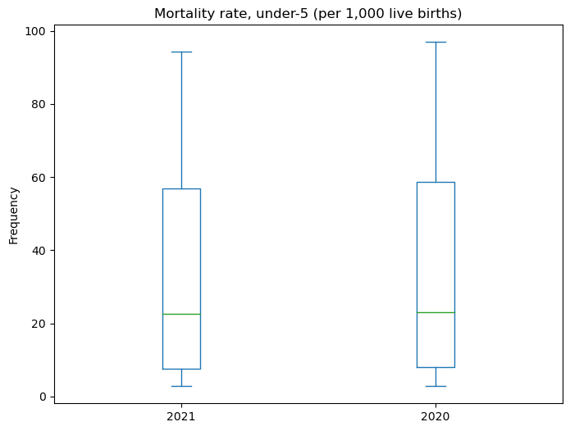

Figure 4 Mortality rate representation in box chart.

In the above, there is represented the data about the mortality rate of the child under the age of 5 per 1,000 live births as per the data. There can be seen that there is the highest maximum number of deaths above 90 in both years' data where as there is a decrease in the maximum number of deaths in 2021 than 2020. The maximum is the upward sideline of the box.

# Line chart

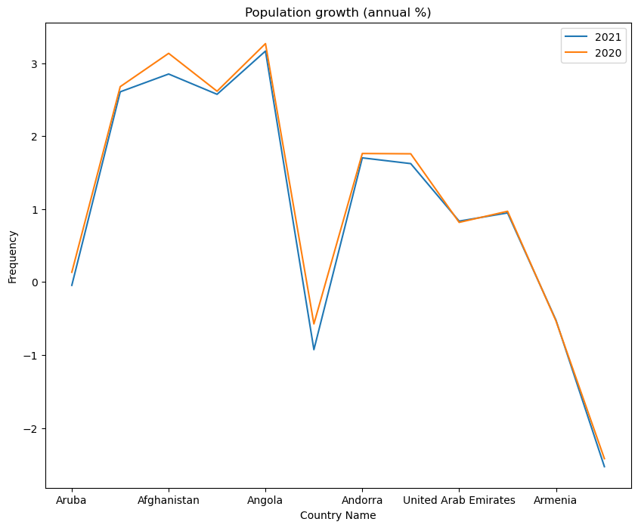

Figure 5 Line chart representation of annual population growth of different countries.

There is a graphical representation of the annual percentage of the population growth which is visualized with the line chart where the data for 2020 and 2021 are represented by 6 countries. The orange line states the 2020 year and the blue line refers to the 2021 year. There is illustrated that there is a decrease in the annual population growth of all the countries in the above diagram.

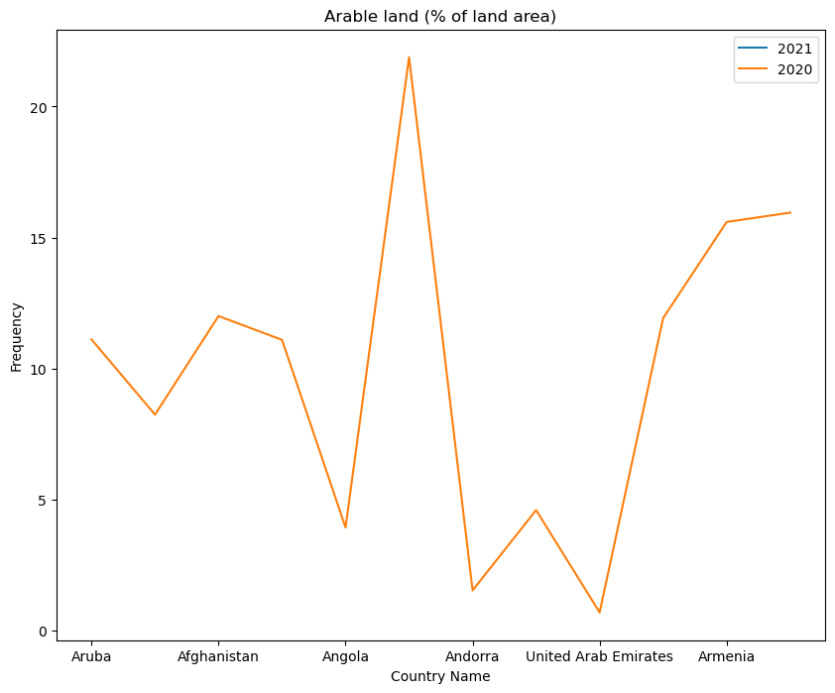

Figure 6 Line chart representation of the Arable land area.

In the above diagram, there is an illustration of the line that illustrates the data related to the indicator factor of Arable land area percentage of different currents from the selected dataset where the data are of 6 countries. In the above, there is an indexed of 2020 and 2021 year data but there may be no data related to the 2021 year on the percentage of Arable land area which may be stated as 0 so the line of the 2021 year data is not visible. From the above diagram, it can be stated that Angola has the highest percentage of Arable land area in that particular country.

# Story

As context of the visualization and proper analysis of the dataset of the World bank where different countries data are provided in the dataset. With the proposed module and methods the above visualization are evacuated. In context of visualized diagram they are effective in providing proper relations between the indicators, and other details of the different countries with the variety of the indicators. Though there is not used of all the indicators and other plots but other also can be evacuated for proper analysis regarding different aspects. There is visualized of data over the time-series data over comparison of different data. With the proposed visualization and analysis there is evacuated and analysis of the progress of different countries over other and also with themselves with the comparison with before years data. This is effective efficient for better comparison and analysis of different countries with the proper graphical representation and analysis.