Download STS from <https://spring.io/tools/sts/all>

Download Xampp from <https://www.apachefriends.org/download.html>

Download mysql workbench from <https://dev.mysql.com/downloads/workbench/>

Install all 3 softwares mentioned above

Set up DB

Start mysql and apache to setup DB and select admin next to mysql as shown below to open phpmyadmin

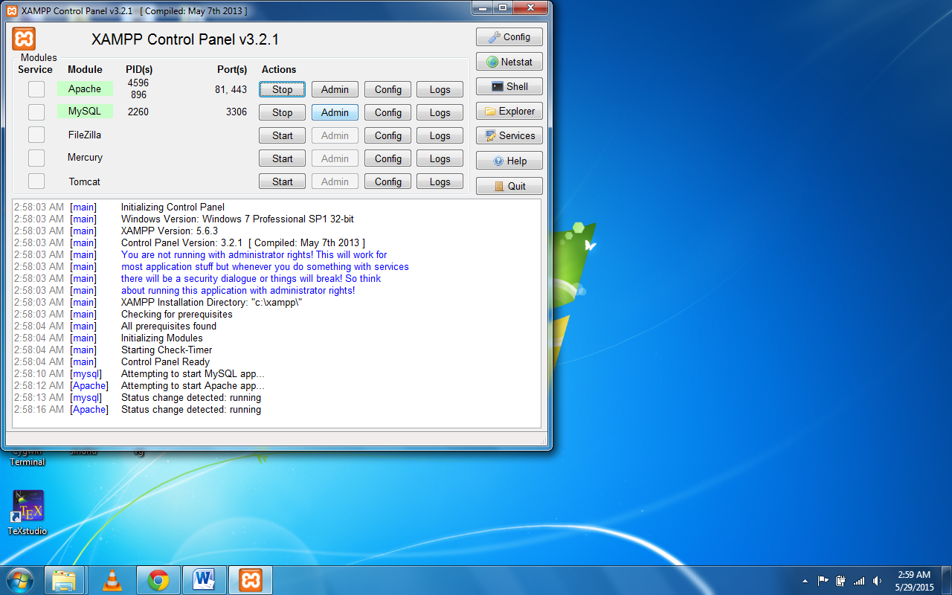

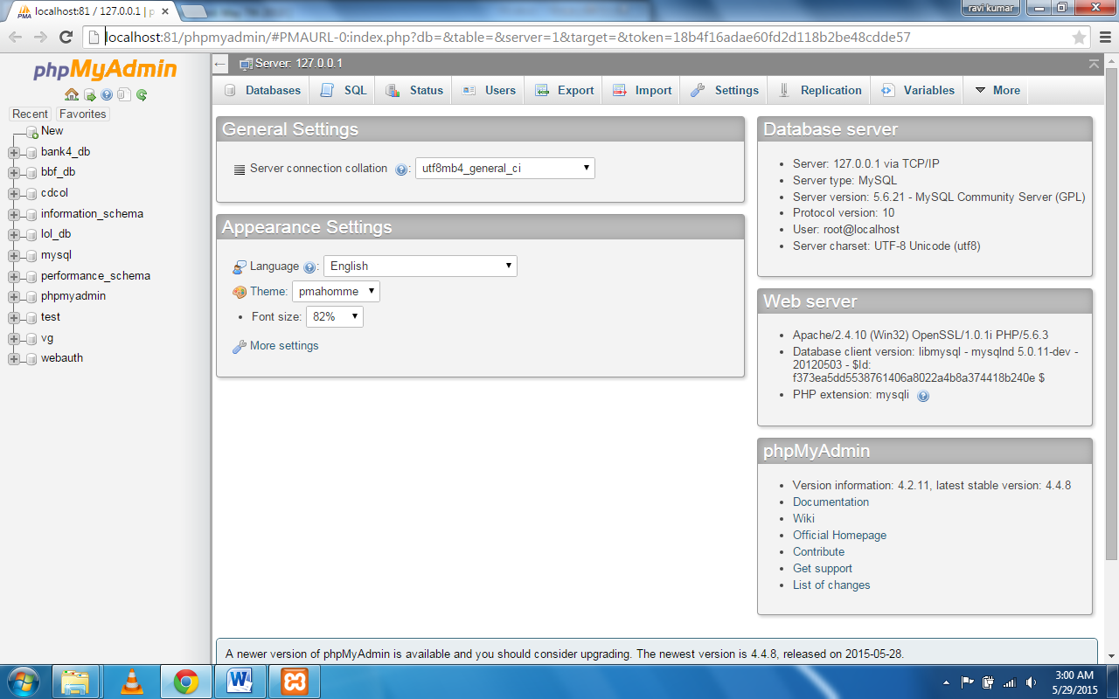

Select users tab and click on add user to add user for database

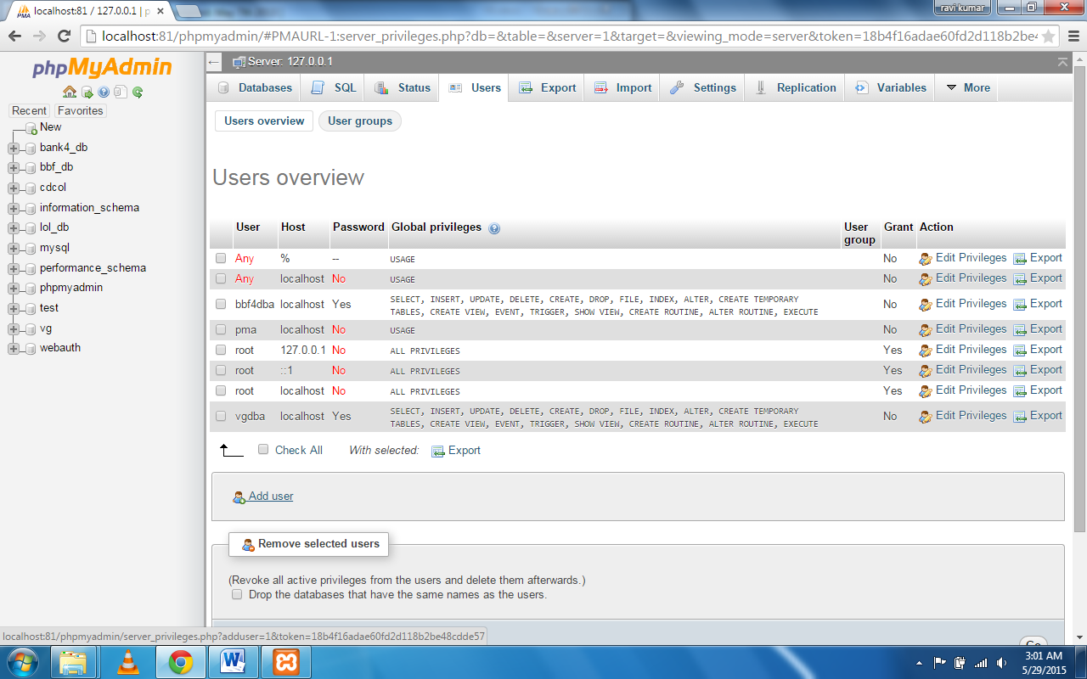

UserName - vgdba

Password - P@ssVG_dba

Global privileges check all

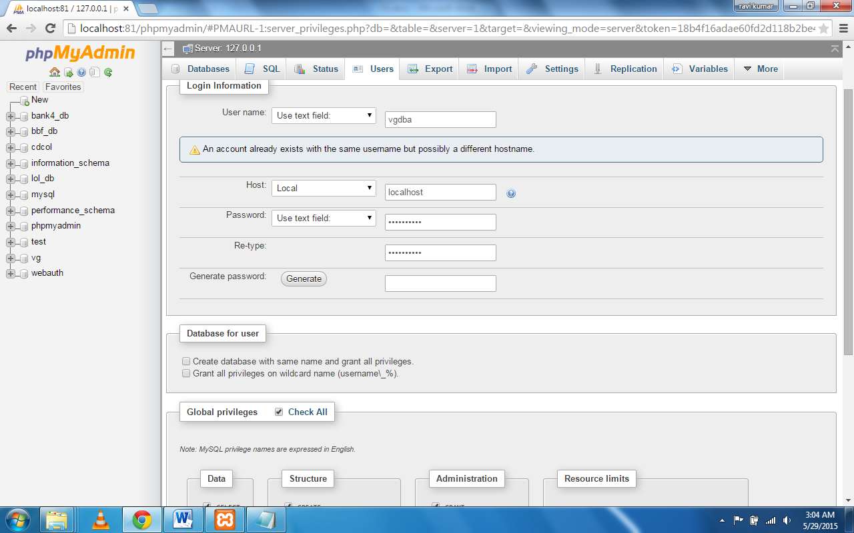

Click on go to create user vgdba

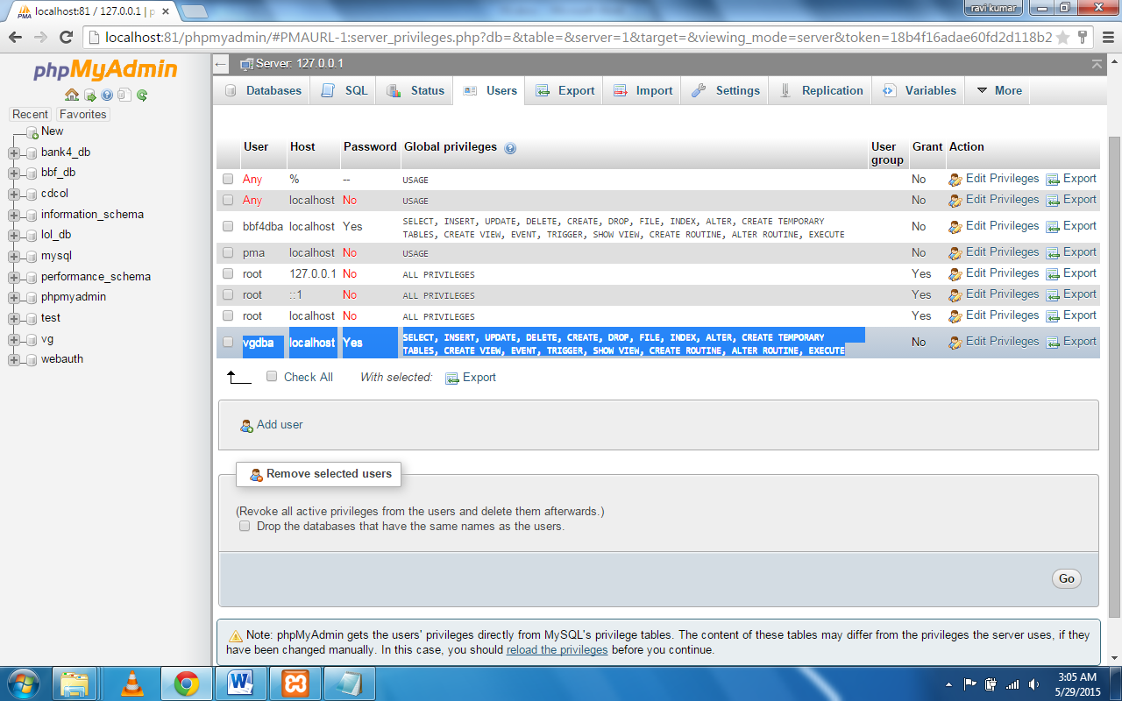

Click on database tab and create vg database

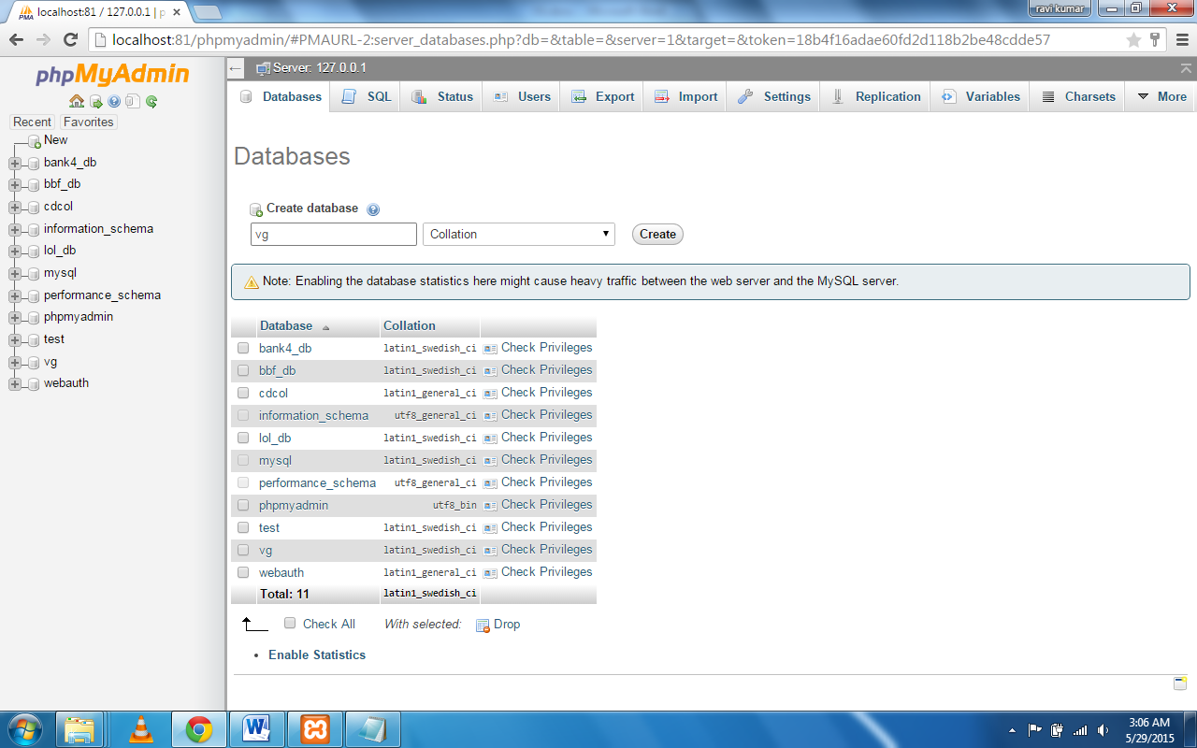

Now you can stop apache in xampp as we only need mysql for our application. Apache is needed for phpmyadmin

Now open STS (Spring Tool suite)

And import project vg into workspace

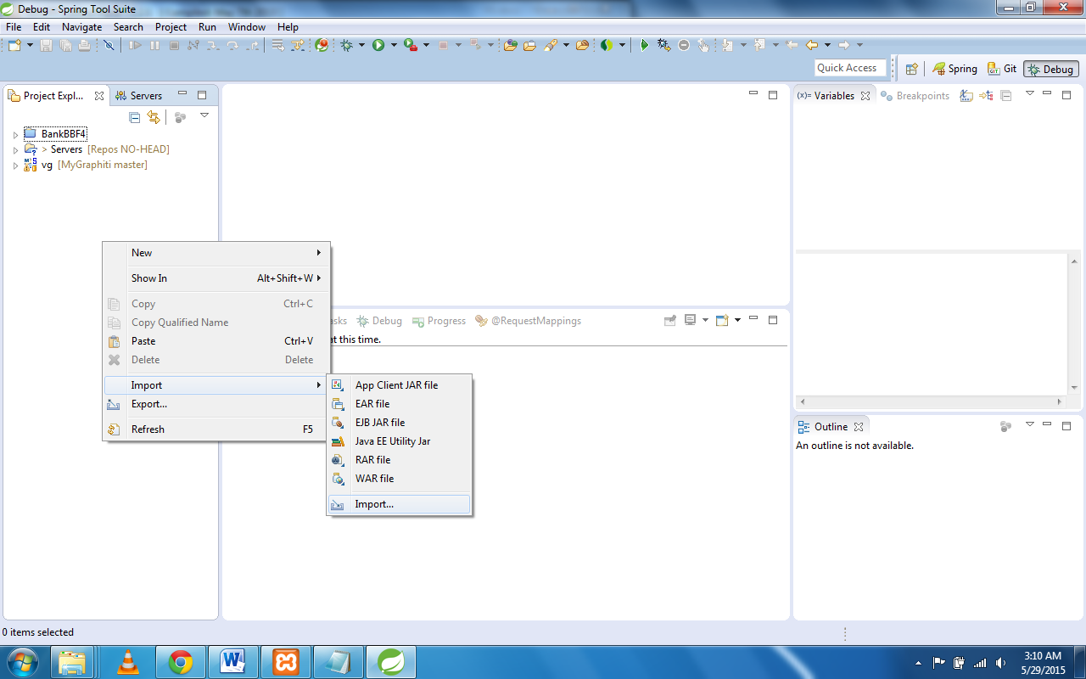

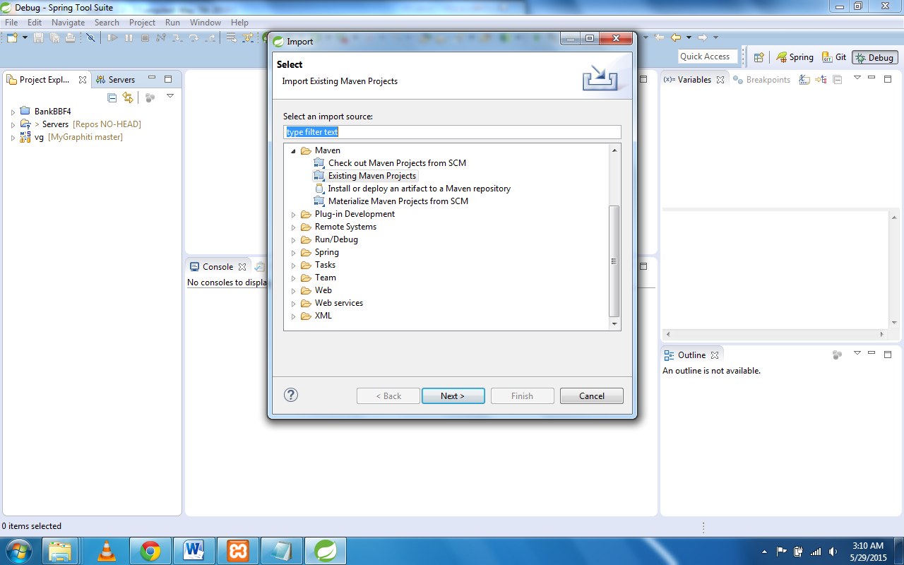

Go to vg repository folder and select the project and finish

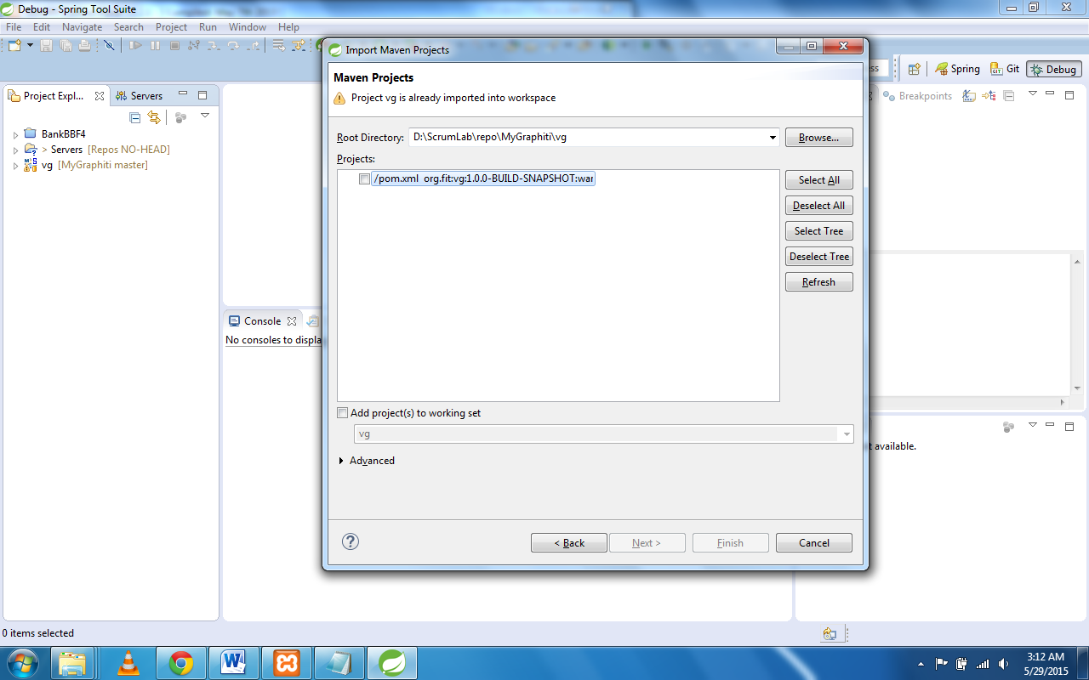

To run the project run on server

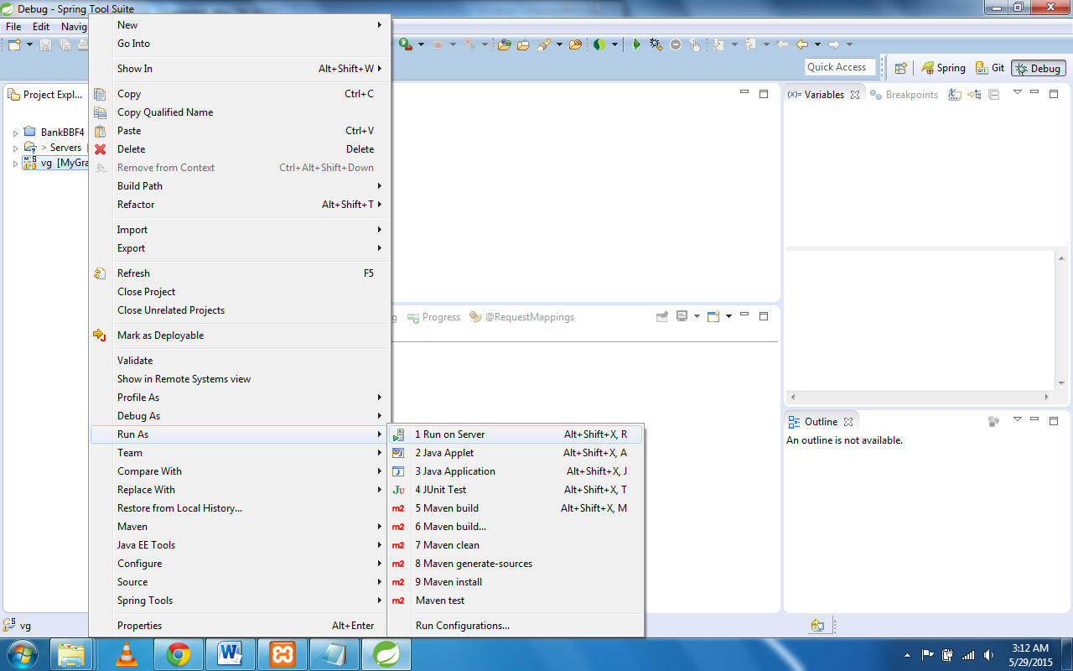

Application should be up and running

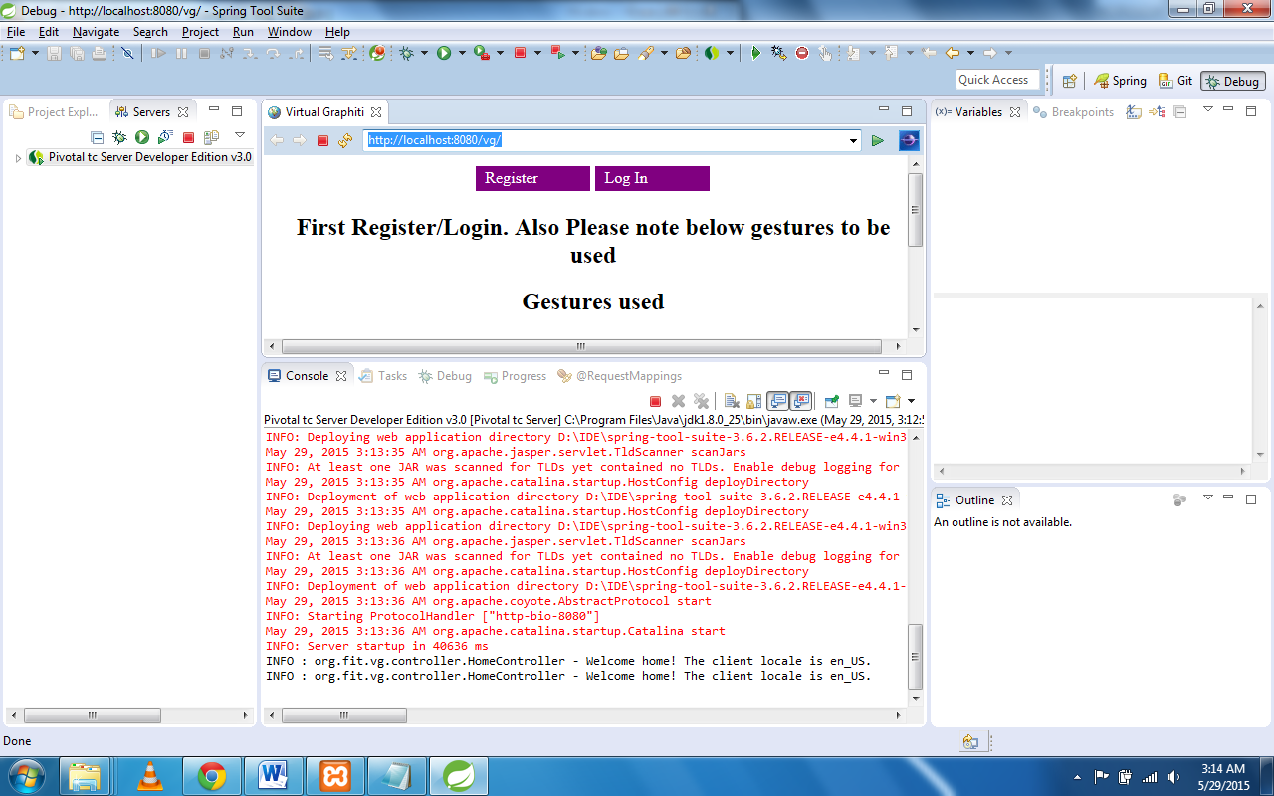

Paste the url in some browser.

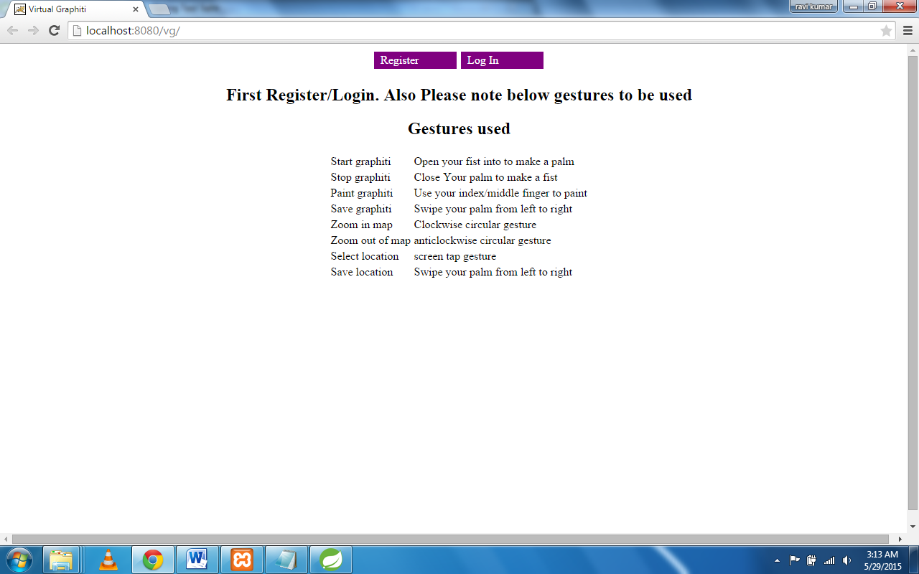

Package structure

org.fit.vg.controller all the controllers

org.fit.vg.config all the configuration files

org.fit.vg.dao Data access objects with queries written

org.fit.vg.model model classes that are used as tables in db

org.fit.vg.service service methods to perform business logic

org.fit.vg.util utility methods.

Resources contain all static resources

Views contain jsp pages used

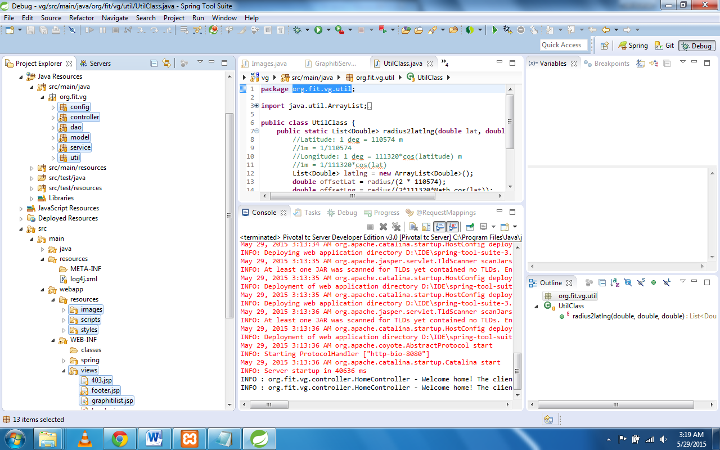

Start mysql workbench if you want an ide to look at database

Configure new connection to vgdba user

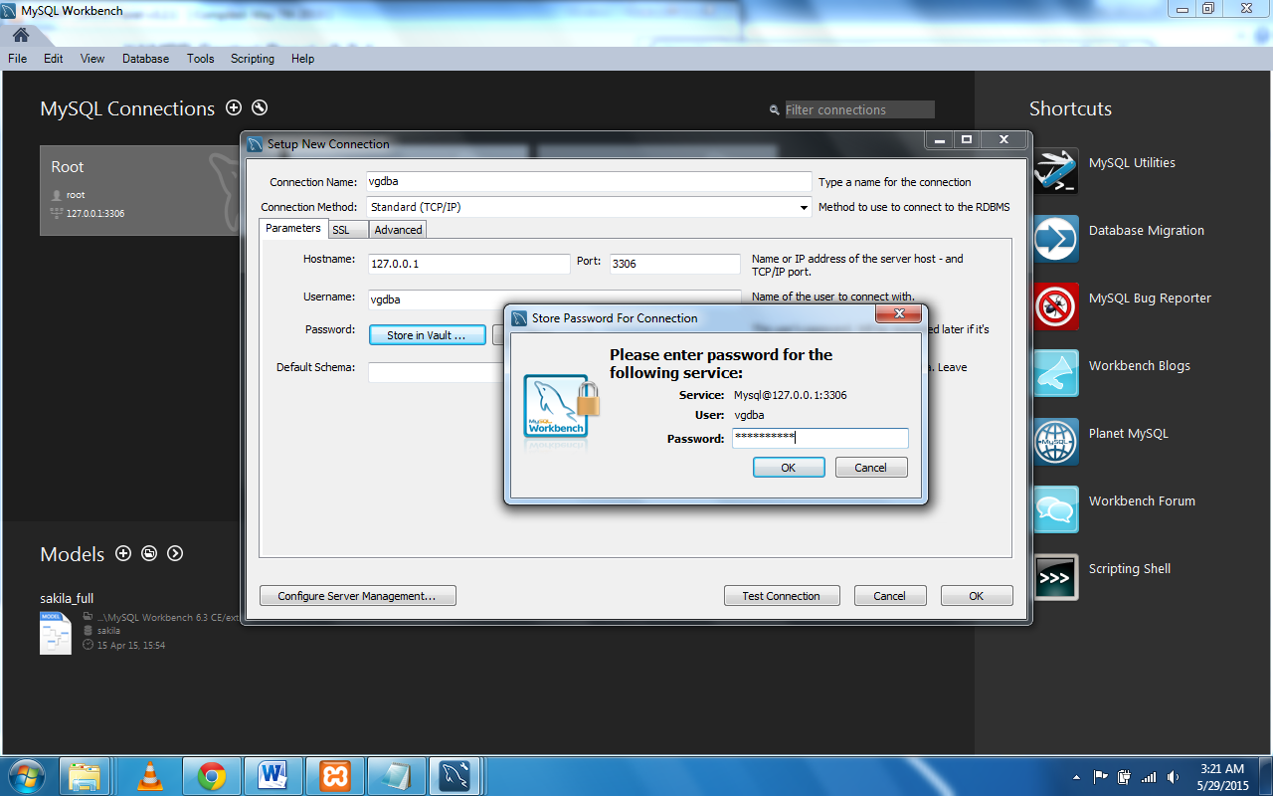

Type below command to use database vg

Use vg;

