Travel Reimbursement Approval Agent
Target Architecture & Feasibility Prototype — Domestic Travel Reimbursement
Architecture Note · Prepared by Ravi, AI Architect

1. Problem Decomposition
Finance teams manually review travel reimbursement claims against a policy document, receipts, and approval thresholds. The task decomposes into six checkable sub-problems, each mapped to a discrete, testable component rather than one monolithic LLM call:
Sub-problem | Component | Why not a single LLM call
What does policy say for this category/city? | Policy Retrieval Tool (RAG) | Needs citable, versioned evidence — not paraphrase
Is the receipt genuine and complete? | Receipt Validation Tool | Deterministic field checks; OCR/Doc-AI, not language reasoning
Has this exact expense been claimed before? | Duplicate Check Tool | Exact-match DB lookup, must never be "fuzzy"
Who must approve, and what caps apply? | Approval Matrix Tool | Business rule lookup; changes independently of policy text
What is the compliant amount and why? | Decision Engine | Deterministic arithmetic + rule fusion over tool outputs
How confident are we, and is this explainable? | LLM Reasoning Step | Natural-language rationale grounded in the above evidence only

Key assumptions (scope boundary for this exercise)
- Domestic travel only, four categories: flight, hotel, meals, taxi. International travel, advances, and mileage claims are out of scope.
- One employee grade hierarchy and one currency (INR); multi-entity/multi-currency is a v2 concern.
- "Policy" is a static mock document for this exercise; production would version policy documents and re-embed on change.
- The LLM is used only for grounded explanation generation and confidence framing — never for arithmetic, cap comparison, or the approve/reject decision itself, which are deterministic code.
- Claims arrive as structured JSON (from an expense app/ERP form). Free-text claim parsing is a v2 concern and would sit in front of Claim Intake.

2. Chosen Agent Pattern
A deterministic orchestrator (state graph) coordinates specialist tools, with a single, narrowly-scoped LLM call for explanation and confidence — not a free-roaming multi-agent debate. This is a policy decision, not a limitation:
- Financial decisions require reproducibility. A state graph with typed tool contracts can be unit-tested per node; an open-ended multi-agent conversation cannot.
- Every branch (Approve / Partial / Reject / Manual Review) is an explicit, auditable code path, not an emergent LLM judgment.
- The LLM adds value exactly where humans need natural-language grounding — the "why" — while rule evaluation stays in deterministic code that Finance/Audit can review line-by-line.
- Target framework: LangGraph for the state machine, Azure OpenAI for the reasoning step, FastAPI for the claim-intake API — consistent with a standard enterprise GenAI stack.

3. Component Architecture
The diagram below shows responsibility boundaries: intake/gateway (enterprise edge), orchestrator + LLM (agent core), a tool belt of four narrow services, their backing data stores, and the decision/notification/ERP layer. Cross-cutting concerns (observability, IAM, secrets, governance) wrap the whole system rather than living inside any one box.
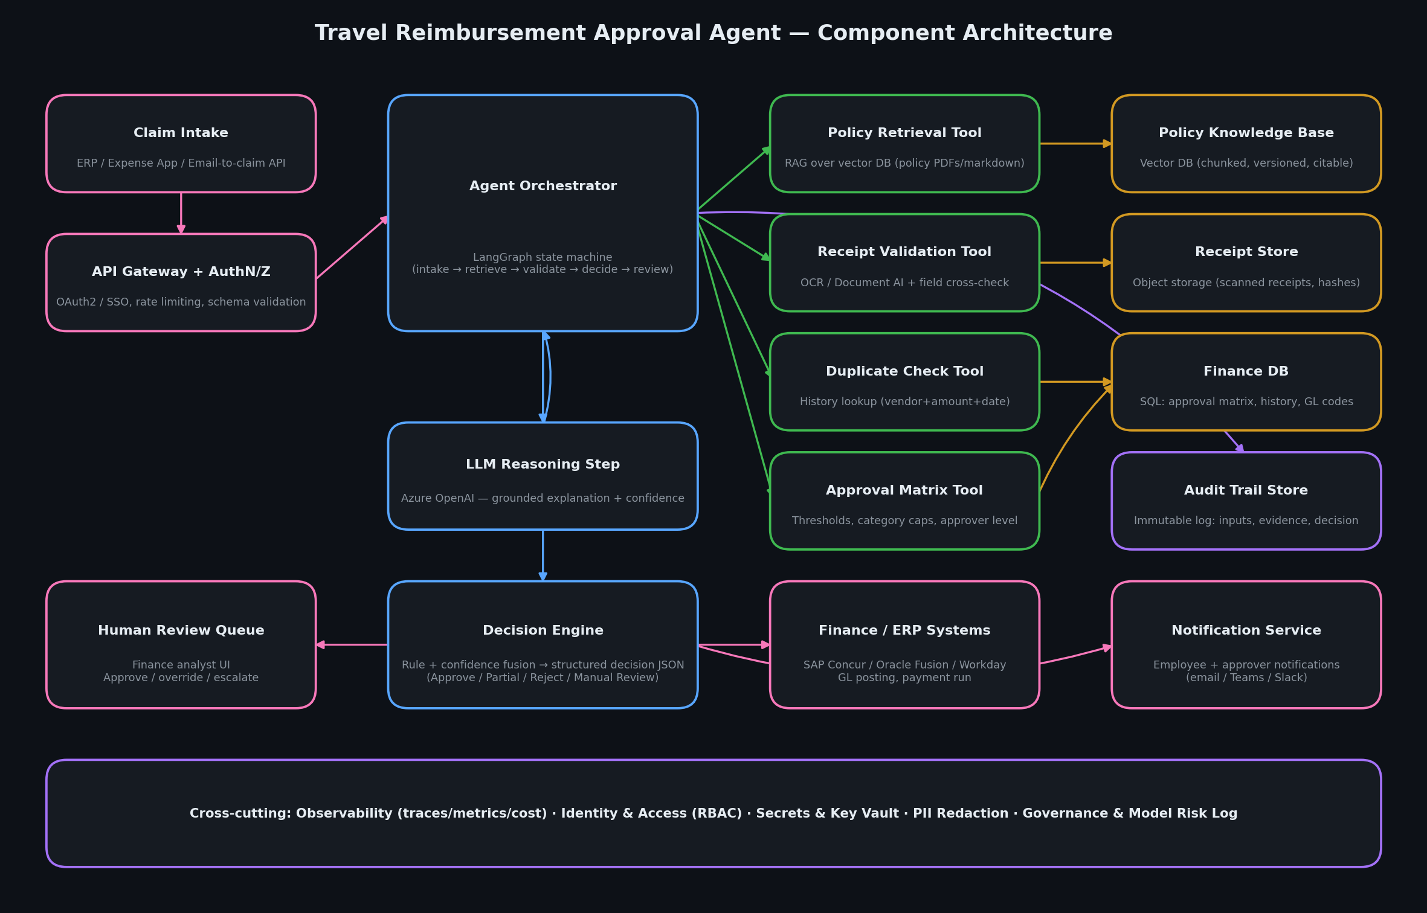
Figure 1 — Component architecture

4. Workflow / Sequence
A single claim's lifecycle, from submission to either an automated decision or a human-reviewed one. Note step 9: the audit record is written before the confidence branch — every claim gets a durable evidence trail regardless of how it resolves.
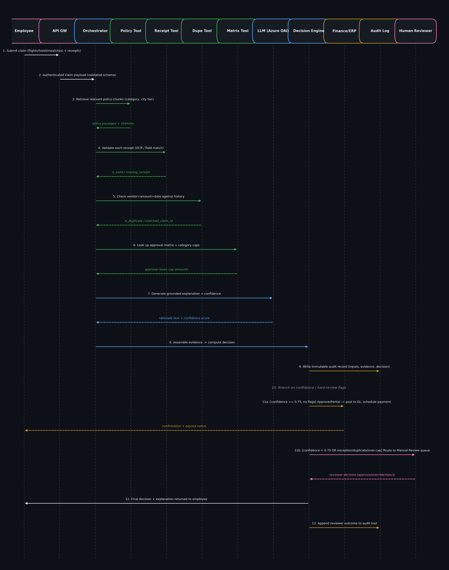
Figure 2 — Claim decisioning sequence

5. Tool / Service Contracts
Each tool is a narrow, independently testable interface. Failure handling is designed so that a tool outage degrades to Manual Review rather than a silent false-positive approval — this is the single most important reliability property of the design.
Tool | Input | Output | Failure handling
PolicyRetrievalTool | query text, top_k | [{id, section, text, score}] | Empty result ⇒ category has no grounded policy ⇒ Manual Review
ReceiptValidationTool | line_item (vendor, amount, date, receipt_id) | {is_valid, reason, confidence} | Missing/unattached receipt ⇒ is_valid=false, never assumed valid
DuplicateCheckTool | employee_id, vendor, amount, date | {is_duplicate, matched_claim_id} | DB unavailable ⇒ raises, orchestrator treats as blocking ⇒ Manual Review (never "assume clean")
ApprovalMatrixTool | total_amount / category+city_tier | {approver_level, auto_approvable} / {cap_amount} | No matching row ⇒ defaults to most conservative approver (Finance Controller, non-auto-approvable)
DecisionEngine | claim + all tool outputs | structured decision JSON (see §8) | Any hard-review flag or confidence < 0.75 ⇒ forced Manual Review, never overridden by the LLM step

Contracts are intentionally boring and typed (JSON-serializable dicts) so they can be implemented as REST/gRPC microservices, LangChain tools, or MCP servers without redesigning the orchestrator.

6. Context, Reliability & Audit

Policy grounding & source references
- Every decision carries a policy_references list of source-document IDs actually retrieved and used — never a hallucinated citation. If the decision engine cites POL-APPROVAL-01, that chunk was returned by the retrieval tool for this claim.
- Policy documents are versioned; the audit record stores the policy KB version hash alongside the decision so a later policy change never silently reinterprets a historical decision.

Confidence & fallback logic
- A simple, explainable confidence score (not an LLM-invented number) starts at 1.0 and is penalized for missing receipts, duplicates, and over-cap items; below 0.75 the claim always falls back to Manual Review.
- Hard rules (exception claimed, duplicate detected, >20% over category cap) force Manual Review regardless of confidence — confidence is a fallback net, not the primary safety mechanism.

Structured outputs
- The Decision Engine's output is a fixed JSON schema (decision, approved/rejected amounts, per-line breakdown, flags, policy references, required approver, rationale) — never free-form LLM text — so it can be consumed directly by ERP posting and analyst UIs.

Audit trail
- Every claim produces an immutable record: input payload, every tool call and its output, the policy chunks retrieved, the confidence computation, the final decision, and (if applicable) the human reviewer's action — sufficient for a Finance/Internal Audit reconstruction of "why" months later.

7. Enterprise Readiness
Area | Approach
Security | mTLS between services; secrets in Key Vault/HSM, never in code or prompts; least-privilege service identities per tool
Privacy | PII (employee ID, bank details) tokenized before reaching the LLM context; only category-level, non-identifying fields sent to the reasoning step
Identity & access | SSO/OAuth2 at the API gateway; RBAC for Finance reviewers vs. read-only auditors; every override attributed to a named reviewer
Finance system integration | Async event (Event Grid/Kafka) or batch file to ERP (SAP Concur/Oracle Fusion) for GL posting; idempotency keys prevent double-posting on retry
Observability | Per-node tracing (LangSmith/OpenTelemetry) of tool latency, retrieval hit-rate, confidence distribution, and Manual Review rate as a leading indicator of policy drift
Cost | LLM called once per claim for explanation only (not per tool call); cache policy retrieval per category/city-tier combination; batch low-priority claims off-peak
Latency | Target < 5s for auto-decidable claims (no LLM call needed on the hard-reject/hard-review paths); LLM reasoning path budgeted at 2-3s p95
Scalability | Stateless orchestrator pods behind a queue; tool services scale independently; approval-matrix/policy lookups are the hot path and should be cached aggressively

8. Input / Output Examples
Six sample claims were run through the prototype end-to-end (full JSON in sample_claims.json / sample_decisions.json). Summary:
Claim | Requested | Approved | Decision | Key flag(s)
CLM-1001 | ₹16,850 | ₹16,850 | Manual Review | Above ₹10k auto-approval threshold → needs Manager sign-off
CLM-1002 | ₹23,100 | ₹20,600 | Partially Approve | Flight ₹17,500 > ₹15,000 cap → excess disallowed
CLM-1003 | ₹11,300 | ₹7,000 | Manual Review | Hotel line item missing receipt
CLM-1004 | ₹8,200 | ₹8,200 | Manual Review | Duplicate of CLM-1001 (same vendor/amount/date)
CLM-1005 | ₹53,300 | ₹0 (pending) | Manual Review | Exception claimed → always routed, never auto-approved
CLM-1006 | ₹6,580 | ₹6,580 | Approve | Fully compliant, under threshold, no flags

Full structured output for CLM-1002 (Partially Approve), showing the schema every claim produces:
{
"decision_id": "85d035f1-7be1-44ea-9177-9d2f2470f277",
"claim_id": "CLM-1002",
"employee_id": "E7734",
"decision": "Partially Approve",
"requested_amount": 23100,
"approved_amount": 20600,
"rejected_amount": 2500,
"confidence": 1,
"flags": [],
"policy_references": [
"POL-APPROVAL-01",
"POL-FLIGHT-01",
"POL-HOTEL-01",
"POL-MEALS-01"
],
"line_item_breakdown": [
{
"category": "flight",
"requested": 17500,
"cap": 15000,
"approvable": 15000,
"receipt_valid": true,
"over_cap_pct": 16.7
},
{
"category": "hotel",
"requested": 4200,
"cap": 7000,
"approvable": 4200,
"receipt_valid": true,
"over_cap_pct": 0
},
{
"category": "meals",
"requested": 1400,
"cap": 1500,
"approvable": 1400,
"receipt_valid": true,
"over_cap_pct": 0
}
],
"required_approver": "Manager",
"rationale": "Some line items exceed policy caps or failed receipt validation; the compliant portion is approved and the remainder is disallowed.",
"generated_at": "2026-09-07T03:33:27.101609+00:00"
}

9. Feasibility Evidence
A runnable Python prototype (agent.py, ~330 lines) implements every tool contract above against mock data (policy_kb.json, finance_db.sqlite) and produces the table in §8 deterministically. Excerpt of the execution trace for CLM-1003 (missing-receipt path):
===== Claim CLM-1003 =====
[intake] claim_id=CLM-1003 employee=E2210 requested_total=11300
[receipt] flight (R-9201) -> valid, cap=15000, amount=6100, over_cap_pct=0%
[receipt] hotel (None) -> INVALID (missing_receipt)
[receipt] meals (R-9203) -> valid, cap=1500, amount=900, over_cap_pct=0%
[approval_matrix] approved_total=7000 -> approver=System (Auto), auto_approvable=True
[decision] Manual Review | approved=7000/11300 | confidence=0.60 | flags=['hotel:missing_receipt']
Full trace for all six claims is in workflow_trace.txt; the runnable source is in agent.py, data in policy_kb.json / sample_claims.json / finance_db.sqlite. This satisfies the assignment's feasibility requirement without a UI: the orchestration logic, tool boundaries, and decision schema are all exercised on realistic sample data.

10. Deployment Architecture
Two deployment targets are shown for the same logical architecture — the tool contracts and decision engine are identical in both; only the hosting substrate changes.
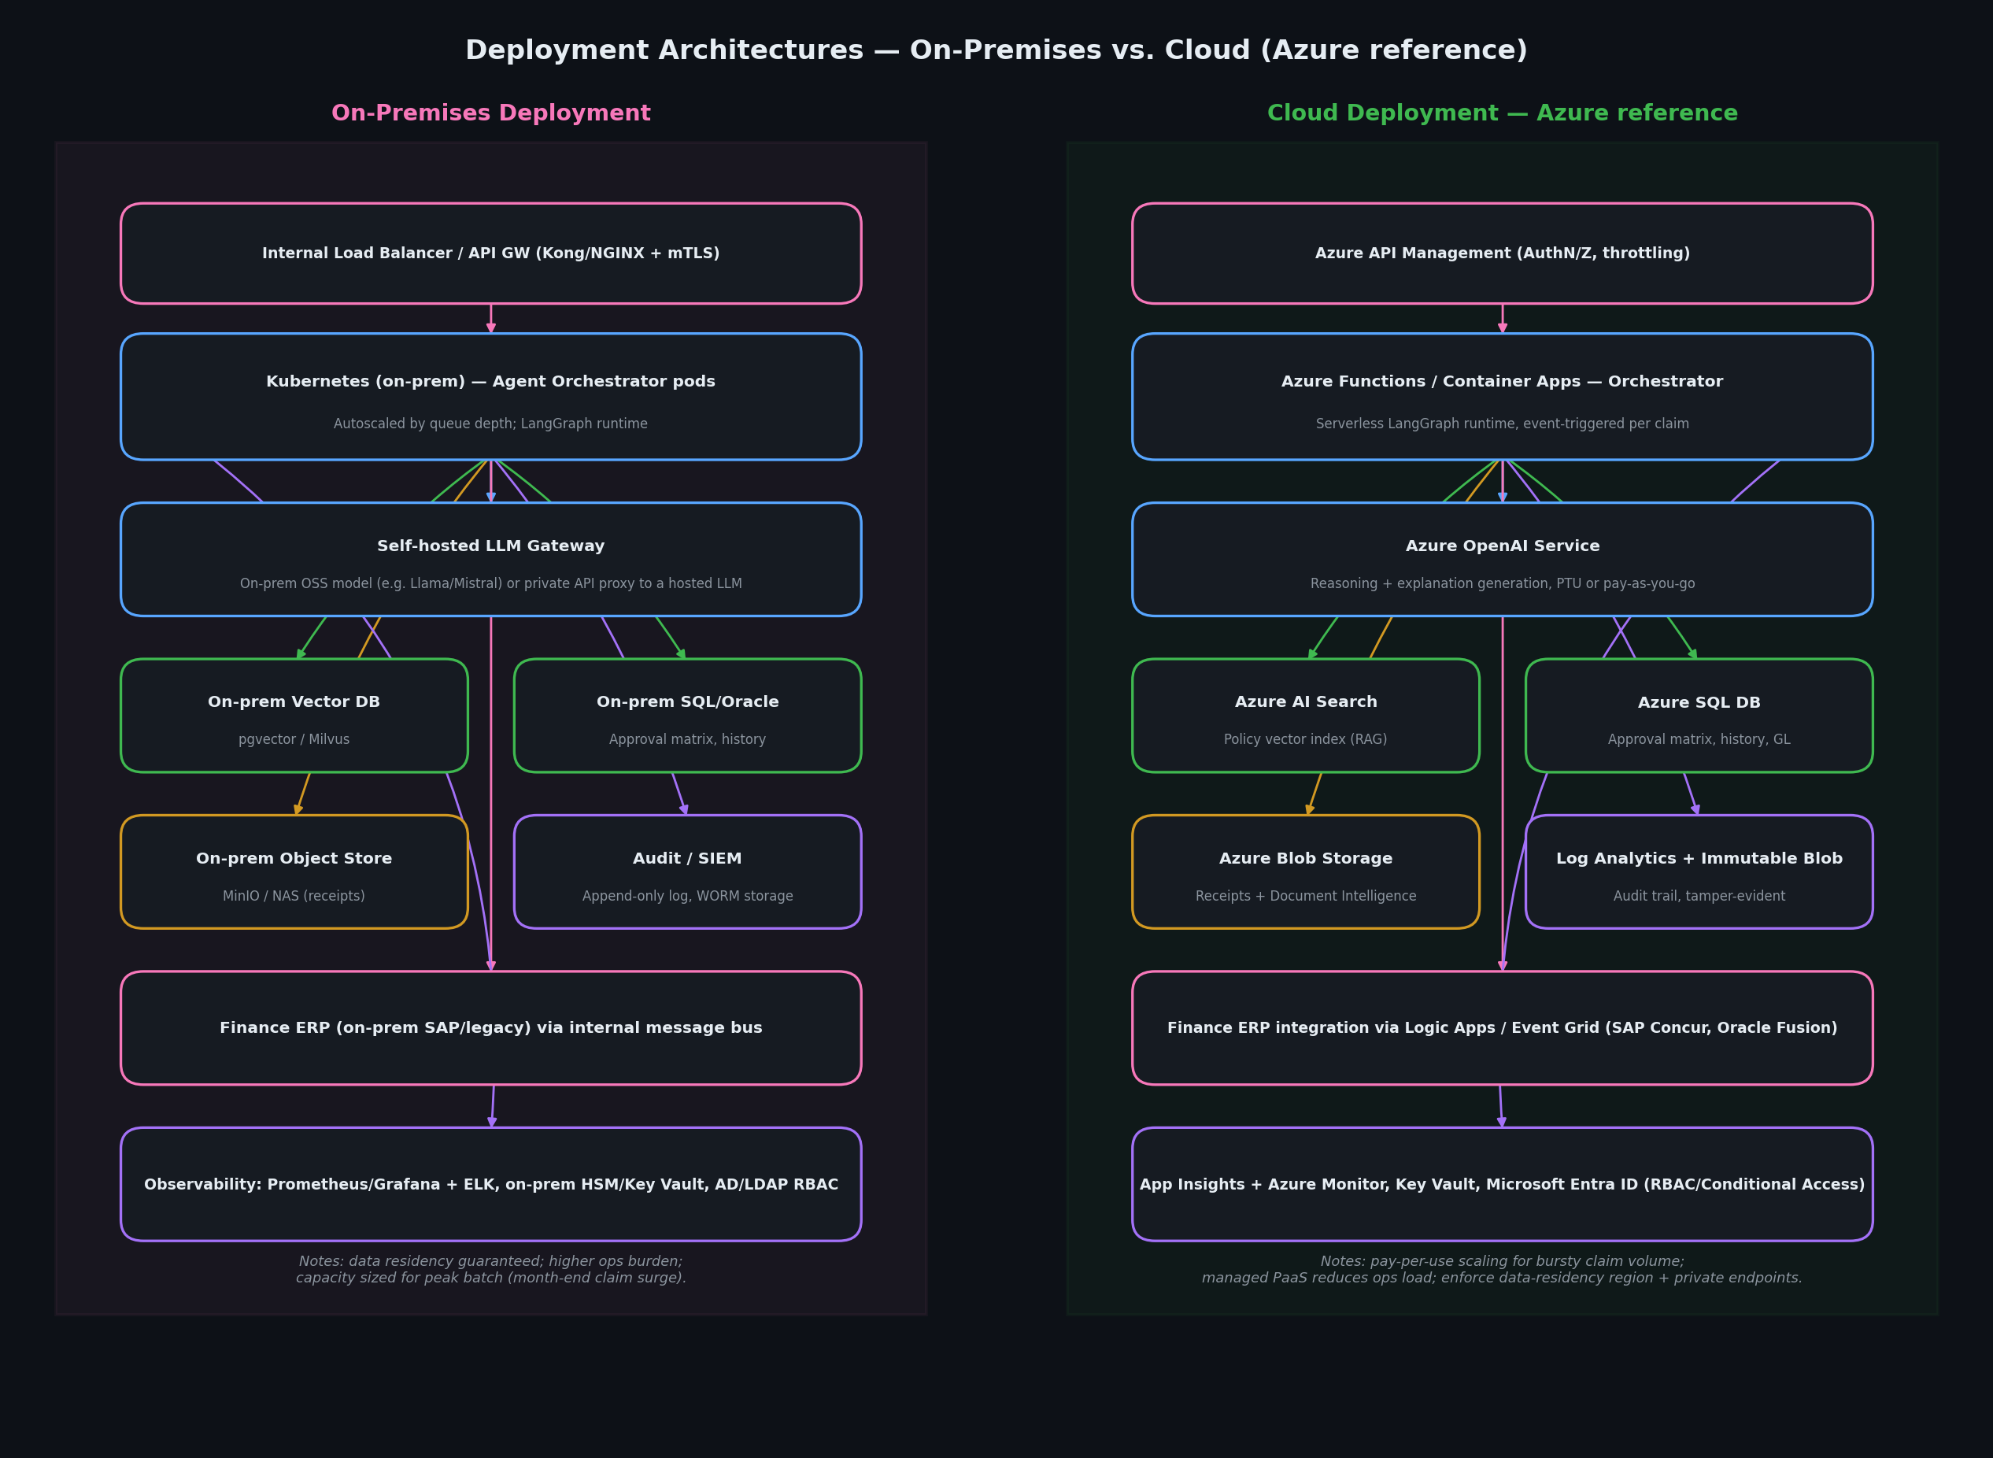
Figure 3 — On-premises vs. cloud (Azure) deployment
- On-premises: Kubernetes-hosted orchestrator, self-hosted or proxied LLM, on-prem vector/SQL/object stores — chosen when data residency or existing SAP/legacy ERP integration mandates it. Higher fixed ops cost, predictable capacity.
- Cloud (Azure): serverless/container orchestrator, Azure OpenAI, Azure AI Search (RAG), Azure SQL, Blob + Document Intelligence for receipts — chosen for bursty claim volume (e.g. month-end) and lower ops overhead. Requires private endpoints and a fixed data-residency region for regulated customers.

11. Risks, Limitations & Next Steps

Manual Review triggers (by design)
- Missing or unreadable receipt for any line item above the policy threshold
- Duplicate vendor+amount+date match against reimbursement history
- Any line item exceeding its category cap by more than 20%
- Claimed policy exception (always, regardless of amount)
- Total claim amount above the system auto-approval threshold (routed to the appropriate human approver, not rejected)
- Composite confidence score below 0.75

Known limitations of this prototype
- Policy retrieval is keyword match, not embeddings — production needs a real vector index and periodic re-indexing on policy updates.
- Receipt validation is mocked (no real OCR/Document AI call) — field cross-checking against actual scanned images is a v2 integration.
- Split-claim fraud (same expense divided across multiple small claims to dodge thresholds) is only partially covered — needs a time-windowed aggregate check across an employee's recent claims, not just exact-match duplicates.
- No multi-currency, multi-entity, or international travel support in this scope.

Governance & production next steps
- Human-in-the-loop UI for the review queue with one-click approve/override/escalate and mandatory reviewer comments on override.
- Model risk log: track LLM explanation drift vs. rule-engine outcome over time; alert if explanation and decision ever diverge.
- Periodic policy-KB re-embedding pipeline with a diff report so Finance can see what changed and re-validate cached decisions if needed.
- Load testing for month-end claim surges; cost monitoring per claim (tool calls + LLM tokens) with a per-claim budget alert.

