Long Quiz Module 7 and 8

Candidate name: **B G Ravi Kumar Hebbar 2416322**

GitHub link: <https://github.com/ravikumarbggit/long_quiz_m7_m8/tree/master>

Snapshots:

**Matrix Multiplication**

**Standard matrix multiplication**

python .\standard\mat-mult.py

[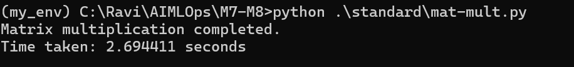](https://github.com/ravikumarbggit/long_quiz_m7_m8/blob/master/assets/images/standard-mat-mult.png)

Time taken is **2.7** seconds

**MPI base matrix multiplication with 2 nodes**

mpiexec /np 2 python .\mpi\mat-mult.py

[](https://github.com/ravikumarbggit/long_quiz_m7_m8/blob/master/assets/images/mp-mat-mult-2-nodes.png)

Time taken is **0.61** seconds

**MPI base matrix multiplication with 4 nodes**

mpiexec /np 4 python .\mpi\mat-mult.py

[](https://github.com/ravikumarbggit/long_quiz_m7_m8/blob/master/assets/images/mp-mat-mult-4-nodes.png)

Time taken is **0.38** seconds

**Banchmarking result**

Matrix dimension: rows_A, cols_A = 300, 400 rows_B, cols_B = 400, 200

With standard multiplication matrix multiplication took 2.7 seconds

With MPI 2 nodes it took 0.61 seconds With MPI 4 nodes it took 0.32 seconds

Improvement in performance ((New Value - Old Value) / Old Value) * 100

**The performance improved by approximately *88.15%*** 🎉