Potato leaf disease detection

A Project Report
submitted in partial fulfillment of the requirements
of
AICTE Internship on AI: Transformative Learning
with
TechSaksham – A joint CSR initiative of Microsoft & SAP

by

Ravi Kumar Gupta , ravikumargupta9470@gmail.com
(STU676aa99bbe7fd1735043483)

Under the Guidance of
Pavan Sumohana

ACKNOWLEDGEMENT

I am immensely grateful for the guidance, encouragement, and unwavering support that I have received throughout the course of this project. This accomplishment would not have been possible without the contributions of several individuals and organizations, to whom I owe my deepest gratitude.
First and foremost, I wish to express my heartfelt thanks to my esteemed guide, Pavan Sumohana, for their exceptional mentorship and dedicated guidance. Their insightful advice and constructive feedback have been invaluable throughout every stage of this project. The patience and expertise demonstrated by my guide in addressing challenges, providing innovative solutions, and steering me in the right direction have been the cornerstone of this successful endeavor. Their belief in my abilities and continuous motivation inspired me to push the boundaries of my potential and achieve excellence in this work.
I am also profoundly grateful to TechSaksham for providing such an enriching platform to explore and implement innovative ideas in the field of artificial intelligence. The transformative learning experience and access to invaluable resources provided through this initiative have significantly enhanced my technical knowledge and professional development. The internship offered me a unique opportunity to translate theoretical concepts into practical applications, and I deeply appreciate the vision of TechSaksham in empowering young minds like me.

ABSTRACT
Potato is a crucial staple crop worldwide, but its productivity is significantly affected by leaf diseases such as Early Blight, Late Blight, and other infections. Traditional disease detection methods rely on manual inspection, which is time-consuming, labor-intensive, and prone to errors. To address this issue, this study proposes a deep learning-based approach for automated potato leaf disease detection using a Convolutional Neural Network (CNN) model.
The proposed system utilizes an image dataset containing three classes: Early Blight, Late Blight, and Healthy leaves. The dataset is preprocessed using resizing, normalization, and augmentation techniques to improve model generalization. A CNN architecture consisting of multiple convolutional layers, max-pooling layers, dropout regularization, and fully connected layers is designed to classify leaf images accurately. The model is trained using the Adam optimizer with sparse categorical cross-entropy loss, and early stopping is implemented to prevent overfitting.
The results demonstrate that the model achieves high classification accuracy, with strong performance in distinguishing between different disease categories. Evaluation metrics such as confusion matrix, precision, recall, and F1-score indicate that the model is effective in identifying infected leaves. The accuracy and loss trends during training and validation further validate the robustness of the approach.
This study highlights the potential of deep learning in precision agriculture, offering a scalable and automated solution for early disease detection, thereby helping farmers take timely preventive measures to reduce crop losses and improve yield quality. Future improvements may involve expanding the dataset, integrating hyperspectral imaging, and deploying the model in real-time IoT-based agricultural monitoring systems.
Keywords: Potato Leaf Disease, Deep Learning, Convolutional Neural Networks (CNN), Image Classification, Precision Agriculture.

TABLE OF CONTENT
Abstract I

Chapter 1. Introduction 1
1.1 Problem Statement 1
1.2 Motivation 1
1.3 Objectives 1
1.4. Scope of the Project 1
Chapter 2. Literature Survey 3
Chapter 3. Proposed Methodology 4
Chapter 4. Implementation and Results 9
Chapter 5. Discussion and Conclusion 11
References 13

LIST OF FIGURES
Figure No. | Figure Caption | Page No.
 | Architecture Diagram

LIST OF TABLES
Table. No. | Table Caption | Page No.

CHAPTER 1
Introduction

  - Problem Statement:
Potatoes are one of the most widely cultivated crops globally and serve as a vital food source for millions of people. However, potato plants are highly susceptible to various diseases, with Early Blight and Late Blight being the most destructive. These diseases can cause severe yield loss, affecting both crop quality and agricultural economics. Traditional disease identification methods rely on manual visual inspection by farmers or agricultural experts, which is time-consuming, labor-intensive, and often inaccurate.With recent advancements in artificial intelligence (AI) and deep learning, there is an opportunity to develop an automated system for detecting potato leaf diseases with high precision. This project aims to address the challenge of early and accurate disease detection using a Convolutional Neural Network (CNN)-based image classification model to help farmers take timely action and prevent large-scale crop losses.

  - Motivation:
The motivation behind this project stems from the urgent need for efficient, cost-effective, and automated disease detection systems in agriculture. Some key reasons include:
- Global Agricultural Losses: Potato diseases contribute to significant economic losses worldwide, particularly in developing countries where resources for advanced diagnostics are limited.
- Manual Inspection Limitations: Human-based disease identification is prone to errors, subjective judgments, and delays, leading to ineffective disease control.
- Technological Advancements: Deep learning models have shown remarkable success in image classification, making them a promising solution for plant disease detection.
- Potential Applications: The model can be integrated into mobile applications, smart farming systems, and IoT-based agricultural monitoring to assist farmers in real-time disease detection.
The successful implementation of this project could improve crop yield, reduce pesticide overuse, and support sustainable agricultural practices.

  - Objective:
The primary objectives of this project are:
- Develop a CNN-based model for classifying potato leaf diseases into Early Blight, Late Blight, and Healthy categories.
- Preprocess and analyze the dataset to improve the model’s performance using techniques like image resizing, normalization, and augmentation.
- Train and evaluate the CNN model to achieve high classification accuracy while preventing overfitting.
- Assess model performance using evaluation metrics such as accuracy, precision, recall, F1-score, and confusion matrix.
- Compare training and validation performance using loss and accuracy plots.
- Provide an efficient and scalable solution that can be deployed in real-world agricultural applications such as mobile apps or IoT-based systems.
.

  - Scope of the Project:
The scope of this project includes:
Dataset Selection: The dataset consists of images classified into three categories: Early Blight, Late Blight, and Healthy potato leaves.
Deep Learning-Based Approach: The model is built using TensorFlow and Keras, leveraging CNN architecture for disease classification.
Performance Evaluation: The system is assessed using classification metrics and visualization tools to ensure its reliability.
Practical Applications: The solution is designed for real-time implementation, allowing farmers and agricultural experts to detect diseases efficiently.
Limitations
The model is limited to three classes (Early Blight, Late Blight, and Healthy) and may not detect other potato diseases.
The dataset size and quality may impact model accuracy. More diverse datasets could enhance generalization.
The model relies on image quality; poor lighting or blurred images may affect detection accuracy.

.

CHAPTER 2
Literature Survey
The paper "Potato Leaf [1] Disease Detection Method Based on the YOLO Model" presents a deep learning-based approach for identifying and classifying potato leaf diseases using the YOLOv7 model. Potato leaf diseases significantly impact global agricultural productivity, necessitating early and accurate detection. The authors propose a methodology that includes data collection, preprocessing, enhancement, and classification to improve detection accuracy.The study leverages YOLOv7’s real-time object detection capabilities, demonstrating superior performance with a classification accuracy of 98.1%. The dataset comprises healthy and diseased potato leaf images, including cases of Early Blight and Late Blight. The model is trained using 80% of the dataset for training, 10% for validation, and 10% for testing. Optimization techniques, such as hyperparameter tuning, further enhance model efficiency.Comparative analysis with CNN and traditional machine learning models highlights YOLOv7’s superior accuracy and computational efficiency. The study contributes to precision agriculture by enabling real-time, automated disease detection, reducing crop losses, and promoting sustainable farming practices. The proposed framework holds significant potential for practical implementation, aiding farmers in disease management through early intervention. Future work may focus on expanding datasets and improving the model's generalizability across various plant species.
This paper introduces the concept [2] of Explainable Artificial Intelligence (XAI) in deep learning-based potato leaf disease detection. With the increasing adoption of deep learning models in plant disease identification, ensuring transparency and interpretability has become a crucial challenge. Traditional convolutional neural networks (CNNs) exhibit high accuracy in classifying plant diseases; however, their black-box nature limits trust and usability in real-world agricultural applications.In this paper, we explore the integration of XAI techniques to enhance the interpretability of deep learning models used for potato leaf disease detection. Specifically, we utilize visualization methods such as Grad-CAM and SHAP to analyze model predictions, providing insights into feature importance and decision-making processes. The dataset used comprises annotated images of potato leaves affected by various diseases, which are preprocessed and classified using CNN architectures.Furthermore, we evaluate the effectiveness of XAI-enhanced models by comparing their interpretability with conventional deep learning approaches. The results demonstrate that incorporating XAI techniques not only improves model transparency but also aids in diagnosing disease patterns more effectively. The findings of this research contribute to the advancement of AI-driven agricultural disease detection systems, fostering trust and adoption among farmers and agricultural experts.
This paper provides an overview of [3] recent advancements in hyperspectral imaging (HSI) for apple quality assessment, focusing on deep learning-based approaches. Several studies have explored the effectiveness of HSI in detecting chemical residues, diseases, and surface defects in apples. Researchers have employed models such as MobileNet, Xception, and ResNet to enhance classification accuracy. Studies have shown that hyperspectral imaging, combined with CNN architectures, can effectively classify apples treated with fungicides and insecticides. For instance, prior research has demonstrated that deep learning models outperform traditional machine learning techniques in feature extraction and classification. Moreover, hyperspectral imaging provides spectral information beyond visible wavelengths, allowing for precise differentiation between fresh and chemically treated apples. Recent studies have also integrated preprocessing techniques like normalization and data augmentation to improve model performance. The use of transfer learning has further optimized the classification process, reducing computational costs while maintaining high accuracy. Additionally, researchers have explored the impact of different spectral bands on classification performance, identifying optimal wavelengths for detection. Overall, the integration of deep learning and hyperspectral imaging has significantly advanced apple quality assessment, offering a non-destructive and reliable method for food safety analysis. Future research should focus on real-time applications and improving model generalization for broader agricultural use.
This paper presents a multi-layer [4] deep learning model for the early detection of potato leaf diseases using a convolutional neural network (CNN) integrated with a user-friendly web application. The increasing demand for food production due to population growth necessitates efficient agricultural practices, particularly in disease management. Traditional methods for detecting plant diseases are often costly, time-consuming, and require skilled personnel. To address these challenges, this study proposes an automated approach utilizing CNN to classify healthy and diseased potato leaves with high accuracy. The dataset consists of 2,250 real-time and database-collected images categorized into healthy, fungal, and bacterial disease classes. The proposed method involves image segmentation techniques for extracting leaf features, followed by CNN-based classification to detect early and late blight infections. Additionally, a web-based application is developed to assist farmers in identifying diseases without requiring expert knowledge. The model achieved an impressive accuracy of 99.76%, demonstrating its effectiveness in real-world applications. By leveraging deep learning and web technology, this system provides a cost-effective and accessible solution for precision agriculture, ultimately contributing to improved crop yield and food security.
The research paper "Potato Leaf Disease Identification with a Multi-Stage Approach" presents a [5] deep learning-based method to accurately classify diseases in potato leaves. Potato crops are vulnerable to various diseases that can significantly impact yield, and traditional detection methods often require expert intervention, making them inefficient for large-scale monitoring. To address this challenge, the study proposes a multi-stage classification approach using Convolutional Neural Networks (CNNs). The dataset comprises images of both healthy and diseased potato leaves, which undergo preprocessing and augmentation techniques to enhance model training. Various deep learning architectures, including ResNet, VGG, and Inception, are evaluated to identify the most effective model for feature extraction and classification. The results demonstrate that the multi-stage approach outperforms conventional single-stage models, achieving high accuracy in disease detection. The proposed system can help farmers and agricultural experts detect diseases early, enabling timely intervention to prevent crop loss. The study concludes that integrating deep learning with automated monitoring systems can revolutionize plant disease detection, with potential applications in mobile-based disease identification, IoT-driven agricultural surveillance, and drone-assisted field analysis. Future work can focus on extending this methodology to other crop diseases and real-time field deployment.

CHAPTER 3
Proposed Methodology

  - System Design
The proposed system follows a deep learning-based image classification approach using a Convolutional Neural Network (CNN) to detect potato leaf diseases. Below is a high-level architecture diagram of the system:.
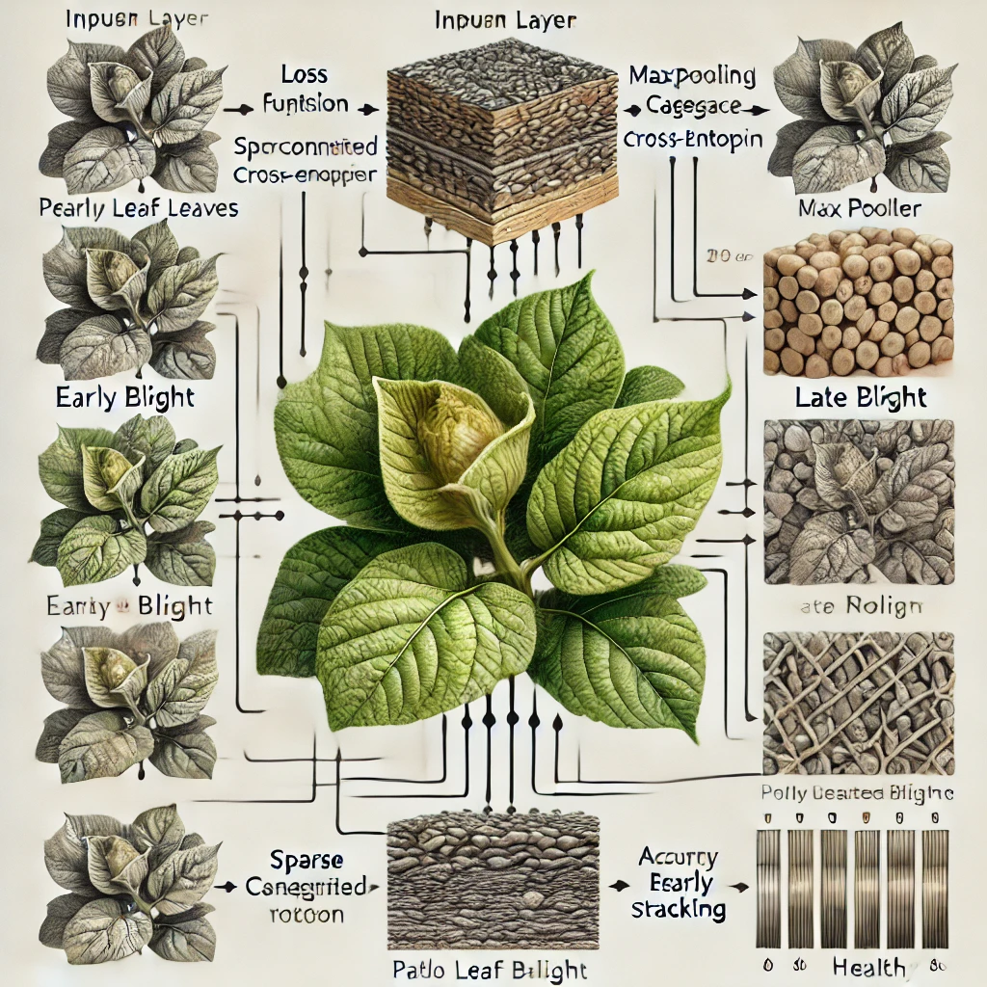
Figure 1 Architecture Diagram

Explanation of System Design
The system follows a step-by-step pipeline for disease detection:
- Dataset Preparation
  - Potato leaf images are collected and labeled into three categories:
    - Early Blight
    - Late Blight
    - Healthy
  - The dataset is split into training (80%) and validation (20%) sets.
- Data Preprocessing
  - Images are resized to 128x128 pixels for uniform input.
  - Normalization is applied by rescaling pixel values to [0,1].
  - Augmentation techniques like rotation, flipping, and zooming are applied to improve model generalization.
- CNN Model Architecture
  - A Sequential CNN model is used, comprising:
    - Input Layer: Rescaled image input.
    - Convolutional Layers: Feature extraction using 3x3 filters.
    - MaxPooling Layers: Reducing spatial dimensions.
    - Flatten Layer: Converts feature maps into a vector.
    - Dense Layers: Fully connected layers for classification.
    - Output Layer: Softmax activation for multi-class classification.
- Model Training
  - The model is trained using Adam optimizer with a sparse categorical cross-entropy loss function.
  - Early stopping is used to prevent overfitting.
- Model Evaluation
  - Accuracy and loss plots are analyzed.
  - A confusion matrix and classification report evaluate the model’s performance.
- Prediction & Deployment (Future Scope)
  - The trained model can be integrated into a mobile app or web platform for real-time disease detection.

  - Requirement Specification
This section details the hardware and software required for the implementation.

3.2.1 Hardware Requirements
Component | Specification
Processor | Intel Core i5/i7 or AMD Ryzen 5/7 (or higher)
RAM | Minimum 8GB (16GB recommended for faster training)
GPU | NVIDIA GTX 1050/RTX 2060 or equivalent (for accelerated training)
Storage | Minimum 50GB free space (for dataset and model storage)
Camera (Optional) | High-resolution camera (for real-time applications)

3.2.2 Software Requirements
Component | Specification
Operating System | Windows 10/11, Ubuntu 20.04+, macOS
Programming Language | Python 3.8+
Deep Learning Framework | TensorFlow/Keras
Libraries Used | NumPy, Matplotlib, Seaborn, Scikit-learn
Development Environment | Jupyter Notebook, VS Code, Google Colab
Dataset | Pre-collected dataset of potato leaf images

CHAPTER 4
Implementation and Result

  - Snap Shots of Result:
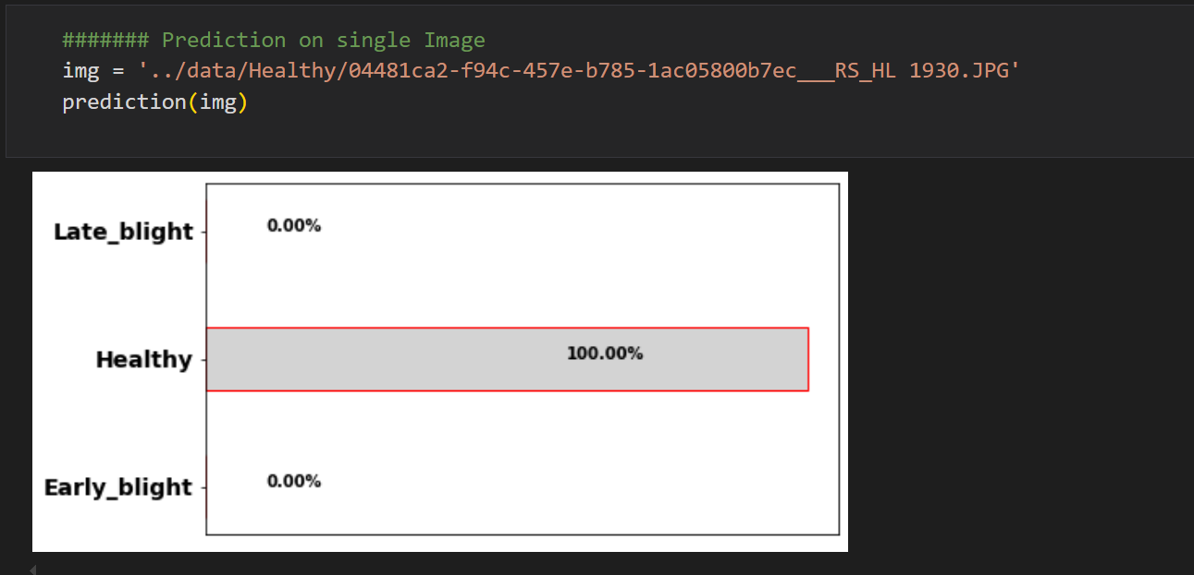
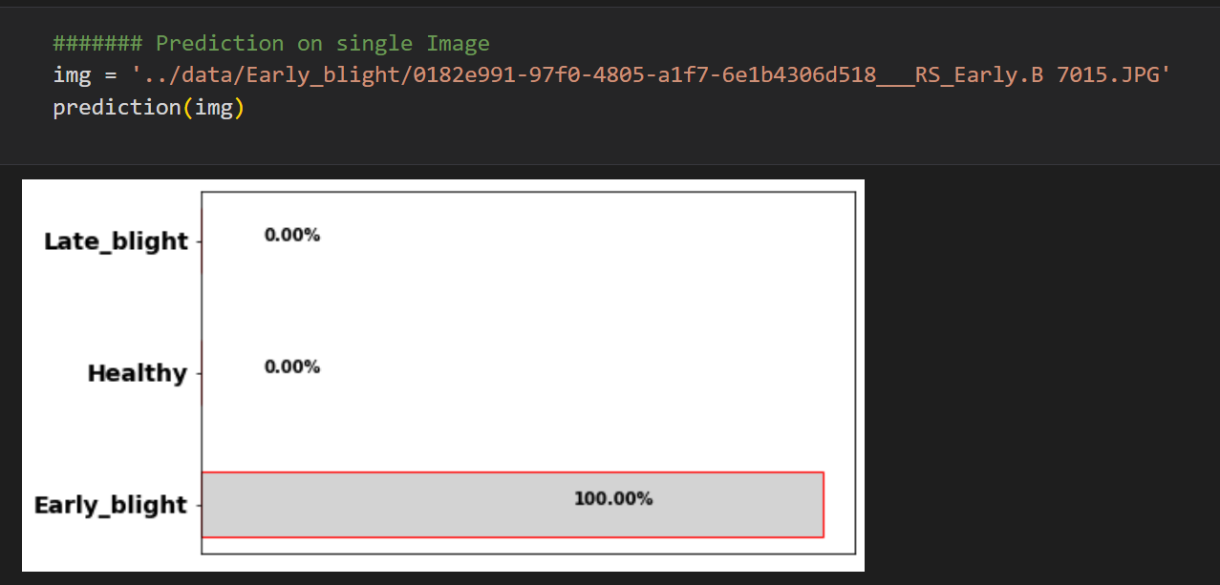
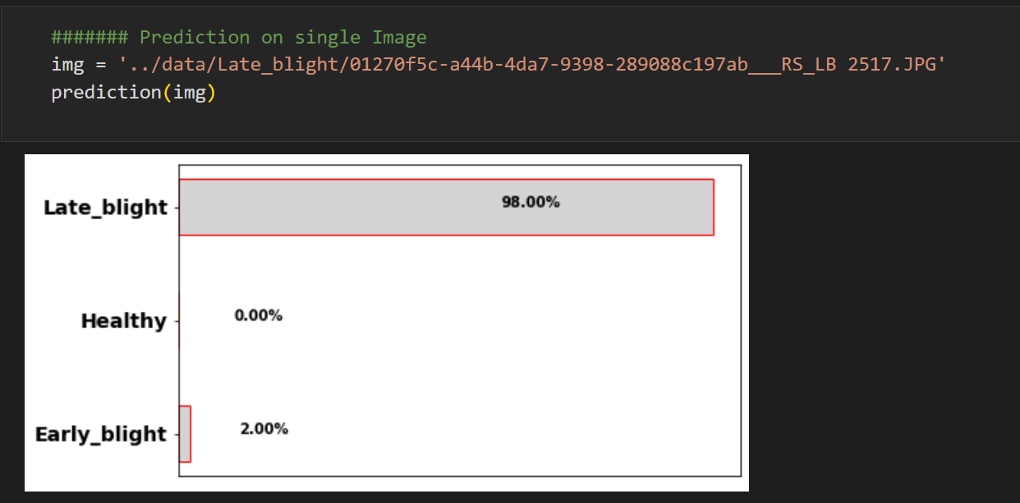
  - GitHub Link for Code:
https://github.com/ravikumargupta9470/potatoLeafDiseaseDetection
  - Link for Dataset :
https://www.kaggle.com/ashokkumarpalivela/potato-diseases

CHAPTER 5
Discussion and Conclusion

  - Future Work:
Although the current model achieves satisfactory accuracy in detecting potato leaf diseases, there are several areas for improvement and expansion:
- Enhancing Dataset Quality and Diversity
  - Expanding the dataset with more diverse images, including different lighting conditions, backgrounds, and angles.
  - Including images from various geographical locations to improve generalization.
- Model Optimization
  - Experimenting with advanced architectures like EfficientNet, DenseNet, or Vision Transformers (ViTs) for improved feature extraction.
  - Implementing techniques such as transfer learning from pre-trained models to enhance performance with limited data.
- Real-Time Deployment
  - Deploying the model in a mobile or web-based application for real-time disease detection.
  - Optimizing the model for edge devices (Raspberry Pi, mobile phones) to facilitate on-field disease identification.
- Integration with Precision Agriculture
  - Combining the model with IoT-based monitoring systems for automated crop health analysis.
  - Utilizing drone-based image collection and classification to cover large agricultural fields.
- Multi-Class Disease Detection
  - Extending the model to detect additional potato leaf diseases beyond Early Blight and Late Blight, including bacterial and viral infections.
  - Developing a multi-label classification system for identifying co-occurring diseases.
- Explainability and Interpretability
  - Implementing techniques like Grad-CAM to visualize model decisions and enhance trust in AI predictions.
  - Developing an interactive user interface where farmers can receive disease descriptions and recommended treatments.

  - Conclusion:
This project successfully implemented a deep learning-based potato leaf disease detection system using Convolutional Neural Networks (CNNs). The proposed model efficiently classifies potato leaf images into three categories—Early Blight, Late Blight, and Healthy—with promising accuracy. The system demonstrates how AI and machine learning can be leveraged in agriculture to facilitate early disease detection, potentially reducing crop losses and improving food security.
The implementation involved data preprocessing, CNN model design, training, and performance evaluation, demonstrating the feasibility of automated plant disease detection. Despite its success, future improvements, such as dataset expansion, model enhancement, and real-time deployment, can further increase its effectiveness and usability in practical agricultural applications.
In conclusion, this project contributes to smart farming by providing a cost-effective and scalable approach for plant disease monitoring, aiding farmers and agricultural researchers in efficient crop management.

REFERENCES

- Bengamra, S., Zagrouba, E., & Bigand, A. (2023, August). Explainable AI for deep learning based potato leaf disease detection. In 2023 IEEE International Conference on Fuzzy Systems (FUZZ) (pp. 1-6). IEEE.
- Srivastava, A., Rawat, B. S., Bajpai, P., & Dhondiyal, S. A. (2024, March). Potato Leaf Disease Detection Method Based on the YOLO Model. In 2024 4th International Conference on Data Engineering and Communication Systems (ICDECS) (pp. 1-5). IEEE.
- Bajpai, A., Sahu, S., Tiwari, N., Srivastava, V., & Yadav, S. (2024, August). An efficient approach for potato leaf disease classification using cascaded cnn-transformers. In 2024 IEEE 12th International Conference on Intelligent Systems (IS) (pp. 1-6). IEEE.
- Agrawal, A., Fating, A., Darvankar, M., Patil, A., & Kapse, Y. (2023, December). Potato Leaf Disease Identification with Multi-Stage Approach: A Comparative Study. In 2023 IEEE Pune Section International Conference (PuneCon) (pp. 1-5). IEEE.
- Shukla, P. K., & Sathiya, S. (2022, June). Early detection of potato leaf diseases using convolutional neural network with web application. In 2022 IEEE World Conference on Applied Intelligence and Computing (AIC) (pp. 277-282). IEEE.

