Amazon Sales Analytics —Business Analyst Project
SQL + Excel Dashboard | Decision-Driven Analytics

Executive Summary
This project was designed to simulate a real-world Business Analyst scenario where large-scale e-commerce product data is analyzed to drive strategic decisions around pricing, discounting, and category performance.
The analysis identified key structural patterns in customer engagement, including high category concentration, ineffective discounting strategies, and dominant mid-range pricing behavior. Based on these findings, a set of data-backed recommendations was developed to optimize business outcomes.
The final output includes a SQL-driven analytics pipeline and an Excel-based dashboard, enabling stakeholders to monitor performance, identify inefficiencies, and make informed decisions at scale.

Problem Framing
In large e-commerce environments, decision-making is often reactive due to:
- Lack of visibility into what drives customer engagement
- Over-reliance on discounting without understanding impact
- Poor identification of high-growth vs underperforming categories
- Limited ability to translate raw data into actionable insights
From a business perspective, the core problem is not lack of data—but lack of structured decision-making frameworks built on data.

Objective
The objective of this project is to:
- Identify key drivers of product performance and engagement
- Evaluate relationships between price, discount, and customer perception
- Detect inefficiencies and growth opportunities
- Build a scalable decision-support solution using SQL and dashboards

Analytical Approach (End-to-End Process)

1. Data Ingestion & Preparation
Raw product-level data was ingested and transformed using SQL:
- Converted pricing and discount fields into numerical formats
- Cleaned inconsistent values (currency symbols, formatting issues)
- Standardized ratings and review counts
- Created derived fields (price segments, discount tiers)

2. KPI Development & Baseline Metrics
Key business metrics were established:
- Average price, discount %, and rating
- Total reviews (proxy for engagement)
- Category-level performance

3. Segmentation & Behavioral Analysis
Products were segmented across multiple dimensions:
- Price Segments (Budget → Luxury)
- Discount Tiers (Low → Very High)
- Rating Bands (Poor → Excellent)
Window functions were used to:
- Analyze cumulative contribution (Pareto / concentration)
- Identify dominant segments
- Track trends across categories

4. Insight Generation & Root Cause Analysis
Instead of stopping at metrics, the analysis focused on:
- Identifying patterns
- Understanding why they exist
- Evaluating business implications
Example:
- High discounts → higher engagement → but lower ratings
- Mid-range pricing → highest review concentration

5. Decision Layer (Insight → Action)
Each insight was translated into:
- A clear business implication
- A recommended action

6. Dashboard Development (Execution Layer)
An Excel dashboard was built to:
- Monitor KPIs in real-time
- Compare segments and categories
- Highlight underperformance through visual indicators

SQL Output Evidence
The following SQL outputs validate the analysis performed and support the insights derived in this project.
🔹 KPI Summary Output
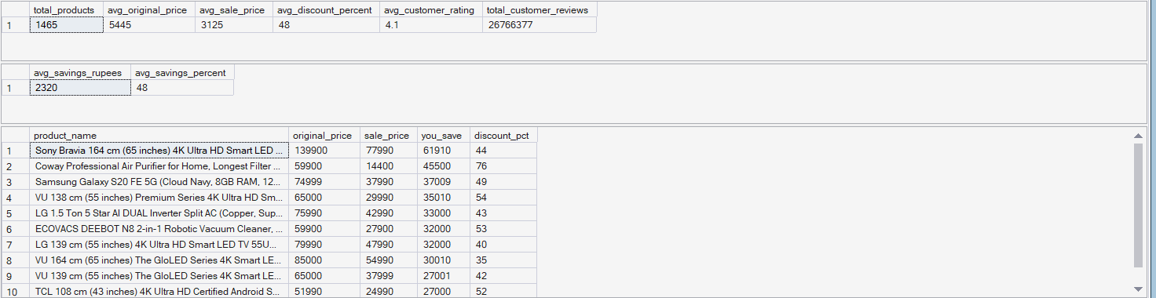
🔹 Category Performance Output
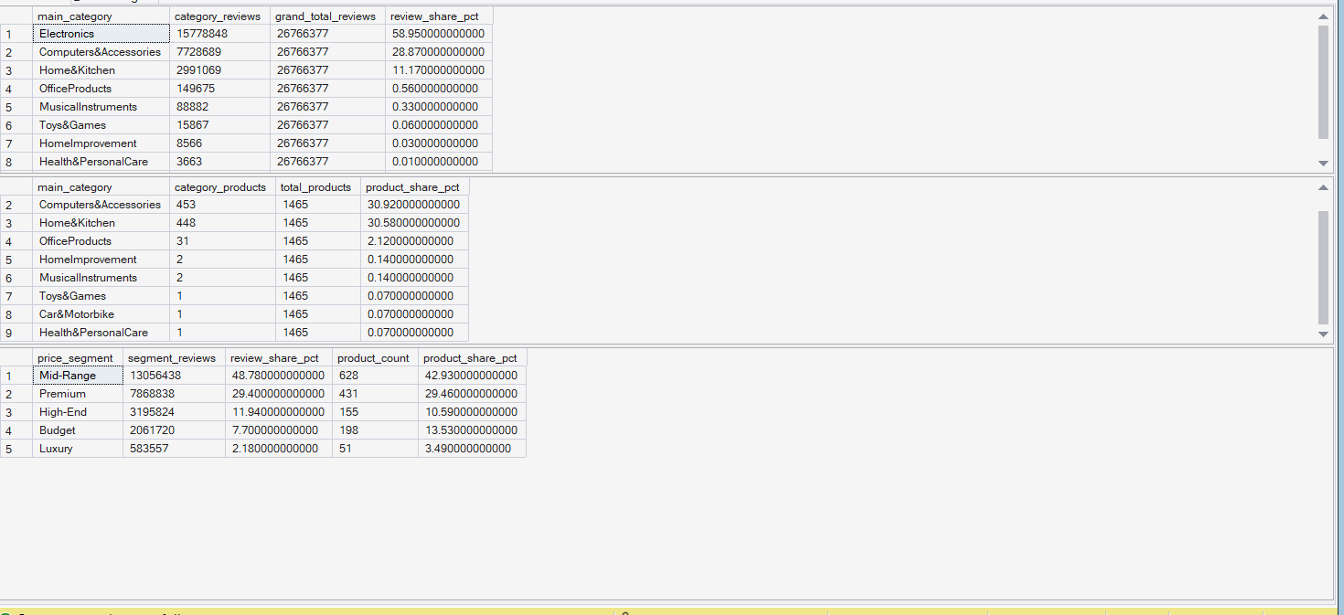
🔹 Price Segment Analysis
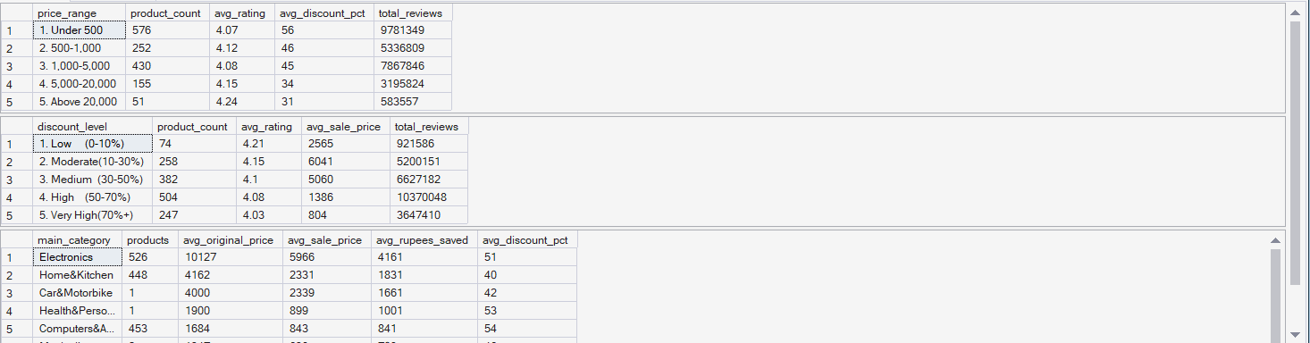

🔹 Discount Analysis Output
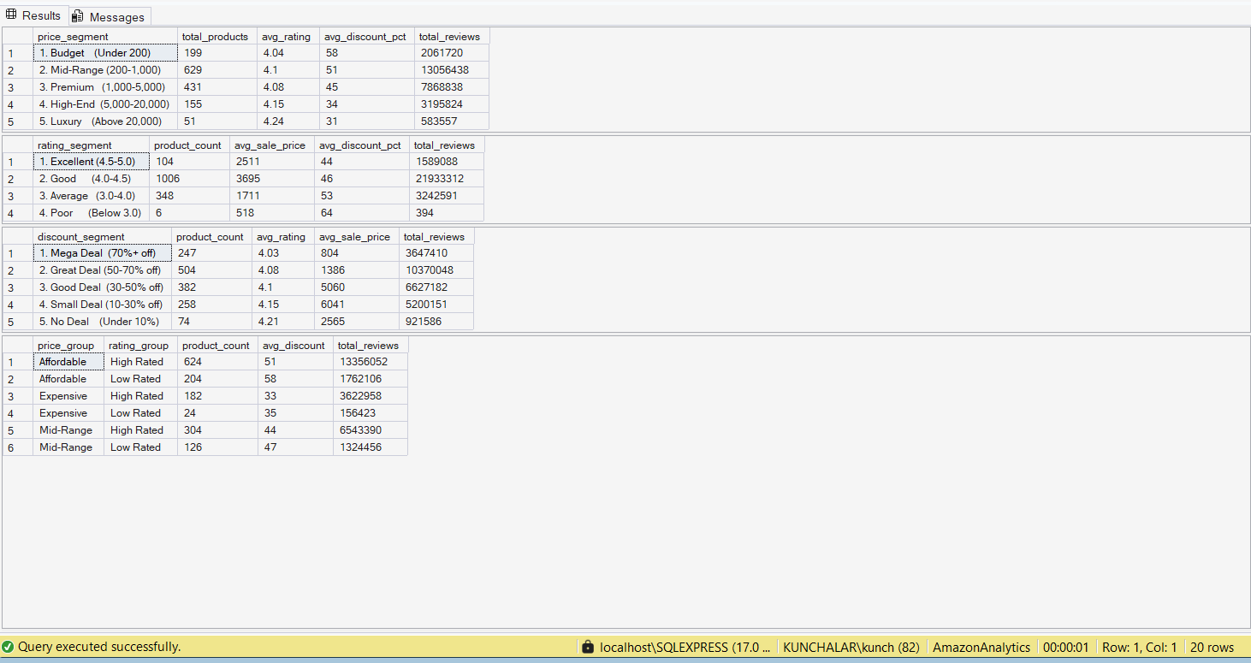

Key Insights & Strategic Recommendations

1. Market Concentration Risk
Insight:
A majority of engagement is concentrated in a small number of categories.
Root Cause:
High demand concentration and better product visibility in dominant categories.
Business Risk:
Over-dependence increases vulnerability and limits growth diversification.
Action:
Invest in underperforming categories through:
- Better product positioning
- Marketing and discoverability improvements

2. Price Does Not Drive Perceived Quality
Insight:
Customer ratings remain stable across all price ranges.
Interpretation:
Customers evaluate products based on value and experience, not price.
Implication:
Premium pricing alone does not guarantee better perception.
Action:
Focus on:
- Review quality
- Product experience
- Content and listing optimization

3. Discount Strategy Inefficiency
Insight:
50–70% discounts maximize engagement, but >70% reduces perceived quality.
Interpretation:
Deep discounts signal low product value rather than high savings.
Trade-off:
Higher discounts increase short-term engagement but harm long-term perception.
Action:
- Optimize discounting within the 50–70% range
- Avoid excessive discounting for non-clearance products

4. Mid-Range Segment Dominance
Insight:
Mid-range products generate the highest engagement.
Interpretation:
This segment balances affordability and perceived quality.
Implication:
Represents the core revenue-driving segment
Action:
- Prioritize this range for new product launches
- Focus marketing and inventory strategy here

5. Underutilized Category Opportunity
Insight:
Certain categories have strong supply but low engagement.
Root Cause Hypothesis:
- Poor discoverability
- Lower conversion rates
- Weak product presentation
Action:
- Improve listings (images, descriptions)
- Increase visibility through ads and promotions

Business Impact
This analysis enables:
- Pricing Optimization → Reduce inefficiencies in discounting
- Category Strategy → Identify high-growth opportunities
- Product Decisions → Improve positioning and engagement
- Leadership Visibility → Data-driven decision-making

Dashboard
The Excel dashboard serves as an operational layer:
- Tracks key KPIs
- Enables segment-level analysis
- Highlights performance gaps
- Supports quick decision-making
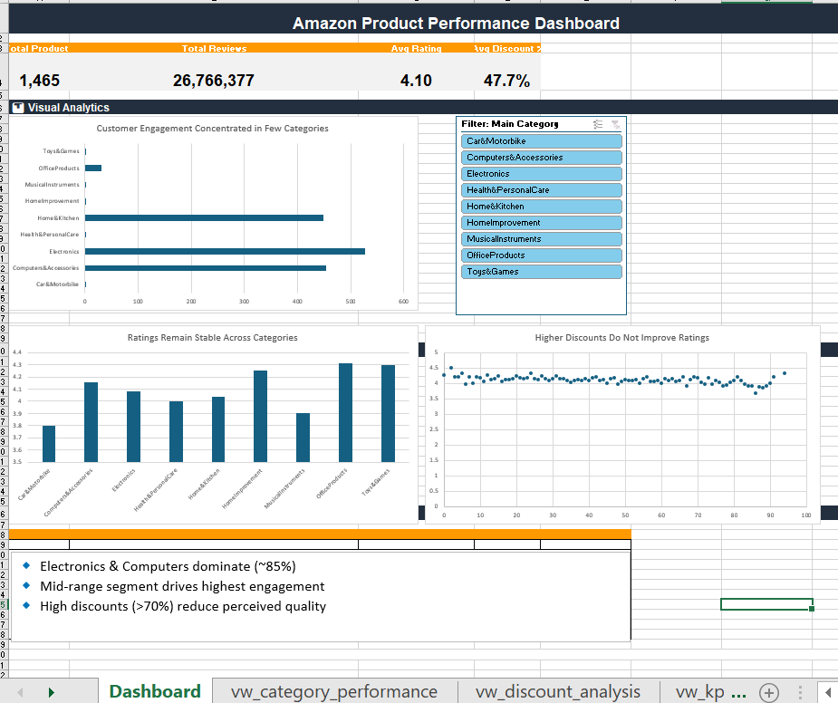

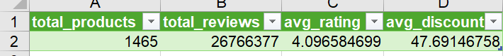

Scalability & Future Enhancements
- Automate data pipeline using SQL + ETL tools
- Integrate with Power BI for real-time dashboards
- Add forecasting models for demand prediction
- Expand dataset to include sales and revenue

Skills Demonstrated
- SQL (Advanced Analytics, Window Functions)
- Data Cleaning & Transformation
- KPI Development
- Segmentation & Behavioral Analysis
- Business Insight Generation
- Dashboard Development
- Strategic Thinking

Author
Ravi Kumar
Business Analyst

