**Computer Networking**

**Basics:**

* **Network**: A computer network is a digital telecommunications network for sharing resources between nodes, which are computing devices that use a common telecommunications technology
* **Node**: A computing device.
* **Bus network**: All the devices are connected on one single long cable
* **Client**: A client is a piece of computer hardware or software that accesses a service available by a server
* **Server**: A server is a computer program or device that provides functionality for other programs or devices called clients
* **Protocol**: A set of rules used in communication between clients

**Network Devices:**

* **Repeater**: A repeater is an electronic device that receives a signal and retransmits it.
* **Hub**: A hub is essentially a multi-port repeater. Wireless Access Point is essentially a hub in the air
  + Active Hub: These are the hubs that have their own power supply and can clean, boost, and relay the signal along with the network. It serves both as a repeater as well as a wiring center.
  + Passive Hub: These are the hubs that collect wiring from nodes and power supply from the active hub. They are generally used to relay signals with cleaning or boosting them
  + Intelligent Hub: It works like active hubs and includes remote management capabilities. They also provide flexible data rates to network devices. It also enables an administrator to monitor the traffic passing through the hub and to configure each port in the hub.
* **Bridge**: A bridge is a repeater with add on the functionality of filtering content by reading mac addresses of source and destination. It was mostly used to interconnect two LANs.
  + Transparent Bridge: These are the bridges in which the stations are completely unaware of the bridge's existence
  + Source Routing Bridge: In these bridges, routing operation is performed by the source station and the frame specifies the route to follow.
* **Switch**: A switch reads each frame and has the intelligence to transmit data to the port it is destined for.
* **Router**: A router is a device like a switch that routes data packets based on their IP addresses. The router is mainly a Network Layer device.
* **Wireless LAN Controller**: A WLAN controller is used to manage large scale deployments of light weight and normal wireless access points
* **Firewall**: A firewall is a network security system that monitors, and controls incoming and outgoing network traffic based on predetermined security rules.
* **IDS**: It’s a software system that warns if there is an intrusion. They just get copies of packets that are analyzed
* **IPS**: It’s a software system can alert you if there may be a problem and block the same. They stay inline of the network and detect and block intrusions.
* **Email Security Appliance**: The Cisco Email Security Appliance is an email security gateway product. It is designed to detect and block a wide variety of email-borne threats, such as malware, spam and phishing attempts
* **Load Balancer**: A load balancer is a device that acts as a reverse proxy and distributes network or application traffic across several servers.

**Types of Networks based on Area:**

* WAN: A Wide Area Network is a telecommunications network that extends over a large geographical area for the primary purpose of computer networking
* LAN: A Local Area Network is a computer network that interconnects computers within a limited area such as a residence, school and so on
* MAN: Metropolitan Area Network
* Wireless Local Area Network (WLAN)
* Campus Area Network (CAN)
* Storage Area Network (SAN)
* Passive Optical Local Area Network (POLAN)
* Enterprise Private Network (EPN)
* Virtual Private Network (VPN)
* Personal Area Network (PAN)

**Types of Networks based on Topology:**

* Mesh Topology
* Ring Topology
* Bus Topology
* Star Topology
* Hybrid Topology
* Point to Point Topology

**Cable Types:**

* **Coaxial Cabling**: Coaxial cable has an inner conductor that runs down the middle of the cable. This type of cabling comes in two types, thinnet and thicknet. Max Transmission Speed of 10 Mbps
* **Twisted-pair Cabling**: Has four pair of wires. It comes in two versions, UTP (Unshielded Twisted-Pair) and STP (Shielded Twisted-Pair). Uses 8P8C/RJ45 Connector
* **Fiber-optic Cabling**: Uses optical fibres to transmit data in the form of light signals. There are two types of fiber-optic cables - Single-mode fiber (SMF) and Multi-mode fiber (MMF). Uses ST/SC Connectors

**Ethernet Standards:**

* **10Base-T** (IEEE 802.3): 10 Mbps with category 3 unshielded twisted pair (UTP) wiring, up to 100 meters long.
* **100Base-TX** (IEEE 802.3u): known as Fast Ethernet, uses category 5, 5E, or 6 UTP wiring, up to 100 meters long.
* **100Base-FX** (IEEE 802.3u): a version of Fast Ethernet that uses multi-mode optical fiber. Up to 412 meters long.
* **1000Base-CX** (IEEE 802.3z): uses copper twisted-pair cabling. Up to 25 meters long.
* **1000Base-T** (IEEE 802.3ab): Gigabit Ethernet that uses Category 5 UTP wiring. Up to 100 meters long.
* **1000Base-SX** (IEEE 802.3z): 1 Gigabit Ethernet running over multimode fiber-optic cable.
* **1000Base-LX** (IEEE 802.3z): 1 Gigabit Ethernet running over single-mode fiber.
* **10GBase-T** (802.3.an): 10 Gbps connections over category 5e, 6, and 7 UTP cables.

**Ethernet Cable Forms:**

* **Straight-through Cable:** On a straight through cable, the wired pins match. Straight through cable use one wiring standard: both ends use T568A wiring standard or both ends use T568B wiring standard.
* **Crossover Cable:** Crossover cable uses two different wiring standards: one end uses the T568A wiring standard, and the other end uses the T568B wiring standard. Pin1->Pin3 and Pin2->Pin6

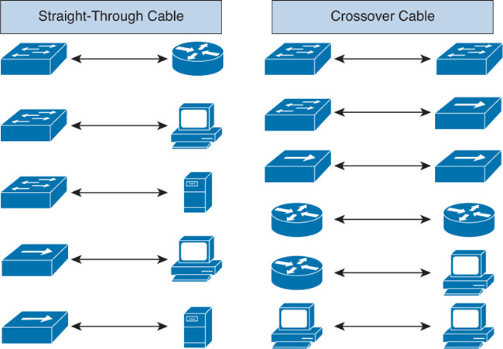

**Data flow Types:**

* **Simplex Mode:** Communication is unidirectional
* **Half-Duplex Mode:** Each station can both transmit and receive, but not at the same time
* **Full-Duplex Mode:** Both stations can transmit and receive simultaneously

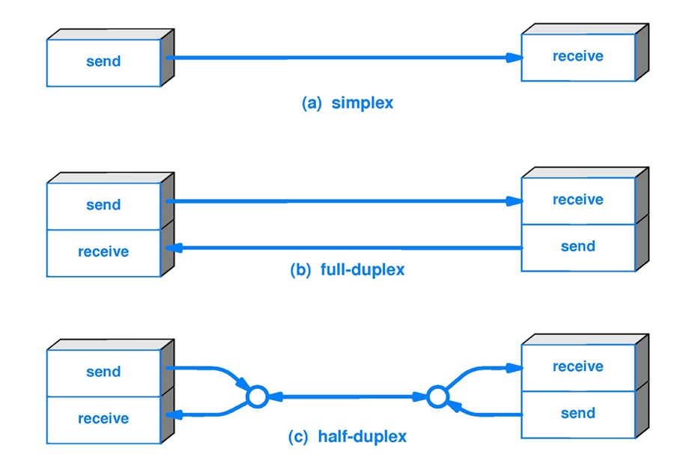

**Communication Types:**

* **Unicast:** Communication from one point to another point
* **Broadcast:** Communication from one point to all other points
* **Multicast:** Communication from one/more points to a set of other points
* **Anycast:** It is a network addressing and routing methodology in which a single destination IP address is shared by nodes in multiple locations.

**Domain:**

* **Broadcast Domain:** A broadcast domain is a logical division of a computer network, in which all nodes can reach each other by broadcast at the data link layer.
* **Collision Domain:** A collision domain is a network segment connected by a shared medium where simultaneous data transmissions collide with one another.

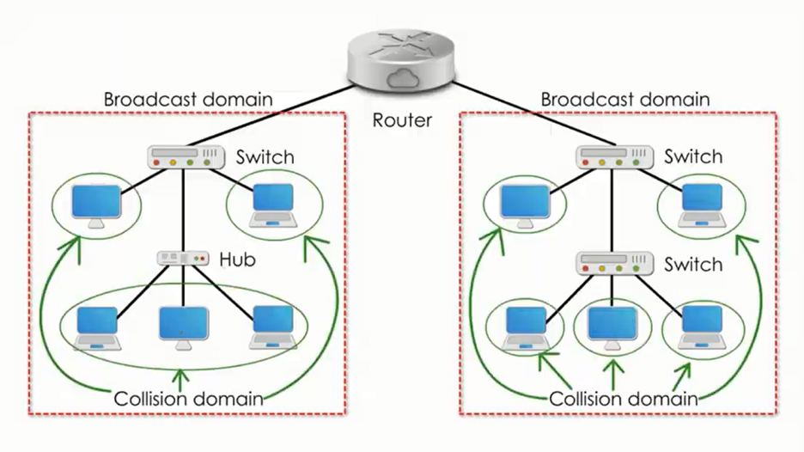

**54321 Rule:**

5 - the number of network segments

4 - the number of repeaters needed to join the segments into one collision domain

3 - the number of network segments that have active (transmitting) devices attached

2 - the number of segments that do not have active devices attached

1 - the number of collision domains

**Types of Layered Models: Layers and Protocol Data Units (PDUs):**

**OSI Model:**

* Physical Layer (Bits)
* Datalink Layer (Frame)
* Network Layer (Packet)
* Transport Layer (Segment)
* Session Layer (Data)
* Presentation Layer (Data)
* Application Layer (Data)

**TCP/IP Model:**

* Physical Layer (Frame) : Physical Addresses (MAC)
* Network Layer (Packet) : IP Addresses (IP)
* Transport Layer (Segment) : Port Addresses (Ports)
* Application Layer (Data) : Specific Addresses (Data)

**Cisco 3-Layer Model:**

* Access Layer : Controls User and Workgroup access to the resources on the network
* Distribution Layer : Serves as the communication point between the access layer and the core
* Core Layer: Responsible for transporting large amounts of traffic quickly