/*

* Python Programming Notes

* Ravi Kumar Reddy K

* github.com/ravikumark816

*/

**Init:**

* Widely used high level programming language created by Guido van Rossum in 1991
* Major versions: 2.x and 3.x
* Hello World:

*print(“Hello World!”)*

* Differences between 2.x and 3.x: <https://www.geeksforgeeks.org/important-differences-between-python-2-x-and-python-3-x-with-examples/>
* To check if the given string is keyword:

*import keyword*

*print(iskeyword(“for”)*

* Print without newline:

*print(“No New Line”, end=””)*

**Namespaces and Scope:**

* A namespace is a system that has a unique name for each and every object in python. Realtime analogy: Surnames of a person. Alice Lee, Alice Clark
* Lifetime of namespace depends upon scope of objects in it.

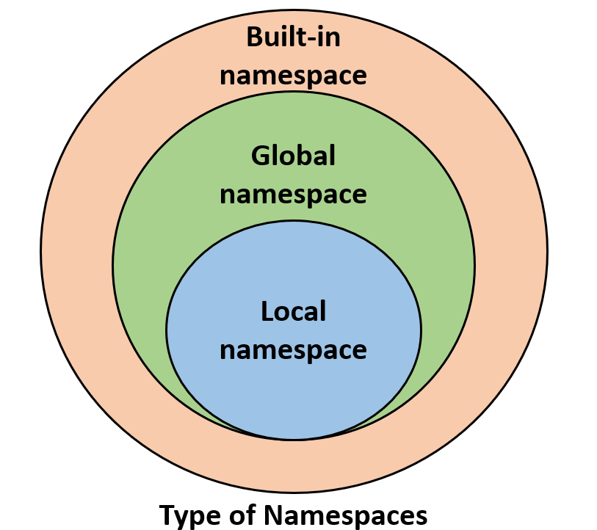

**Statements, Indentation and Comments:**

* Multiline Statements:

*s = 1 + 2 + 3 + *

*4 + 5 + 6 + *

*7 + 8 + 9*

* Interpreter considers the new line char as the terminator of one instruction
* All statements with the same distance to the right belong to the same block of code.
* Comments:

*# Single Line Comments*

*“””*

*Multi Line Comments*

*“””*

*Completed Python Basics section in GFG*