/*

* C++ Programming Notes

* Ravi Kumar Reddy K

* github.com/ravikumark815

*/

**Preset:**

* Invented by Bjarne Stroustrup in 1979
* Middle Level Language
* Versions: C++ 14, C++11, C++99

**Hello World:**

#include <iostream>

using namespace std;

int imGlobal = 0;

const double PI = 3.141;

int main(int argc, char**argv) {

cout << "Hello World\n";

return 0;

}

* Namespaces
* main: Start executing from here
* Cout allows us to output information to console
* “<<” Stream insertion operator: Takes string on the right to cout stream
* “endl” Issue newline and force write to console
* argc: No of arguments passed to main
* argv: Array of pointers to strings in the arg vector
* int: Return an integer when done executing
* imGlobal: Global variable and accessible everywhere else.
* const double PI: Global variable whose value cannot be changed anywhere else

**Comments:**

/*

Multi

Line

Comment

*/

// Single Line Comment

**Common Header files:**

* #include <cstdlib> // Sorting, Searching, import c libraries, rand, memmgmt, and other general-purpose functions
* #include <iostream> // Read and Write data
* #include <string> // Work with strings
* #include <limits> // Min and max values
* #include <vector> // Work with vectors
* #include <sstream> // Work with string streams
* #include <numeric> // Work with sequences of values
* #include <ctime> // Work with time
* #include <cmath> //Common math functions

**Data Types:**

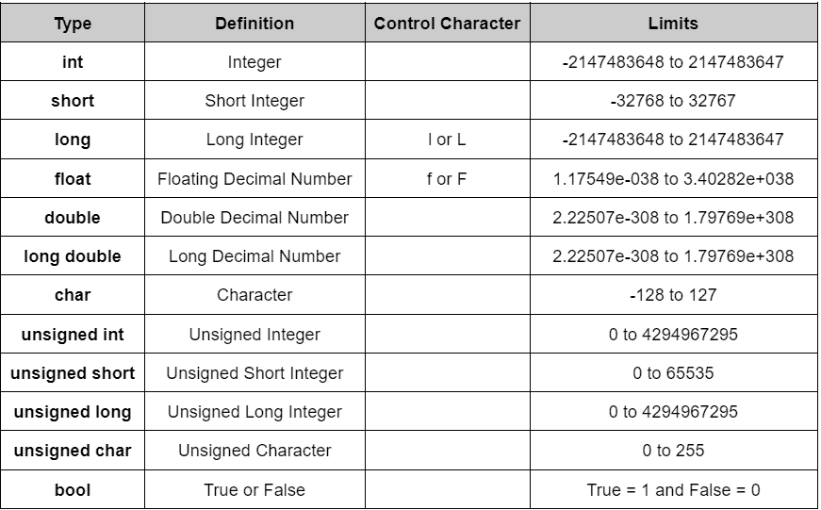

**Input and Output:**

* cout << “Min int” << numeric_limits<int>::min();
* cout << “Max short int” << numeric_limits<short int>::max();
* printf(“Sum = %.7f\n”), (1.1111111+1.1111111)); // To print formatted output of float upto 7 decimal places
* cout << “int Byte:” << sizeof(int) << endl;
* printf(“%c %d %5d %.3f %s\n”, ‘A’, 10, 5, 3.1234, “Hi); // O/p: A 10 5 3.123 Hi //Right justify
* cin >> num_str; //to take in input for num1
* int num1 = stoi(num_str) //To convert num1 from string to int;

**Operators, Precedence, Associativity:**

