Build an E-commerce website for bike Accessories named – BikerZone

Live URL : <https://ravikumarkubusada.github.io/eCommerce-UI/dist/eCommerce-UI/#/>

Repo link: <https://github.com/ravikumarkubusada/ravikumarkubusada.github.io>

It has 2 pages (screen shots below)

1. Product – catalog
2. Product checkout

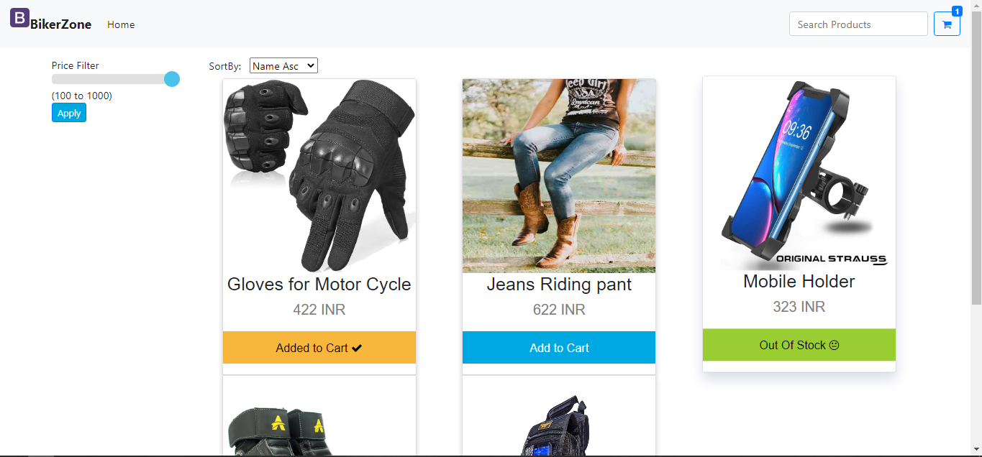

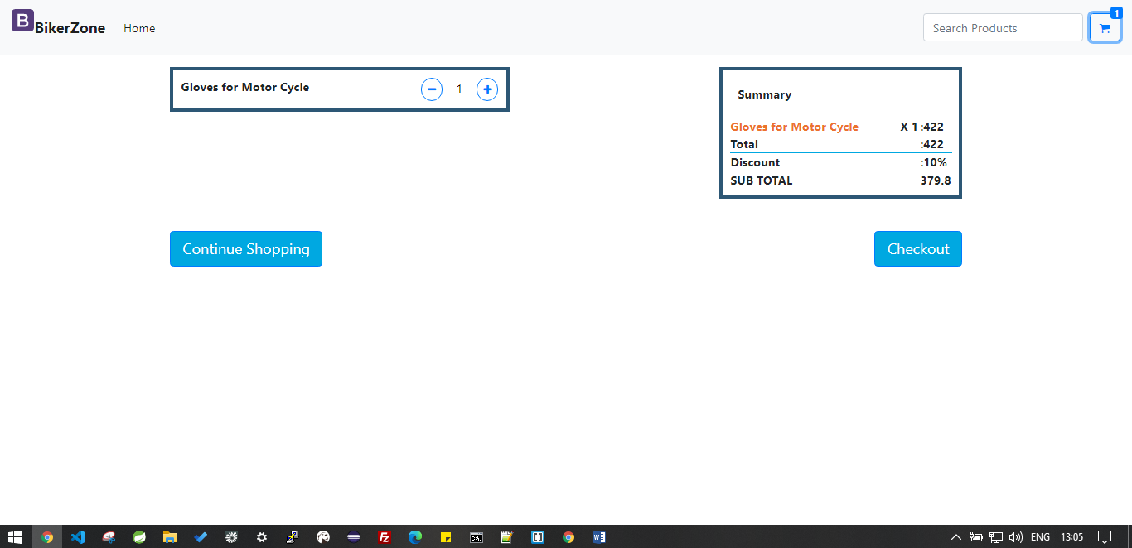

Assumptions:

1. Search the product after 3 characters
2. Used flexbox and also bootstrap row and col
3. Done the media quires for 720px width only