“Computerization of services in Hotels and Hotel management-A Comparative study of public sector and private sector Hotels in Himachal Pradesh”

Submitted to the department of Computer Applications of
VALLABH GOVT COLLEGE MANDI (H.P.)
for the partial fulfillment of project for Bachelor of Computer Applications.

2008-09

Under the supervision of: Submitted by:
Mr. Vijay Thakur Sourabh Bhardwaj,
Roll No.:-BCIII-08-41

CERTIFICATE-1

It is certified that project report “Computerization of services in

Hotels and Hotel Management-A Comparative study of public and

Private sector Hotels in Himachal Pradesh”

Submitted by Sourabh, Roll No.BCIII-2008-41 in partial fulfillment

of the requirement of Degree of BCA, embodies original work and

has been done under my supervision

Dated: ………………..2009. Sign of Guide

CERTIFICATE-II

The project report entitled “Computerization of services in

Hotels and Hotel Management-A Comparative study of public and

Private sector Hotels in Himachal Pradesh”

Submitted to BCA Department of VALLABH GOVT. COLLEGE MANDI (H.P.) in practical fulfillment of the requirement for the degree of B.C.A. From Himachal Pradesh University.
I declare that project report “Computerization of services in

Hotels and Hotel Management-A Comparative study of public and

Private sector Hotels in Himachal Pradesh” is my original work.

Dated:……………….. 2009. Sign of Candidate

ACKNOWLEDGEMENT

I extend my sincerest gratitude to my respected teacher Mr. VIJAY THAKUR under whose supervision and direction this project has been undertaken. He is the guiding force and prime inspiration to lift me from the initialization state to the successful completion of the project. His friendly guidance and discussions over the complexities of a real time project have invoked a deep thought in me.
Undertaking a project such as this places an equal if not greater pressure on friends and family members closest to me. Thanks to all those who helped me in one-way or other, and to all, whose names go unmentioned.

Sourabh Bhardwaj

PREFACE

The entitled project “Computerization of services in Hotels and Hotel
Management-A Comparative study of public and private sector Hotels in Himachal Pradesh” is made keeping in mind all the aspects of the hotels. By all the aspects I mean, it will be capable of doing all the necessary operations/functions that are done in any Hotel for example-reservation of the customer, booking of the customer ,clearing the Guest Folio of the customer etc. Since all the work that is to be done by this software can also be done manually, but this consumes time and labour. So this software will be a relief to those who have to do all this work manually. The knowledge of computers and programming has become a basic skill needed to survive in present information based on society.
The motive to make this project is to make such kind of software which is very easy to use. There will not be need of any training and the person who does not have much knowledge of computers can also use this .Through this project the details of the customers that visit in the hotel can be retrieved if necessary. All the records of the customers will be kept for further enquiries.

Sourabh Bhardwaj

Tentative Chapter Plan

Chapter 1 Introduction & Conceptual Framework
  - Introduction.
  - Concept of Management and Services.
  - Concept of Hotel Management.
  - Concept of Mechanization, Automation and Computerization.
  - Computerization of services provided by Hotels and Hotel Management.

Chapter 2 Need or Rationale, Objectives and Research Methodology

Chapter 3 Profile of Public and Private Hotels

Chapter 4 Analysis, Design and Testing

Chapter 5 Summary/Conclusion

Chapter 6 Annexure

Chapter 7 Bibliography

Chapter--1

Introduction & Conceptual Framework

(1.1) Introduction:-

The project “Computerization of services in Hotels and Hotel
Management” is designed once and can be updated many times, so the burden of application maintenance is short listed by all the general guidelines. The main task ahead is to see all the things whether they are running smoothly or not, this software will be capable of doing or performing following tasks:-
- Reservation.
- Registration.
- Billing/Clearance of Guest Folio.
- Checkout.

This software will be developed keeping in mind the various aspects of
hotels in public sector as well as in private sector. This software is intended to be developed for Deluxe Class / Super-Deluxe Class Hotels. A Comparison will be done of Deluxe Class Hotels in public sector and in private sector and then the resultant / desired software will be developed.
MS-Access database management system will be used as “Backend” which will be capable of recording information and high level language “Java” will serve as “Frontend” for the software. The database will be capable of doing following operations:

1. Keeping records of various customers that visit in the hotel.

2. Keeping records of various items that are served to the customers.

3. Keeping records of customer’s Check-in/Check-out timings.

(1.2) Concept of Management and Services:-

Hospitality Services:-
Our hospitality management division offers a full menu of services encompassing all aspects of operations in the hospitality industry. From pre-opening planning and marketing to day to day operation and asset repositioning, we offer the flexibility and ease where you need us, when you need us. We tackle every project with a holistic approach, taking into consideration every element that would contribute to the success of the project, including but no limited to, market demand dynamics, business mix, competition, management, occupancy trends, government support, capital costs and funding opportunities. Out team of industry specialists is experienced in analyzing a wide range of hospitality developments and has been actively involved in projects located throughout the Middle East, Asia and Africa. Depending on each project's life-cycle stage, our Strategy Team can also provide assistance in preparing start-up planning, market entry strategies, and marketing program or exit strategies.
Real Estate Consultancy:-
As a result of the surge in investment capital throughout the Middle East, the real estate market has been subject to intense development pressure with private individuals, major corporate and government agencies all active in the market. Many clients have sought our expert advice in understanding current market dynamics in the various regional economies in order to guide their investment activities, whilst others have sought input on individual projects, either seeking our input on proposed development concepts or identifying best-use scenarios for specific land plots. These typically lead to the preparation of detailed financial forecasts and subsequently to the raising of project finance where our specialized Corporate Finance team is able to add significant value to the deal placement process. The real estate assignments we have conducted have encompassed a wide range of client groups include the following:
- Private Funds and Family Trust
- Investment Houses
- Private Sector Corporate
- Developers
Performance Management Services:-
Performance management includes activities to ensure that goals are consistently being met in an effective and efficient manner. Performance management can focus on performance of the organization, a department, processes to build a product or service, employees, etc. Information in this topic will give you some sense of the overall activities involved in organizational performance management. Then you might enhance your understanding by reviewing closely related library topics referenced from the section We proud our selves to be a locally started company and therefore have a comprehensive local market knowledge, which is key to reducing risk. Our Real Estate and Hospitality Consultancy team regularly assists clients in the maximization of their asset performance through the provision of a range of tailored services:
- Contract Negotiation and Compliance
- Operational Audits
- Capital Expenditure Reviews
- Sales and Marketing Reviews
Services Listings:-
- Feasibility and Valuation Studies
- Due Diligence and Appraisals
- Feasibility Analysis and Business Planning
- Strategic Planning, and Impact Studies
- Market Research
- Site Selection and Analysis
- Hotels and F&B Design and Development
- Strategic Planning/ Re-Concepting and Repositioning
- Operational Reviews, Operational Analysis and Systems Implementation
- Client Representation and Asset Management
- Financial Consulting and Ownership structure
- Total Cost Management Critical Path Method
- Scheduling
- Executive Search Services and Employee Development Program

(1.3) Concept of Hotel Management:-

Definition of Hotel:-

Hotel or inn is defined by British laws “as a place where a bonafide traveler can receive food and shelter, provided he is in a position to pay for it and in a fit condition to be received”. A hotel must provided food shelter to traveler on payments and have the right to refuse it if the traveler is drunk, disorderly kept or is not in position to pay for the services.
The industry is also known as hospitality industry the main purpose of the industry is to provide the guest’s quality service and make him feel at home.

Tourism and Hotel Industry:-

Tourism is the fastest growing and second largest industry of the world and has tremendous potentiality for carrying foreign exchange. The number of the foreign tourists visiting India is merely 0.30% of the total world tourist traffic. Besides promoting international understanding it helps the national economy and raises the standards of living of the people.
It has been genuinely said if there are no hotels there is no tourism. The hotel industry is an essential part of tourism development and vice versa. The hotel industry depends upon the demand for different types of accommodations, availability of suitable enfranchise and services and the economy feasibility of the developments. The concept of modern hotel business in India started late compared to the bold business elsewhere in Europe and America. Every hotel small or large has is own special atmosphere and ambience.
Tourism is the way in which all of us can favor the mysteries, plunder the unknown depths, acquire understanding and experience the world in its fullness.
Mainly there are four sections in a hotel. These are:
- Front Office
- House-Keeping
- F & B Production
- F & B Service

1. Front Office: -
The Front Office is referred to as a brain of the modern hotels. To the guest, the managers are largely represented by the front office and the unseen head will be judged favorably or otherwise by the guest treatment there being the nerve center of the modern hotel. The front office staff should be kept aware of what is happening at virtually every level of hotel structure.
The front office can also be referred as the nerve center of any hotel operations, larger establishments have a front office organization in a hotel organization in a larger hotel usually includes the front desk, the uniformed service and reservation.
The front office staff has direct contact with the staff. The members handle reservation greet guest, register new guest, handle key, handles incoming and outgoing mails, take messages for guest, provide information, listen to complaints and handles check in and check out procedures.

2. House keeping: -
The house keeping department any hotel is responsible for the cleanliness, maintenance and aesthetic upkeeps of the hotel. It is an extension of basic home keeping multiplied into commercial proportions. The hotel’s main profit is on the sale of the room, food and beverage and other minor operations services such as laundry etc. In other words largest margin of profit comes from sales. A good operation ensures optimal room sales to bring in the maximum profit. To make a room appealing to a guest is the fast of housekeeping, which has to ensure the basic human needs of comfort and security.

3. Food and Beverage Production:-
The catering industry is a combination of production and service, which most be fully coordinated to attain a high degree of efficiency. The demands of the customer are very immediate and nature of food is highly perishable, that business lost is gone forever.
Food production is the most revenue-earning venture of a hotel besides the revenue earned from the letting of rooms. The smooth functioning of the restaurants is to the existence of the kitchen. The kitchen is under the charge of the executive chef, who compiles the
menu for the various outlets in consultation with the management and taking into account of guest suggestions and priorities.
Food production comprises number of functions that may be performed in more types of kitchen the number of functions and types of kitchen depend on the characteristics of the specific operation. Typical major functions include preparing cold foods, baking and preparing beverages, food and beverages production can be defined as that phase where the unfinished or semi-finished food and beverages products are converted into finished products, which can be served for the guest.

4. Food and Beverage Service: -
The food and beverage service department plays a vital role in the smooth functioning of any hotel. This is incomplete without food and beverage service department. It is the major revenue-earning department for hotel. The food, which is cooked by chefs has to be served to the guest though a decent channel. The food and beverage service personnel undertake this job. The image of the hotel depends on the service personnel. The guest forms a good image of the hotel if the service rendered is prompt and quick. Hence the service department plays a vital role in building the reputation of the hotel

(1.4) Concept of Mechanization, Automation and Computerization:-

Concept of Computerization:-

It's the introduction of machinery or computers to carry out tasks that were once done by manual labour, e.g. car production was once labour intense but the introduction of machinery and robotic arms and computers alleviated the need for manual labour to carry out repetitive tasks .
The introduction of automation and computer technology and robotics led to the shedding of labour forced into redundancy as tasks were and still are replaced with the knock on effect of increased unemployment. It is an ongoing process with the positive side being the advancement of technology and opportunities in that field . good luck . need any more , shout .“A computer is a machine that manipulates data according to a list of instructions.”
The first devices that resemble modern computers date to the mid-20th century (1940–1945), although the computer concept and various machines similar to computers existed earlier. Early electronic computers were the size of a large room, consuming as much power as several hundred modern personal computers (PC). Modern computers are based on tiny integrated circuits and are millions to billions of times more capable while occupying a fraction of the space. Today, simple computers may be made small enough to fit into a wristwatch and be powered from a watch battery. Personal computers, in various forms, are icons of the Information Age and are what most people think of as "a computer"; however, the most common form of computer in use today is the embedded computer. Embedded computers are small, simple devices that are used to control other devices—for example, they may be found in machines ranging from fighter aircraft to industrial robots, digital cameras, and children's toys.
The ability to store and execute lists of instructions called programs makes computers extremely versatile and distinguishes them from calculators. The Church–Turing thesis is a mathematical statement of this versatility: any computer with a certain minimum capability is, in principle, capable of performing the same tasks that any other computer can perform. Therefore, computers with capability and complexity ranging from that of a personal digital assistant to a supercomputer are all able to perform the same computational tasks given enough time and storage capacity.

Concept of Mechanization and Automation:-

Mechanization or mechanization (BE) is providing human operators with machinery to assist them with the physical requirements of work. It can also refer to the use of machines to replace manual labor or animals. A step beyond mechanization is automation. The use of hand powered tools is not an example of mechanization.
The term is most often used in industry. The addition of powered machine tools, such as the steam powered lathe dramatically reduced the amount of time needed to carry out various tasks, and improves productivity. Today very little construction of any sort is carried out with hand tools.

Automation or industrial automation or numerical control is the use of control systems such as computers to control industrial machinery and processes, reducing the need for human intervention. In the scope of industrialization, automation is a step beyond mechanization. Whereas mechanization provided human operators with machinery to assist them with the physical requirements of work, automation greatly reduces the need for human sensory and mental requirements as well. Processes and systems can also be automated.
Automation plays an increasingly important role in the global economy and in daily experience. Engineers strive to combine automated devices with mathematical and organizational tools to create complex systems for a rapidly expanding range of applications and human activities.
Many roles for humans in industrial processes presently lie beyond the scope of automation. Human-level pattern recognition, language recognition, and language production ability are well beyond the capabilities of modern mechanical and computer systems. Tasks requiring subjective assessment or synthesis of complex sensory data, such as scents and sounds, as well as high-level tasks such as strategic planning, currently require human expertise. In many cases, the use of humans is more cost-effective than mechanical approaches even where automation of industrial tasks is possible.
Specialized hardened computers, referred to as programmable logic controllers (PLCs), are frequently used to synchronize the flow of inputs from (physical) sensors and events with the flow of outputs to actuators and events. This leads to precisely controlled actions that permit a tight control of almost any industrial process.
Human-machine interfaces (HMI) or computer human interfaces (CHI), formerly known as man-machine interfaces, are usually employed to communicate with PLCs and other computers, such as entering and monitoring temperatures or pressures for further automated control or emergency response. Service personnel who monitor and control these interfaces are often referred to as stationary engineers.

Impact:-
Automation has had a notable impact in a wide range of highly visible industries beyond manufacturing. Once-ubiquitous telephone operators have been replaced largely by automated telephone switchboards and answering machines. Medical processes such as primary screening in electrocardiography or radiography and laboratory analysis of human genes, sera, cells, and tissues are carried out at much greater speed and accuracy by automated systems. Automated teller machines have reduced the need for bank visits to obtain cash and carry out transactions. In general, automation has been responsible for the shift in the world economy from agrarian to industrial in the 19th century and from industrial to services in the 20th century.
The widespread impact of industrial automation raises social issues, among them its impact on employment. Historical concerns about the effects of automation date back to the beginning of the industrial revolution, when a social movement of English textile machine operators in the early 1800s known as the Luddites protested against Jacquard's automated weaving looms — often by destroying such textile machines— that they felt threatened their jobs. One author made the following case. When automation was first introduced, it caused widespread fear. It was thought that the displacement of human operators by computerized systems would lead to severe unemployment.
Critics of automation contend that increased industrial automation causes increased unemployment; this was a pressing concern during the 1980s. One argument claims that this has happened invisibly in recent years, as the fact that many manufacturing jobs left the United States during the early 1990s was offset by a one-time massive increase in IT jobs at the same time. Some authors argue that the opposite has often been true, and that automation has led to higher employment. Under this point of view, the freeing up of the labour force has allowed more people to enter higher skilled managerial as well as specialized consultant/contractor jobs (like cryptographers), which are typically higher paying. One odd side effect of this shift is that "unskilled labour" is in higher demand in many first-world nations, because fewer people are available to fill such jobs.
At first glance, automation might appear to devalue labor through its replacement with less-expensive machines; however, the overall effect of this on the workforce as a whole remains unclear. Today automation of the workforce is quite advanced, and continues to advance increasingly more rapidly throughout the world and is encroaching on ever more skilled jobs, yet during the same period the general well-being and quality of life of most people in the world (where political factors have not muddied the picture) have improved dramatically. What role automation has played in these changes has not been well studied.

Current emphasis:-

Currently, for manufacturing companies, the purpose of automation has shifted from increasing productivity and reducing costs, to broader issues, such as increasing quality and flexibility in the manufacturing process.
The old focus on using automation simply to increase productivity and reduce costs was seen to be short-sighted, because it is also necessary to provide a skilled workforce who can make repairs and manage the machinery. Moreover, the initial costs of automation were high and often could not be recovered by the time entirely new manufacturing processes replaced the old. (Japan's "robot junkyards" were once world famous in the manufacturing industry.)
Automation is now often applied primarily to increase quality in the manufacturing process, where automation can increase quality substantially. For example, automobile and truck pistons used to be installed into engines manually. This is rapidly being transitioned to automated machine installation, because the error rate for manual installment was around 1-1.5%, but has been reduced to 0.00001% with automation.^{[5]} Hazardous operations, such as oil refining, the manufacturing of industrial chemicals, and all forms of metal working, were always early contenders for automation.
Another major shift in automation is the increased emphasis on flexibility and convertibility in the manufacturing process. Manufacturers are increasingly demanding the ability to easily switch from manufacturing Product A to manufacturing Product B without having to completely rebuild the production lines. Flexibility and distributed processes have led to the introduction of Automated Guided Vehicles with Natural Features Navigation.

Automation tools:-

Different types of automation tools exist:

ANN, DCS, HMI, SCADA, PLC

(1.5) Computerization of services provided by Hotels and Hotel Management:-

In a hotel, there are many functions that are to be performed to manage the hotel. Some of the main operations are:
- Reservation.
- Registration.
- Billing/Clearance of Guest Folio.

Reservation can be made in many ways :- 1). Walk-in Reservation
2) Instant Reservation
3) Online Reservation
4) Telephonic Reservation
As cleared by its name, Online Reservation can only made through computers. On the other hand, other type of reservations like walk-in, telephonic, instant etc. reservations can be done by both ways i.e. manually entering the data into registers and computerized. Entering data into registers is very complicated task and also very time consuming. When there is need to search any particular record, one should have to go through all the records which is time consuming task. Also the registration process is done by the same way. And finally, the billing is done. This also repeats the same process. As we can see, all the tasks can be done manually but which consumes time and labour.
These all are the services that every hotel provides and should be made computerized. By making these all tasks computerized, all the work can be done with ease and this also saves time. One major advantage of making these all services computerized is that if there is any need to search for a particular record, this can be done with very ease because user has to just enter the name of the customer. So by making all these services computerized, all the records are maintained with an organized manner and can be retrieved very easily when required.

Hotel management means to manage all the resources of a hotel. Hotel management includes four major sections:-
- Front Office
- House Keeping
- Food and Beverage Production
- Food and Beverage Service.
Benefits of making these ser vies computerized:-
- Security
- A large amount of data can be stored on a single disk.
- Accuracy
- Less chances of data loss.

CHAPTER--2

Need, Objectives and Methodology

Need or rationale of the study:-

Here is the need of making a project ”Computerization of services in Hotels and Hotel Management – A comparative study of public and private sector hotels in Himachal Pradesh.” Though there are many hotels in Himachal Pradesh which are already computerized, but still there are hotels which are not computerized but going to be. So there will be a need of this kind of software which will manage all the functions of a hotel.

Objectives:-

- To study the existing manual system prevailing in the hotel.

- To study the incorporation of computing system in place of existing one, keeping in view the changing needs of the hotels.

- To suggest appropriate measures towards the preparation and maintenance.

- To draw a software and model for the computerized preparation and maintenance of various records in the hotels.

The main objective of the project is to develop software for Hotel Management which will manage all the functions of a hotel.

Methodology:-

The information regarding this project is collected from public sector and private sector hotels. And other required information is gathered from Internet. In this project all the work is done in high level language “JAVA” and “MS-ACCESS”. Java will serve as the ‘Front-End’ and ‘MS-Access’ will serve as the ‘Back-End’ for the project.

Java:-
Although there were many languages before the origin of Java, but they all are not platform independent. Java is originated especially for the purpose of platform independency. Java is developed by Sun Micro System in 1991 by:-
- James Gosling
- Patrick Naughton
- Chris Worth
- Ed Frank
- Mike Sheridon
Due to its platform independent codes Java is very popular on the internet.

Features of Java:-
1. Simple and Easy to learn.
2 Object Oriented.
3 Compiled and Interpreted.
4 Architectural neutral and portable
5. Multithreaded.
- Dynamic.
- High performance

MS Access:-
MS Access is a powerful multi-user database. It can be used to store and manipulate large amount of information and automate repetitive tasks. By using MS Access it is easy to use data input forms. Data in Access is organized in the form of tables. Database in Access has a default extension of (.mdb).

Features:-
1. Window based Application.
2. Large data management capacity.
3. Importing, exporting and linking external files.
4. Built in functions.

CHAPTER--3

Profile of Public and Private Hotels

Profile of Hotel Mandav Mandi:
HOTEL MANDAV MANDI Named after the sage of yore and built in a patch of woodland, Himachal Tourism’s. Hotel Mandav is located close to the bus stand. The water of the Beas flow below, and the hotel’ windows overlook Mandi town, its old temples and the wide concourse, the Paddal Maedeh. Tarna Hill which rises above the town faces the hotel. The nearest airport is at Bhunter 59 km away. The broad-gauge railhead is at Pathankot, a distance of 210 km. From Pathankot the narro gauge railway connects Jogindernagar which is 56 km from Mandi. From Chandigarh one can drive directly to Mandi via Ropar and Bilaspur, the distance is 203 km The drive takes around 5 hours. Luxury buses from Delhi and Shimla, and bound for Kullu-Manali go via Mandi
Accommodation:
The deluxe rooms/suites are air-conditioned .Airy, specious, well furnished and have attached baths with running hot and cold water.
Restaurant- serves India, Chinese, Continental and Himachali Cuisine-including special dishes of Mandi region, Bar.
Facilities:
CTV with Multi Channels, Rooms service, laundry and dry cleaning, Parking within premises, Safe deposit, Doctor on Call.
Place to see:
BHOOTNATH TEMPLE:- Practically synonymous with Mandi and located in its very heart, this is as old as the town itself and dates back to the 1520s. In March, the festival of shivratri is a major event and the Bhootnath temple is its focus. For an entire week the town celebrates the arrival of hundreds of local deities on elaborately decorated palanquins.
SYAMAKALI TEMPLE:- Also called the temple of Tarna Devi, this is high on Tarna Hill which rises above the town. In the 17th century this was built by Raja Syama Sen after particularly trying time when the goddess gave him success.

Profile of Hotel Grand Ashok:
The Grand Ashok Bangalore is a 183-room hotel with extensive landscaped gardens, built on a 10.33 acre site on Kumara Krupa High Grounds, located in the heart of the city's main commercial and shopping district, it overlooks an 18-hole golf course.
The hotel offers 18 suites, 90 executive rooms and 75 standard rooms. Two specialty restaurants, a 24-hour Coffee Shop and a very popular bar; an outdoor swimming pool, health club, beauty parlor and barber shop, tennis courts and other guest services.
It also offers Conference and Banquet facilities at its three major conference halls and a smaller Board Room, national and international conferences, seminars and banquets have been hosted with professional expertise.
Our comprehensive conference package includes the services of a Business Centre with secretarial and communication assistance, E-mail and fax facilities, and audio-visual equipment.
Distances: New International Airport at Devanhalli - 40 kms, Mysore : 153 kms, Ooty : 281 kms, Bandipur : 225 kms, Mudumalai - 250 kms, Karapura (Kabini) - 220 kms, Hunsur : 200 kms, Madikeri - 270 kms, Mangalore : 350 kms, Hassan : 170 kms, Tirupati : 225 kms

CHAPTER—4

System Analysis, Design and Testing

The word system covers a verb rod spectrum of concepts. In our daily life, we come into contact with the Transportation system, the Electronic system, the electronic system, the accounting system, and the computer system. Similarly, business systems are the means by which business organization achieve their predefined goals. A business system combines policies, personnel, and equipment and computer facilities to co-ordinate the activities of a business organization. Essentially, a business system represents an organized way of achieving the pre-determined objective of an organization.
There are various definitions of the word system, but most of them seem to have a common idea that suggest that a system is an orderly grouping of independent components linked together according to a plan to achieve a specific goal. The word component may refer to physical parts, managerial steps or a subsystem in a multilevel structure. The components may be simple or complex, basic or advanced. They may be single computer with a keyboard, memory and printer or series of intelligent terminals linked to a main frame.

I. System Analysis:

Problem:-
The success of a system depends largely on how accurately a problem is defined, thoroughly investigated, and properly carried out through the choice of solution. User need identification and analysis are concerned with what the user needs rather then what he/she wants. Not until the problem has been identified, defined, and evaluated should the analyst think about solutions and whether the problem is worth solving. This step is intended to help the user and the analyst understand the real problem rather than its symptoms.
The user or the analyst may identify the need for a candidate system or for enhancements in the existing system. For example, the cashier of a bank may become concerned about the long customer lines in the lobby or about the number of tellers who are “over” or “short” when they balance their cash. Similarly, an analyst who is the familiar with the operation may point out a bottleneck and suggest improvements.
Often problems come into focus after a joint meeting between the user and the analyst. In either case, the user initiates an investigation by filling out a request from for information. The request provides for statements of objectives and expected benefits.
The objectives of the problem situation must be understood within the framework of the organization’s MIS objectives. If objectives are
Misunderstood, it is easy to solve the wrong problem. It illustrates that the successful design of a system requires a clear knowledge of what the system is intended to do.
System analysis and design refers to the process of examining the business situation with the intent of improving it through better procedures and methods. System development can generally be thought of as having two major components: System Analysis & System Design. System Design is the process of planning a new system or replace or complement the existing system. But before this planning can be done, we must thoroughly understand the existing system and determine how computers can best be used to make its operation more effective. It also includes the construction of program and program testing. The major steps are:

1) The first step is to determine how the output is to be produced and in which format. Samples of output are also presented.

2) The operational phases are handle through program construction and testing of a list of programs needed to meet the system objectives and complete documentation

3) The finally detail related to justification of the system and an estimate of the impact of the candidate system on the user and the organization are documented.

4) The final report prior to the implementation of phases to procedure flow chart, record and report, layout and a workload program for implementation the candidate system.

5) Cost must also be available at this point. Projected costs must be closed to actual cost of implementation.

System analysis then is the process of gathering and interpreting facts, diagnosing problems and using the information to recommend improvement to the system should do. Design states how accomplish the objective.

Environment:-

The following hardware and software were available with “Computerization of services in Hotels and Hotel Management-A Comparative study of public sector and private sector Hotels in Himachal Pradesh ” are:

Hardware Configuration:-

AMD Anthlon™ 64 Processor 3200+ CPU
2.00 GHz, 256 MB DDR SDRAM
80 GB Hard Disk
15” Color Monitor
52X CD-RW
Multimedia Keyboard, Optical Mouse.
System Software:-

Microsoft Windows-XP Professional
J2sdk-1_4_1_01-windows-i586
Notepad
MS Access-2003
MS Word-2003 for report Typing
Power Conditioning:-
UPS 600 VA with 30 minutes Battery Backup

Normalization:-

The basic Objectives of normalization are to reduce redundancy, which means that information is to be stored only once. Storing information several times leads to wastage of storage space and increase in the total size of data stored. Relations are normalized so that when relation in the database are to be altered during the lifetime of the database, we don’t lose information or introduce inconsistencies. The type of alterations normally needed for relation is:

Insertion of new data values to relation. This should be possible without being forced to leave blank fields for some attributes.

Deletion of a tuple, namely, a row of a relation . This should be possible without losing vital information unknowingly.

.
Functional Dependency:-
As the concept of dependency is very important, it is essential that we first understand it will and then proceed to the idea of normalization. There is no fool-proof algorithmic method of identifying dependency. We have to use our commonsense and judgments of specify dependencies.

Properties of normalized relations:-

Ideals relation after normalization should have the following properties:
No data values should be duplicated in different rows unnecessarily.
A value must be specified (and required) for every attribute in a row.
Each relation should be self-contained. In other words, if a row from a relation is deleted, important information should not be accidentally lost.
When a row is added to a relation, other relations in the database should not be affected.
A value of an attribute in a tuple may be changed independent of other tuples in the relation and other relations.

First Normalization:-

First normal form, abbreviated as 1NF. This form is also called a flat-file. There is no composite attributes, and every attribute is single and describe one property.

Converting a relation to the 1NF is the first essential step of normalization. There are successive higher normal forms known as 2NF, 3NF, BCNF, 4NF and 5NF. Each form is improvement over the earlier form.
1NF
2NF
3NF
4NF
5NF

Figure 1: Successive normal forms of a relation

Dependency among attributes in a relation. Identification of an attributeor asset of attributes as the key of a relation. Multivalued dependency between attributes.

Second Normal Form Relation: -

We will now define relation in Second Normal Form (2NF). A relation is said to be in 2NF if is it is in 1NF and non-key attributes are functionally dependent on the key attribute. Further, if the key has more then one attribute then no non – key attribute should be functionally dependent upon the part of key attributes.

Third Normal Form:-

A Third Normal Form normalization will be needed where all attribute in a relation tuple is not functionally dependent only one key attribute. If two non-key attributes are functionally dependent, then there will be unnecessary duplication of data.

Fourth and Fifth Normal Form:-

When attribute in a relation have Multivalued dependency, further Normalization to 4NF and 5NF ^{required}.

Feasibility Study:-

Feasibility is the determination of whether or not a project is worth doing. The process followed in marking this determination is called a feasibility study. This type of study determines if a project can and should be taken once it has been determined that a project is feasible, the analyst can go ahead and prepare the project specification which finalizes project requirements.
The important outcome of the proposed system is the determination whether the system requested a feasible or not. That requirements need for a rigorous feasibility study in the conduct of the feasibility study, the analyst will usually consider three distinct but interrelated types of feasibility. They are:

Technical Feasibility:-

This is the concerned with specifying equipment and software that will success fully satisfy the user requirement. The technical needs of the system may vary considerably, but might include. The facility to produce output in a given time. Response time under certain conditions ability to process a certain volume of transaction at a particular speed. Facility to communicate data to distant location.
In technical feasibility, configuration of the system’s is given more importance their actual make a hardware. The configuration should give the complete picture about the system’s requirement how many works section are required, how these units are interconnected so that they could operate and communicate smoothly what speeds of input and output should be achieved at particular quality of printing. Specific hardware and software products can then be evaluated. Keeping in view with the logical needs out of all types of feasibility, technical feasibility generally is the most difficult to determine.

Operational Feasibility:-
It is mainly related to human organizational and Political aspects. The points to be considered are:
What change will be brought with the system?
What organizational structure is disturbed?
What new skill will be required?
Generally project wills not rejected simply because of operational infeasibility but such considerations are likely to critically affect the nature and scope of the eventual recommendations.
This feasibility study is carried out by a small group of people who are familiar with information system techniques, who understand the parts of the business that are relevant to the project and are skilled in system analysis design process.

Economical Feasibility:-

Economic analysis is the most frequently used technique for evaluating the effectiveness of a proposed system. More commonly known as cost/benefit analysis; the procedure is to determine the benefits and saving that are expected from a proposed system and compare them with costs. If benefits outweigh costs, a decision is taken to design and implement the system other wise, further justification or alternative in the proposed system will have to be made if it is to have a chance of being approved. This is an on going effort that improves in accuracy at each phase of the system life cycle.

II. System Design:-

System Modules:-

This system is based on a lot of data base inter-relationships. The user is however kept opaque to all of these interrelationships and will feel as if he is working with the single integrated system. To keep the resends of each student’s and to store information of each student’s we design different tables.

Data Base Design:-

The selection of the tables and the access was method of the system is aimed at providing efficient processing capability while at the same time minimizing the redundancy and inconsistency of the data between various files MS-ACCESS is used as it provides all the above mentioned qualities. All the tables in the system are in the normalized form following is the detailed discussions of all the tables are used in the system in addition the contents of each record are listed. The primary key(s) are not with the null attribute. Each table has its own primary keys which uniquely identify each record.

The system consists of the following files about the students.

Master Files-

Master files of the system are those in which the data are entered during the enrollment of the employee in the organization.

Transaction files:-

An input validation check has been placed in all of the transaction tables. If the student with the student roll-number exists in the master these transaction tables allows to enter, modify data otherwise student does not exist in the master would we found.

III Testing:-

No program or system design is perfect; communication between the user and designer is not always complete or clear; and time is usually short. The result is errors and more errors. The number and nature of errors in a new design depend on several factors:
- Communication between the user and the designer
- The programmer’s ability to generate a code that reflects exactly the system specification
- The time frame for the design

Theoretically, a newly designed system should have all the pieces in working order, but in reality, each piece works independently. Now is the time to put all the pieces into one system and test it to determine whether it meets the user’s requirements. Testing is vital to the success of the system. System testing makes a logical assumption that if all the parts of system are correct, the goal will be successfully achieved. Non-testing leads to errors that may not appear until months later. This creates two problems:
The time lag between the cause and the appearance of the problem, and
The effect of system errors on files and records within the system.

Types of System Tests:-

System testing begins by testing programs modules separately, followed by testing “bundled” modules as a unit. A program module may function perfectly in isolation but fail when interfaced with other modules. The approach is to test each entity with successively larger ones, up to the system last level.
System testing consisting of the following steps:

Program(s) testing

String testing

System testing

System documentation

1. Program testing:-

A program represents the logical elements of a system. For a program to run satisfactorily, it must compile and test data correctly and tie in properly with other programs. Achieving and error free program is the responsibility of the programmer. Program testing checks for two types of errors: syntax and logic. A syntax error is a program statement that violates one or more rules of the language in which it is written. A logic error, on the other hand, deals with incorrect date fields, out –of –range items, and invalid combination.

2. String testing:-

Programs are invariably related to one another and interact in a total system. Each program is tested to see whether it conforms to related programs in the system. Each portion of the system is tested against the entire module with both test and live data before the entire system is ready to be tested.

3. System testing:-

System testing is design to uncover weaknesses that were not found in earlier tests. This includes forced system failure and validation of the total system as it will be implemented by its user(s) in the operational environment. Generally, it bring with low volume of transaction based on live data.

4. System documentation:-

All design and test documentation should be finalized and entered in the library for the further reference. This library is the central location for maintenance of the new system. The format, organization, and language of each documentation should be in line with the system standards.

Source Code:

import java.awt.*;
import java.awt.event.*;
import javax.swing.*;
import java.sql.*;
public class Hotel extends JFrame implements ActionListener
{
JPanel p,p1,p2,p3,lgn,cst,regn,bkng,room,bill,main,thnx,mnu,cart,enq;
GridBagLayout gb;
CardLayout cl;
GridBagConstraints gbc;
MyWinLis wl;
MyFocusLis ff;
Connection con;
Statement st;
PreparedStatement ps;
ResultSet rs;
Font mfnt,mfnt1;

//For Login Form
JLabel l1,l2,l56;
JTextField t1;
JPasswordField t2;
JButton b1,b2,b3;

//For Customer Form
JLabel l3,l4,l5,l6,l7,l8,l9,l10,l11,l12,l13,l14,l15,l16,l17,l17a;
JTextField t3,t4,t5,t6,t7,t8,t9,t10,t11;
JTextArea ta1,ta2;
JComboBox cb1;
JButton b4,b5;
JRadioButton r1,r2,r3,r4,r5,r6;
MyItemLis il;

//For Registration Form
JLabel l18,l19,l20;
JTextField t12;
JPasswordField t13,t14;;
JButton b6,b7;

//For Booking Form
JLabel l21,l22,l23,l24,l25,l26,l27,l28,l29,l29a;
JTextField t15,t16,t17,t18,t19,t20,t21;
JTextArea ta3,ta4;
JButton b8,b9,b12;

//For Rooms Form
JList rlst;
JButton b11;

//For Billing Form
JLabel l31,l32,l33,l34,l35,l37,l38,l39,l40,l41,l42,l43,l44,l45,l48,l49,l49a;
JTextField t24,t25,t26,t27,t28,t30,t31,t32,t33,t34,t35,t36,t37,t38,t39;
JButton b13,b14;
JComboBox cb2;

//For Main Form
JButton b15,b16,b17,b18,b22,b25,b28;

//For Thanks Form
JLabel l46,l47;
JButton b19;

//For Menu Form
JLabel l50,l51,l52,l65a;
JCheckBox c1,c2,c3,c4,c5,c6,c7;
JTextField t40,t41,t42,t43,t44,t45,t46,t47;
JButton b20,b21,b26;

//For Finishing Form
JLabel l53,l54,l55,l57,l58,l59,l60,l61,l62,l63,l64;

//For Enquiry Form
JLabel l66,l67,l68,l69,l70,l71,l72,l73,l74,l75,l76,l78,l79,l80;
JTextField t50,t51,t52,t53,t54,t55,t56,t57,t58,t59;
JTextArea ta5;
JList elst;
JButton b27,b30,b31;

public Hotel()
{
super("Software for Hotel Management System");
p=new JPanel();
p1=new JPanel();
p2=new JPanel();
p3=new JPanel();
lgn=new JPanel();
cst=new JPanel();
regn=new JPanel();
bkng=new JPanel();
room=new JPanel();
bill=new JPanel();
main=new JPanel();
thnx=new JPanel();
mnu=new JPanel();
enq=new JPanel();
gb=new GridBagLayout();
gbc=new GridBagConstraints();
mfnt=new Font("Arial",Font.BOLD,25);
mfnt1=new Font("Comic Sans MS",Font.BOLD,14);
Insets ss=new Insets(5,5,5,5);
gbc.insets=ss;
cl=new CardLayout();

p.setLayout(cl);
gbc.fill=GridBagConstraints.BOTH;
wl=new MyWinLis();
addWindowListener(wl);
ff=new MyFocusLis();

//Initializing Finishing Form Objects
l53=new JLabel("Hotel Management System");
l54=new JLabel(" Login Form");
l55=new JLabel("Welcome to Main Form");
l57=new JLabel(" ");
l58=new JLabel("Customer Details Filling Form");
l59=new JLabel(" ");
l60=new JLabel("Booking Details Filling Form");
l61=new JLabel(" ");
l62=new JLabel("Billing Form");
l63=new JLabel(" ");
l64=new JLabel(" ");
l53.setFont(mfnt);
l54.setFont(mfnt);
l55.setFont(mfnt);
l58.setFont(mfnt);
l60.setFont(mfnt);
l62.setFont(mfnt);

//Initializing Login Form Objects

l1=new JLabel("UserName");
l2=new JLabel("Password");
l56=new JLabel("New User ?");
l1.setFont(mfnt1);
l2.setFont(mfnt1);
l56.setFont(mfnt1);
t1=new JTextField(10);
t2=new JPasswordField(10);
b1=new JButton("Login");
b2=new JButton("Exit");
b3=new JButton("Create New Account");
b1.addActionListener(this);
b2.addActionListener(this);
b3.addActionListener(this);
lgn.setLayout(gb);
addLogin(l53,1,2,4,1);
addLogin(l54,3,3,2,1);
addLogin(l1,2,5,1,1);
addLogin(l2,2,6,1,1);
addLogin(l56,2,9,1,1);
addLogin(t1,4,5,1,1);
addLogin(t2,4,6,1,1);
addLogin(b1,4,7,1,1);
addLogin(b2,4,8,1,1);
addLogin(b3,4,9,1,1);

//Initializing Customer Form Objects

l3=new JLabel("Customer Code");
l4=new JLabel("Last Name");
l5=new JLabel("First Name");
l6=new JLabel("Sex");
l7=new JLabel("Age");
l8=new JLabel("Maritial status");
l9=new JLabel("Nationality");
l10=new JLabel("Country");
l11=new JLabel("PassPort No.");
l12=new JLabel("Visa No.");
l13=new JLabel("Residential Address");
l14=new JLabel("Official Address(if any)");
l15=new JLabel("Phone No.");
l16=new JLabel("Email ID");
l17=new JLabel("Status");
l17a=new JLabel(" ");
l3.setFont(mfnt1);
l4.setFont(mfnt1);
l5.setFont(mfnt1);
l6.setFont(mfnt1);
l7.setFont(mfnt1);
l8.setFont(mfnt1);
l9.setFont(mfnt1);
l10.setFont(mfnt1);
l11.setFont(mfnt1);
l12.setFont(mfnt1);
l13.setFont(mfnt1);
l14.setFont(mfnt1);
l15.setFont(mfnt1);
l16.setFont(mfnt1);
l17.setFont(mfnt1);
t3=new JTextField(10);
t4=new JTextField(10);
t5=new JTextField(10);
t6=new JTextField(5);
t7=new JTextField(10);
t8=new JTextField(10);
t9=new JTextField(10);
t10=new JTextField(15);
t11=new JTextField(20);
ta1=new JTextArea(5,10);
ta2=new JTextArea(5,10);
cb1=new JComboBox();
cb1.addItem("New");
cb1.addItem("Occasional");
cb1.addItem("Regular");
cb1.addItem("BlackListed");
r1=new JRadioButton("Male");
r2=new JRadioButton("Female");
r3=new JRadioButton("Married");
r4=new JRadioButton("Unmarried");
r5=new JRadioButton("Indian");
r6=new JRadioButton("Foreigner");
b4=new JButton("Save Details");
b5=new JButton("Back to Main");
b4.addActionListener(this);
b5.addActionListener(this);
il=new MyItemLis();
r1.addActionListener(this);
r2.addActionListener(this);
r3.addActionListener(this);
r4.addActionListener(this);
r5.addActionListener(this);
r6.addActionListener(this);
r5.addItemListener(il);
r6.addItemListener(il);
cst.setLayout(gb);
t7.setEnabled(false);
t8.setEnabled(false);
t9.setEnabled(false);
addCustomer(l58,1,1,4,1);
addCustomer(l59,1,2,1,1);
addCustomer(l3,2,4,1,1);
addCustomer(l4,2,5,1,1);
addCustomer(t4,4,5,1,1);
addCustomer(l5,2,6,1,1);
addCustomer(t5,4,6,1,1);
addCustomer(l6,2,7,1,1);
addCustomer(l7,2,8,1,1);
addCustomer(l8,2,9,1,1);
addCustomer(l9,2,10,1,1);
addCustomer(l10,2,11,1,1);
addCustomer(l11,2,12,1,1);
addCustomer(l12,2,13,1,1);
addCustomer(l13,2,14,1,1);
addCustomer(l14,2,16,1,1);
addCustomer(l15,2,18,1,1);
addCustomer(l16,2,19,1,1);
addCustomer(l17,2,20,1,1);
addCustomer(l17a,3,4,1,1);
addCustomer(t3,4,4,1,1);
p1.add(r1);
p1.add(r2);
addCustomer(p1,4,7,1,1);
addCustomer(t6,4,8,1,1);
p2.add(r3);
p2.add(r4);
addCustomer(p2,4,9,1,1);
p3.add(r5);
p3.add(r6);
addCustomer(p3,4,10,1,1);
addCustomer(t7,4,11,1,1);
addCustomer(t8,4,12,1,1);
addCustomer(t9,4,13,1,1);
addCustomer(ta1,4,14,1,1);
addCustomer(ta2,4,16,1,1);
addCustomer(t10,4,18,1,1);
addCustomer(t11,4,19,1,1);
addCustomer(cb1,4,20,1,1);
addCustomer(b4,2,21,1,1);
addCustomer(b5,4,21,1,1);

//Initialising Registration Form

l18=new JLabel("UserName");
l19=new JLabel("Password");
l20=new JLabel("Retype Password");
l18.setFont(mfnt1);
l19.setFont(mfnt1);
l20.setFont(mfnt1);
t12=new JTextField(10);
t13=new JPasswordField(10);
t14=new JPasswordField(10);
b6=new JButton("Save Details");
b7=new JButton("Back");
b6.addActionListener(this);
b7.addActionListener(this);
regn.setLayout(gb);
addRegistration(l18,2,2,1,1);
addRegistration(l19,2,3,1,1);
addRegistration(l20,2,4,1,1);
addRegistration(t12,4,2,1,1);
addRegistration(t13,4,3,1,1);
addRegistration(t14,4,4,1,1);
addRegistration(b6,2,5,1,1);
addRegistration(b7,4,5,1,1);

//Initialising Booking Form Objects

l21=new JLabel("Booking No.");
l22=new JLabel("Customer Code");
l23=new JLabel("Room No.");
l24=new JLabel("Date Of Arrival");
l25=new JLabel("No. Of Persons");
l26=new JLabel("Relationship");
l27=new JLabel("Name");
l28=new JLabel("Address");
l29=new JLabel("Date of Departure");
l29a=new JLabel(" ");
l21.setFont(mfnt1);
l22.setFont(mfnt1);
l23.setFont(mfnt1);
l24.setFont(mfnt1);
l25.setFont(mfnt1);
l26.setFont(mfnt1);
l27.setFont(mfnt1);
l28.setFont(mfnt1);
l29.setFont(mfnt1);
t15=new JTextField(10);
t16=new JTextField(10);
t16.addFocusListener(ff);
t17=new JTextField(10);
t18=new JTextField(10);
t19=new JTextField(10);
t20=new JTextField(10);
t21=new JTextField(10);
ta3=new JTextArea(5,10);
ta4=new JTextArea(5,10);
b8=new JButton("Save Details");
b9=new JButton("Back to Main");
b12=new JButton("Available rooms");
b12.addActionListener(this);
b8.addActionListener(this);
b9.addActionListener(this);
bkng.setLayout(gb);
addBooking(l60,1,1,4,1);
addBooking(l61,1,2,1,1);
addBooking(l21,2,4,1,1);
addBooking(l22,2,5,1,1);
addBooking(l27,2,6,1,1);
addBooking(l28,2,7,1,1);
addBooking(l23,2,10,1,1);
addBooking(l24,2,11,1,1);
addBooking(l29,2,12,1,1);
addBooking(l29a,3,4,1,1);
addBooking(l25,2,13,1,1);
addBooking(l26,2,14,1,1);
addBooking(t15,4,4,1,1);
addBooking(t16,4,5,1,1);
addBooking(t20,4,6,1,1);
addBooking(ta4,4,7,3,1);
addBooking(t17,4,10,1,1);
addBooking(b12,7,10,1,1);
addBooking(t18,4,11,1,1);
addBooking(t21,4,12,1,1);
addBooking(t19,4,13,1,1);
addBooking(ta3,4,14,3,1);
addBooking(b8,2,16,1,1);
addBooking(b9,4,16,1,1);

//Initialising Rooms Form Objects

b11=new JButton("Done");
b11.addActionListener(this);
rlst=new JList();
rlst.setSelectionMode(0);
room.setLayout(gb);
addRooms(rlst,2,2,10,10);
addRooms(b11,4,20,1,1);

//Initialising Billing Form Objects

l31=new JLabel("Bill No.");
l32=new JLabel("Room No.");
l33=new JLabel("Departure Date");
l34=new JLabel("Billing Days");
l35=new JLabel("Total Room Rent");
l37=new JLabel("Service Charges");
l38=new JLabel("Gross Bill Amount");
l39=new JLabel("Service Tax( In %)");
l40=new JLabel("Discount Allowed");
l41=new JLabel("Net Bill Amount");
l42=new JLabel("Amount Recieved");
l43=new JLabel("Outsatnding Amount(if any)");
l44=new JLabel("Billing mode");
l45=new JLabel("Credit Card No.");
l48=new JLabel("Booking No.");
l49=new JLabel("Booking Date");
l49a=new JLabel(" ");
l31.setFont(mfnt1);
l32.setFont(mfnt1);
l33.setFont(mfnt1);
l34.setFont(mfnt1);
l35.setFont(mfnt1);
l37.setFont(mfnt1);
l38.setFont(mfnt1);
l39.setFont(mfnt1);
l40.setFont(mfnt1);
l41.setFont(mfnt1);
l42.setFont(mfnt1);
l43.setFont(mfnt1);
l44.setFont(mfnt1);
l45.setFont(mfnt1);
l48.setFont(mfnt1);
l49.setFont(mfnt1);
t24=new JTextField(10);
t25=new JTextField(10);
t26=new JTextField(10);
t27=new JTextField(10);
t28=new JTextField(10);
t30=new JTextField(10);
t31=new JTextField(10);
t32=new JTextField(10);
t33=new JTextField(10);
t34=new JTextField(10);
t35=new JTextField(10);
t35.addFocusListener(ff);
t36=new JTextField(10);
t37=new JTextField(10);
t37.setEnabled(false);
t37.addFocusListener(ff);
t38=new JTextField(10);
t38.addFocusListener(ff);
t39=new JTextField(10);
b13=new JButton("Save and Print");
b14=new JButton("Thanks");
b13.addActionListener(this);
b14.addActionListener(this);
cb2=new JComboBox();
cb2.addItem("By Cash");
cb2.addItem("By Credit Card");
cb2.addActionListener(this);
bill.setLayout(gb);
addBill(l62,1,1,4,1);
addBill(l63,1,2,1,1);
addBill(l31,2,4,1,1);
addBill(l32,2,5,1,1);
addBill(l48,2,6,1,1);
addBill(l49,2,7,1,1);
addBill(l49a,3,4,1,1);
addBill(l33,2,8,1,1);
addBill(l34,2,9,1,1);
addBill(l35,2,10,1,1);
addBill(l37,2,12,1,1);
addBill(l38,2,13,1,1);
addBill(l39,2,14,1,1);
addBill(l40,2,15,1,1);
addBill(l41,2,16,1,1);
addBill(l44,2,17,1,1);
addBill(l45,2,18,1,1);
addBill(l42,2,19,1,1);
addBill(l43,2,20,1,1);
addBill(t24,4,4,1,1);
addBill(t25,4,6,1,1);
addBill(t38,4,5,1,1);
addBill(t39,4,7,1,1);
addBill(t26,4,8,1,1);
addBill(t27,4,9,1,1);
addBill(t28,4,10,1,1);
addBill(t30,4,12,1,1);
addBill(t31,4,13,1,1);
addBill(t32,4,14,1,1);
addBill(t33,4,15,1,1);
addBill(t34,4,16,1,1);
addBill(cb2,4,17,1,1);
addBill(t37,4,18,1,1);
addBill(t35,4,19,1,1);
addBill(t36,4,20,1,1);
addBill(b13,2,24,1,1);
addBill(b14,4,24,1,1);

//Initialising Main Form Objects

b15=new JButton("Customer's Form");
b16=new JButton("Booking Form");
b17=new JButton("Billing Form");
b18=new JButton("Logout");
b22=new JButton("Services");
b28=new JButton("Enquiry");
b15.addActionListener(this);
b16.addActionListener(this);
b17.addActionListener(this);
b18.addActionListener(this);
b22.addActionListener(this);
b28.addActionListener(this);
main.setLayout(gb);
addMain(l55,1,2,4,1);
addMain(l57,1,4,1,1);
addMain(b15,3,5,1,2);
addMain(b16,4,5,1,2);
addMain(b22,3,7,1,2);
addMain(b17,4,7,1,2);
addMain(b28,3,9,1,2);
addMain(b18,4,9,1,2);

//Initialising Thanks Form Objects

l46=new JLabel("Thanks for using this software.");
l47=new JLabel("This software is developed by 'Mr. Sourabh Bhardwaj ' ");
l46.setFont(mfnt);
l47.setFont(mfnt);
b19=new JButton("Return to main Main");
b19.addActionListener(this);
thnx.setLayout(gb);
addThanks(l46,5,4,3,3);
addThanks(l47,5,8,3,3);
addThanks(b19,5,12,3,3);

//Initialising Menu Form Objects

l50=new JLabel("Services provided by the Hotel");
l51=new JLabel("");
l52=new JLabel("");
l65a=new JLabel(" ");
l50.setFont(mfnt);
c1=new JCheckBox("BreakFast");
c2=new JCheckBox("Lunch");
c3=new JCheckBox("Dinner");
c4=new JCheckBox("Laundary");
c5=new JCheckBox("Telephone");
c6=new JCheckBox("Gym");
c7=new JCheckBox("Swimming Pool");
c1.addItemListener(il);
c2.addItemListener(il);
c3.addItemListener(il);
c4.addItemListener(il);
c5.addItemListener(il);
c6.addItemListener(il);
c7.addItemListener(il);
c1.setFont(mfnt1);
c2.setFont(mfnt1);
c3.setFont(mfnt1);
c4.setFont(mfnt1);
c5.setFont(mfnt1);
c6.setFont(mfnt1);
c7.setFont(mfnt1);
t40=new JTextField(10);
t41=new JTextField(10);
t42=new JTextField(10);
t43=new JTextField(10);
t44=new JTextField(10);
t45=new JTextField(10);
t46=new JTextField(10);
t47=new JTextField(10);
t40.setText("0");
t41.setText("0");
t42.setText("0");
t43.setText("0");
t44.setText("0");
t45.setText("0");
t46.setText("0");
t40.setEnabled(false);
t41.setEnabled(false);
t42.setEnabled(false);
t43.setEnabled(false);
t44.setEnabled(false);
t45.setEnabled(false);
t46.setEnabled(false);
b20=new JButton("Total");
b21=new JButton("Back to Main");
b26=new JButton("Ok");
b20.addActionListener(this);
b21.addActionListener(this);
b26.addActionListener(this);
mnu.setLayout(gb);
addMenu(l50,2,1,3,1);
addMenu(l51,2,2,1,1);
addMenu(l52,2,3,1,1);
addMenu(l65a,3,4,1,1);
addMenu(b20,2,11,1,1);
addMenu(c1,2,4,1,1);
addMenu(c2,2,5,1,1);
addMenu(c3,2,6,1,1);
addMenu(c4,2,7,1,1);
addMenu(c5,2,8,1,1);
addMenu(c6,2,9,1,1);
addMenu(c7,2,10,1,1);
addMenu(t40,4,4,1,1);
addMenu(t41,4,5,1,1);
addMenu(t42,4,6,1,1);
addMenu(t43,4,7,1,1);
addMenu(t44,4,8,1,1);
addMenu(t45,4,9,1,1);
addMenu(t46,4,10,1,1);
addMenu(t47,4,11,1,1);
addMenu(b26,2,12,1,1);
addMenu(b21,4,12,1,1);

//Initialising Enquiry Form Objects

l66=new JLabel("Name");
l67=new JLabel("Customer Code");
l68=new JLabel("Age");
l69=new JLabel("Nationality");
l70=new JLabel("Address");
l71=new JLabel("Phone No.");
l72=new JLabel("Email-id");
l73=new JLabel("Alloted Room No.");
l74=new JLabel("Date of Arival");
l75=new JLabel("Date of Departure");
l76=new JLabel("No. of persons");
l66.setFont(mfnt1);
l67.setFont(mfnt1);
l68.setFont(mfnt1);
l69.setFont(mfnt1);
l70.setFont(mfnt1);
l71.setFont(mfnt1);
l72.setFont(mfnt1);
l73.setFont(mfnt1);
l74.setFont(mfnt1);
l75.setFont(mfnt1);
l76.setFont(mfnt1);
l78=new JLabel(" ");
l79=new JLabel("");
l80=new JLabel("Customer's Enquiry Form");
l80.setFont(mfnt);
t50=new JTextField(10);
t50.addFocusListener(ff);
t51=new JTextField(10);
t52=new JTextField(10);
t53=new JTextField(10);
t54=new JTextField(10);
t55=new JTextField(15);
t56=new JTextField(10);
t57=new JTextField(10);
t58=new JTextField(10);
t59=new JTextField(10);
ta5=new JTextArea(5,10);
b27=new JButton("Back to main");
b27.addActionListener(this);
b30=new JButton("Ok");
b30.addActionListener(this);
b31=new JButton("Find");
b31.addActionListener(this);
elst=new JList();
elst.setSelectionMode(0);
//elst.addItem("Customer's Code List");
enq.setLayout(gb);
addEnquiry(l80,2,1,3,1);
addEnquiry(l79,2,2,1,1);
addEnquiry(l78,3,4,1,1);
addEnquiry(l66,2,4,1,1);
addEnquiry(l67,2,5,1,1);
addEnquiry(l69,2,6,1,1);
addEnquiry(l70,2,7,1,1);
addEnquiry(l68,2,8,1,1);
addEnquiry(l71,2,9,1,1);
addEnquiry(l72,2,10,1,1);
addEnquiry(l73,2,11,1,1);
addEnquiry(l74,2,12,1,1);
addEnquiry(l75,2,13,1,1);
addEnquiry(l76,2,14,1,1);
addEnquiry(t50,4,4,1,1);
addEnquiry(t51,4,5,1,1);
addEnquiry(t53,4,6,1,1);
addEnquiry(ta5,4,7,1,1);
addEnquiry(t52,4,8,1,1);
addEnquiry(t54,4,9,1,1);
addEnquiry(t55,4,10,2,1);
addEnquiry(t56,4,11,1,1);
addEnquiry(t57,4,12,1,1);
addEnquiry(t58,4,13,1,1);
addEnquiry(t59,4,14,1,1);
addEnquiry(b27,2,17,1,1);
addEnquiry(b30,8,14,1,1);
addEnquiry(b31,4,17,1,1);
addEnquiry(elst,8,4,20,10);

//Adding Panels

p.add("Login",lgn);
p.add("Customer",cst);
p.add("Registration",regn);
p.add("Booking",bkng);
p.add("Rooms",room);
p.add("Bill",bill);
p.add("Main",main);
p.add("Menu",mnu);
p.add("Thanks",thnx);
p.add("Enquiry",enq);
getContentPane().add(p);
setSize(1024,768);
show();
try
{
Class.forName("sun.jdbc.odbc.JdbcOdbcDriver");
con=DriverManager.getConnection("jdbc:odbc:htl");

}
catch(Exception e)
{
t1.setText("Error in Connection ");
}
}
public void addLogin(Component cc,int col,int r,int w,int h)
{
gbc.gridx=col;
gbc.gridy=r;
gbc.gridwidth=w;
gbc.gridheight=h;
gb.setConstraints(cc,gbc);
lgn.add(cc);
}
public void addCustomer(Component cc,int col,int r,int w,int h)
{
gbc.gridx=col;
gbc.gridy=r;
gbc.gridwidth=w;
gbc.gridheight=h;
gb.setConstraints(cc,gbc);
cst.add(cc);
}
public void addRegistration(Component cc,int col,int r,int w,int h)
{
gbc.gridx=col;
gbc.gridy=r;
gbc.gridwidth=w;
gbc.gridheight=h;
gb.setConstraints(cc,gbc);
regn.add(cc);
}
public void addBooking(Component cc,int col,int r,int w,int h)
{
gbc.gridx=col;
gbc.gridy=r;
gbc.gridwidth=w;
gbc.gridheight=h;
gb.setConstraints(cc,gbc);
bkng.add(cc);
}
public void addRooms(Component cc,int col,int r,int w,int h)
{
gbc.gridx=col;
gbc.gridy=r;
gbc.gridwidth=w;
gbc.gridheight=h;
gb.setConstraints(cc,gbc);
room.add(cc);
}
public void addBill(Component cc,int col,int r,int w,int h)
{
gbc.gridx=col;
gbc.gridy=r;
gbc.gridwidth=w;
gbc.gridheight=h;
gb.setConstraints(cc,gbc);
bill.add(cc);
}
public void addMain(Component cc,int col,int r,int w,int h)
{
gbc.gridx=col;
gbc.gridy=r;
gbc.gridwidth=w;
gbc.gridheight=h;
gb.setConstraints(cc,gbc);
main.add(cc);
}
public void addThanks(Component cc,int col,int r,int w,int h)
{
gbc.gridx=col;
gbc.gridy=r;
gbc.gridwidth=w;
gbc.gridheight=h;
gb.setConstraints(cc,gbc);
thnx.add(cc);
}
public void addMenu(Component cc,int col,int r,int w,int h)
{
gbc.gridx=col;
gbc.gridy=r;
gbc.gridwidth=w;
gbc.gridheight=h;
gb.setConstraints(cc,gbc);
mnu.add(cc);
}
public void addEnquiry(Component cc,int col,int r,int w,int h)
{
gbc.gridx=col;
gbc.gridy=r;
gbc.gridwidth=w;
gbc.gridheight=h;
gb.setConstraints(cc,gbc);
enq.add(cc);
}
public void actionPerformed(ActionEvent ee)
{

if(ee.getSource()==b1)
{
try
{
ps=con.prepareStatement("Select * from Users where UserName=? and Password=?");
ps.setString(1,t1.getText());
ps.setString(2,t2.getText());
rs=ps.executeQuery();
t1.setText("");
t2.setText("");
rs.next();
t1.setText(rs.getString(1));
t2.setText(rs.getString(2));
cl.show(p,"Main");
}
catch(Exception e)
{
t1.setText("Illegal User Name or Password");
t2.setText("");
}
}
if(ee.getSource()==b2)
{
System.exit(0);
}
if(ee.getSource()==b3)
{
cl.show(p,"Registration");
}
if(ee.getSource()==b4)
{
try
{
ps=con.prepareStatement("Insert into Customer values(?,?,?,?,?,?,?,?,?,?,?,?,?,?,?)");
ps.setString(1,t3.getText());
ps.setString(2,t4.getText());
ps.setString(3,t5.getText());
if(r1.isSelected())
{
ps.setString(4,"Male");
}
else
{
ps.setString(4,"Female");
}
ps.setInt(5,Integer.parseInt(t6.getText()));
if(r3.isSelected())
{
ps.setString(6,"Married");
}
else
{
ps.setString(6,"Unmarried");
}
if(r5.isSelected())
{
ps.setString(7,"Indian");
}
else
{
ps.setString(7,"Foreigner");
}
ps.setString(8,t7.getText());
ps.setString(9,t8.getText());
ps.setString(10,t9.getText());
ps.setString(11,ta1.getText());
ps.setString(12,ta2.getText());
ps.setString(13,t10.getText());
ps.setString(14,t11.getText());
ps.setString(15,(String)cb1.getSelectedItem());
int i;
i=ps.executeUpdate();
t3.setText("Customer details successfully added");
t4.setText("");
t5.setText("");
r1.setSelected(true);
r2.setSelected(false);
t6.setText("");
r3.setSelected(false);
r4.setSelected(true);
r5.setSelected(true);
r6.setSelected(false);
t7.setText("");
t8.setText("");
t9.setText("");
ta1.setText("");
ta2.setText("");
t10.setText("");
t11.setText("");
}
catch(Exception e)
{
t3.setText("Error in adding Customer details");
}
}

if(ee.getSource()==b5)
{
cl.show(p,"Main");
}
if(ee.getSource()==b6)
{
try
{
ps=con.prepareStatement("Insert into Users values(?,?)");
String str1,str2;
str1=t13.getText();
str2=t14.getText();
if(str1.equals(str2))
{
ps.setString(1,t12.getText());
ps.setString(2,t13.getText());
int i=ps.executeUpdate();
t12.setText("UserName successfully added");
t13.setText("");
t14.setText(""); }
else
{
t12.setText("Please retype your UserName And Password correctly");
}
}
catch(Exception e)
{
t12.setText("Error in making new account");
}
}
if(ee.getSource()==b7)
{
cl.show(p,"Login");
t12.setText("");

}
if(ee.getSource()==b8)
{
try
{
ps=con.prepareStatement("Insert into Booking values (?,?,?,?,?,?,?)");
ps.setString(1,t15.getText());
ps.setString(2,t16.getText());
ps.setInt(3,Integer.parseInt(t17.getText()));
ps.setString(4,t18.getText());
ps.setString(5,t21.getText());
ps.setInt(6,Integer.parseInt(t19.getText()));
ps.setString(7,ta3.getText());
int i;
i=ps.executeUpdate();
ps=con.prepareStatement("Update Rooms set Status= 'NotAvailable' Where RNo=?");
ps.setInt(1,Integer.parseInt(t17.getText()));
i=ps.executeUpdate();
t15.setText("Booking successfully added");
t16.setText("");
t17.setText("");
t20.setText("");
t21.setText("");
ta4.setText("");
t17.setText("");
t18.setText("");
t19.setText("");
ta3.setText("");
}
catch(Exception e)
{
t15.setText("Error in Booking");
}
}
if(ee.getSource()==b9)
{
cl.show(p,"Main");
}
if(ee.getSource()==b11)
{
String rr;
rr=(String)rlst.getSelectedValue();
rr=rr.substring(0,3);
t17.setText(rr);
cl.show(p,"Booking");
}
if(ee.getSource()==b12)
{
String ss[];
ss=new String[50];
int i=0;
try
{
ps=con.prepareStatement("Select * from Rooms where status='available'");
rs=ps.executeQuery();
while(rs.next())
{
ss[i]=rs.getInt(1) + " " + rs.getString(2) + " " + rs.getInt(3);
i++;
}
rlst.setListData(ss);
rlst.setVisibleRowCount(5);
}
catch(Exception e)
{
t17.setText("Sorry !! No Rooms are Available");
}
cl.show(p,"Rooms");
}
if(ee.getSource()==b13)
{
try
{
ps=con.prepareStatement("Insert into Billing values (?,?,?,?,?,?,?,?,?,?,?,?,?,?)");
ps.setString(1,t24.getText());
ps.setString(2,t25.getText());
ps.setString(3,t26.getText());
ps.setInt(4,Integer.parseInt(t27.getText()));
ps.setInt(5,Integer.parseInt(t28.getText()));
ps.setInt(6,Integer.parseInt(t30.getText()));
ps.setInt(7,Integer.parseInt(t31.getText()));
ps.setInt(8,Integer.parseInt(t32.getText()));
ps.setInt(9,Integer.parseInt(t33.getText()));
ps.setInt(10,Integer.parseInt(t34.getText()));
ps.setString(11,(String)cb2.getSelectedItem());
ps.setInt(12,Integer.parseInt(t35.getText()));
ps.setString(13,t37.getText());
ps.setInt(14,Integer.parseInt(t36.getText()));
int i;
i=ps.executeUpdate();

//For printing the bill
PrintUtilities.printComponent(this);
}
catch(Exception e)
{
t24.setText("Error in Billing");
t25.setText("");
t26.setText("");
t27.setText("");
t28.setText("");
t30.setText("");
t31.setText("");
t32.setText("");
t33.setText("");
t34.setText("");
t35.setText("");
t36.setText("");
t37.setText("");
t38.setText("");
t39.setText("");
}
}
if(ee.getSource()==b14)
{
cl.show(p,"Thanks");
t24.setText("");
t25.setText("");
t26.setText("");
t27.setText("");
t28.setText("");
t30.setText("");
t31.setText("");
t32.setText("");
t33.setText("");
t34.setText("");
t35.setText("");
t36.setText("");
t37.setText("");
t38.setText("");
t39.setText("");
}
if(ee.getSource()==b15)
{
int num;
String str;
try
{
ps=con.prepareStatement("Select top 1 * from Customer order by CCode desc");
rs=ps.executeQuery();
rs.next();
str=rs.getString(1);
num=Integer.parseInt(str.substring(1));
num++;
if(num<10)
{
str="C00" + num;
}
else if(num<100)
{
str="C0" + num;
}
else if(num<1000)
{
str="C" + num;
}
t3.setText(str);
r1.setSelected(true);
r2.setSelected(false);
r3.setSelected(false);
r4.setSelected(true);
r5.setSelected(true);
r6.setSelected(false);

}
catch(Exception e3)
{
t3.setText("Error in Code generation");
}
cl.show(p,"Customer");
}
if(ee.getSource()==b16)
{
int num;
String str;
try
{
ps=con.prepareStatement("Select top 1 * from Booking order by BNo desc");
rs=ps.executeQuery();
rs.next();
str=rs.getString(1);
num=Integer.parseInt(str.substring(1));
num++;
if(num<10)
{
str="B00" + num;
}
else if(num<100)
{
str="B0" + num;
}
else if(num<1000)
{
str="B" + num;
}
t15.setText(str);
}
catch(Exception e3)
{
t15.setText("Error in Code generation");
}
cl.show(p,"Booking");
t17.setText("");
}
if(ee.getSource()==b17)
{
int num;
String str;
try
{
ps=con.prepareStatement("Select top 1 * from Billing order by BillNo desc");
rs=ps.executeQuery();
rs.next();
str=rs.getString(1);
num=Integer.parseInt(str.substring(3));
num++;
if(num<10)
{
str="BNo00" + num;
}
else if(num<100)
{
str="BNo0" + num;
}
else if(num<1000)
{
str="BNo" + num;
}
t24.setText(str);
t25.setText("");
t26.setText("");
t27.setText("");
t28.setText("");
t31.setText("");
t32.setText("");
t33.setText("");
t34.setText("");
t35.setText("");
t36.setText("");
t37.setText("");
t38.setText("");
t39.setText("");
}
catch(Exception e3)
{
t24.setText("Error in Code generation");
}
cl.show(p,"Bill");
}
if(ee.getSource()==b18)
{
t1.setText("");
t2.setText("");
cl.show(p,"Login");
}
if(ee.getSource()==b19)
{
cl.show(p,"Main");
}
if(ee.getSource()==b20)
{
int num;
num=0;
num=Integer.parseInt(t40.getText())+Integer.parseInt(t41.getText())+Integer.parseInt(t42.getText())+Integer.parseInt(t43.getText())+Integer.parseInt(t44.getText())+Integer.parseInt(t45.getText())+Integer.parseInt(t46.getText());
t47.setText(String.valueOf(num));
}
if(ee.getSource()==b21)
{
cl.show(p,"Main");
t40.setText("0");
t41.setText("0");
t42.setText("0");
t43.setText("0");
t44.setText("0");
t45.setText("0");
t46.setText("0");
t47.setText("0");
}
if(ee.getSource()==b22)
{
c1.setSelected(false);
c2.setSelected(false);
c3.setSelected(false);
c4.setSelected(false);
c5.setSelected(false);
c6.setSelected(false);
c7.setSelected(false);
cl.show(p,"Menu");

}
if(ee.getSource()==b26)
{
try
{
t30.setText(t47.getText());
t40.setEnabled(true);
t40.setText("Details added successfully");
t41.setText("0");
t42.setText("0");
t43.setText("0");
t44.setText("0");
t45.setText("0");
t46.setText("0");
}
catch(Exception e)
{
t40.setEnabled(true);
t40.setText("Error in adding details");
t41.setText("0");
t42.setText("0");
t43.setText("0");
t44.setText("0");
t45.setText("0");
t46.setText("0");
}
}
if(ee.getSource()==b27)
{
cl.show(p,"Main");
}
if(ee.getSource()==b28)
{
t50.setText("");
t51.setText("");
t53.setText("");
ta5.setText("");
t52.setText("");
t54.setText("");
t55.setText("");
t56.setText("");
t57.setText("");
t58.setText("");
t59.setText("");
cl.show(p,"Enquiry");
}
if(ee.getSource()==b30)
{
try
{
String rr;
rr=(String)elst.getSelectedValue();
t51.setText(rr);
t53.setText("");
ta5.setText("");
t52.setText("");
t54.setText("");
t55.setText("");
t56.setText("");
t57.setText("");
t58.setText("");
t59.setText("");
}
catch(Exception ee2)
{
t51.setText("Can not find record");
t53.setText("");
ta5.setText("");
t52.setText("");
t54.setText("");
t55.setText("");
t56.setText("");
t57.setText("");
t58.setText("");
t59.setText("");
}
}
if(ee.getSource()==b31)
{
try
{
ps=con.prepareStatement("Select * from Customer where CCode=?");
ps.setString(1,t51.getText());
rs=ps.executeQuery();
rs.next();
t53.setText(rs.getString(7));
ta5.setText(rs.getString(11));
t52.setText(String.valueOf(rs.getInt(5)));
t54.setText(String.valueOf(rs.getString(13)));
t55.setText(rs.getString(14));
ps=con.prepareStatement("Select * from Booking where Ccode=?");
ps.setString(1,t51.getText());
rs=ps.executeQuery();
rs.next();
t56.setText(String.valueOf(rs.getInt(3)));
t57.setText(rs.getString(4));
t58.setText(rs.getString(5));
t59.setText(String.valueOf(rs.getInt(6)));
}
catch(Exception ee1)
{
t51.setText("Error in Record finding");
t50.setText("");
t53.setText("");
ta5.setText("");
t52.setText("");
t54.setText("");
t55.setText("");
t56.setText("");
t57.setText("");
t58.setText("");
t59.setText("");
}

}
if(ee.getSource()==r1)
{
r2.setSelected(false);
r1.setSelected(true);
}
if(ee.getSource()==r2)
{
r1.setSelected(false);
r2.setSelected(true);
}
if(ee.getSource()==r3)
{
r4.setSelected(false);
r3.setSelected(true);
}
if(ee.getSource()==r4)
{
r3.setSelected(false);
r4.setSelected(true);
}
if(ee.getSource()==r5)
{
r6.setSelected(false);
r5.setSelected(true);
}
if(ee.getSource()==r6)
{
r5.setSelected(false);
r6.setSelected(true);
}
if(ee.getSource()==cb2)
{
String str;
str=(String)cb2.getSelectedItem();
if(str.equals("By Credit Card"))
{
t37.setEnabled(true);
t35.setEnabled(true);
}
else if(str.equals("By Cash"))
{
t37.setEnabled(false);
t35.setEnabled(true);
}
}

}
public static void main(String a[])
{
Hotel ht =new Hotel();
}
class MyWinLis extends WindowAdapter
{
public void windowClosing(WindowEvent w)
{
Hotel ht;
ht=(Hotel)w.getSource();
ht.dispose();
System.exit(0);
}
}
class MyFocusLis implements FocusListener
{
public void focusGained(FocusEvent e)
{
}
public void focusLost(FocusEvent e)
{
if(e.getSource()==t16)
{
try
{
ps=con.prepareStatement("Select * from Customer where CCode=?");
ps.setString(1,t16.getText());
rs=ps.executeQuery();
rs.next();
t20.setText(rs.getString(3) + " " + rs.getString(2));
ta4.setText(rs.getString(11));
}
catch(Exception ex)
{
t13.setText("Invalid Customer No. ! Try Again");
t20.setText("");
ta4.setText("");

}
}
if(e.getSource()==t38)
{
try
{
ps=con.prepareStatement("Select * from Booking where RNo=?");
ps.setString(1,t38.getText());
rs=ps.executeQuery();
rs.next();
t25.setText(rs.getString(1));
t39.setText(rs.getString(4));
ps=con.prepareStatement("Select Date()");
rs=ps.executeQuery();
rs.next();
t26.setText(rs.getString(1));
ps=con.prepareStatement("Select DateDiff('d',?,?)");
ps.setString(1,t39.getText());
ps.setString(2,t26.getText());
rs=ps.executeQuery();
rs.next();
t27.setText(rs.getString(1));
ps=con.prepareStatement("Select * from Rooms where RNo=?");
ps.setString(1,t38.getText());
rs=ps.executeQuery();
rs.next();
int rent;
rent=rs.getInt(3)*Integer.parseInt(t27.getText());
t28.setText(String.valueOf(rent));
int amt,st,ar;
amt=Integer.parseInt(t28.getText())+Integer.parseInt(t30.getText());
t31.setText(String.valueOf(amt)) ;
st=amt*10/100;
t32.setText(String.valueOf(st));
t33.setText("0");
amt=amt+st;
t34.setText(String.valueOf(amt));

}
catch(Exception ex)
{
t25.setText("Invalid Booking No. ! Try Again " + ex.getMessage());
}
}

if(e.getSource()==t35)
{
int ar;
ar=Integer.parseInt(t34.getText())-Integer.parseInt(t35.getText());
t36.setText(String.valueOf(ar)) ;
}
if(e.getSource()==t37)
{
t35.setText(String.valueOf(t34.getText()));
}
if(e.getSource()==t50)
{

String ss[];
ss=new String[20];
int i=0;
try
{
ps=con.prepareStatement("Select * from Customer where FName=?");
ps.setString(1,t50.getText());
rs=ps.executeQuery();
while(rs.next())
{
ss[i]=rs.getString(1);
i++;
}
elst.setListData(ss);
elst.setVisibleRowCount(5);
t51.setText("");
t53.setText("");
ta5.setText("");
t52.setText("");
t54.setText("");
t55.setText("");
t56.setText("");
t57.setText("");
t58.setText("");
t59.setText("");

}
catch(Exception e1)
{
t51.setText("Sorry !! No such record Available");
}

}

}

}
class MyItemLis implements ItemListener
{
public void itemStateChanged(ItemEvent ee)
{
if(ee.getSource()==r6)
{
if(r6.isSelected())
{
t7.setEnabled(true);
t8.setEnabled(true);
t9.setEnabled(true);
}
else
{
t7.setEnabled(false);
t8.setEnabled(false);
t9.setEnabled(false);
}
}
if(ee.getSource()==c1)
{
if(c1.isSelected())
{
t40.setEnabled(true);
t40.setText("");
}
else
{
t40.setEnabled(false);
t40.setText("0");
}
}
if(ee.getSource()==c2)
{
if(c2.isSelected())
{
t41.setEnabled(true);
t41.setText("");
}
else
{
t41.setEnabled(false);
t41.setText("0");
}
}
if(ee.getSource()==c3)
{
if(c3.isSelected())
{
t42.setEnabled(true);
t42.setText("");
}
else
{
t42.setEnabled(false);
t42.setText("0");
}
}
if(ee.getSource()==c4)
{
if(c4.isSelected())
{
t43.setEnabled(true);
t43.setText("");
}
else
{
t43.setEnabled(false);
t43.setText("0");
}
}
if(ee.getSource()==c5)
{
if(c5.isSelected())
{
t44.setEnabled(true);
t44.setText("");
}
else
{
t44.setEnabled(false);
t44.setText("0");
}
}
if(ee.getSource()==c6)
{
if(c6.isSelected())
{
t45.setEnabled(true);
t45.setText("");
}
else
{
t45.setEnabled(false);
t45.setText("0");
}
}
if(ee.getSource()==c7)
{
if(c7.isSelected())
{
t46.setEnabled(true);
t46.setText("");
}
else
{
t46.setEnabled(false);
t46.setText("0");
}
}
}
}
}

User Manual

Login Form:-

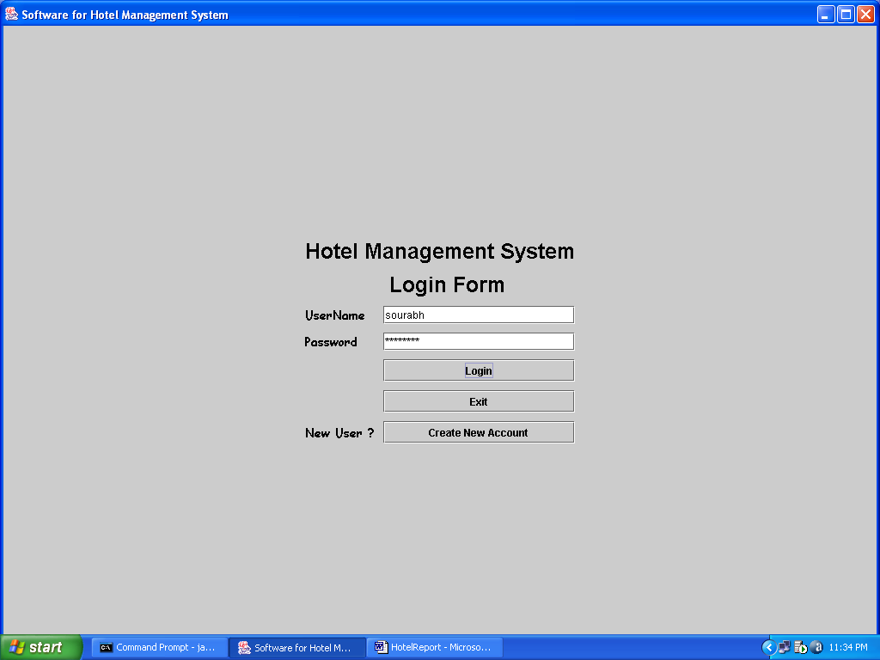

Main Form:-

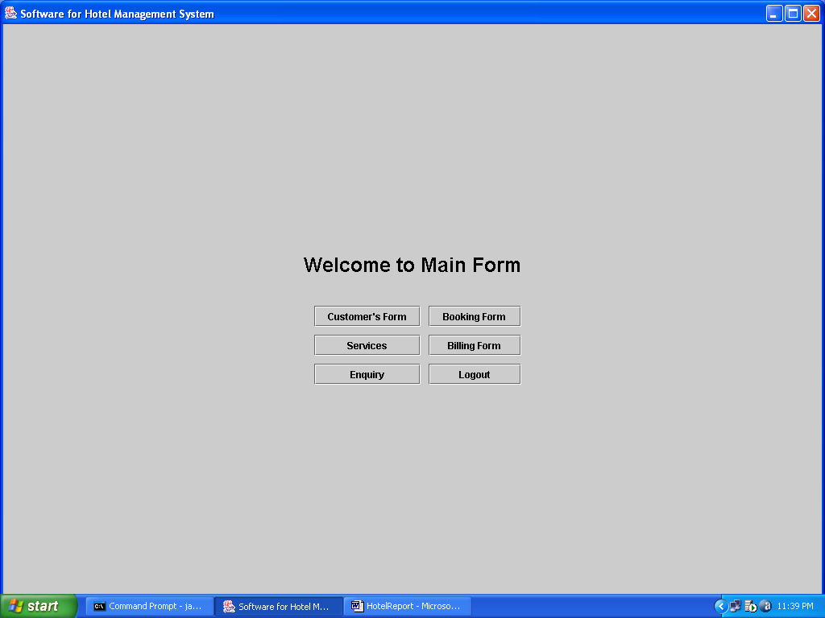

Customer Form:-

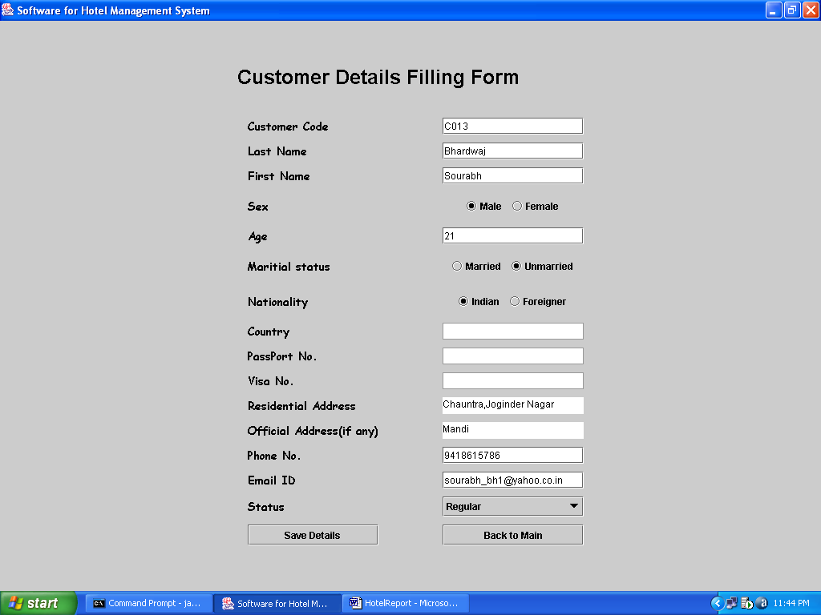

Booking Form:-

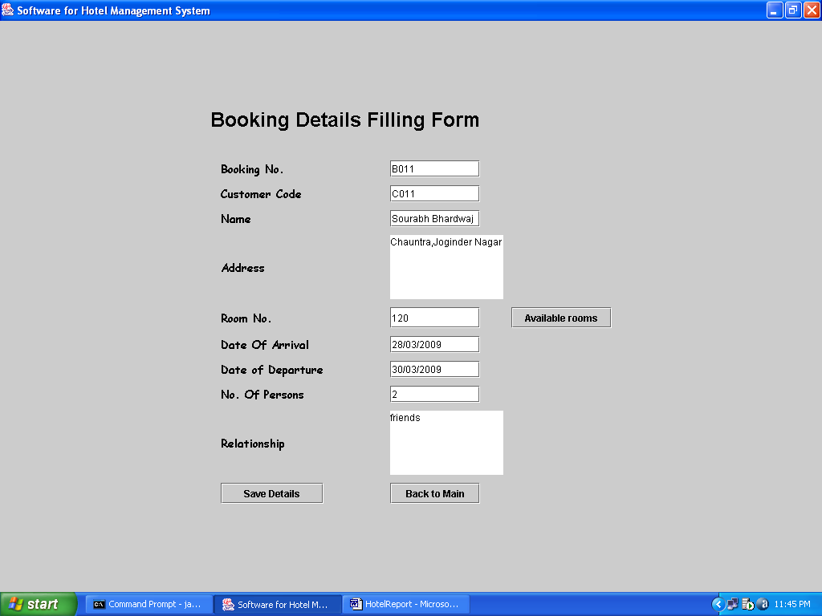

Billing Form:-

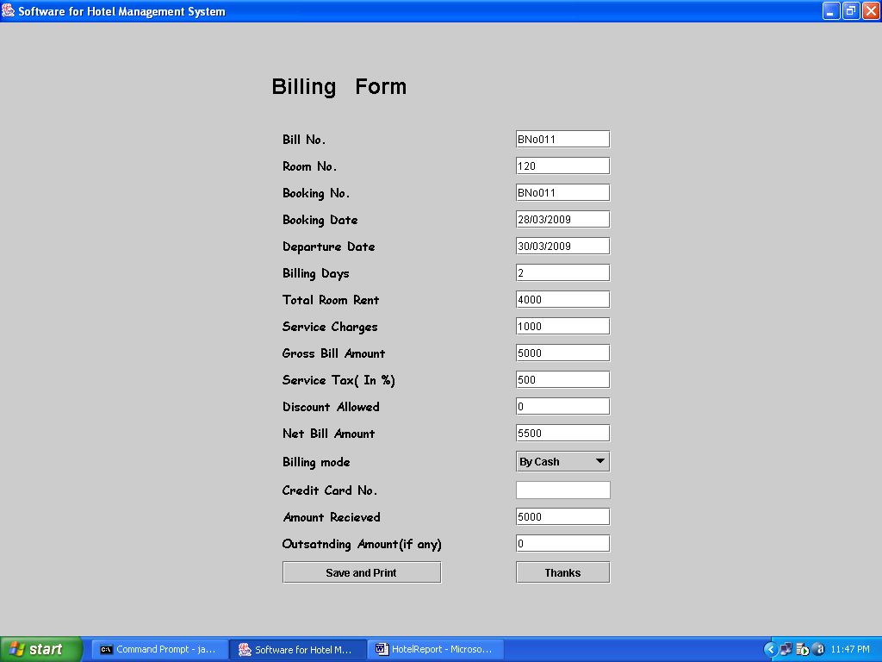

Enquiry Form:-

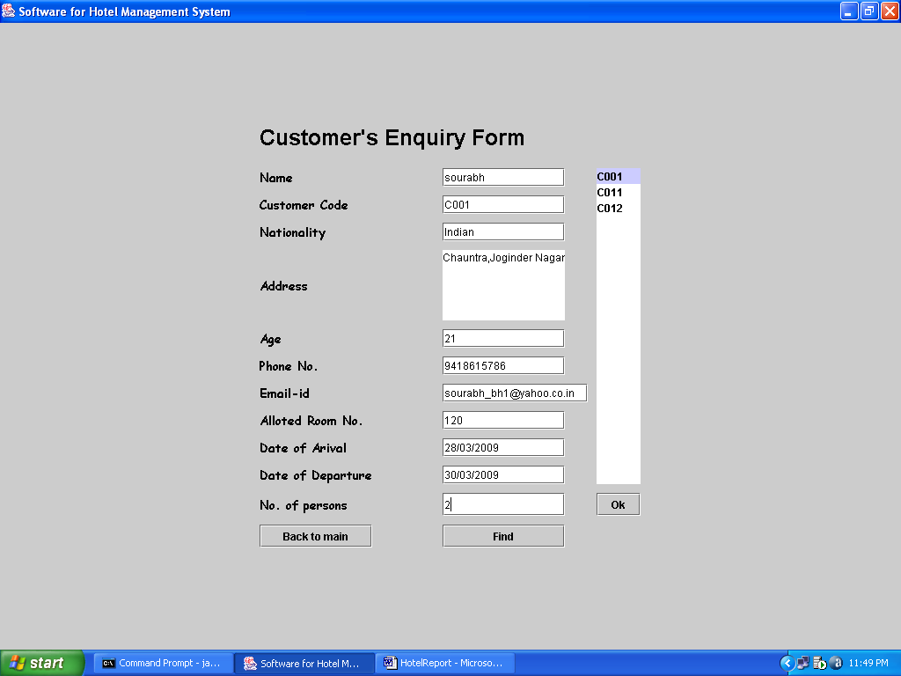

Chapter--5

Conclusion

The project is based on the operational aspects of a hotel and a study of all the functions of the different department in the hotel.
It gives complete exposure of the requirement of the management for smooth functioning. The management policies differ from one hotel to another in thus outlook but there is not much difference in the functioning of the hotels.
I also would like to thank all the teachers of BCA and especially Mr. Vijay Thakur in giving me the guidance in completing the project.
The objective of the project was to study the various aspects of a hotel in general and the front office, housekeeping and the food and beverage departments in the depth to identify its drawbacks and suggest suitable solution during training period. The study is limited by lack of time and information.
There are different forms and tables are used. The data is stored in tables automatically. I tried my best to do this project. However the whole system can not be changed, but the computerized system designed not only saves time but at the same time reduces labour & expenditures. In traditional system, there were lot of irregularities founds in generating data to where as in modified and computerized system in every problem overcome with the press of button. This system provides the security from loss, disclosure, modification and destruction of data. This system provides integrity of proper functioning of programs.

Chapter--6

Annexure

ANN - Artificial neural network
DCS - Distributed Control System
HMI - Human Machine Interface
SCADA - Supervisory Control and Data Acquisition
PLC - Programmable Logic Controller
WWW – World Wide Web
PLC-Programmable Logic Controllers
HMI - Human-Machine Interfaces
CHI- Computer Human Interfaces
MMI-Man-Machine Interfaces
F & B –Food and Beverage
HTTP- Hyper Text Transfer Protocol

Chapter--7

Bibliography

Here I would like to mention about the sources of information in due course of writing the project report & would like to state that the information obtained through different presentation & news article has greatly contributed to the successful completion of the project. The list of different sources is mentioned below:

- John Zokowski ,Java 2 J2SE 1.4
- Y. Daniel Liang ,An Introduction to Java Programming
- Patrick Naughton ,The Complete Reference Java 2
- C.Desai,Data Base System
- Kalyani publications, Database Management System

