1. Valid active Worker

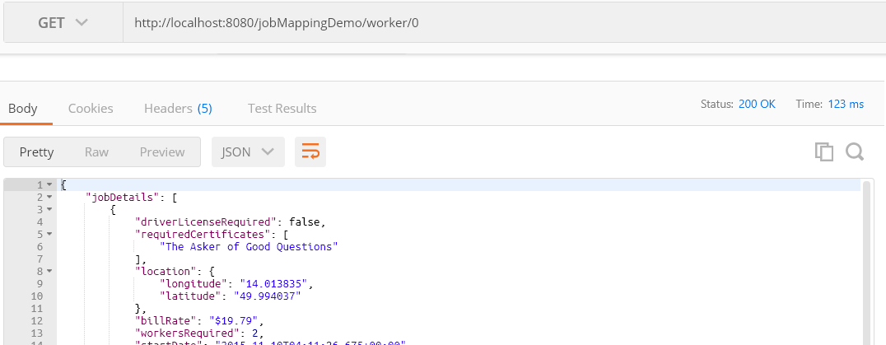

1. Valid and not active worker

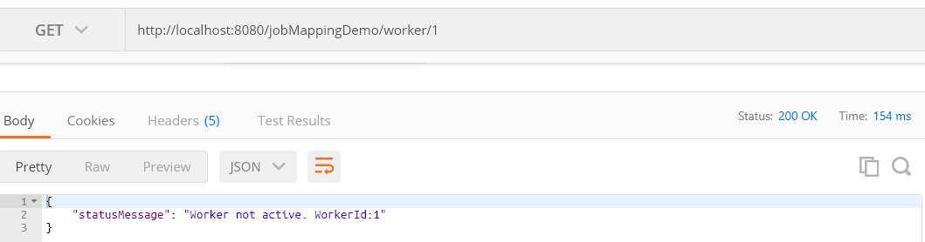

1. Valid worker not in List

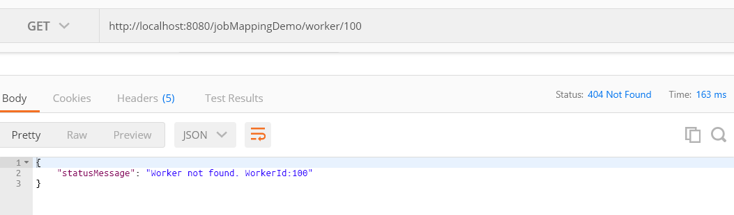

1. Invalid/non integer workerId

