# Introduction

Ideally development in a city should take place uniformly across all parts. But the reality is often different and some areas are left behind whereas other areas are developed at faster pace. This creates a sense of inequity among the residents of the city. Mumbai is one of the most developed cities in India and it is often called the financial capital of India. Whereas the large part of Mumbai is filled with skyscrappers, there are still a big part which even lacks the most basic developmental needs. In this case study we will try to find and highlight such differences on an aggregate scale.

# Data used

For this case study, we will be using the following data:

1. Zip code data for Mumbai

2. Geolocation data for the zip codes

3. Infrastructure details using Foursquare API

# Methodology

The methodology used for this study is as follows:

Zip codes, longitudes and latitudes were extracted using BeautifulSoup from [here](https://geographic.org/streetview/india/maharashtra/konkan/mumbai.html). The page was downloaded using requests module and then web-scrapped. The data was placed inside a pandas dataframe for easier manipulation.

The data was cleaned for easier interpretation.

Foursquare API was used to get nearby venues using longitudes and latitudes obtained earlier. The client id and client secret have been replaced with dummy text in the notebook for maintaining privacy.

Data thus obtained had text data only and machines cannot understand text data as it is. So, in order to remove this limitation, the text data was coded using one-hot encoding. One-hot encoding converts text data into vector form which is very easily understood by machines.

The data was grouped by zip areas and the data was summed up to understand total infrastructural development in the given area. The total no of venues was identified for each zip area. Based on these total values, the zip areas were classified into 3 categories namely underdeveloped, developing and developed areas. The areas with less than or equal to 10 venues were classified as underdeveloped areas. The areas with more than 10 but less than or equal to 25 venues were classified as developing areas. The areas with more than 25 venues were classified as developed areas. The limits for classification were obtained after looking at the distribution of total no of venues across the city.

The different classes were identified and mapped on the city map using folium.

# Results

Out of 225 areas for which the venue data was available:

1. 129 were identified as underdeveloped areas.
2. 61 were identified as developing areas.
3. 35 were identified as developed areas.

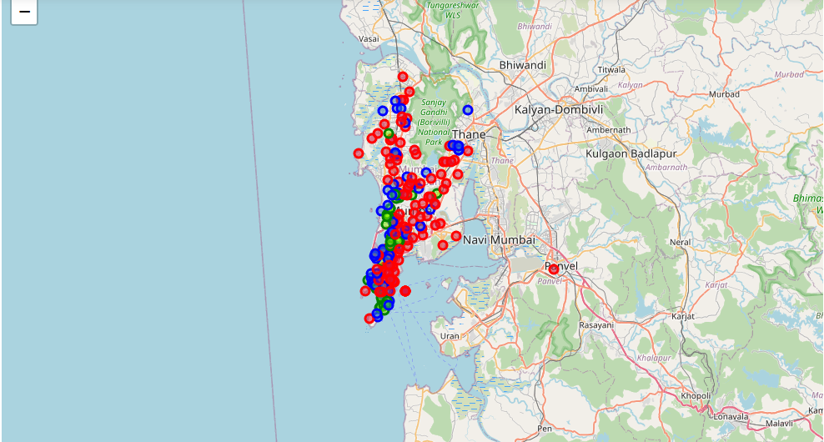

In the above map, underdeveloped areas have been marked in red, developing areas have been marked in blue and developed areas have been marked in green.

# Discussion

Despite Mumbai being hailed as the financial capital of India, it can be seen that a large portion of its area is underdeveloped and only a very small portion of its area can be considered as developed. This points to a large inequality in distribution of resources where a small portion of population enjoys majority of the resources and a large portion gets only small amount of resources.

This inequality also points towards the kind of efforts put into development of city by the state government. The government has been developing the areas that allow them to keep the title of financial capital and have been overlooking the general needs of the population.

Every single citizen has equal rights on the resources of the city and it should be provided to him without him having to ask but it does not seem to be the case in Mumbai. The government is fully aware of the said inequality and has done next to nothing for improving the situation. The government needs to become cognizant of the requirements of its people. Government can pursue project with public private partnerships for the development of these underdeveloped areas.

# Conclusion

There appears to be a large population in Mumbai living on very small amount of resources and the government seems to have forgotten about them. The government needs to focus on these areas for development work first and then take it from there.