Dataset with various parameters which causes wildfires we have considered from different locations in Jim Corbett forest of Uttarakhand.

The AutoML service of Microsoft Azure suggest the best model based on the type of Datset we give. As a result we are suggested with XGBOOST model.

Please refer the procedure in azure automl documents, also the codes attached.

***1. Finding Model***

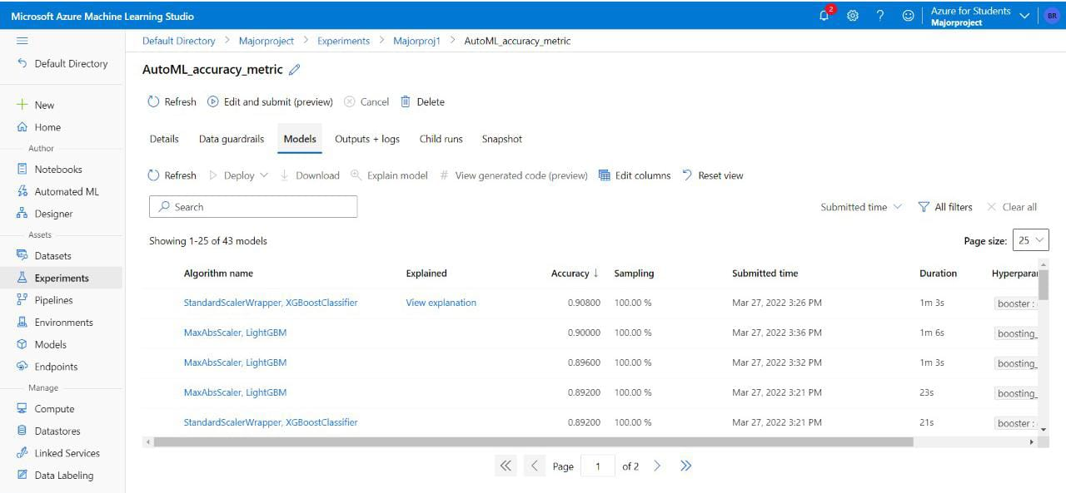

***2. Deploying the Best Model***

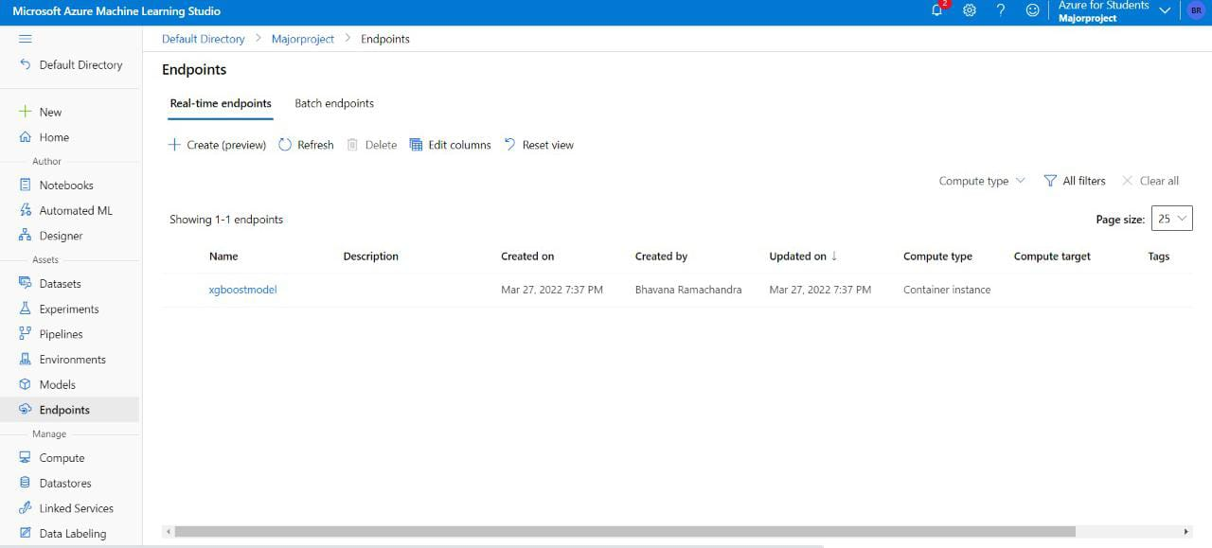

***3. Test with Real time Data***

