Hive_Class_3_Assignment

1. Download vehicle sales data -> https://github.com/shashank-mishra219/Hive-Class/blob/main/sales_order_data.csv

**-->sales_order_data.csv**

**In local path - /home/cloudera/sales_order_data.csv**

**Using Filezilla**

2. Store raw data into hdfs location

**[cloudera@quickstart ~]$ hdfs dfs -put sales_order_data.csv /challenge**

3. Create a internal hive table "sales_order_csv" which will store csv data sales_order_csv .. make sure to skip header row while creating table

**hive> create table sales_order_data_v1**

**(**

**ordernumber int, quantityordered int, priceeach float, orderlinenumber int, sales float, status string, qtr_id int, month_id int, year_id int, productline string, msrp int, productcode string, phone string, city string, state string, postalcode string, country string, territory string, contactlastname string, contactfirstname string, dealsize string**

**)**

**row format delimited**

**fields terminated by ','**

**TBLPROPERTIES(“skip.header.line.count” = “1”);**

4. Load data from hdfs path into "sales_order_csv"

**hive> load data inpath '/challenge/sales_order_data.csv' into table sales_order_data_v1;**

**hive> set hive.cli.print.header = true;**

**( property to show headers )**

5. Create an internal hive table which will store data in ORC format "sales_order_orc"

**hive> create table sales_order_orc**

**(**

**ordernumber int, quantityordered int, priceeach float, orderlinenumber int, sales float, status string, qtr_id int, month_id int, year_id int, productline string, msrp int, productcode string, phone string, city string, state string, postalcode string, country string, territory string, contactlastname string, contactfirstname string, dealsize string**

**)**

**stored as ORC;**

6. Load data from "sales_order_data_v1" into "sales_order_orc"

**hive> from sales_order_csv insert overwrite table sales_order_orc select *;**

**or**

**hive> insert overwrite table sales_order_orc select * from sales_order_data_v1;**

**a.** Calculatye total sales per year

**select sum(sales), year_id from sales_order_data_orc**

**group by year_id;**

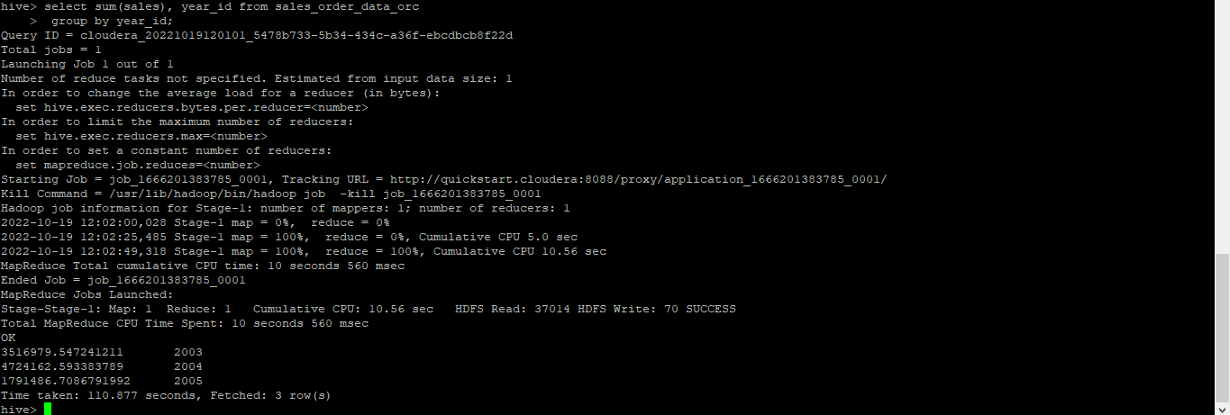

**b.** Find a product for which maximum orders were placed

**select productline, count(productcode)as no_of_order**

**from sales_order_data_orc**

**group by productline**

**order by no_of_order desc limit 1;**

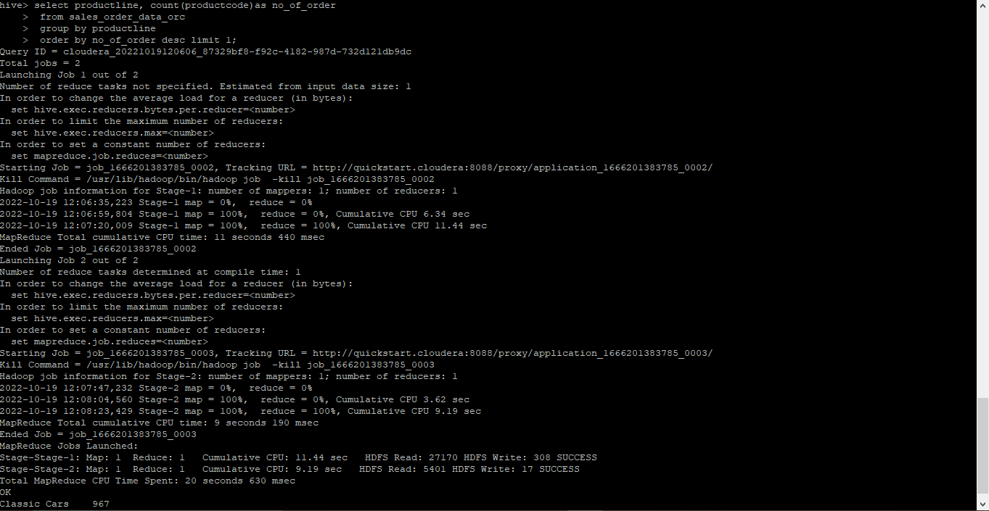

**c.** Calculate the total sales for each quarter

**select qtr_id, sum(sales) as total_sales**

**from sales_order_data_orc**

**group by qtr_id;**

**(for year wise quater sales)**

**select year_id, qtr_id, sum(sales) as total_sales**

**from sales_order_data_orc**

**group by year_id,qtr_id;**

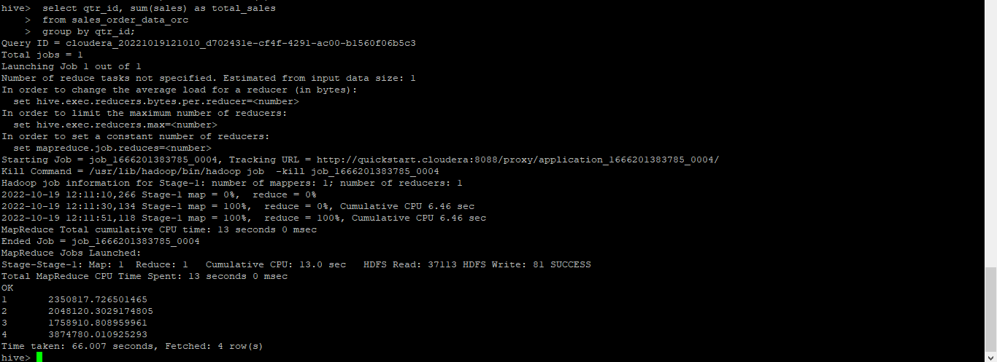

**d.** In which quarter sales was minimum

**select qtr_id, sum(sales) as total_sales**

**from sales_order_data_orc**

**group by qtr_id**

**order by total_sales limit 1;**

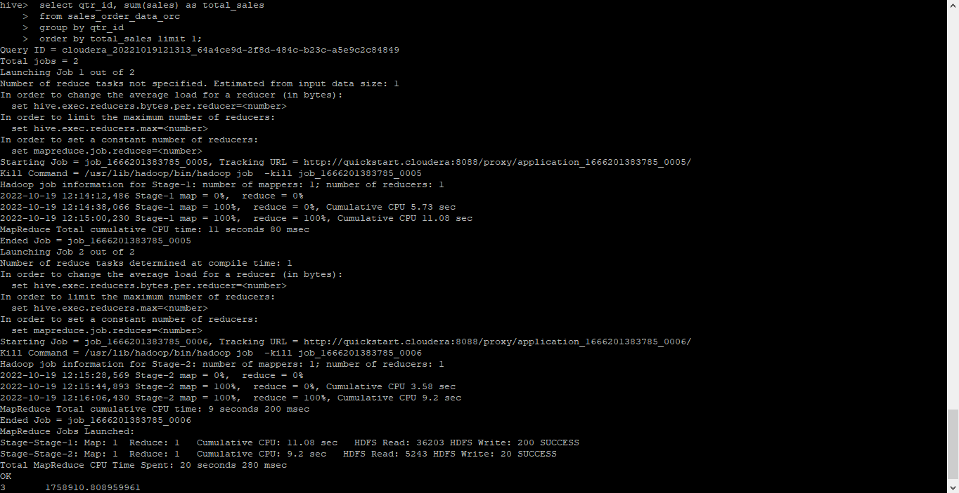

**e.** In which country sales was maximum and in which country sales was minimum

**For min sales :**

**select country, sum(sales)as total_sales**

**from sales_order_data_orc**

**group by country**

**order by total_sales;**

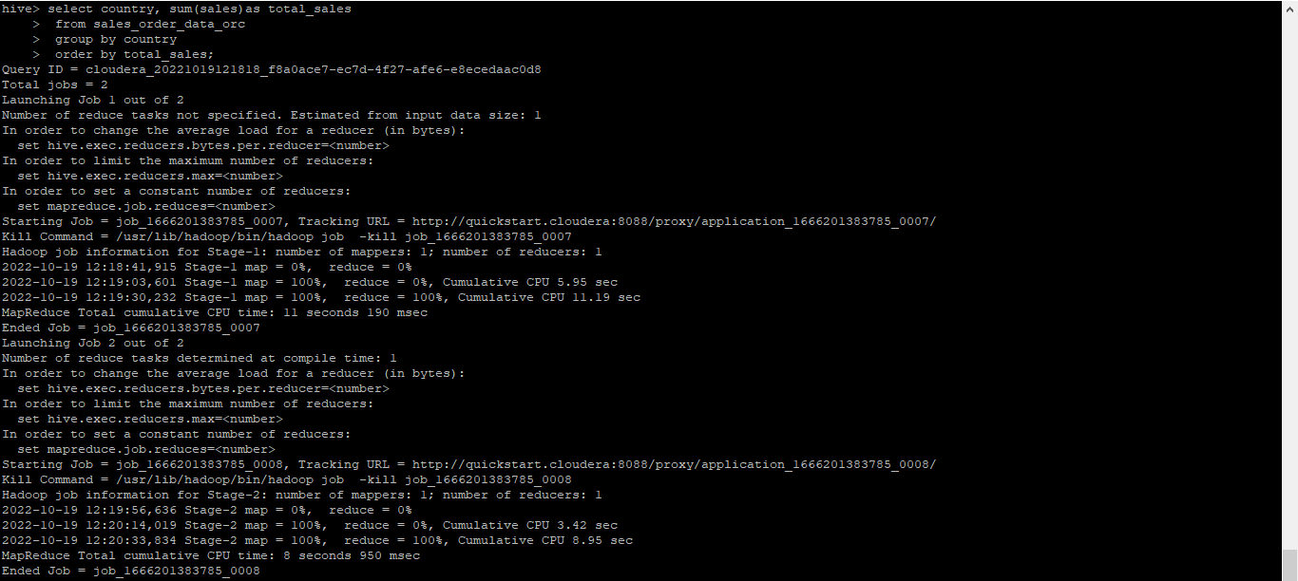

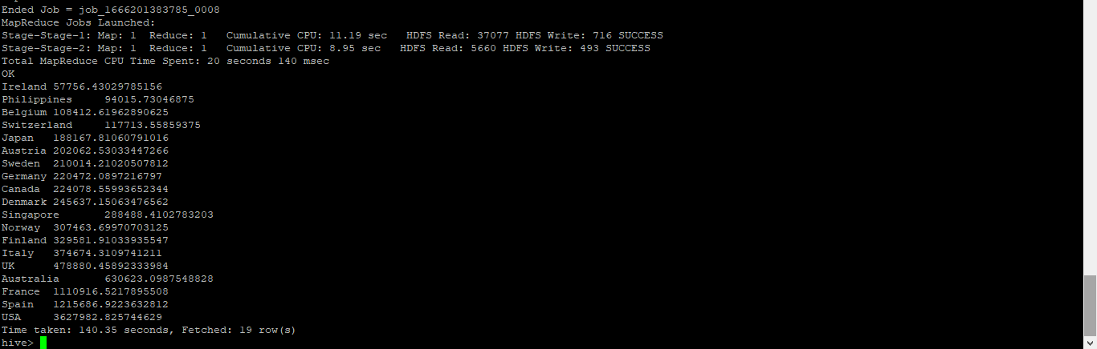

**For max sales :**

**select country, sum(sales)as total_sales**

**from sales_order_data_orc**

**group by country**

**order by total_sales desc limit 1;**

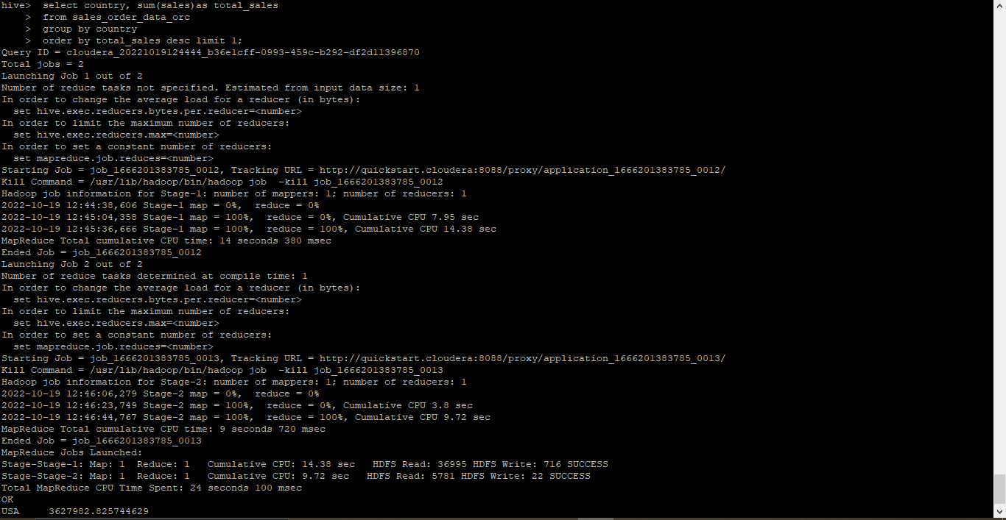

**f.** Calculate quartelry sales for each city

**select city, qtr_id, sum(sales)**

**from sales_order_data_orc**

**group by city, qtr_id;**

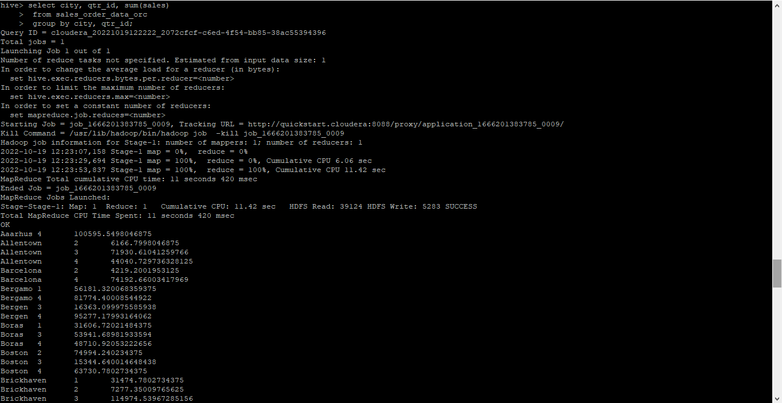

**h.** Find a month for each year in which maximum number of quantities were sold

**select month_id,year_id,quantityordered from (select distinct month_id,year_id, quantityordered ,dense_rank() over(partition by year_id order by quantityordered desc) as rnk from sales_order_dat_v1)a where a.rnk = 1;**

