**1960s**

(Source: <https://theculturetrip.com/north-america/usa/california/articles/the-history-of-pop-music-in-5-defining-decades/>) (<http://www.thepeoplehistory.com/60smusic.html>)

In the ‘60s popular music had been characterized by its largely teen fan base. When the portable radio was introduced; it became even easier for teens to take their tunes wherever they went.

**SURF ROCK**

Pop was traveling, and picking up influences — from the beaches of California, bands like **the Beach Boys** were taking the harmonies from traditional pop songs and layering them with the **“surf rock”** rhythm that they became known for.

**MOTOWN AND R&B**

The "Motown Sound" and popular R&B music had a major significance in terms of the Civil Rights movement and integration in American society during the sixties. Motown records consisted mainly of African-American groups, singers, songwriters and management and their musical and business success proved in breaking down the barriers of segregation and granted African-American performers and musicians a chances to reappropriate much of the success that had been credited to white rock 'n' rollers and pop artists who had success in singing "black music" during the previous decade. (<http://www.thepeoplehistory.com/60smusic.html>)

Singers and bands like the Marvelettes, Stevie Wonder, Aretha Franklin and the Jackson Five are some of the popular Motown and R&B artists.

**BRITISH INVASION IN THE 1960s**

But the true driving force of pop in the ‘60s came from across the Atlantic, with Beatlemania and the British Invasion into the American charts. The British Invasion brought rock and pop music and bands to the U.S., where they became wildly popular. The Beatles were the ones who started the phenomenon with their mix of beat, rock, and pop ballads immediately took over American pop charts. It extended to other British bands, that took part in this invasion included the English rock group, The Rolling Stones, the Kinks, the Who, Cream, and the Yardbirds were all making appearances on the U.S. charts.. English rock groups were not the only ones who were dominating the U.S charts, but also individual artists like Tom Jones. Through all of this, not only the pop genre, but also the rock genre was forming into something not solely defined by the American solo-pop and rock artists/bands of the previous decade. Now, bands were introduced into the fray, and pop was splitting into sub-genres that included **Bubblegum pop**—defined by its upbeat sound and its direct aim at teen audiences—and **Baroque pop**, which blended pop and rock and baroque music together. Rock music sub-genres such as folk rock, surf rock, blues rock, and psychedelic rock were formed during the British Invasion.

**POPULAR ARTISTS IN THE 60s**

**THE BEATLES**

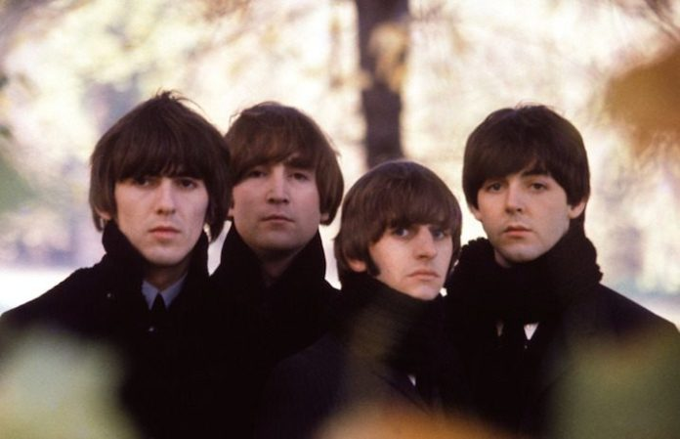

Insert this video: The Beatles- I Want To Hold Your Hand (Live at the Ed Sullivan Show) <https://www.youtube.com/watch?v=jenWdylTtzs>

Hey Jude by The Beatles (<https://www.youtube.com/watch?v=A_MjCqQoLLA>)

The Beatles were a legendary rock group that formed in Liverpool, England, in 1960, and went on to transform popular music as a creative, highly commercial art form over the next decade. The Beatles were one of the most popular bands of all time, producing songs like "Yesterday, "Hey Jude," "Penny Lane, "With A Little Help From My Friends," "Let It Be," "Day Tripper" and "Come Together” that consists of members—John Lennon, Paul McCartney, George Harrison and Ringo Starr.

**THE ROLLING STONES**

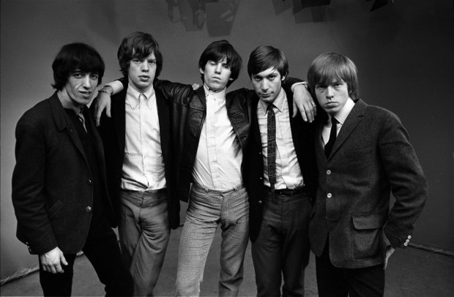

Insert video: Doom and Gloom by The Rolling Stones (<https://www.youtube.com/watch?v=EHcsuiKgg0U>)

I Can’t Get No (Satisfaction) by The Rolling Stones (<https://www.youtube.com/watch?v=nrIPxlFzDi0>)

In 1962, one of the most successful and critically acclaimed rock bands of all time, the Rolling Stones was started in London. Named after the Muddy Waters song "Rollin' Stone," the original band included frontman Mick Jagger, guitarists Keith Richards and Brian Jones, bassist Bill Wyman, drummer Charlie Watts and pianist Ian Stewart. Guitarist Ron Wood joined Jagger, Richards and Watts in 1975. The Stones, in their various incarnations, have rocked on for more than 50 years, selling more than 200 million albums worldwide.

**THE BEACH BOYS**

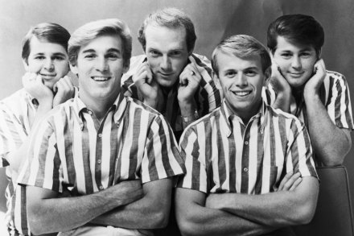

Insert video:

Wouldn’t It Be Nice by The Beach Boys (<https://www.youtube.com/watch?v=nZBKFoeDKJo>)

Surfin’ USA by The Beach Boys (<https://www.youtube.com/watch?v=2s4slliAtQU>)

The Beach Boys are an American rock band formed in Hawthorne, California in 1961. The group's original lineup consisted of brothers Brian, Dennis, and Carl Wilson, their cousin Mike Love, and their friend Al Jardine. Distinguished by their vocal harmonies and early surf songs, they are one of the most influential acts of the rock era.The band drew on the music of jazz-based vocal groups, 1950s rock and roll, and black R&B to create their unique sound, and with Brian as composer, arranger, producer, and de facto leader, they often incorporated classical elements and unconventional recording techniques in innovative ways.

**TOM JONES**

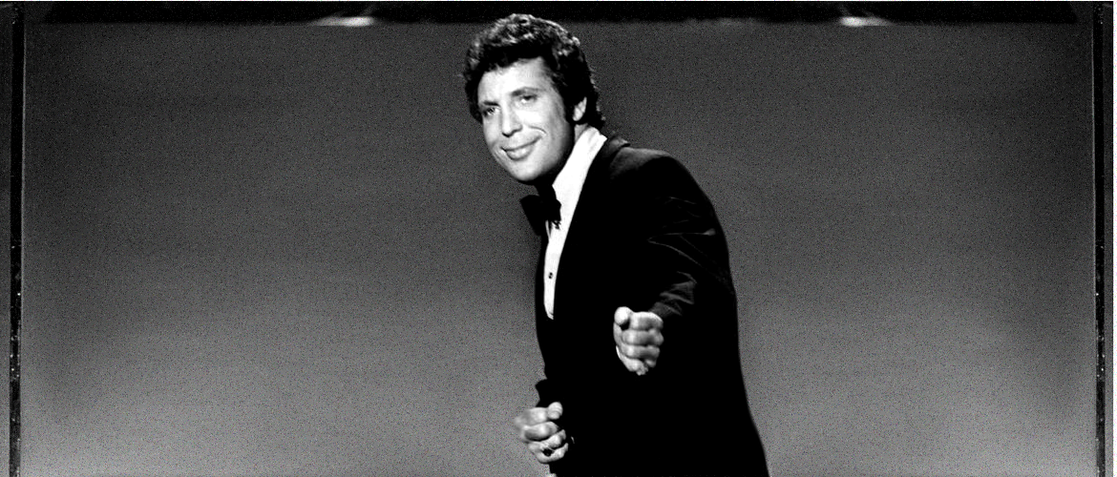

Insert video:

Delilah (<https://www.youtube.com/watch?v=2FCiyeyuF0g>)

Green Green Grass of Home (<https://www.youtube.com/watch?v=u81CTfbc99c>)

Tom Jones is a Welsh singer born on June 7, 1940, in Pontypridd, Wales. Influenced as a child by American blues, R&B and rock 'n' roll, over the past five decades the singing legend has produced hits in both the United States and the United Kingdom. Highlights include classics such as "Once Upon a Time," "With These Hands," "Green, Green Grass of Home" and "Delilah." He continued to put forth successful albums from the '80s into the new millennium, with hits particularly catered to the British and European markets.

**STEVIE WONDER**

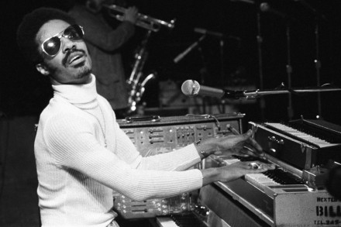

Insert video:

Isn’t She Lovely (<https://www.youtube.com/watch?v=IVvkjuEAwgU>)

Superstition (<https://www.youtube.com/watch?v=0CFuCYNx-1g>)

Stevie Wonder is an American musician, singer and songwriter, considered to be one of the most creative musical performers of the 20th century. Blind from birth, he was a child prodigy and became a skilled musician by the age of eight. After signing a contract with Motown label, he was renamed ‘Little Stevie Wonder’ and made his recording debut at the age of 12.Subsequently, he emerged as an able artist with his hit single “Fingertips” and later, his passionate delivery of the pounding single “Uptight (Everything’s Alright)” confirmed the arrival of a compelling performer. In the following years, Wonder had numerous hits with several chartbusters including “I Was Made to Love Her” and “For Once in My Life”.

**THE JACKSON 5**

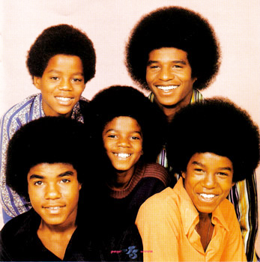

Insert video:

I Want You Back (<https://www.youtube.com/watch?v=s3Q80mk7bxE>)

I’ll Be There (<https://www.youtube.com/watch?v=VzLzUqdGBNo>)

The Jackson 5 were one of the biggest phenomenons in pop music during the late 60s, and the last great group to come out of the Motown hitmaking machine before Marvin Gaye and Stevie Wonder shifted the label's focus to more individual visions. The Jackson 5's infectious brand of funky pop-soul was a definite departure from the typically smooth, elegant Motown sound, as befitting the group's youth and the dawn of a new decade. That youth, coupled with the merchandising juggernaut that sprang up behind them, inevitably got them tagged a bubblegum group. But they were far more talented musically than that label would suggest, especially lead singer Michael, and their material, while sunny and upbeat, didn't pander to its audience. Solo careers and overexposure gradually weakened the Jackson 5, but their best music still holds up surprisingly well as some of the most vibrant mainstream pop/R&B of its era.

**BOB DYLAN**

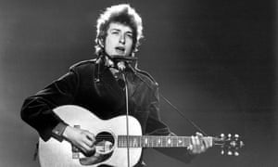

Insert video:

Knockin’ On Heaven’s Door (<https://www.youtube.com/watch?v=rm9coqlk8fY>)

Like A Rolling Stone (<https://www.youtube.com/watch?v=IwOfCgkyEj0>)

Folk rock singer-songwriter Bob Dylan was born Robert Allen Zimmerman on May 24, 1941, in Duluth, Minnesota. While attending college, he began performing folk and country songs, taking the name "Bob Dylan." In 1961 Dylan signed his first recording contract, and he emerged as one of the most original and influential voices in American popular music. Dylan has continued to tour and release new studio albums, including Together Through Life (2009), Tempest (2012), Shadows in the Night (2015) and Fallen Angels (2016). The legendary singer-songwriter has received Grammy, Academy and Golden Globe awards, as well as the Presidential Medal of Freedom and the Nobel Prize for Literature.