**1970s (THEME: DISCO)**

(SOURCE: <http://www.thepeoplehistory.com/70smusic.html>, <https://www.retrowaste.com/1970s/music-in-the-1970s/>)

There was more variety in music in the 1970s than ever before. Music listeners had dozens of genres to choose from and many of them rose to popularity at different points during the decade. Funk, Soul, R&B, Pop, Hard Rock, Soft Rock and Disco all carved out their place in the music world in the 1970s. The late 70s also witness the birth of another young music style: hip-hop. Some of the best Rock N’ Roll of all time was recorded in the 70s. From David Bowie to Led Zeppelin to Pink Floyd, the list I could make would keep you scrolling for days. The 70s were a golden era for vinyl records. They were affordable to everyone and everyone had a record player. It seems like almost every song ever made in the 80s had a 70s sample in it. Music equipment had finally given artists more than 4 tracks to work with and music became much more experimental than it was technically capable of being in the 60s.

**DISCO AND DANCE MUSIC**

If ever a musical style defined a decade, Disco was the definition of the 1970s. Although its popularity was relatively short-lived, the genre hosted a great deal of songs and artists that people are still dancing to today and had a large influence on the fashions of the decade, too. Van McCoy's "The Hustle" has often been referred to as the definitive disco track and many people say it was the first disco song created.

**FAMOUS ARTISTS IN DISCO AND DANCE MUSIC**

**THE BEE GEES**

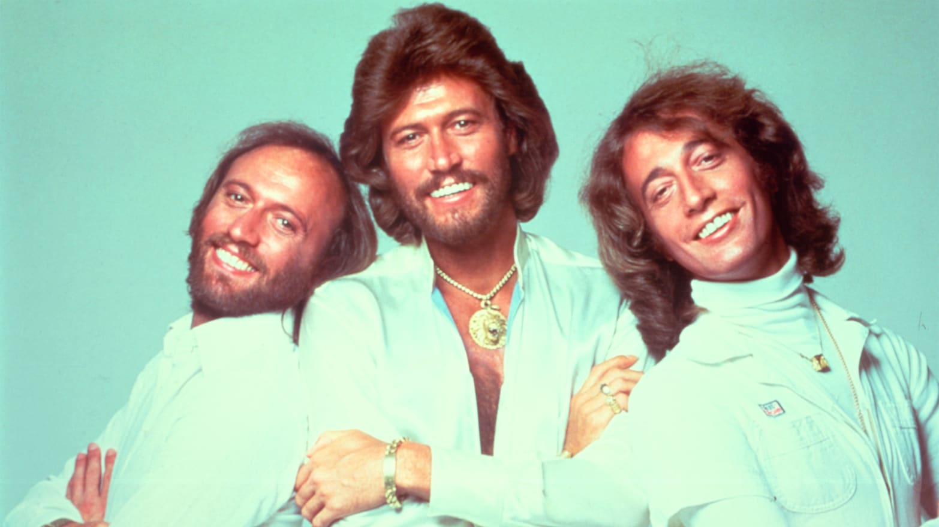

Insert video:

Stayin’ Alive (<https://www.youtube.com/watch?v=I_izvAbhExY>)

How Deep Is Your Love (<https://www.youtube.com/watch?v=XpqqjU7u5Yc>)

The Bee Gees, English-Australian pop-rock band that embodied the disco era of the late 1970s. In becoming one of the best-selling recording acts of all time, the Bee Gees (short for the Brothers Gibb) adapted to changing musical styles while maintaining the high harmonies, elaborate melodies, and ornate orchestrations that were their trademark. The principal members were Barry Gibb, Robin Gibb, and Maurice Gibb.

**ABBA**

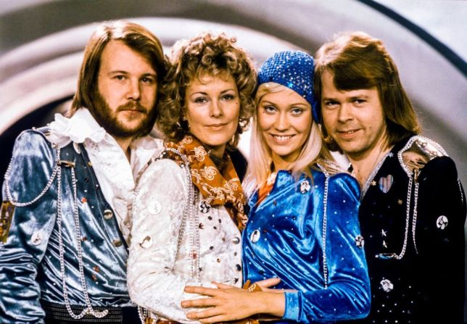

Insert video:

Dancing Queen (<https://www.youtube.com/watch?v=xFrGuyw1V8s>)

Mamma Mia (<https://www.youtube.com/watch?v=unfzfe8f9NI>)

Swedish Europop group that was among the most commercially successful groups in the history of popular music. In the 1970s it dominated the European charts with its catchy pop songs. Members included songwriter and keyboard player Benny Andersson, songwriter and guitarist Björn Ulvaeus, and vocalists Agnetha Fältskog. and Anni-Frid Lyngstad.

**PROGRESSIVE ROCK**

Progressive rock was another popular genre during the 1970s. This type of music was typically characterized by rock music combined with another genre, such as classical or opera, to create a hybrid genre. Songs from this genre were often longer and bands tended to be more spontaneous and experimental while they were playing live. Many progressive rock albums were also concept albums, meaning that they followed a theme throughout the entire album or series of albums.

**FAMOUS ARTISTS IN PROGRESSIVE ROCK MUSIC**

**PINK FLOYD**

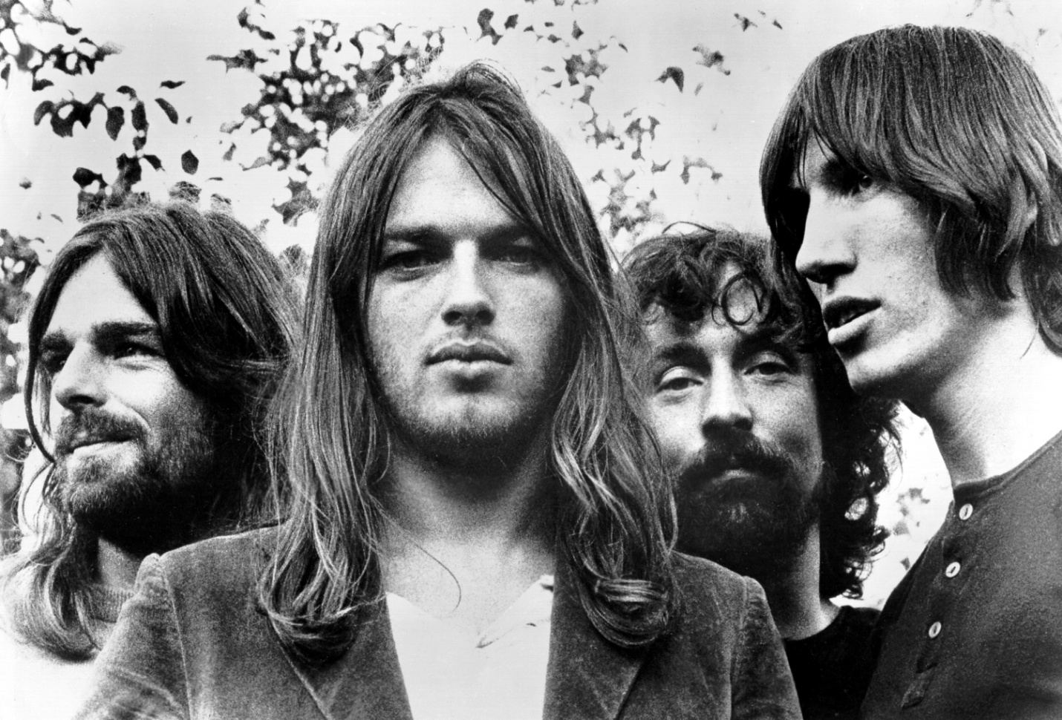

Insert video:

Another Brick On The Wall (<https://www.youtube.com/watch?v=YR5ApYxkU-U>)

Comfortably Numb (<https://www.youtube.com/watch?v=_FrOQC-zEog>)

Pink Floyd was an English rock band formed in London in 1965. Gaining a following as a psychedelic rock band, they were distinguished for their extended compositions, sonic experimentation, philosophical lyrics and elaborate live shows, and became a leading band of the progressive rock genre. They are one of the most commercially successful and influential groups in popular music history. The principal members were lead guitarist Syd Barrett, bassist Roger Waters, drummer Nick Mason, keyboard player Rick Wright, and guitarist David Gilmour.

**QUEEN**

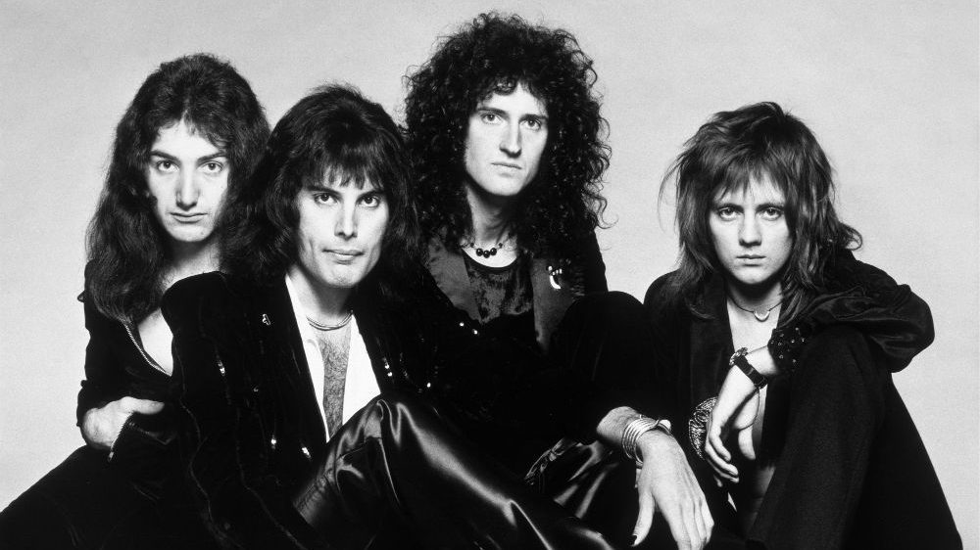

Insert video:

Bohemian Rhapsody (https://www.youtube.com/watch?v=fJ9rUzIMcZQ)

Don’t Stop Me Now (<https://www.youtube.com/watch?v=HgzGwKwLmgM&list=PL2tMgWgIvcWnpy6by9T0ZKyxLcZ2W4Pcs&index=12>)

British rock band whose fusion of heavy metal, glam rock, and camp theatrics made it one of the most popular groups of the 1970s. Although generally dismissed by critics, Queen crafted an elaborate blend of layered guitar work by virtuoso Brian May and overdubbed vocal harmonies enlivened by the flamboyant performance of front man and principal songwriter Freddie Mercury. The members were Freddie Mercury, Brian Ma, John Deacon, and Roger Taylor.

**LED ZEPPELIN**

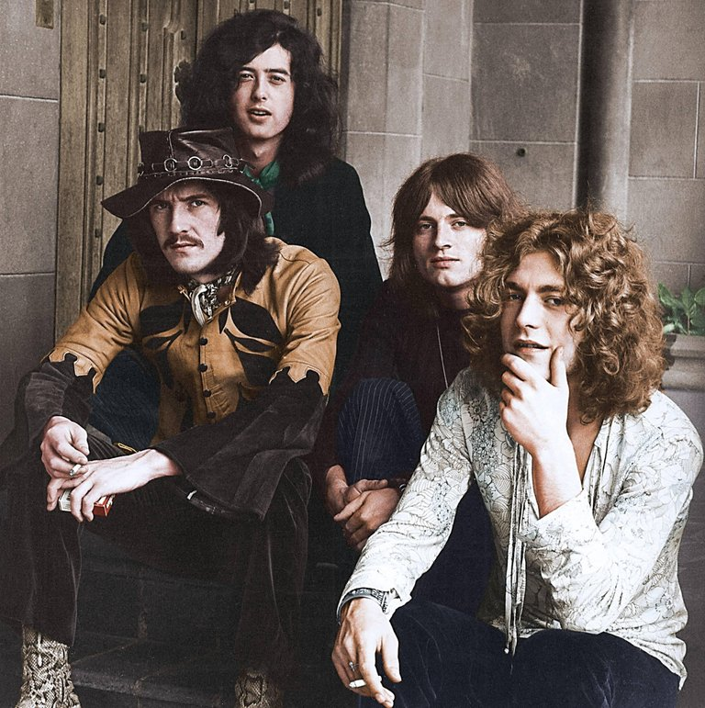

Insert video:

Immigrant Song (Live in 1972) (<https://www.youtube.com/watch?v=RlNhD0oS5pk>)

Stairway To Heaven (<https://www.youtube.com/watch?v=QkF3oxziUI4>)

British rock band that was extremely popular in the 1970s. Although their musical style was diverse, they came to be well known for their influence on the development of heavy metal and progressive rock. The members were Jimmy Page, Robert Plant, John Paul Jones, and John Bonham.

**PUNK ROCK AND NEW WAVE**

The punk rock genre also emerged in the 1970s. This was a style that continued on the legacy of the 1960s but with a more upbeat and harder style. Heavy guitar riffs and more decibels helped to motivate those who were still upset about the status quo in the country. On the other hand, New Wave, similar to punk music but more radio friendly and with an electronic flair, also emerged in the late seventies and went on to become a predominant genre in the next decade.

**FAMOUS ARTISTS IN PUNK ROCK AND NEW WAVE MUSIC**

**DAVID BOWIE**

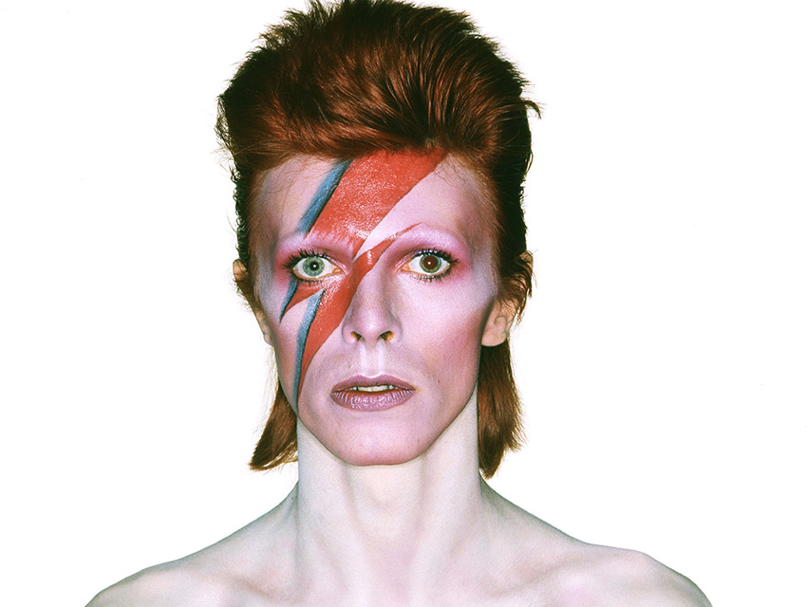

Insert video:

Space Oddity (<https://www.youtube.com/watch?v=iYYRH4apXDo>)

Rebel Rebel (<https://www.youtube.com/watch?v=Vy-rvsHsi1o>)

David Bowie, British singer, songwriter, and actor who was most prominent in the 1970s and best known for his shifting personae and musical genre hopping.

**THE RAMONES**

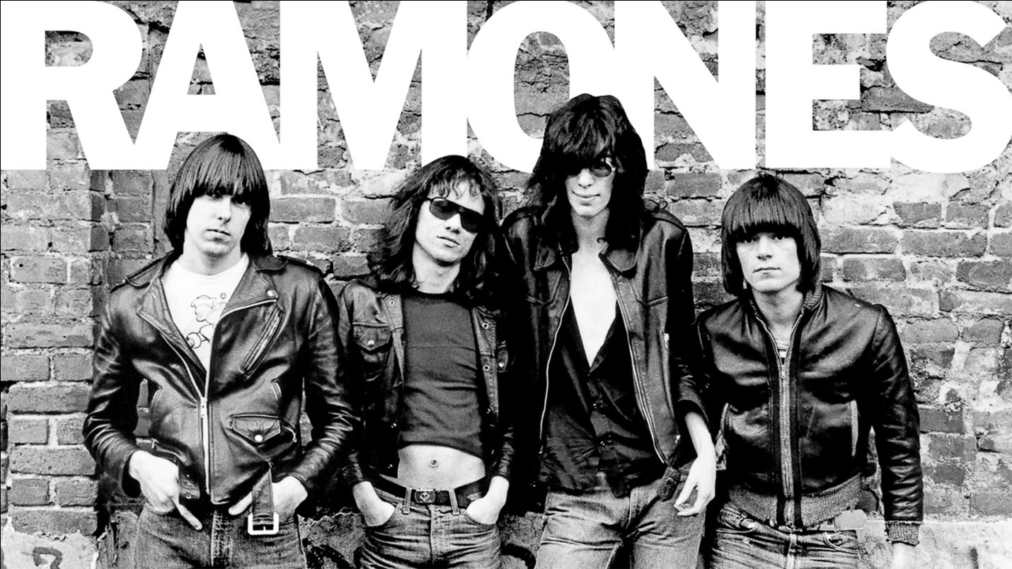

Insert video:

I Wanna Be Sedated (<https://www.youtube.com/watch?v=bm51ihfi1p4>)

American band that influenced the rise of punk rock on both sides of the Atlantic Ocean. The original members were Joey Ramone, Johnny Ramone, Dee Dee Ramone, and Tommy Ramone.

**FUNK AND SOUL MUSIC**

Funk music came out of the R&B, Jazz and Soul music of the late 1960s after artists added more beats and psychedelic tones to their songs. This genre saw the height of its popularity encompass the 1970s with artists like James Brown, Parliament-Funkadelic, Sly and the Family Stone and Kool and the Gang dominating the music charts. Funk was known for its danceable beats, strange costumes, outrageous personalities and often socially conscious lyrics.

**FAMOUS ARTISTS IN FUNK AND SOUL MUSIC**

**EARTH, WIND AND FIRE**

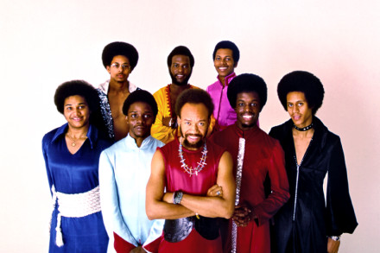

Insert video:

September (<https://www.youtube.com/watch?v=Gs069dndIYk>)

Let’s Groove (<https://www.youtube.com/watch?v=Lrle0x_DHBM>)

Earth, Wind & Fire, American pop, soul, and jazz-fusion band that became one of the best-selling and most influential groups of the 1970s. The principal members were Maurice White, Philip Bailey, Verdine White, Fred White, Al McKay, Johnny Graham, Ralph Johnson, Larry Dunn, and Andrew Woolfolk.

**JAMES BROWN**

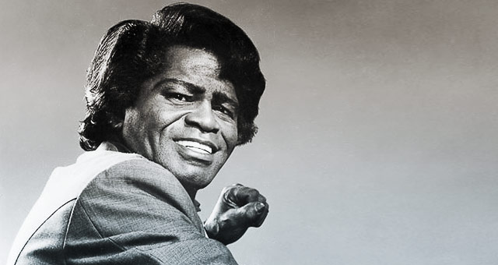

Insert video:

I Feel Good (https://www.youtube.com/watch?v=U5TqIdff_DQ)

It’s a Man’s Man’s Man’s World (<https://www.youtube.com/watch?v=H77fRz1rybs>)

Known as the “Godfather of Soul Music.” James Brown, American singer, songwriter, arranger, and dancer, who was one of the most important and influential entertainers in 20th-century popular music and whose remarkable achievements earned him the sobriquet “the Hardest-Working Man in Show Business.”

**OTHER FAMOUS ARTISTS IN THE 70s**

**ELTON JOHN**

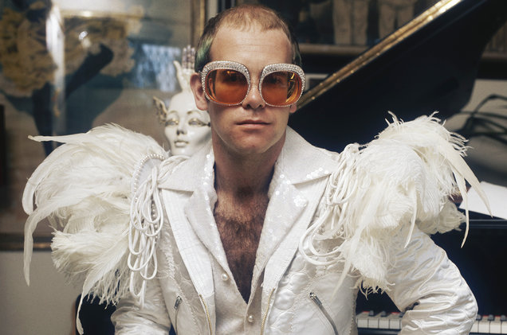

Insert video:

Rocket Man (<https://www.youtube.com/watch?v=DtVBCG6ThDk>)

I’m Still Standing (<https://www.youtube.com/watch?v=ZHwVBirqD2s>)

Elton John, British singer, composer, and pianist who was one of the most popular entertainers of the late 20th century. He fused as many strands of popular music and stylistic showmanship as Elvis Presley in a concert and recording career that included the sale of hundreds of millions of records.

**JOHN LENNON**

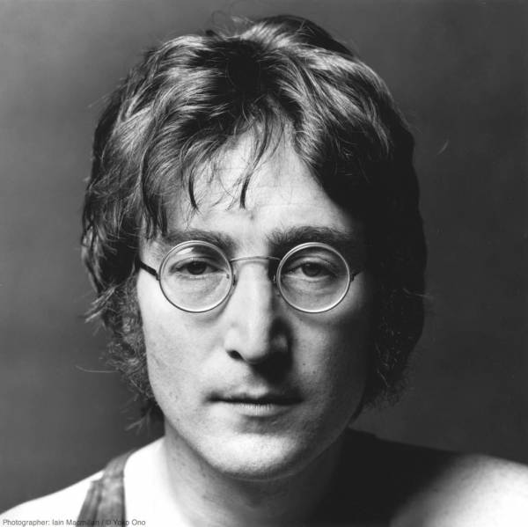

Insert video:

Imagine (<https://www.youtube.com/watch?v=YkgkThdzX-8>)

Happy Xmas (War Is Over) (<https://www.youtube.com/watch?v=yN4Uu0OlmTg>)

John Lennon, in full John Winston Ono Lennon, (born October 9, 1940, Liverpool, England—died December 8, 1980, New York, New York, U.S.), leader or coleader of the British rock group the Beatles, author and graphic artist, solo recording artist, and collaborator with Yoko Ono on recordings and other art projects.

**BILLY JOEL**

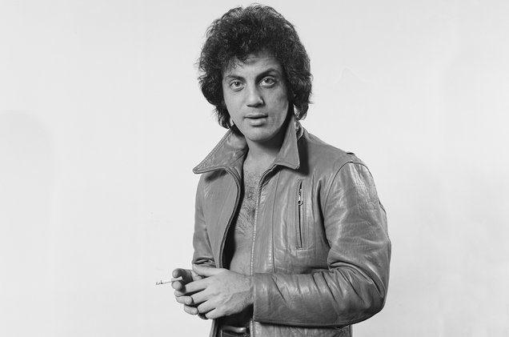

Insert video:

Piano Man (<https://www.youtube.com/watch?v=gxEPV4kolz0>)

We Didn’t Start The Fire (<https://www.youtube.com/watch?v=eFTLKWw542g>)

Billy Joel, in full William Martin Joel, (born May 9, 1949, Bronx, New York, U.S.), American singer, pianist, and songwriter in the pop ballad tradition whose numerous hit songs in the 1970s and ’80s made him an enduring favourite on the concert circuit.