Sources: <http://www.thepeoplehistory.com/80smusic.html> ; <https://mentalitch.com/music-of-the-1980s/>

**The Start of 1980’s Music**

The 1980s opened with a tragic note when John Lennon was shot to death by a fan named Mark Chapman just as the former was coming back into the public eye with a new solo album. Lennon’s death triggered a global outpouring of grief. Speaking of genres, the 1980s introduced (or re-introduced) many of them such as the resurgence of **heavy metal**, the advent of **new wave**, **hip-hop**, **rap music**, **hair metal**, and **pop,** all of which influenced music in the present. The 1980s also reflected the beginning of an era of great gap when it comes to income. As many pop stars were becoming affluent during the 1980s, they wanted to prove to the world that they could be generous and have a serious intention by tackling certain causes. As a result, rock and artists contributed to the world by participating in charity concerts and recordings. These include Band Aid, We Are the World, as well as Live Aid and Farm Aid concerts.

**The rise of Pop**

Pop stars and their music changed in the 1980s with the help of MTV and a greater focus on image. A new breed of mega-stars emerged, becoming iconic mascots for the genre and defining the decade through fashion, talent and persona. Some of the superstars to emerge were Madonna, Michael Jackson, Whitney Houston and Prince. They experienced a level of fame and success not seen since Elvis Presley and the Beatles. These stars influenced fashion through their music videos, giving fans a first-hand glimpse into emerging trends. Their songs set the gold standard for what pop music should be, and through constant reinvention they were able to navigate the pop culture world and keep themselves relevant.

**Most Popular Artists of Pop in the 1980s**

**1. Michael Jackson**

Born: Michael Joseph Jackson on August 29, 1958 in Gary, Indiana

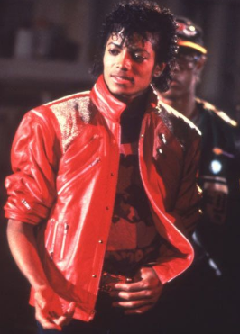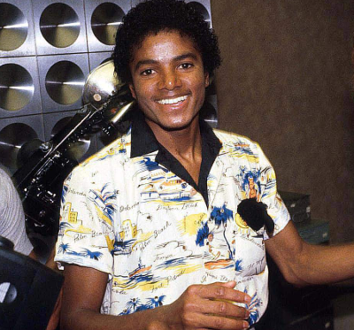

Died: June 25, 2009 in Los Angeles, California

Known as the “King of Pop”, he was slowly coming into his own until he became a dominant figure in the 1980s. Jackson’s music videos, notably for “Beat It,” “Billie Jean” and “Thriller,” helped break down racial barriers and revolutionize the medium into an art form and promotional tool.

Insert: Rock with You - <https://www.youtube.com/watch?v=5X-Mrc2l1d0> ; Billie Jean - <https://www.youtube.com/watch?v=Zi_XLOBDo_Y>

### ****2.  Madonna****

Born: Madonna Louise Ciccone on August 16, 1958 in Bay City, Michigan



Starting from a humble background, Madonna rose to become one of the one of the best-known musical figures in the 1980s. Her raunchy image, pleasure-celebrating dance music and bizarre music videos gave feminism a much-needed reshaping throughout the decade. She broke sexual boundaries and made eroticism one of the critical important elements of pop music, and challenging religious and social conventions.

Insert: La Isla Bonita - <https://www.youtube.com/watch?v=zpzdgmqIHOQ&list=PLtso_D2e-GWRaH8Fhncm9ZbQUeTCvos_6> ; Material Girl - <https://www.youtube.com/watch?v=6p-lDYPR2P8&list=PLtso_D2e-GWRaH8Fhncm9ZbQUeTCvos_6&index=4>

### ****3.  Prince****

Born: Prince Roger Nelson on June 7, 1958 in Minneapolis, Minnesota

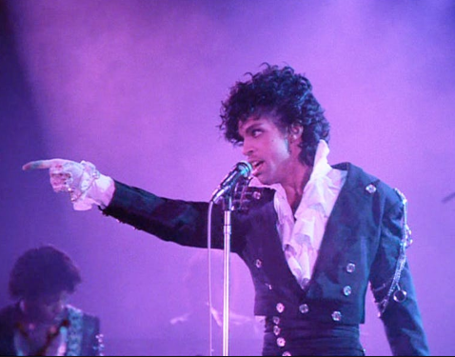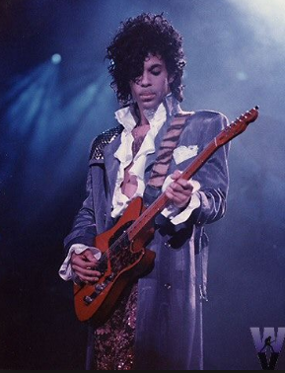

Died:  April 21, 2016 in Chanhassen, MN

For over three decades, Prince has been known for his innovative, eclectic work, not to mention his flamboyant stage presence and a wide vocal range. Often referred to also as the “Artist Formerly Known as Prince,” the multi-instrumentalist artist found huge fame through his eponymous effort in 1979. Thanks to his eclectic blending of funk, R&B, soul, hip-hop, disco, jazz and pop plus his sexually-laced lyrics, Prince continued his success through his later records and received several awards throughout his career.

Insert: When Doves Cry - <https://www.youtube.com/watch?v=UG3VcCAlUgE&list=PL8cFaF2b783IMywRod51qpahGewGEqNYP> ; Prince Raspberry Beret - <https://www.youtube.com/watch?v=UG3VcCAlUgE&list=PL8cFaF2b783IMywRod51qpahGewGEqNYP>

**Most Popular Artists of Rock in the 1980s**

### ****1.  Queen****

Formed: 1970 in London, England

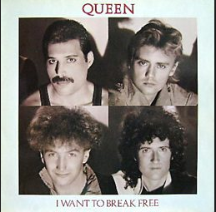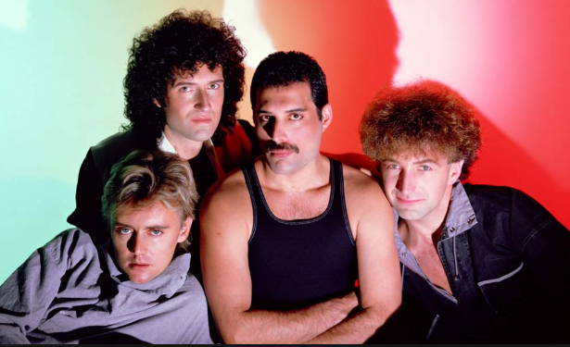

Queen is British rock band who reached the peak of their career in the 1970s and the 1980s. The group, who was then fronted by the charismatic late singer Freddy Mercury in their heyday, is well known for its sports anthems and classic rock songs, especially the hits “We Are the Champions” and the epic opera-rock “Bohemian Rhapsody” whose promotional video became one of the earliest successful music videos.

Insert: Another One Bites the Dust - <https://www.youtube.com/watch?v=rY0WxgSXdEE&list=PLeoBVKHKNsGq4F3u9q5VKnMWk-tYRfxfs> ; I Want to Break Free - <https://www.youtube.com/watch?v=f4Mc-NYPHaQ&list=PLeoBVKHKNsGq4F3u9q5VKnMWk-tYRfxfs&index=3>

### ****2.  Guns N’ Roses****

Formed: 1985 in Los Angeles, California

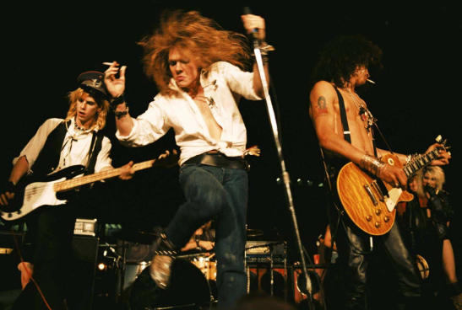

[Guns N' Roses](https://www.allmusic.com/artist/guns-n-roses-mn0000540883) brought raw, ugly rock & roll crashing back into the charts. They were not nice boys: nice boys don't play rock & roll. They were ugly, misogynistic, and violent; they were also funny, vulnerable, and occasionally sensitive, as their breakthrough hit, "Sweet Child O' Mine," showed.

Insert: Sweet Child O’ Mine - <https://www.youtube.com/watch?v=1w7OgIMMRc4> ; November Rain - <https://www.youtube.com/watch?v=8SbUC-UaAxE&list=PL2wCCiky2eR3F10yLWLaIU9oZ5MLUeW7->

Created By: Olores, Francis A.